<https://chowdhury-joyjit.medium.com/field-notes-for-the-databricks-certified-spark-developer-exam-ca0b6eb452fc>

<https://www.rakirahman.me/spark-certification-study-guide-part-1/#introduction>

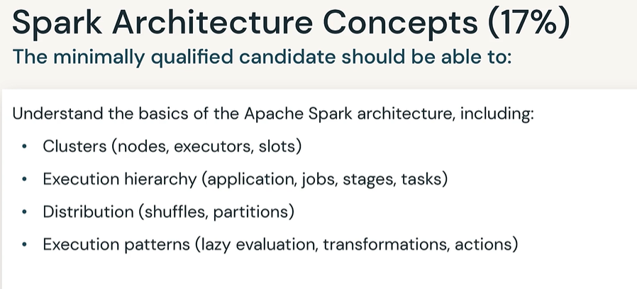

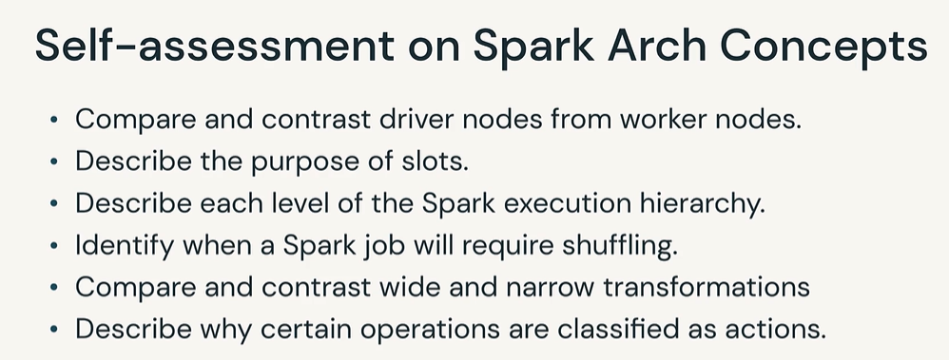

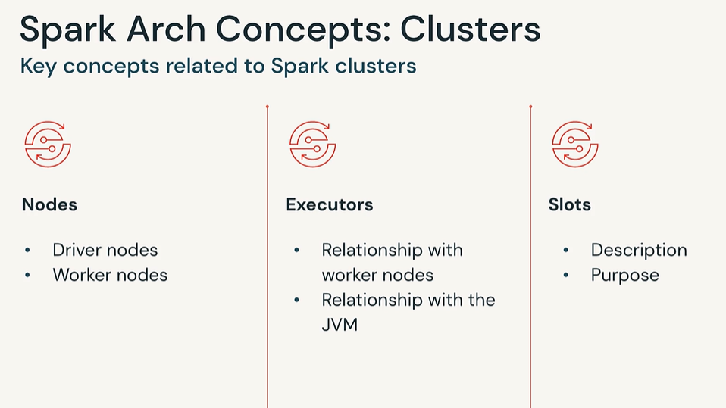

**What Is Apache Spark?**

**Cluster computing platform** designed to be fast and general purpose. In spark, all the components and layers are loosely coupled and its components are integrated. One of the reasons why **spark** has become so popular is because it is a fast**, in-memory data processing engine**.  **Likewise, hadoop mapreduce,** spark also works to **distribute data across the cluster**. It helps to **process data in parallel**. Spark uses master/slave architecture, one master node, and many slave worker nodes. Here, Driver is the central coordinator.

* 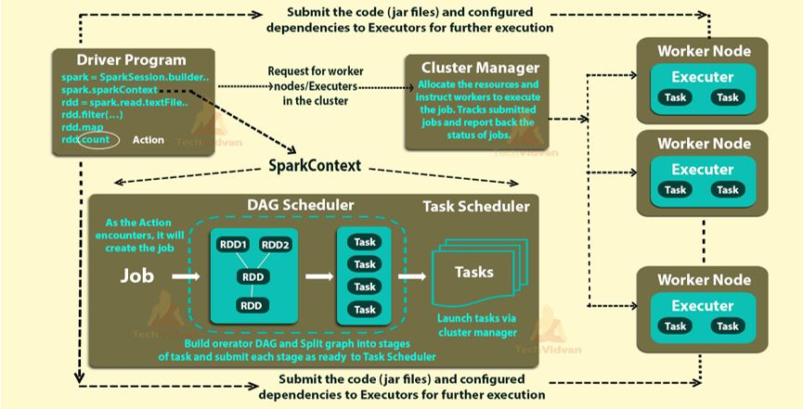

**What are the steps that occur when you run a Spark application on a cluster?**

* The **user submits** an **application** using **spark-submit.**
* As soon as you do a Spark submit, your **user program and other configuration mentioned are copied onto all the available nodes in the cluster**. So that the program becomes the local read on all the worker nodes. Hence, the parallel executors running on the different worker nodes do not have to do any kind of network routing.
* **Spark-submit** **launches** the
  + **driver program** and
  + **invokes the main()** method specified by the user.

**Driver/Master**

* Maintains information about the lifetime the Spark Application
* **Heart** of a Spark Application. It is a **master** node of a spark application
* *Spark driver* is **entry point** of the spark shell.
* Respondingto user program
* **Analyzing, distributing and scheduling work across the executor**
* **The two main functions performed by the driver are**
* **Converting the user program into tasks**
  + This driver program creates tasks by converting applications into small execution units. After that executor executes the task
* **Scheduling those tasks on the executors with the help of the cluster manager.**
  + The driver program **contacts the cluster manager to** ask for resources **to launch executors**.
  + The cluster manager launches executors on behalf of the driver program.
  + **The entire resource allocation and the tracking of the jobs and tasks are performed by the cluster manager.**
* Whenever you write any execution code in Spark, you will give the main class which is the entry point to your program and that point is executed by the Spark driver.
* The Spark driver **creates the Spark context or Spark session**
* Using the Spark context**,** the different transformations and actions are processed.
* Driver **contains** the following components such as **DAG Scheduler, Task scheduler, backend scheduler and block manager.**
* **Using spark context,** 
  + the driver **converts the code into a logical directed acyclic graph (DAG) based on the different transformations** in the program. **It** **will create RDD lineage.**
* **DAG scheduler** 
  + **converts RDD lineage into tasks.**
* **Task scheduler**
  + **Once the action is called RDD lineages are split into different stages of tasks and submitted to the task scheduler.**
  + Once these tasks are created, **they are launched by the cluster manager on the worker nodes** and this is done with the help of a class called **task scheduler.**
* **Job is the collection of different task stages**.
* **Executors execute all the tasks assigned by the driver in parallel to compute and save results.** Meanwhile, the application is running,
* The driver program **monitors the executors that run**.
* Driver program **runs in its own Java process.**
* These drivers **handle a large number of distributed workers**. These distributed workers are actually executors
* It **stores the metadata about all RDDs as well as their partitions**.
* In the spark architecture driver program schedules future tasks.
* If any worker crashes, its tasks will be sent to different executors to be processed again. Spark automatically deals with failed or slow machines by re-executing failed or slow tasks.
* If the **driver’s main() method exits or it calls SparkContext.stop(),** it will terminate the executors and release resources from the cluster manager.

**Worker:**

* **Executors** are worker nodes processes **in charge of running individual tasks** in a given Spark job. They are launched at the beginning of a Spark application and typically run for the entire lifetime of an application. Once they have run the task **they send the results to the driver.**
* **They also provide in-memory storage for RDDs that are cached by user programs through Block Manager.**
* **Anything that says RDD, that will run on the worker**. Otherwise rest whatever you provide in the program will be run on the driver. So command 1 to 100 is a scala collection. Since no RDD is specified, that will run in the driver machine.
* **Action commands are executed on the worker nodes** and results are returned to the driver machine.
* **Each executor works as a separate java process**
* **Each executor** **processes a specified chunk of data.** This chunk is called a **spark partition**. It is a collection of rows**. That sits on** **one physical machine in the cluster**. This is completely separated from the hard disk partitions which have to do with storage space on a hard drive.
* The executors areresponsible for actually executing the work that the driver assigns them. This means, each executor **is responsible for only two things:**
  + **Executing code assigned to it by the driver.**
  + **Reporting the state of the computation, on that executor, back to the driver node.**
* Users can also select for dynamic allocations of executors. We can also add or remove spark executors dynamically according to overall workload.
* – It performs all the data processing.
* – Executors Write data to external sources. They also read data from external sources.
* – **We can store computation results in-memory. It is also possible to store data in cache as well as on hard disks.**
* – Executors do interact with the storage systems.

**Executor cores/Slots/Treads:**

* Spark parallelizes at 2 level.
  + Splitting the work among the executors.
  + Splitting the work based on slots.
* **Executor Cores are also known as slots or threads.**
* **Slots are nothing but cores in the machine.**
* **Each executor has a number of slots/core and each slot/core can be assigned a task.**
* Spark executors run the actual programming logic of data processing in the form of tasks.
* The two main roles of the executors are
* To **run the tasks** and return the results to the driver.
* It provides in-memory storage for the RDD data set and data frames that are cached by the user.

So, **the executor is the actual unit of execution that** performs tasks for the data processing.

**Executor JVM**

* **Each executor comprises a jvm.**
* **Number of java processes is the same as the number of executors**.
* Executors run on worker nodes in their own java processes.
* In your spark-submit you can add --deploy-mode cluster and see that executors are running on worker nodes in their own JVM instances.
* Each application *has its own executors****.***
  + **Can there be multiple executors on a given worker node** for a single application? Or only one? **Yes, it is possible**. In principle, youconfigure Spark to have a certain number of executors and a certain number of cores per executor. **If a node has enough memory and cores, it is very much possible that the cluster assigns two executors to the same node.** At the end of the day, those are just resources to be handed out.
  + $ ./bin/spark-submit --class org.apache.spark.examples.SparkPi \
    - --master yarn-cluster \
    - --num-executors 3 \
    - --driver-memory 4g \
    - --executor-memory 2g \
    - --executor-cores 1 \
    - lib/spark-examples*.jar \ 10

#### **Spark Context**

It allows us to **access further functionalities of spark**.

This helps to establish a connection to spark the execution environment.

It provides access to spark cluster even with a resource manager.

**Sparkcontext act as master of spark application.**

It offers various functions. Such as:

* Getting the current status of spark application
* Canceling the job/Stage
* Running job synchronously/asynchronously
* Persistent/Un-persisting RDD
* Programmable dynamic allocation
  + **from pyspark.sql import SparkSession**
  + **spark = SparkSession.builder.getOrCreate()**
  + **sc = spark.sparkContext**
* which allocate resources across applications.
* acquires *executors* on nodes in the cluster, which are processes that run computations and store data for your application.
* Next, it sends application code (defined by JAR or Python files passed to SparkContext) to the executors.
* **Spark context object will do all coordination right from beginning it will connect to the resource manager then it will submit the code/ to workers and sends tasks etc.**

#### **Role of Apache Spark Cluster Managers**

* Cluster managers are **responsible for acquiring resources on the spark cluster**. Then it provides all to a spark job. It works as an external service for spark. **We have 3 types of cluster managers.**
* Likewise memory for client spark jobs, CPU memory. For a spark application to run we can launch any of the cluster managers. Such as **Hadoop YARN, Apache Mesos or the simple standalone spark cluster manager.**
* Due to the different set of scheduling capabilities provided by all cluster managers.
* Standalone cluster manager is the easiest one to get started with Apache spark. When we develop a new spark application we can use standalone cluster manager.
* **SparkContext can connect to several types of *cluster managers*** (either Spark’s own standalone cluster manager, **Mesos, YARN or Kubernetes),**

This means that the cluster manager is responsible for maintaining all Spark Application–related processes.

* It controls physical machines and allocates resources to Spark Applications. This can be one of several core cluster managers: Spark’s standalone cluster manager, YARN, or Mesos. This means that **there can be multiple Spark Applications running on a cluster at the same time.**
* Cluster Manager-A pluggable component in Spark, to launch Executors and Drivers. The cluster manager allows Spark to run on top of other external managers like Apache Mesos or YARN.

There would be one driver program that works with the cluster manager to schedule tasks on the worker nodes. So, once these tasks are completed, they will return the result to the driver program.

**What is Spark Cluster?**

Spark Cluster is a cluster where our Spark job executes. **It consists of Driver, Executors and Cluster Manager that work together to complete the task**. **SparkContext object in main program (driver program) coordinates spark applications on a cluster**

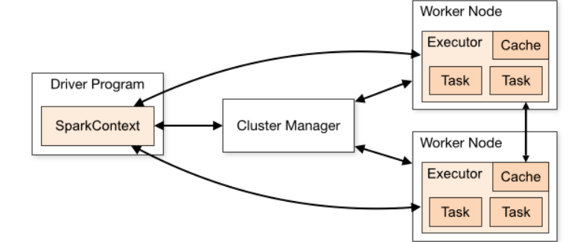

There are some cluster managers in which spark-submit run the driver within the cluster(e.g. YARN ). While in others, it only runs on your local machine.

In this architecture, **all the components and layers are loosely coupled**. These components are integrated with several extensions as well as libraries.

**Spark has its own built-in cluster manager i.e. standalone cluster manager.** Although, in spark, we can work with some open source cluster manager.

There are **mainly two abstractions on which spark architecture** is based. They are:

1. Resilient Distributed Datasets (RDD)
2. Directed Acyclic Graph (DAG)

#### **1. Resilient Distributed Datasets (RDD)**

These are the **collection of objects which are logically partitioned.**

It **supports in-memory computation over spark clusters**.

Spark RDDs are***immutable*** in nature.

While we talk about datasets**, it supports Hadoop datasets and parallelized collections.**

**Hadoop Datasets are created from the files stored on HDFS.**

Parallelized collections are based on existing scala collections.

**As RDDs are immutable, it offers two operations: transformations *and actions*.**

#### **2. Directed Acyclic Graph (DAG)**

On decomposing its name:

* Directed- Graph which is directly connected from one node to another**. This creates a sequence.**
* Acyclic – It defines that there is **no cycle or loop available**.
* Graph – It is a combination of *vertices and edges*, with all the connections in a sequence

**We can call it a sequence of computations, performed on data.** In this graph, edge refers to transformation on top of data. while vertices refer to an RDD partition.

This **helps to eliminate the Hadoop mapreduce multistage execution model.** It also provides efficient performance over Hadoop.

**In a standalone cluster you will get one executor per worker** unless you play with spark.executor.cores and a worker has enough cores to hold more than one executor.

1. **You can assign the number of cores per executor with --executor-cores**
2. **--total-executor-cores is the max number of executor cores per application**

The term "core" is unfortunate. Spark uses the term to mean "available threads to process partitions". Inevitably, the term "core" gets confused with the physical CPU cores on each machine. In our courses, we tend to use the term "threads" or "slots" to refer to these threads, to avoid confusion.

Consider the following sample program written in PySpark.

* + **from pyspark.sql import SparkSession**
  + **spark = SparkSession.builder.getOrCreate()**
  + **sc = spark.sparkContext**

or

**from pyspark import SparkContext**

First, we are **importing the SparkContext** which is the entry point of Spark functionality.

**sc = SparkContext("local", "count app")**

Creates a SparkContext object.

words = sc.parallelize (["scala", "java", "hadoop", "spark", "akka", "spark vs hadoop", "pyspark", "pyspark and spark"])

**Creating a sample RDD ‘words’ by the parallelize method.**

words_filter = words.filter(lambda x: 'spark' in x)

The words containing the string ‘spark’ is filtered and stored in words_filter.

counts = words_filter.count()

print "Number of elements filtered -> %i" % (counts)

//sample output

Number of elements

filtered -> 4

#### 

#### **Spark Shell**

Apache spark provides an interactive spark shell which allows us to run applications on. It helps in processing a large amount of data because it can read many types of data. Run/test of our application code interactively is possible by using spark shell.

#### **Spark Application**

Even when there is no job running, spark applications can have processes running on its behalf. **It is a self-contained computation that runs user-supplied code to compute a result.**

#### **Task**

**It is a unit of work**, which we sent to the executor. **Every stage has some task, one task per partition.**

#### **Job**

**It parallels computation consisting of multiple tasks.**

#### **Stages**

**Each job is divided into small sets of tasks which are known as stages.**

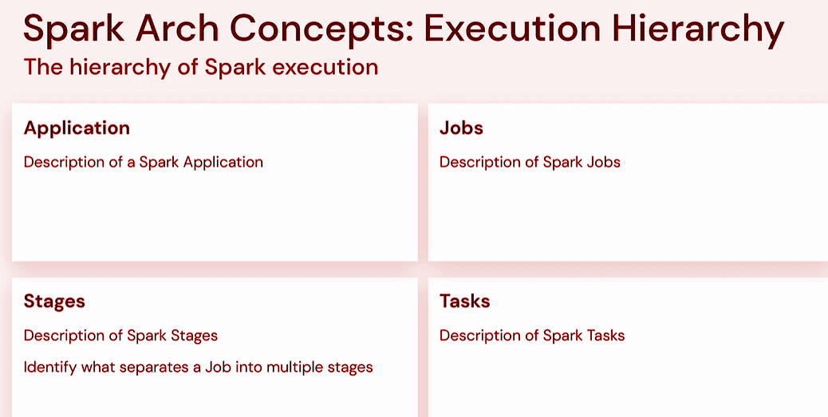

**from pyspark.sql import SparkSession**

**spark = SparkSession.builder.getOrCreate()**

**spark**

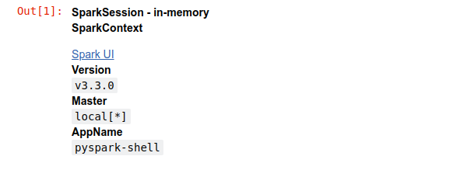

**sc = spark.sparkContext**

# Parallelize rdd

**rdd_0 = sc.parallelize(["She saw Sharif's shoes on the sofa but was she so sure those were Sharif's shoes she saw?"])**

# Tokenize sentence into words

**rdd_1 = rdd_0.flatMap(lambda x: x.split())**

# Create pair rdd

**rdd_2 = rdd_1.map(lambda x: (x, 1))**

# Count occurences of words

**rdd_3 = rdd_2.reduceByKey(lambda a,b: a+b)**

# Persist rdd

**rdd_3.persist()**

# Collect rdd

**rdd_3.collect()**

In the above code, we have a Spark application with multiple RDD transformations executing on a dataset, and at the end, we are computing the result with a single action function.

## 

## **Spark Jobs**

So, what Spark does is that as soon as action operations like collect(), count(), etc., is triggered, the **driver program**, which is responsible for launching the spark application as well as considered the entry point of any spark application, **converts this spark application into a single job which can be seen in the figure below.**

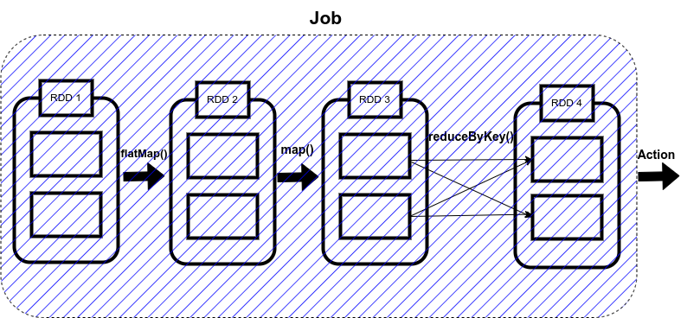

**A job is defined as a series of stages combined.**

## 

## **Spark Stages**

Now here comes the concept of Stage. **Whenever there is a shuffling of data over the network, Spark divides the job into multiple stages. Therefore, a stage is created when the shuffling of data takes place.**

These stages can be either processed parallelly or sequentially depending upon the dependencies of these stages between each other. **If there are two stages, Stage 0 and Stage 1, and if they are not sequentially dependent, they will be executed parallelly.**

**The sequential processing of RDDs in a single stage is called pipelining.**

So, in our code, **we have used reduceByKey() function, which shuffles our data in order to group the same keys**. **Since shuffling of data is taking place only once, our job will be divided into two stages** as shown in the figure below.

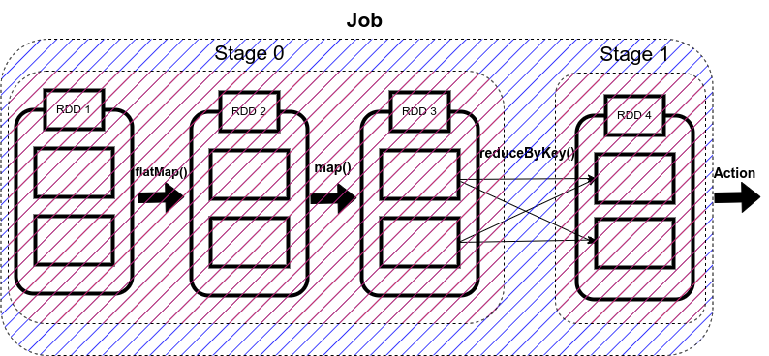

There are **two types of stages in Spark:**

1.**ShuffleMapStage in Spark**

**2. ResultStage in Spark**

#### **1. ShuffleMapStage**

As the name suggests, it is a type of stage in the spark that **produces data for shuffle operation. The output of this stage acts as an input for the other following stages.** In the above code, Stage 0 will act as the ShuffleMapStage since it produces data for shuffle operation, which acts as an input for Stage 1.

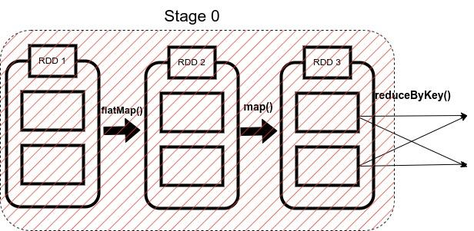

#### **2. ResultStage in Spark**

**The final stage in a Job executes an action operation by running a function (in our example, the action operation is collect) on an RDD.** It computes the result of the active operation.

**Stage 1 in our example acts as a ResultStage since it gives us a result of an action operation performed on an RDD**. In our code, after the data shuffling, similar keys got grouped using reduceByKey() function, so this stage gives us the final result of our code using the collect (action operation) function.

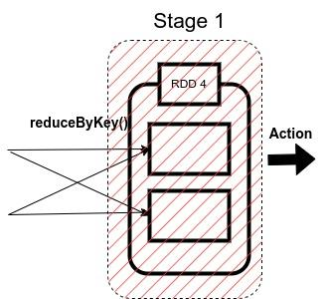

**A stage is further a group of tasks executed together.** Now we will go through what a task is.

## 

## **Spark Tasks**

**The single computation unit performed on a single data partition is called a task.** **It is computed on a single core of the worker node.**

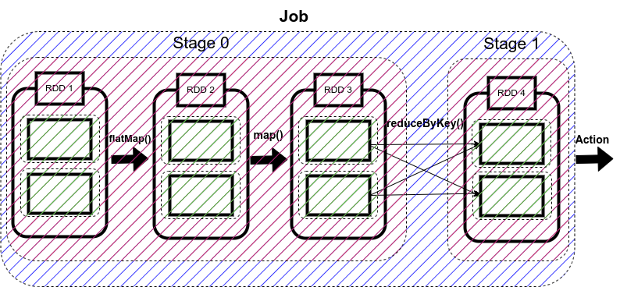

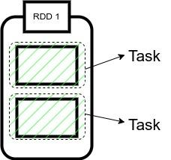

**Whenever Spark is performing any computation operation like transformation etc, Spark is executing a task on a partition of data.**

**Since in our code, we have two partitions of data here, therefore, we have two tasks here**.

**Each is computing the same operation on a different partition in parallel on a different core of the same worker node.**

Some important points to note:

1. The cluster manager assigns each worker node resources to execute the tasks.

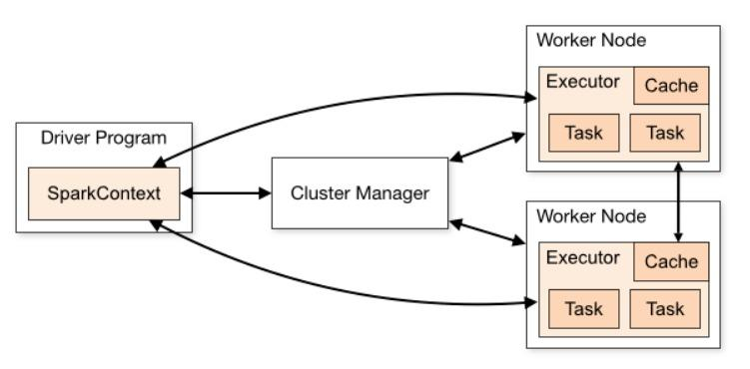

2. A core is the CPU’s computation unit; it controls the total number of concurrent tasks an executor can execute or run.

**Suppose if the number of cores is 3, then executors can run 3 tasks at max simultaneously.**

3. Executors are responsible for executing tasks individually. Parallel processing of the tasks by an executor depends upon the number of cores assigned to it, as mentioned in the second point.

4. **Each working node has Cache memory for storage, and as soon as a result is computed, it is sent to the driver’s program.**

So this is how a Spark application is converted into Job, which is further divided into Stages and Tasks.

## 

## **Implementation: Jobs, Stages, and Tasks**

Now we will be executing the sample code we took as an example to see how Spark’s internal execution works.



So firstly, we will **import the Spark session and then will create the object of this Spark session as ‘spark’** as shown in the above code. When we view this object, it will show the configuration of our Spark clusters like Version, App name, and master.

We can also see Spark UI in this object. It is a graphical user interface that allows us to view all our Spark Application’s jobs, stages, and tasks.

Let’s click on it.

We can see that a new window opens, but there is nothing to view as we haven’t run our application yet.

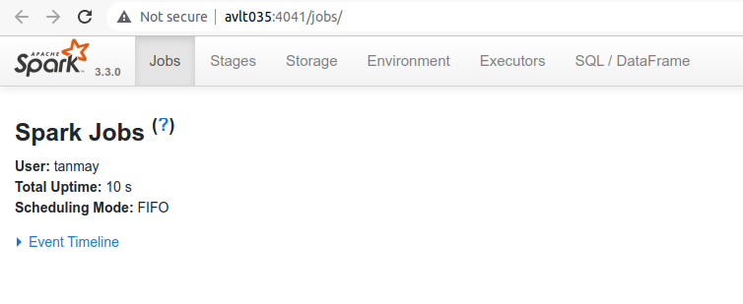

Now we will run our code to output the count of each word in a sentence. **We will explicitly create a SparkContext object (it is always necessary to create a SparkContext object to work with RDDs)** as we are working with the RDDs, as shown in the code.

Then we will create an RDD with the name rdd_0, which will contain our sentence passed in the form of a list followed by our first transformation i.e flatMap(), which will split our sentence into a list of words.

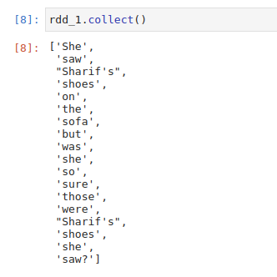

After this, we apply map transformation to create a pair RDD in which we assign value 1 to each word and save it in rdd_2.

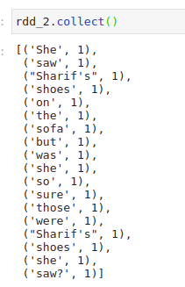

Now to count the occurrence of each word, we will use reduceByKey() method to sum the values of similar words, and we will store it in rdd_3.

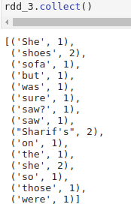

This is how our code is working, now, after executing it when we open the Spark UI, we can see that one job has been completed successfully. **It also contains information about Stages, Tasks, Storage, etc, which we can open by clicking on the corresponding tab.**



So in our case, we have one job which has been completed successfully.

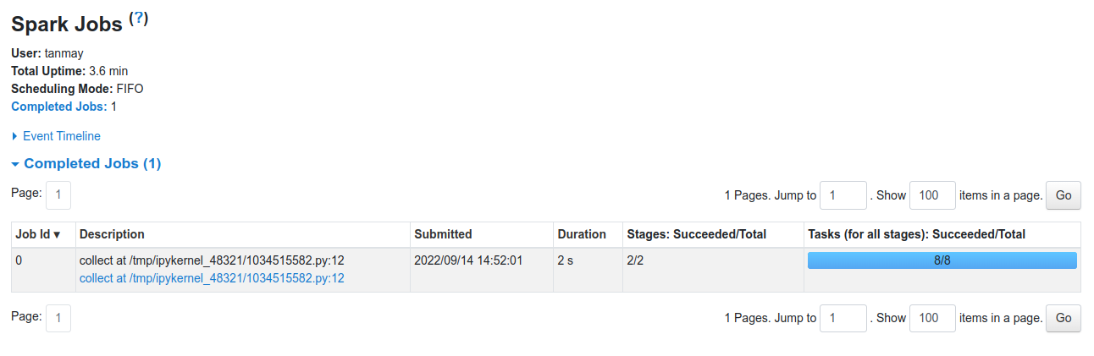

**When we click on the stages tab, we get the information regarding each stage. In our case, there will be two stages. It displays the information regarding the amount of data shuffled. Time is taken to complete a stage, etc.**

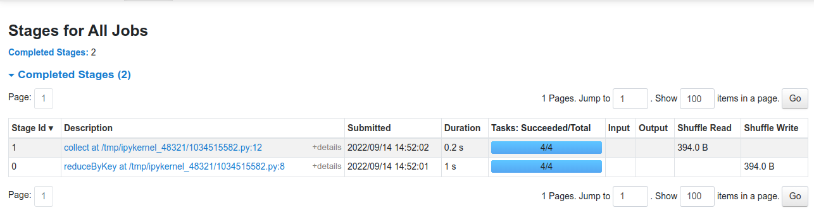

Similarly, we can see information regarding the tasks that got executed while running the Spark Application.

## 

**DAG is responsible for**

**dividing jobs into multiple stages,**

**optimizing our application,**

**what operations can be performed serially or parallelly,**

**how to execute our application, etc.**

DAG refers to Directed Acyclic Graph whose vertices represent an RDD, and the edges represent the operation on that RDD.

As we write our Spark Application, Spark converts this into a DAG that is executed by the core engine.

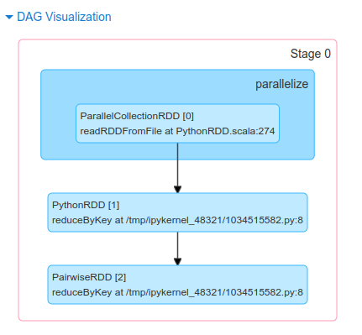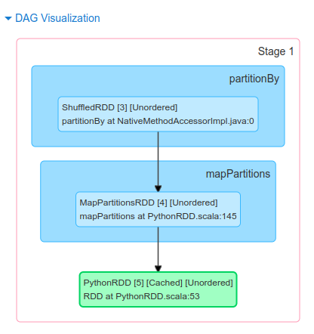

**DAG Scheduler**

**As soon as an action function is called, the created DAG is submitted to the DAG scheduler.**

It **completes the computation and execution of stages for a job**. It also keeps track of the RDDs and runs jobs in minimum time.

It also pipelines the tasks into stages.

**After this, the DAG Scheduler sends the tasks to Task Scheduler, which further sends them to the Cluster manager.**

**Divides the entire computation into stages based on the dependencies between tasks**

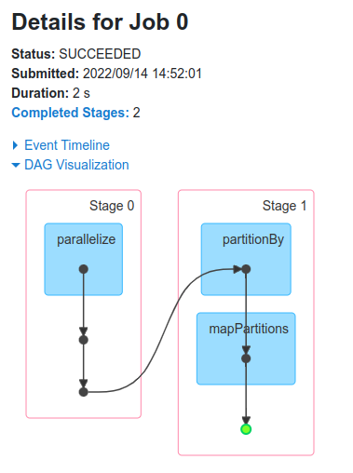

The cluster manager provides resources to the worker node executors required to run the tasks.

<https://www.analyticsvidhya.com/blog/2022/09/all-about-spark-jobs-stages-and-tasks/>

An application is a combination of several jobs.

**Each job is a sequence of stages that depend on each other, and these stages are formed by tasks.**

**Tasks are the smallest unit of work in Spark**, and they are responsible for performing the actual computation on data partitions.

1. **Application: The top-level Spark program** you have written.
2. Jobs: **Your application is divided into multiple jobs based on actions like count(), save(), or collect().** **Each job corresponds to an action.**
   1. A job in Spark refers to a sequence of transformations on data. **Whenever an action like count(), first(), collect(), and save() is called on RDD (Resilient Distributed Datasets), a job is created.** A job could be thought of as the total work that your Spark application needs to perform, broken down into a series of steps.
   2. Consider a scenario where you’re executing a Spark program, **and you call the action count() to get the number of elements. This will create a Spark job. If further in your program, you call collect(), another job will be created.** **So, a Spark application could have multiple jobs, depending upon the number of actions.**
3. Stages: **A job is divided into stages based on operations that can be executed in parallel. Stages are created due to transformations such as map(), filter(), or reduce().**
   1. **A stage in Spark represents a sequence of transformations that can be executed in a single pass, i.e., without any shuffling of data.** When a job is divided, it is split into stages. **Each stage comprises tasks, and all the tasks within a stage perform the same computation.**
   2. **The boundary between two stages is drawn when transformations cause data shuffling across partitions. Transformations in Spark are categorized into two types: narrow and wide.** 
      1. **Narrow transformations:**

**Transformations that does not result in data movement between partitions are called Narrow transformations. Functions such as map(), flatMap(), filter(), union() are some examples of narrow transformation**. **Narrow transformations are operations that can be performed on a single partition of a DataFrame without needing to shuffle the data across multiple partitions.** These types of transformations are often faster and more efficient than wide transformations because they can be executed in parallel on each partition of the data. Narrow transformations are executed within a single stage without requiring data exchange between nodes.

Here are some examples of actions in Spark that can be done as a narrow transformation:

* **count()** - returns the number of rows in the DataFrame. This operation can be done as a **narrow transformation** because **it only requires counting the rows in each partition** and summing the results.
* **first()** - returns the first row of the DataFrame. This operation can be done as a **narrow transformation** because it only requires returning the first row of each partition and selecting the minimum value**.**
* **take(n)** - returns the first n rows of the DataFrame. This operation can be done as a **narrow transformation** because it only requires selecting the first n rows of each partition and concatenating the results.
* **foreach()** - applies a function to each row of the DataFrame. This operation can be done as **a narrow transformation** because it only requires applying the function to each row of each partition in parallel.
* **reduce()** - applies a function **to reduce the rows of the DataFrame to a single value**. This operation can be done as a **narrow transformation if the function is associative and commutative**, which allows the computation to be performed in parallel on each partition and then combined across partitions.

Note that the efficiency of these operations as narrow transformations may depend on the data distribution and the computation required for each row. **If the computation required for each row is too complex, it may not be possible to perform the operation as a narrow transformation.**

* + 1. **Wide transformation:** Transformations that involves data movement between partitions are called **Wide transformations or shuffle transformations**. Functions **such as groupByKey(), aggregate(), aggregateByKey(), join(), repartition(), orderBy() and groupBy() are some examples of a wide transformations.** A wide transformation is a type of transformation where **each input partition can contribute to multiple output partitions. It involves shuffling and data movement across partitions**, often resulting in a stage boundary in Spark. Wide transformations require coordination and data exchange across nodes.
    2. In Spark, a DataFrame is an immutable distributed collection of data that is organized into named columns. **The data in a DataFrame is stored across multiple machines in a cluster,** and Spark provides a set of operations to manipulate the data in the DataFrame
    3. Key points:
    4. **narrow: map, flatmap, filter, union, coalesce, repartition**.
       1. **one to one mapping between rdd partition and file blocks**
    5. **wide :reducebykey, groupbykey, join, distinct, cogroup**

**wide transformation > more shuffling >more time and cost**

### Scala

// Example data for demonstration purposes

val data = sc.parallelize(Seq(

("sensor1", 1),

("sensor2", 2),

("sensor3", 3),

("sensor4", 4),

("sensor5", 5)

))

**// Wide transformation: groupByKey**

val groupedData = data.groupByKey()

**// Narrow transformation: mapValues**

val sumData = groupedData.mapValues(_.sum)

// Show the result

sumData.foreach(println)

In this example, we have a dataset of sensor readings and corresponding values. The wide transformation is groupByKey, which groups the data by the sensor, creating a key-value pair where the key is the sensor and the value is an iterable of all the corresponding values. **This is a wide transformation because it shuffles the data across the cluster, which can be expensive for large datasets.**

**The narrow transformation is mapValues, which applies a function to each value in the iterable created by groupByKey**. In this case, the function is _.sum**, which computes the sum of all the values for each sensor. This is a narrow transformation because it does not require shuffling the data across the cluster.** Finally, we print out the resulting dataset using foreach.

### Python

**# Create an RDD of key-value pairs**

rdd = sc.parallelize([(1, 2), (3, 4), (5, 6)])

**# Narrow transformation: mapValues() - only depends on one partition**

narrow_rdd = rdd.mapValues(lambda x: x * 2)

print("Narrow transformation output:", narrow_rdd.collect())

**# Wide transformation: reduceByKey() - depends on multiple partitions**

wide_rdd = rdd.reduceByKey(lambda x, y: x + y)

print("Wide transformation output:", wide_rdd.collect())

In the example above, **mapValues() is a narrow transformation because it only operates on one partition at a time, whereas reduceByKey() is a wide transformation because it requires shuffling data across multiple partitions.**

The mapValues() transformation applies a function to the values of each key-value pair in the RDD, but only within the same partition, so it doesn't require shuffling the data across the network. The output is a new RDD with the same partitioning scheme as the original RDD.

The reduceByKey() transformation applies a function to the values of each key across all the partitions of the RDD, and combines the results to produce a new RDD with each unique key and its corresponding reduced value. This requires shuffling data across the network to ensure that all values for a given key end up on the same partition before being reduced.

## **SQL**

-- Create a temporary view of a DataFrame with two columns: id and value

df.createOrReplaceTempView("my_table")

**-- Narrow transformation: SELECT and WHERE - operates on a single partition**

SELECT id, value * 2 FROM my_table WHERE id < 3;

**-- Wide transformation: GROUP BY and SUM - requires shuffling data across partitions**

SELECT id, SUM(value) FROM my_table GROUP BY id;

In the example above, the first SQL query performs a narrow transformation because it applies a SELECT and WHERE clause that only depend on a single partition of the DataFrame. The output is a new DataFrame with the same partitioning scheme as the original DataFrame.

The second SQL query performs a wide transformation because it requires shuffling data across multiple partitions to group values by key. The output is a new DataFrame with a different partitioning scheme, where each partition contains the results for a different key.

**Note that Spark SQL queries can be optimized and executed using either a narrow or wide transformation depending on the query plan** and the underlying data distribution. It's important to understand the query execution plan and the characteristics of the data to choose the most efficient transformation.

In Spark, "fault tolerance" refers to the ability of the system to continue working correctly in the event of failures, such as node failures, network failures, or disk failures. Fault tolerance is an important feature of distributed systems like Spark, where failures are common and can cause data loss and application downtime.

**Immutable DataFrames are another important concept in Spark**. In an immutable DataFrame, the data cannot be modified after it has been created. Instead, any operation on the DataFrame creates a new DataFrame that contains the results of the operation. **This property is essential for fault tolerance in Spark because it allows the system to recover from failures by simply recreating the lost DataFrame from its lineage** (i.e., the sequence of operations that created it).

**By using immutable DataFrames, Spark can ensure that the data is consistent and recoverable, even in the event of failures. I**f a node fails during a computation, the system can simply recreate the lost DataFrame from its lineage on another node, without having to worry about data corruption or inconsistencies.

1. Tasks: **Each stage is further divided into tasks that can be executed in parallel on different data partitions.**
   1. **A task in Spark is the smallest unit of work that can be scheduled**. Each stage is divided into tasks. A task is a unit of execution that runs on a single machine. When a stage comprises transformations on an RDD, those transformations are packaged into a task to be executed on a single executor.
   2. For example, if you have a Spark job that is divided into two stages and you’re running it on a cluster with two executors, each stage could be divided into two tasks. Each executor would then run a task in parallel, performing the transformations defined in that task on its subset of the data.
   3. In summary, a **Spark job is split into multiple stages at the points where data shuffling is needed, and each stage is split into tasks that run the same code on different data partitions.**

Now, the **Directed Acyclic Graph (DAG) is a graph representation of the sequence of operations (transformations and actions)** in your Spark application. In other words, it's a **representation of the entire computation process**. DAGs are used to plan the execution of tasks by dividing them into stages, which are then assigned to different worker nodes in the cluster. **Each node in the DAG represents an RDD operation, and the edges between the nodes represent the dependencies between these operations**.

The relationship between DAG and Task is as follows:

1. **The DAG represents the overall flow of operations in your Spark application, from the input data to the final result.**
2. **Tasks are the individual units of work that correspond to a specific operation on a partition of data.**
3. **The DAG scheduler in Spark divides the entire computation into stages based on the dependencies between tasks.**
4. **These stages are further divided into tasks that are executed in parallel on different data partitions.**

In summary, tasks are the smallest units of work in your Spark application, and the DAG represents the sequence of operations and dependencies between these tasks. Understanding the operations in your application and the corresponding tasks will help you grasp the meaning of each task in your jobs.

1. **Two transformations read.csv and withColumn belong to the same stage since there's no data shuffling between them.**
2. Tasks are the smallest unit of work, sent to one executor. **The number of tasks depends on the number of data partitions. Each task performs transformations on a chunk of data.**

To visualize the job, stages, and tasks, you can use the Spark web UI at http://localhost:4040 (default URL) while your Spark application is running. It gives you a detailed overview of your job's stages and tasks.

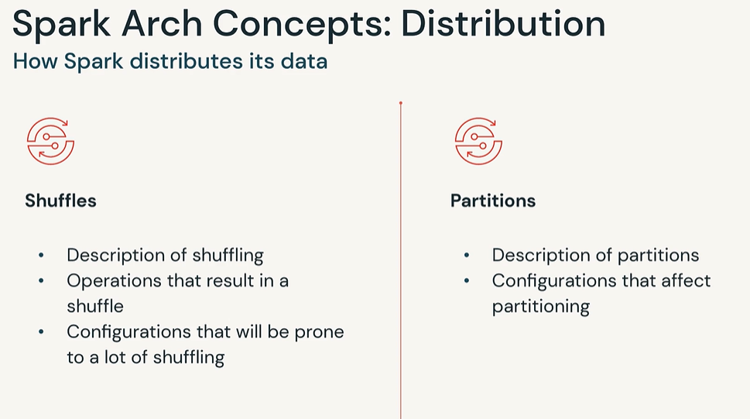

**What is shuffling?**

Apache **Spark processes queries by distributing data over multiple nodes and calculating the values separately on every node**.

However, **occasionally, the nodes need to exchange the data.** After all, that’s the purpose of Spark - processing data that doesn’t fit on a single machine.

**Shuffling is the process of exchanging data between partitions.**

As a result, data rows can move between worker nodes when their source partition and the target partition reside on a different machine.

**Spark doesn’t move data between nodes randomly.**

**Shuffling is a time-consuming operation, so it happens only when there is no other option.**

**When do we need shuffling?**

Spark nodes read chunks of the data (data partitions), but they don’t send the data between each other unless they need to. When do they do it?

**When you explicitly request data repartitioning (using the repartition functions), when you join DataFrames or group data by a column value** then **shuffling happens**

**What’s the most common problem with shuffling in Apache Spark?**

What if one worker node receives more data than any other worker? You will have to wait for that worker to finish processing while others do nothing.

**Apache Spark node workers can’t coordinate and share parts of a single partition. The unlucky worker node has to finish the task on its own while the others wait.**

What’s even worse, **the worker may fail, and the cluster will need to repeat a part of the computation. You can avoid such problems by enabling speculative execution - use the spark.speculation parameter**. **With this feature enabled, the idle workers calculate a copy of long-running tasks, and the cluster uses the results produced by the worker who finished sooner.**

**When does one worker receive more data than others?**

**It happens when one value dominates the partitioning key (for example, the null).** All rows with the same partitioning key value must be processed by the same worker node (in the case of partitioning). **So if we have 70% of null values in the partitioning key, one node will get at least 70% of the rows.**

**When this happens, we have two options**.

First, **we can isolate the dominating value by filtering it out from the DataFrame.** After filtering, we can calculate the aggregate using the remaining rows. After that, we can calculate the aggregate of the filtered out value separately. It may help because we should have more resources available while calculating the aggregate of a smaller dataset.

We can **also redistribute the values of the filtered out dataset using a different partitioning key,** calculate a partial aggregate, and then combine them to get the final result.

The **second solution is to create a surrogate partitioning key by combining multiple columns or generating an artificial partitioning value.** Such a key should help us uniformly distribute the work across all worker nodes.

Of course, sometimes, we can’t split the work into partial aggregates or use surrogate keys because we would get an invalid aggregate value. We need to deploy a Spark cluster with more powerful nodes for such situations.

**We split the data once before calculations. Every worker gets an entire partition (sometimes multiple partitions), and they don’t share the data until everyone finishes their task.**

Wouldn’t it be better if nodes coordinated the work and helped the worker who got stuck with the largest partition? I don’t think so. In such a case, we would complain about an inefficient coordination algorithm. The process would resemble pushing papers between corporate departments. Can you imagine doing it efficiently?

<https://medium.com/towards-data-architecture/spark-shuffling-395468fbf623>

**Data Shuffling**

Shuffling is **the process of distributing data across the cluster workers in order to process it in parallel**.It happens generally when data is not evenly distributed, when data should be arranged in a specific way to be processed or when there is not enough memory on a single node to store all the required data for processing.

**Causes**

**Data skew: Spark shuffling may take place when some keys in a dataset are significantly more heavily populated with data than others**. Operations like groupByKey, reduceByKey or same sort of joins which call for the grouping or aggregation of data by key, can also cause data shuffling. But not only, the shuffling can be caused by different other factors like :

**Partitioning:** Spark divides data among nodes through a procedure known as partitioning. **The possibility of shuffling exists if the data is not distributed among partitions equally.**

**Spark operations:** Grouping, aggregating the data by key or when joining two datasets, some operations, such **as groupByKey, reduceByKey and join, will cause shuffling.**

**Caching :** Shuffling may **occur if a dataset is cached in memory and the amount of data in the cache exceeds the amount of memory on a single node.**

**Data locality:** Spark tries to minimize shuffling by putting data on the same node as the computation that will be run on it. **It must be moved to the node where the computation is being done if the data is not already stored there**.

Data shuffling is a performance killer and costly process as it leads to network data transfer by data travel between nodes, High disk I/O and Rearranging files operations. The performance of Spark applications can then be enhanced by being aware of these elements and avoiding shuffling whenever possible.

**Solutions to avoid it**

Generally, avoiding shuffling in spark requires changing how data is stored on the underlying storage systems and thinking differently in the computation phase in order to reduce or avoid shuffling large volumes of data. Here are some attention point / tips to avoid shuffling:

**Use partitioning on computation engine level :** Ensure that the data is evenly distributed across the nodes and Y**ou can use the repartition or coalesce to change the number of partitions in a DataFrame.**

**Use Partitioning in the underlying storage system:** Ensure partitioning data in the underlying storage system: If you are using a storage system that supports data partitioning or data bucketing, you can use the data partitioning features of the storage system to partition the data in a way that minimizes shuffling. Partitioning your data according to the consumption pattern**, as example partitioning the data by a date or by a category it is commonly a good choice.** This will ensure that data with the same partition key are stored together and then minimizing shuffling when performing queries on the data.

**Compression format :** Use an efficient file format and compression type: The file format and compression type that you use can have a significant impact on the performance of shuffling. **Using a file format that is optimized for Spark, such as Apache Parquet or Apache ORC, and a compression type that is efficient for shuffling, such as Snappy or LZ4 helps to minimize shuffling** and improve the performance of your Spark applications.

**Use data locality:** Spark tries to reduce shuffling by storing data on the same node as the computation that will be run on it. To ensure that data is stored locally and reduce shuffling, techniques like data partitioning and caching can be used.

**Avoid certain operations:** such as **groupByKey and reduceByKey cause** it can trigger shuffling in order to group or aggregate the data.

**Use filtering and aggregation instead of groupBy:** If you only need to filter the data or perform simple aggregations, you can use the filter and agg transformations instead of groupBy. These transformations do not trigger shuffling.

Use broadcast datasets**: Broadcast can help to distribute smaller datasets to all the cluster nodes if you need to combine two sizable datasets.** As a result, less information may need to be shuffled.

Use the sortWithinPartitions transformation**: If you need to sort the data within each partition, you can use the sortWithinPartitions transformation instead of sort.** This will minimize shuffling by sorting the data within each partition rather than across all the partitions.

Use a partitioner**:** A partitioner can be used to manage how the data is distributed among the nodes when performing a join or cogroup operation on two datasets. **The HashPartitioner, for instance, can be used to evenly distribute the data among the nodes.**

Use data serialization**:** You can improve the performance of shuffling by **using a fast data serialization format.**

Use SparkSQL**:** Use SparkSQL to express your queries more effectively if you need to filter, group, or aggregate data. **Most of the time, SparkSQL can reduce shuffling and improve the execution of these queries.**

Use the repartitionByRange transformation:If you need to sort the data and you are using a range-based partitioner, such as the RangePartitioner, **you can use the repartitionByRange transformation instead of sort.** This will minimize shuffling by sorting the data within each partition and ensuring that data with the same key is placed in the same partition.

**Use the** join **transformation:** **If you are performing a join on two datasets, you can use the join transformation instead of cogroup or groupBy.** The join transformation does not trigger shuffling, as it relies on data partitioning to ensure that data with the same key is placed in the same partition.

Use the window function: If you need to perform windowed aggregations, using window functions can be helpful to specify the window and the aggregation function. **The window function does not trigger shuffling, as it operates on the data within each partition.**

* **By default, Spark/PySpark creates partitions that are equal to the number of CPU cores in the machine.**
* Data of each partition resides in a single machine.
* **Spark/PySpark creates a task for each partition.**
* [Spark Shuffle operations](https://sparkbyexamples.com/spark/spark-shuffle-partitions/) move the data from one partition to other partitions.
* **By default, DataFrame shuffle operations create 200 partitions.**

**Partition in memory:** You can partition or repartition the DataFrame by calling[**repartition() or coalesce()**](https://sparkbyexamples.com/pyspark/pyspark-repartition-vs-coalesce/) **transformations.**

Note: When you want to reduce the number of partitions, It is recommended to use [PySpark coalesce() over repartition()](https://sparkbyexamples.com/pyspark/pyspark-repartition-vs-coalesce/) as it uses fewer resources due to less number of shuffles it takes.

The *coalesce* method reduces the number of partitions in a DataFrame. It avoids full shuffle, instead of creating new partitions, it shuffles the data using default Hash Partitioner , and adjusts into existing partitions, this means it can only decrease the number of partitions.

The *repartition* method can be used to either increase or decrease the number of partitions in a DataFrame. Repartition is a full Shuffle operation, where whole data is taken out from existing partitions and equally distributed into newly formed partitions.

**Observations**:

* coalesce keeps five partitions even though we attempted to create 10.
* Sincecoalesce avoids f**ull shuffle**, its more performant than repartition. See the execution time of **416ms vs 639 ms**.

**Partition on disk:**

**While writing the PySpark DataFrame back to disk,** you can choose how to partition the data based on columns by **using partitionBy() of pyspark.sql.DataFrameWriter. This is similar to** [**Hives partitions**](https://sparkbyexamples.com/apache-hive/hive-partitions-explained-with-examples/)**.** When you write Spark DataFrame to disk by calling partitionBy(), **PySpark splits the records based on the partition column and stores each partition data into a sub-directory**.

You can also create partitions on multiple columns using Spark partitionBy(). Just pass columns you want to partition as arguments to this method.

**partitionBy**, instead of coalesce and repartition functions, **it will change the folder structure of the underlying data.** In the above example, we can partition the data by *country* column, as it has low cardinality and is more likely to be used as a filter condition.

**However, partitionBy has no control on how many part files will be created under each folder.** **When the data is key-value oriented, partitioning becomes essential. Because the range of keys or comparable keys is in the same partition, shuffling is minimized. As a result, processing becomes significantly faster.**

**3.1 Local mode**

When you running **on local in standalone mode, Spark partitions data into the number of CPU cores you have on your system** or the value you specify at the time of creating SparkSession object

import pyspark

from pyspark.sql import SparkSession

spark = SparkSession.builder

.appName('SparkByExamples.com') \

.master("local[5]").getOrCreate()

The above example provides local[5] as an argument to master() **method meaning to run the job locally with 5 partitions. Though if you have just 2 cores on your system, it still creates 5 partition tasks.**

df = spark.range(0,20)

print(df.rdd.getNumPartitions())

Above example yields output as 5 partitions.

**HDFS cluster mode**

When you running Spark jobs on the Hadoop cluster the default number of partitions is based on the following.

* **On the HDFS cluster, by default, Spark creates one Partition for each block of the file.**
* In Version 1 Hadoop the HDFS block size is 64 MB and in Version 2 Hadoop the HDFS block size is 128 MB
* Total number of cores on all executor nodes in a cluster or 2, whichever is larger

**For example if you have 640 MB file and running it on Hadoop version 2, creates 5 partitions with each consists on 128 MB blocks (5 blocks * 128 MB = 640 MB). If you repartition to 10 then it creates 2 partitions for each block.**

**Spark configuration**

* **spark.default.parallelism configuration default value set to the number of all cores on all nodes in a cluster**, on local it is set to a number of cores on your system.
* **spark.sql.shuffle.partitions configuration default value is set to 200** and it is used when you call shuffle operations like <a href="https://sparkbyexamples.com/spark/spark-dataframe-union-and-union-all/">union()</a>, <a href="https://sparkbyexamples.com/spark/using-groupby-on-dataframe/">groupBy()</a>, <a href="https://sparkbyexamples.com/spark/spark-sql-dataframe-join/">join()</a> and many more. **This property is available only in DataFrame API but not in RDD.**

You can change the values of these properties through programmatically using the below statement.

spark.conf.set("spark.sql.shuffle.partitions", "500")

You can also set the partition value of these configurations using spark-submit command.

./bin/spark-submit --conf spark.sql.shuffle.partitions=500 --conf spark.default.parallelism=500

**Dynamically Changing Spark Partitions**

When you create an RDD/DataFrame from a file/table, based on certain parameters Spark creates them with a certain number of partitions and it also provides a way to change the partitions runtime in memory and options to partition based on one or multiple columns while writing to disk.

**How to Choose Spark Partition Column?**

When using partitionBy(), you have to be very cautious with the number of partitions it creates, as having too many partitions creates too many sub-directories in a directory which brings unnecessarily and overhead to NameNode (if you are using Hadoop) since it must keep all metadata for the file system in memory.

**Another good example of partition is on the Date column. Ideally, you should partition on Year/Month but not on a date.**

Too Many Partitions Good?

* If you are a beginner, you would think too many partitions will boost the [Spark Job Performance](https://sparkbyexamples.com/spark/spark-performance-tuning/) actually, it won’t and it’s overkill.
* Spark has to create one task per partition and most of the time goes into creating, scheduling, and managing the tasks then executing.

Too Few Partitions Good?

* Too few partitions are not good as well, as you may not fully utilize your cluster resources.
* Less parallelism
* Applications may run longer as each partition takes more time to complete.

The recommendation is to keep your partition file size ranging 256MB to 1GB.

**How to decide the partition key(s)?**

* **Do not partition by columns having high cardinality**. For example, don’t use your partition key such as roll_no, employee_ID etc. Instead your state code, country code, geo_code etc.
* **Partition data by specific columns that will be mostly used during filter and groupBy operations**

[Resilient Distributed Datasets](https://www.projectpro.io/article/working-with-spark-rdd-for-fast-data-processing/273) are collection of various data items that are so huge in size, that they cannot fit into a single node and have to be partitioned across various nodes. **Spark automatically partitions RDDs and distributes the partitions across different nodes.**

Characteristics of a Partition in Spark

* Every machine in a spark cluster contains one or more partitions.
* The number of partitions in spark are configurable and having too few or too many partitions is not good.
* **Partitions in Spark do not span multiple machines.**

**One important way to increase parallelism of** [**spark processing**](https://www.projectpro.io/article/apache-spark-makes-data-processing-preparation-faster/225) **is to increase the number of executors on the cluster.**

**For custom partitioning developers have to check the number of slots in the hardware and how many tasks an executor can handle to optimize performance and achieve parallelism.**

How many partitions should a Spark RDD have?

Having too large a number of partitions or too few - is not an ideal solution. **The number of partitions in spark should be decided thoughtfully based on the cluster configuration and requirements of the application.** Increasing the number of partitions will make each partition have less data or no data at all. **Apache Spark can run a single concurrent task for every partition of an RDD, up to the total number of cores in the cluster. If a cluster has 30 cores then programmers want their RDDs to have 30 cores at the very least or maybe 2 or 3 times of that.**

As already mentioned above, **one partition is created for each block of the file in HDFS which is of size 64MB**.However, when creating a RDD a second argument can be passed that defines the number of partitions to be created for an RDD.

val rdd= sc.textFile (“file.txt”, 5)

The above line of code will create an RDD named textFile with 5 partitions. Suppose that you have a cluster with four cores and assume that each partition needs to process for 5 minutes. In case of the above RDD with 5 partitions, 4 partition processes will run in parallel as there are four cores and the 5th partition process will process after 5 minutes when one of the 4 cores, is free. The entire processing will be completed in 10 minutes and during the 5th partition process, the resources (remaining 3 cores) will remain idle. **The best way to decide on the number of partitions in an RDD is to make the number of partitions equal to the number of cores in the cluster so that all the partitions will process in parallel and the resources will be utilized in an optimal way.**

Spark still uses RDDs as a fundamental abstraction for distributed data processing. However, **since the introduction of DataFrames and Datasets, RDDs have become a lower-level API that is mainly used for low-level transformation** and processing of unstructured data. **DataFrames and Datasets are higher-level abstractions built on top of RDDs that provide a more efficient and expressive API for working** with structured and semi-structured data. DataFrames and Datasets provide a more SQL-like programming interface and can leverage Spark's Catalyst optimizer to perform advanced query optimization and code generation. **RDDs are particularly useful for handling unstructured data or performing custom operations that are not supported by the higher-level abstractions**.

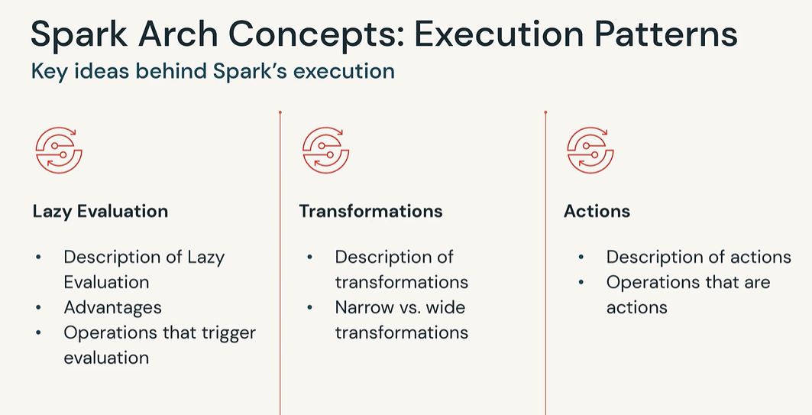

Lazy Evaluation in Apache Spark

By **strategically postponing transformations until actions are triggered, Spark leverages lazy evaluation to minimize unnecessary computations, improve resource utilization, and enhance overall performance.**

In Spark, **transformations** are operations that convert an input RDD (Resilient Distributed Dataset) or DataFrame into a new RDD or DataFrame.

When transformations are called in Spark, they do not immediately compute their results. Instead, **Spark builds up a logical execution plan called the DAG (Directed Acyclic Graph) that represents the sequence of transformations to be applied**.

The DAG is an internal representation of the computation.

**The execution of transformations is deferred until an action is invoked on the RDD or DataFrame.**

**Actions** in Spark, **trigger the execution of the entire DAG**, and the computed results are returned to the driver program or written to an external storage system.

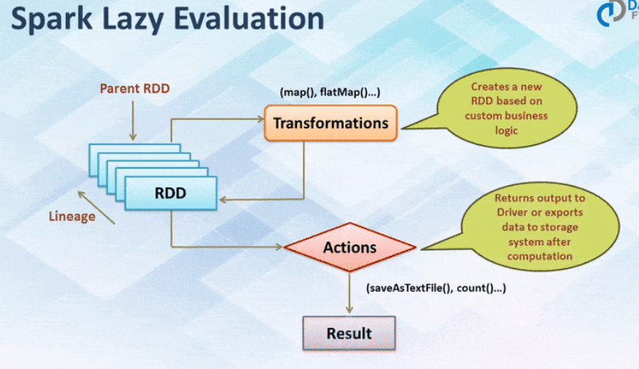

## Difference between TRANSFORMATIONS and ACTIONS?

| **Basis** | **Transformations** | **Actions** |
| --- | --- | --- |
| Definition | Operation responsible for **creating a new RDD, DataFrame, or Dataset** from an existing one. | Operations responsible for **triggering the execution of computations and returning results or writing data to an external system**. |
| Return Type | **Returns a new RDD, DataFrame, or Dataset,** representing the transformed data. | **Returns a value** or produces a side effect **(e.g., writing to storage, printing, or updating external state).**  production of final results. |
| Evaluation | **Lazily evaluated**. They are not executed immediately but only when an action is triggered. | **Causes the evaluation of the DAG** and the execution of the preceding transformations. |
| Execution | **Its execution can be optimized by applying various techniques such as operator fusion, predicate pushdown, and column pruning to minimize unnecessary.** | It **executes eagerly**, leading to the execution of the transformations required to produce the desired results. |
| Examples | * Common transformations in Spark include Map * **Filter** * **FlatMap** * **GroupBy** * **ReduceByKey** * **Distinct** * **Sort** * **Sample** * **Union** * **Join** * **Aggregations** * Transformations are **immutable, meaning they do not modify the original RDD or DataFrame** but create a new one with the applied transformation. | Actions are eager operations and can cause significant computational and I/O costs, especially when working with large datasets.   * **Collect** * **Count** * **First** * **Take** * **Reduce** * **Aggregate** * **Save** * **Foreach** * **CountByKey** * **CollectAsMap** |

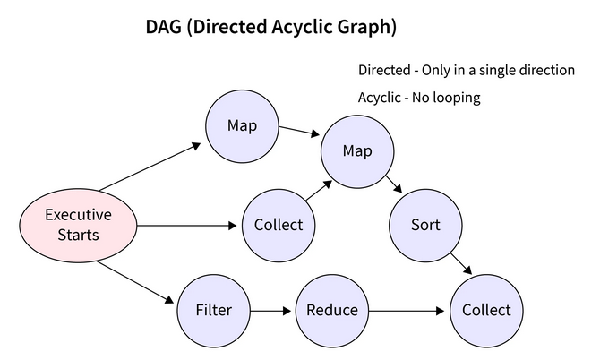

Since RDD’s are immutable, any transformations on it result in a new RDD leaving the current one unchanged, creating an RDD lineage.

## **Spark’s Catalyst Optimizer – Used in transformations**

**Spark's Catalyst Optimizer is a powerful query optimization framework that is built into Apache Spark's SQL and DataFrame API.** It is responsible for optimizing and transforming the logical and physical execution plans of Spark queries. **The Catalyst Optimizer performs a wide range of optimizations including predicate pushdown, column pruning, operator reordering, constant folding, and more.**

Some of the key features and benefits of Spark's Catalyst Optimizer are:

1. **Logical and Physical Query Plans**:

Catalyst operates on two levels: logical and physical plans. **The logical plan** represents the **high-level operations and transformations specified by the user**, while the **physical plan represents the actual execution steps.**

1. **Rule-Based Optimization**:

Rule-based optimization applies a **set of predefined optimization rules that match a specific pattern** in the plan query plans, transforming and simplifying them to produce an optimized plan.

1. **Predicate Pushdown**:

Catalyst **pushes predicates (filters) as close to the data source as possible. This reduces the amount of data that needs to be processed in a query.**

1. **Column Pruning**:

Catalyst performs column pruning **by eliminating unnecessary columns from the query plan.** It analyzes he columns used by each operator and removes any unused columns, reducing data transfer and memory consumption.

1. **Expression Simplification**:

Catalyst simplifies complex expressions by applying algebraic and logical simplification rules. **It simplifies expressions by replacing them with equivalent, simpler forms, reducing the complexity of the overall query plan.**

1. **Extensibility**:

Catalyst allows users to define their own optimization rules and strategies. This enables customization and fine-tuning of the optimization process to suit specific use cases or data scenarios.

## **What are the Advantages of Using Lazy Evaluation?**

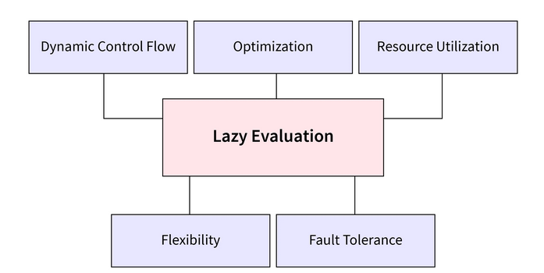

* **Optimized Performance**:

by delaying computations which means that unnecessary computations and operations can be avoided**, resulting in improved runtime efficiency and reduced processing time.**

* **Resource Efficiency**:

By delaying the execution of computations until they are needed, unnecessary resource allocation, memory consumption, and CPU usage can be avoided.

* **Short-Circuiting**:

Lazy evaluation enables short-circuiting, **where computations are terminated early if the result is already determined.** This is particularly useful when dealing with conditions or loops where the subsequent computations are irrelevant or unnecessary based on an earlier result.

* **Flexibility and Composition**:

By deferring computations, lazy evaluation allows functions and expressions to be composed, combined, and reused in various contexts without immediately executing them**. This enables modularity, code reuse, and the creation of more flexible and composable** software components.

* **Dynamic Control Flow**:

Lazy evaluation facilitates dynamic control flow and conditional execution. It allows programs to evaluate and execute different parts of the code based on runtime conditions, enabling more dynamic and adaptable behavior.

* **Incremental and On-Demand Processing**:

Lazy evaluation supports incremental and on-demand processing of data**.** It allows for processing data in smaller chunks or batches, reducing memory requirements and improving efficiency when dealing with large datasets.

* **Error Handling and Fault Tolerance**:

Lazy evaluation can improve error handling and fault tolerance in applications. By postponing computations until necessary**, it provides an opportunity to catch and handle errors more effectively**.

<https://sparkbyexamples.com/apache-spark-rdd/spark-rdd-transformations/>

<https://sparkbyexamples.com/spark/spark-rdd-actions/>

<https://www.linkedin.com/pulse/spark-transformations-actions-lazy-evaluation-mohammad-younus-jameel/>

Databricks

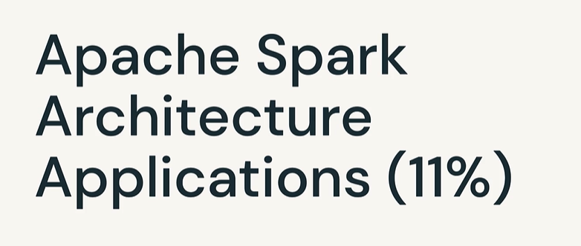

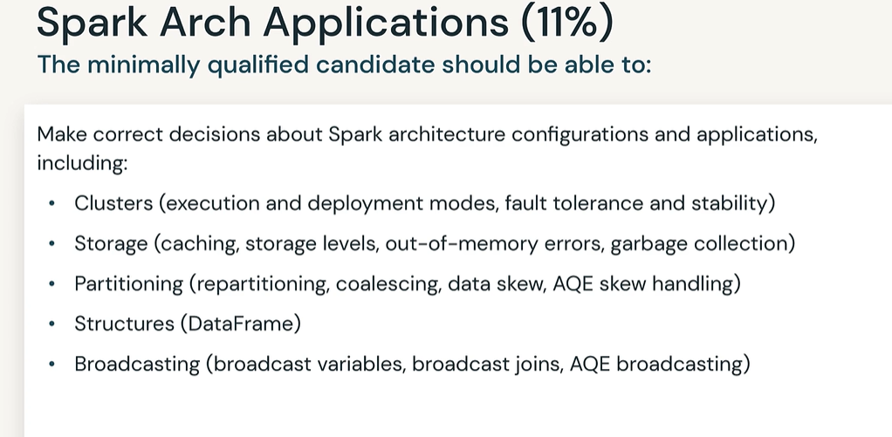

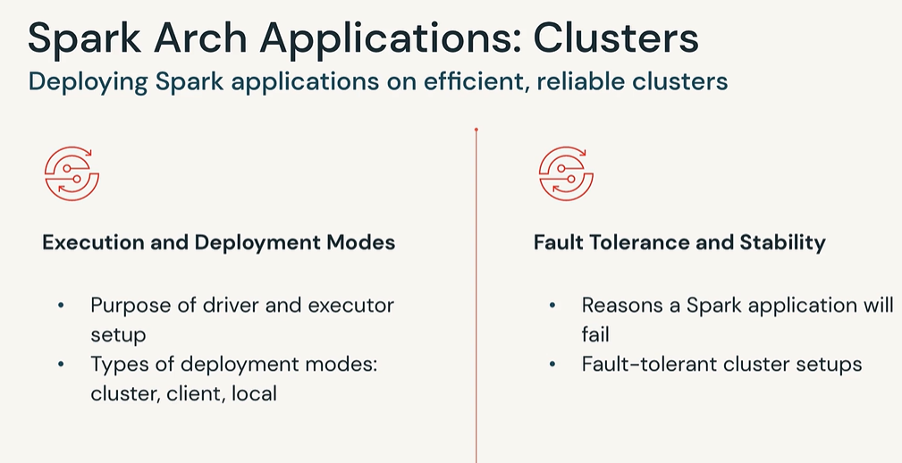

<https://medium.com/@sephinreji98/understanding-spark-cluster-modes-client-vs-cluster-vs-local-d3c41ea96073>

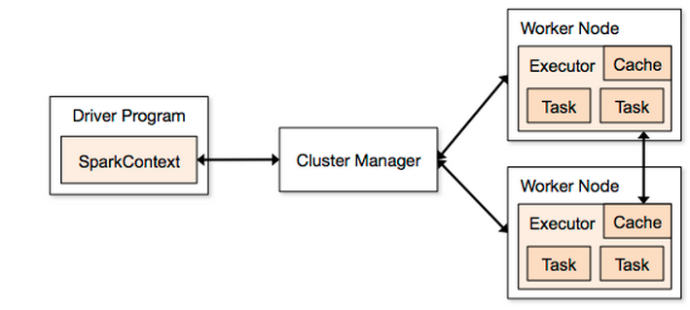

Spark cluster modes refer to the **different ways in which Spark can be deployed on a cluster of machines to process large-scale data**. As we know Spark is a distributed computing framework that we can run in several modes, ranging from a single machine to a large-scale cluster of machines.

Before entering in to each modes, we need to know some basic terms:

1. **Resource Manager:**In Spark, **a resource manager is responsible for allocating resources to Spark applications running on a cluster.** Spark has a pluggable architecture that **allows different cluster managers to be used as resource managers**, **such as Apache Mesos, Hadoop YARN, and Kubernetes.**
2. **Application Master:**Application **Master is a program that is responsible for managing a specific Spark application running** on a cluster. **Some major responsibilities of Application Master is** **Allocating resources, coordinating tasks, fault tolerance and reporting the status of spark application to the Driver program**.
3. **Container:** Each container represents a virtual machine, or a process, that runs on a node in the cluster and is assigned with a certain amount of resources to execute the tasks or the executor. **Containers are created by the resource manager,** such as YARN or Mesos.
4. **Executor:** In Spark, **an executor is a process that runs on a worker node in a cluster** and is responsible for executing tasks. It’s launched by the Application Master and are responsible for processing the data and performing computations.

# **Client Mode:**

When u start a spark shell**,** application driver creates the spark session in your local machine which request to Resource Manager present in cluster to create Yarn application. YARN Resource Manager start an Application Master (AM container). **For client mode Application Master acts as the Executor launcher.** Application Master will reach to Resource Manager and request for further containers. Resource manager will allocate new containers.

**Note**: In all the below images, the box contains Resource manager, Application Master & containers/Executors is considered as the cluster

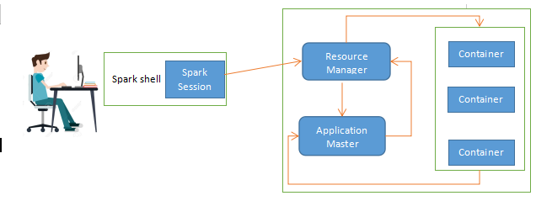

**Once the containers are allocated with requested configurations, Application Master will launch Executors in each containers.** Each executor runs in its own JVM and can run multiple tasks concurrently. Executors can be added or removed dynamically during the execution of a Spark application, depending on the available resources in the cluster.

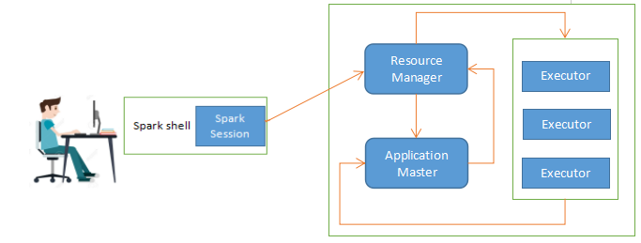

After these setups, these executors will directly communicate with Drivers which is present in the system in which you have submitted the spark application.

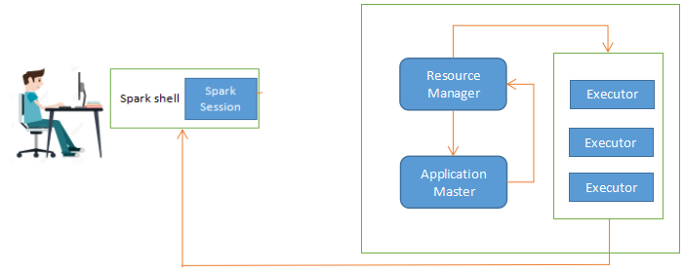

**In this mode client have more control over the application. This enables user interaction with the application while it is running, progress monitoring, and application modification as needed**. Additionally, it gives the user direct access from the client machine to the application’s output and logs, which can be helpful for debugging and troubleshooting.

**Client mode is frequently used** in interactive settings where the user has to engage with the Spark application and get real-time feedback, **such as Jupyter notebooks or development environments**. Additionally, it can be helpful in situations when the user wants to execute a Spark job with a short lifespan and no need for ongoing monitoring.

**The major disadvantage of client mode is the driver node is running in client** machine and therefore if we shutdown the machine or any issues occur, it will affect the entire application run.

**Client mode is not suitable for Production.** **For debugging purpose we can use this client mode( because u can see output in your terminal)**

# **Cluster Mode:**

For cluster mode, there’s a small difference compare to client mode in place of driver**.** Here **Application Master will create driver in it and driver will reach to Resource Manager**

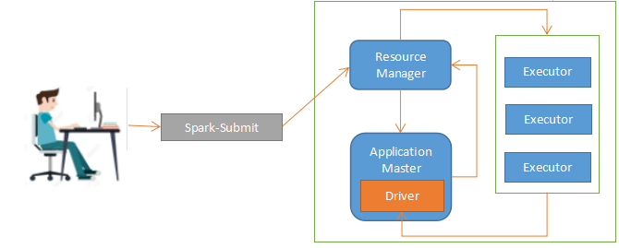

For **Production systems cluster mode is the best choice**.

# Local Mode:

**In local mode, Spark runs on a single machine, using all the cores of the machin**e. It is the simplest mode of deployment and is mostly used for testing and debugging.

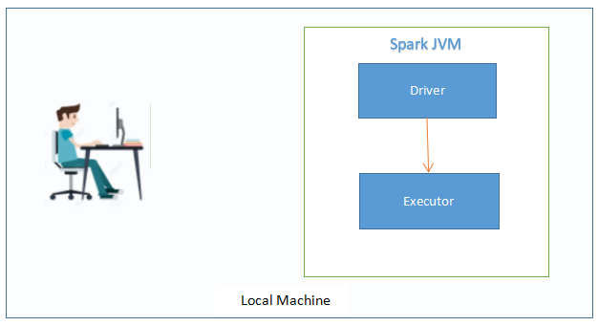

Here you don’t need to much worry about complex cluster setups or configurations. This is a **good choice for users who are just starting with Spark,** or for **those who need to test small-scale data processing workflows.**

**How Spark handles fault tolerance.**

**Spark Fault Tolerance is the ability of a system to continue to function properly even if some of its components fa**il (or have one or more faults within them). When compared to a naively designed system, where even a minor failure can cause a total breakdown, the decrease in operating quality is proportional to the severity of the failure. In high-availability or life-critical systems, spark fault tolerance is especially important. Graceful degradation refers to the ability of a system to maintain functionality when parts of it fail.

Intrinsically, Apache Spark possesses strong attributes to support Spark fault tolerance. In the programming world, faults and application failures at the production scale are extremely common. To tackle such incidents, Spark recovers loss once the failure occurs.

**This self-recovery feature of Spark is due to the presence of a Resilient Distributed Dataset (RDD). Besides, Spark fault tolerance through DAG, Directed Acyclic Graph, that controls the background of all the modifications or activities mandated to finish a task**. It works like a backbone of this software because it can recover the loss if the application faces any error or failure.

Spark’s fault-tolerant semantics are as follows:

* Because the Apache Spark RDD is immutable, each Spark RDD retains the lineage of the deterministic operation that was used to create it on a fault-tolerant input dataset.
* If any partition of an RDD is lost due to a worker node failure, that partition can be re-computed using the lineage of operations from the original fault-tolerant dataset.
* If all of the RDD transformations are deterministic, regardless of Spark cluster failures, the data in the final transformed RDD will always be the same.

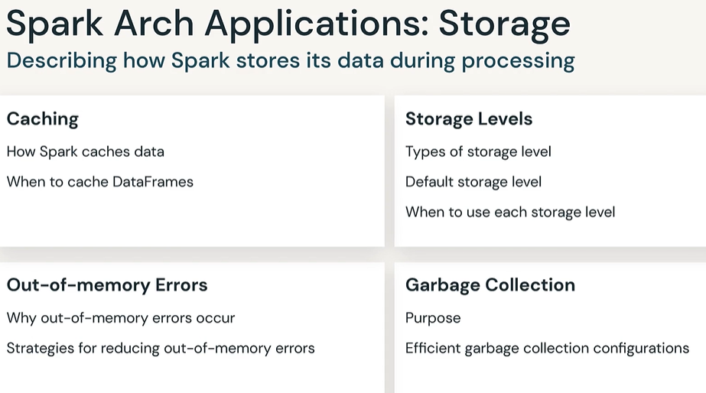

**If we don’t use caching in the right places** (or maybe don’t use it at all), **we can cause severe performance issues**.

df.cache()

df.persist()

**The default storage level for both cache() and persist() for the DataFrame is MEMORY_AND_DISK (Spark 2.4.5)**

**Spark SQL**

df = spark.read.parquet("s3://.....")

df.createOrReplaceTempView("df")

spark.sql("CACHE TABLE df")

**The caching operation when using Python API is lazy while in Spark SQL, it is eager;** when we use caching in Python API, the caching will only occur after the execution of an “action” on this DataFrame.

**When to cache?**

**Reusing Data:** Caching is optimal **when you need to perform multiple operations on the same dataset to avoid reading from storage repeatedly.**

**Frequent Subset Access:** Useful for frequently accessing small subsets of a large dataset, reducing the need to load the entire dataset repeatedly.

Let’s look at an example:

df = spark.read.parquet("s3://.....")

df.createOrReplaceTempView("df")

df = spark.sql("SELECT id, avg(time), count(transaction_id) FROM df GROUP BY id")

for column in df.columns:  
 n_unique_values = df.select(column).distinct().count()  
 if n_unique_values == 1:  
 print(column)

E**very time the following line is executed (in this case 3 times), Spark reads the Parquet file and executes the query.**

n_unique_values = df.select(column).distinct().count()

In the following example, I only added the caching:

df = spark.read.parquet("s3://.....")

df.createOrReplaceTempView("df")

df = spark.sql("SELECT id, avg(time), count(transaction_id) FROM df GROUP BY id")

**df.persist() <---------- THE ONLY CHANGE**

for column in df.columns:  
 n_unique_values = df.select(column).count().distinct()  
 if n_unique_values == 1:  
 print(column)

Now, Spark will read the Parquet, execute the query only once, and then cache it. **Then the code in the loop will use the cached, pre-calculated DataFrame.**

Imagine that you are working with a lot of data, and you run a series of queries and actions on it without using caching. It runs again and again without you even noticing. This can add hours to the job running time or even make the job fail.

**The best way to make sure everything has run as expected is to look at the execution plan**.

You can see in the following execution plan the keywords **InMemoryTableScan**and**InMemoryRelation**,**which indicate that we are working on a cached DataFrame.**

**Since cache() is a transformation, the caching operation takes place only when a Spark action (for example, count(), show(), take(), or write()) is also used on the same DataFrame, Dataset, or RDD in a single action.**

**An RDD that is not cached, nor checkpointed, is re-evaluated again each time an action is invoked on that RDD.** There are two function calls **for caching an RDD: cache() and persist(level: StorageLevel).** The difference among them is that cache() will cache the RDD into memory, whereas persist(level) can cache in memory, on disk, or off-heap memory according to the caching strategy specified by level. **persist() without an argument is equivalent with cache().** We discuss caching strategies later in this post. **Freeing up space from the Storage memory is performed by unpersist().**

When to use caching: As suggested in this post, it is recommended to use caching in the following situations:

* RDD re-use in iterative machine learning applications
* RDD re-use in standalone Spark applications
* When RDD computation is expensive, caching can help in reducing the cost of recovery in the case one executor fails

***When a DataFrame is cached and a subsequent operation is performed on the cached DataFrame, Spark first compares the analyzed logical plan of the operation to the one used when the DataFrame was cached. If the plans match, Spark retrieves the data from the cache; otherwise, it does not access the cached data.***

### **Methods Of Persistence Storage Levels**

We can Persist RDD in two ways. One is cache() and other is persist(). Caching or persisting a Spark DataFrame or Dataset is a lazy operation, implying that the DataFrame won’t be cached until you initiate an action. This lazy approach to caching allows Spark to optimize the execution plan and avoid unnecessary caching of intermediate data that may not be used in subsequent computations. It helps in efficiently utilizing resources and improving overall performance.

**cache() method by default saves it to MEMORY_AND_DISK storage level** where as with persist() method we can persist data on multiple storage levels.

**The persist method is used to persist an RDD (Resilient Distributed Dataset) or DataFrame in memory so that it can be reused efficiently across multiple Spark operations**.

The persist() method can be used to specify the level of storage for the persisted data. The available storage levels include **MEMORY_ONLY,**

**MEMORY_ONLY_SER,**

**MEMORY_AND_DISK,**

**MEMORY_AND_DISK_SER,**

**DISK_ONLY, and**

**OFF_HEAP.**

The MEMORY_ONLY and MEMORY_ONLY_SER levels store the data in memory, while the MEMORY_AND_DISK and MEMORY_AND_DISK_SER levels store the data in memory and on disk. The DISK_ONLY level stores the data on disk only, **while the OFF_HEAP level stores the data in off-heap memory.**

When you use the persist() method without specifying a storage level, it defaults to MEMORY_ONLY storage level.

### Types of Storage levels

1. **MEMORY_ONLY:** This storage level **stores** the **RDD or DataFrame as deserialized Java objects in the JVM heap**. This provides fast access to the data but consumes more memory.
2. **MEMORY_ONLY_SER:** This is the same as MEMORY_ONLY but the difference being it **stores RDD as serialized objects to JVM memory.** **This reduces memory usage but requires deserialization when the data is accessed.**
3. **MEMORY_AND_DISK:**It **stores partitions that do not fit in memory on disk and keeps the rest in memory**. **This can be useful when working with datasets that are larger than the available memory.**
4. **MEMORY_AND_DISK_SER**: Similar to MEMORY_AND_DISK, but **stores serialized Java objects on disk.**
5. **DISK_ONLY:** Data is stored only on disk, **and it is read into memory on-demand when accessed**. This storage level has the least memory usage **but may result in slower access times**.
6. **OFF_HEAP:** **The data is stored off the JVM heap in serialized form. This can be useful for large data sets that do not fit into the heap.**

### **When to Use What**

* **Use MEMORY_ONLY or MEMORY_ONLY_SER when:**
  + 1. Sufficient memory is available.
    2. Minimal CPU overhead is desired.
    3. No need for data spill to disk.
* **Use MEMORY_AND_DISK or MEMORY_AND_DISK_SER when:**
  + 1. Memory is limited.
    2. A balance between memory usage and CPU time is required.
    3. Some data can be spilled to disk.
* **Use DISK_ONLY when:**
  + 1. The dataset is too large to fit in memory.
    2. Disk I/O is acceptable.
    3. Recomputation is acceptable.

### **Unpersist RDD in Spark**

When you persist a dataset in Spark, it will store the data in the specified storage level until you explicitly remove it from memory or disk. **You can remove a persisted dataset using the unpersist() method.**

**These methods prove particularly advantageous when dealing with repetitive operations on the same dataset**. However, being safe is advised during the caching or persisting process, as it may result in Considerable amount of memory or disk space consumption.

**Driver Memory Issues**

**1. Collect Operation in Driver**

**The `collect` operation in Spark is a common source of out-of-memory issues in the driver**. The `collect` operation is used to retrieve data from distributed Spark workers and consolidate it on the driver. **When the collected data is too large to fit into the driver’s memory, it can lead to an out-of-memory error**. Below is an example of how you can run into this issue in PySpark:

from pyspark.sql import SparkSession  
spark = SparkSession.builder.appName(“CollectExample”).getOrCreate()  
df = spark.read.parquet(“large_data.parquet”)  
collected_data = df.collect() # Collecting data to the driver

**We can solve this problem with two approaches:** either use **spark.driver.maxResultSize or repartition**. **Setting a proper limit using spark.driver.maxResultSize** can protect the driver from OutOfMemory errors **and repartitioning before saving the result to your output file can help too.**

df.**repartition**(1).write.csv(“/output/file/path”)

**2. Broadcast Join**

1. **While broadcast variables can reduce data shuffling, they require memory on each executor**. Broadcasting large data can consume excessive memory on the executors.

When performing a BroadcastJoin Operation,the table is first materialized at the driver side and then broadcasted to the executors. In this case, two possibilities arise to resolve this issue: **either increase the driver memory or reduce the value for spark.sql.autoBroadcastJoinThreshold.**

Here’s an example:

from pyspark.sql   
import SparkSessionspark = SparkSession.builder.appName(“BroadcastJoinExample”).getOrCreate()  
large_df = spark.read.parquet(“large_data.parquet”)  
small_df = spark.read.parquet(“small_data.parquet”)  
joined_data = large_df.join(broadcast(small_df), “common_column”)

**To mitigate this issue, you can either increase the driver memory or set a threshold limit for broadcast tables to prevent excessive memory usage.**

# **Executor Memory Issues**

Now, let’s discuss common reasons for out-of-memory issues related to Spark executors.

## **OutOfMemory at the Executor Level**

**Total executor memory = total RAM per instance / number of executors per instance**

There are a few common reasons also that would cause this failure:

1. Inefficient queries
2. High concurrency
3. Incorrect configuration

### **1. Inefficient Queries**

**Example: Selecting all the columns from a Parquet/ORC table.**

**Explanation:** Each column needs some in-memory column batch state. The overhead will directly increase with the number of columns being selected.

The Catalyst optimizer in Spark tries as much as possible to optimize the queries, but it can’t help you with scenarios like this when the query itself is inefficiently written.

**Solution: Try to reduce the load of executors by filtering as much data as possible,** using **partition pruning**(partition columns) if possible, it will largely decrease the movement of data. **But there could be another issue that can arise in big partitions. You can resolve it by setting the partition size: increase the value of spark.sql.shuffle.partitions.**

**2. High Concurrency**

High concurrency can also lead to out-of-memory issues in Spark. **If you assign too many cores to each executor without considering the machine’s capacity, it can result in memory constraints.** **When multiple cores within an executor process a large partition, the memory is divided among them, potentially causing memory exhaustion.**

To avoid this issue, follow the guideline of assigning only four to five cores to each executor and ensure that the total number of cores doesn’t exceed the machine’s capacity. In case of an inappropriate number of spark cores for our executors, we will have to process too many partitions. All these will be running in parallel and will have their memory overhead; therefore, they need the executor memory and can probably cause OutOfMemory errors.

**To fix this, we can configure spark.default.parallelism and spark.executor.cores and based on your requirement you can decide the numbers.**

### **3. Incorrect Configuration**

Each Spark Application will have a different requirement of memory.

There is a possibility that the application fails due to YARN memory overhead issue(if Spark is running on YARN). Therefore, based on each requirement, the configuration has to be done properly so that output does not spill on the disk. Configuring memory using **spark.yarn.executor.memoryOverhead** will help you resolve this.

e.g.

--conf “spark.executor.memory=12g”

--conf “spark.yarn.executor.memoryOverhead=2048”

or, --executor-memory=12g

**3. Large Partitions**

**If one of your data partitions is significantly larger than the others, it can lead to out-of-memory problems. Spark** typically uses ORC or Parquet formats to store data, and reading a large partition may involve data uncompression and the creation of substantial metadata and overhead objects. This can exceed the memory limits of the executor.

To address this issue**, ensure that your partitions are of appropriate size** and consider splitting large partitions into smaller ones.

## **Garbage Collection**

**Spark runs on the Java Virtual Machine (**[**JVM**](https://dzone.com/articles/jvm-architecture-explained)**).** Because Spark can store large amounts of data in memory, it has a major reliance on Java’s memory management and garbage collection (GC). Therefore, garbage collection (GC) can be a major issue that can affect many Spark applications.

Common symptoms of excessive GC in Spark are:

* Application speed.
* Executor heartbeat timeout.
* GC overhead limit exceeded error.

Spark’s memory-centric approach and data-intensive applications make it a more common issue than other Java applications. Thankfully, it’s easy to diagnose if your Spark application is suffering from a GC problem. **The Spark UI marks executors in red if they have spent too much time doing GC.**

Spark executors are spending a significant amount of CPU cycles performing garbage collection. This can be determined by looking at the “Executors” tab in the Spark application UI. **Spark will mark an executor in red if the executor has spent more than 10% of the time in garbage collection than the task time,** as you can see in the diagram below

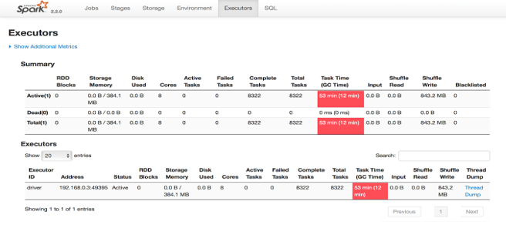

The Spark UI indicates excessive GC in red

### **Addressing Garbage Collection Issues**

Here are some of the basic things we can do to try to address GC issues.

#### **Data Structures**

**If using RDD-based applications, use data structures with fewer objects. For example, use an array instead of a list.**

#### **Specialized Data Structures**

If you are dealing with primitive data types, consider using specialized data structures like Koloboke or fastutil. These structures optimize memory usage for primitive types.

#### **Storing Data Off-Heap**

The Spark execution engine and Spark storage can both store data off-heap. You can switch on off-heap storage using the following commands:

* –conf spark.memory.offHeap.enabled = true
* –conf spark.memory.offHeap.size = Xgb.

Be careful when using off-heap storage as it does not impact on-heap memory size, i.e. it won’t shrink heap memory. So, to define an overall memory limit, assign a smaller heap size.

#### **Built-in vs. User Defined Functions (UDFs)**

**If you are using Spark SQL, try to use the built-in functions as much as possible, rather than writing new UDFs. Most of the Spark UDFs can work on UnsafeRow and don’t need to convert to wrapper data types.** This avoids creating garbage, also it plays well with code generation.

#### **Be Stingy About Object Creation**

**Remember we may be working with billions of rows. If we create even a small temporary object with 100-byte size for each row, it will create 1 billion * 100 bytes of garbage.**

So far we have focused on memory management, data skew, and garbage collection as the causes of slowdowns and failures in your Spark applications. For Part III of the series, we will turn our attention to resource management and cluster configuration were issues such as data locality, IO-bound workloads, partitioning, and parallelism can cause some real headaches unless you have good visibility and intelligence about your data runtime.

Garbage collection is an essential component of any Java-based application, and this is especially true for Apache Spark, which heavily relies on the Java Virtual Machine (JVM) to execute its code. Garbage collection refers to the process of automatically freeing up memory that is no longer being used by the application, and it plays a critical role in ensuring that your Spark application runs smoothly and efficiently.

One of the most important reasons why garbage collection is important in Spark is that it helps **prevent memory leaks**. As your application processes large amounts of data, it can create a large number of objects in memory. If these objects are not properly disposed of, they can build up over time and consume an increasingly large amount of memory, eventually causing your application to crash or become unresponsive. Garbage collection helps prevent this by **periodically freeing up memory** that is no longer being used.

Another key advantage of garbage collection is that it helps improve the overall performance of your Spark application. When the JVM **runs out of memory**, it must pause the application and perform a **garbage collection cycle to free up memory**. This can cause the application to become unresponsive and can lead to slow performance. By properly configuring the garbage collector and choosing the right GC algorithm for your use case, you can minimize the impact of garbage collection on the performance of your application and ensure that it runs smoothly and efficiently.

In Spark, there are **two** main garbage collectors that can be used: the **Parallel GC and the G1 GC**. The **Parallel GC is the default GC algorithm** for Spark and is recommended for most use cases. It uses **multiple threads** to perform garbage collection and is generally considered to be **faster and more efficien**t than other GC algorithms.

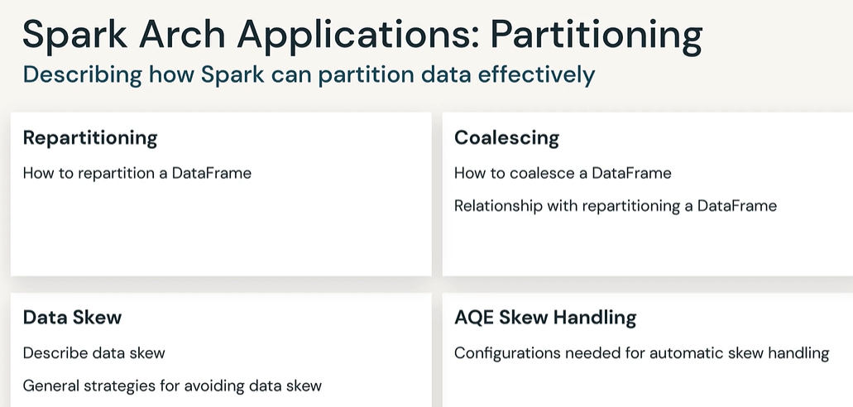

## Spark Partitioning in a nutshell

In order to achieve high parallelism, Spark will split the data into smaller chunks called partitions which are distributed across different nodes in the Spark Cluster. Every node, can have more than one executor each of which can execute a task.

The distribution of the work into multiple executors requires data to be partitioned and distributed across the executors, so that the work can be done in parallel in order to optimise the data processing for a specific job.

Repartitioning can be done in two ways in Spark, using coalesce and repartition methods. Repartitioning is used to address data skew issues, optimize filtering and sorting operations, and improve performance during join operations. It can also be used to optimize writing data to disk.

Repartitioning can be done in two ways in Spark:

1. Coalesce: Coalescing is the process of reducing the number of partitions in an RDD or DataFrame. It combines existing partitions to create larger partitions and is a more efficient way of reducing the number of partitions than using repartition. Coalesce should be used when the data size is reduced significantly as compared to the number of partitions.
2. Repartition: Repartitioning is the process of increasing or decreasing the number of partitions in an RDD or DataFrame. It is a more expensive operation than coalesce as it shuffles data across the network, but it can be used to increase parallelism and optimize the performance of Spark applications. Repartitioning should be used when the data size is increased significantly as compared to the number of partitions.

# Use-cases where repartitioning is used & examples

Some common use-cases for using repartitioning in Spark include:

## Data skew

Repartitioning can be used to address data skew issues, where some partitions have a significantly larger amount of data compared to others. By repartitioning the data and redistributing it evenly across partitions, the workload can be balanced, and processing time can be improved.

Example

Suppose you have a dataset of customer transactions, and some customers have many more transactions than others, causing data skew. You want to perform some aggregations on the data, such as summing the total transaction amount for each customer.

Without repartitioning, the data may be unevenly distributed across partitions, leading to some partitions having significantly more data than others. This can result in some partitions taking much longer to process than others, leading to slow overall performance.

To address this data skew, you can repartition the data based on the customer ID column so that each partition contains a more even distribution of customers. This can be done using the repartition() method in Spark:

val transactions = spark.read.csv("customer_transactions.csv")  
val transactionsByCustomer = transactions.groupBy("customer_id").sum("transaction_amount")  
val evenlyDistributedData = transactionsByCustomer.repartition(10, "customer_id")

In this example, we are repartitioning the data into 10 partitions based on the customer_id column to evenly distribute the workload across nodes. By doing this, we can improve performance and avoid data skew issues.

# Join operations

When performing join operations on large datasets, repartitioning can be used to co-partition the data before the join operation. This can improve performance by minimizing data shuffling during the join.

Example

Suppose you have two large DataFrames, df1 and df2, that you want to join on a common column id. However, the data in both DataFrames is not evenly distributed among partitions, and some partitions may have a significantly larger amount of data than others, causing data skew. To address this, you can use repartitioning to co-partition the data before the join.

First, you can repartition both DataFrames based on the id column:

df1 = df1.repartition("id")  
df2 = df2.repartition("id")

This will ensure that both DataFrames are partitioned based on the same column and that data with the same id values are stored in the same partitions across both DataFrames.

Then, you can perform the join operation on the repartitioned DataFrames:

joined_df = df1.join(df2, "id")

Since the data is co-partitioned, the join operation will be more efficient, as data shuffling during the join will be minimized.

# Filtering and sorting

Repartitioning can also be used to optimize filtering and sorting operations. By partitioning the data based on the filter or sort criteria, Spark can perform these operations in parallel across multiple partitions, leading to faster processing times.

Example

Suppose we have a large dataset of online customer transactions, with columns such as transaction_id, customer_id, transaction_date, and transaction_amount. We want to filter the dataset to only include transactions made by customers in a particular city and sort the remaining data by transaction date.

To optimize this operation, we can first partition the data by the customer’s city using the repartition() method:

transactions = spark.read.format("csv").load("transactions.csv")  
// Repartition the data based on the customer's city  
transactions = transactions.repartition("customer_city")  
// Filter transactions made by customers in a particular city  
city_transactions = transactions.filter("customer_city = 'New York'")  
// Sort the remaining data by transaction date  
sorted_transactions = city_transactions.sort("transaction_date")

By repartitioning the data based on the customer’s city, Spark can parallelize the filtering and sorting operations across multiple partitions, improving performance and reducing data shuffling.

# Writing data to disk

Repartitioning can be used to optimize writing data to disk. By reducing the number of partitions and increasing their size, the amount of overhead incurred during writing can be reduced, resulting in faster write times.

Example

Suppose we have a large dataset with millions of records that we want to write to disk in CSV format. Initially, the data is partitioned into 100 partitions, each containing 100,000 records.

However, we find that writing the data to disk is taking longer than expected due to the high number of small partitions. To optimize the write operation, we can repartition the data into fewer partitions with a larger size.

We can use the following code to repartition the data:

data = data.repartition(10)

This will create 10 partitions, each containing 1 million records. By reducing the number of partitions and increasing their size, we can minimize the overhead incurred during writing and improve write performance.

We can then write the data to disk using the write.csv() function:

data.write.csv("output.csv")

This will write the data to a single CSV file with a smaller overhead compared to writing multiple files for each partition.

# Load balancing

Repartitioning can be used to balance the workload across multiple nodes in a cluster. By evenly distributing the data across partitions, the workload can be distributed evenly, leading to more efficient use of cluster resources.

Example

Suppose we have a large dataset of customer orders and we want to perform some processing on it in parallel using a cluster of Spark nodes. However, the data is not evenly distributed across the partitions, with some partitions having significantly more data than others. This can result in some nodes being underutilized while others are overloaded.

To address this, we can use repartitioning to evenly distribute the data across partitions. For example, we can use the repartition method to increase the number of partitions and redistribute the data:

orders = spark.read.csv("orders.csv", header=True)  
// Check the current partitioning  
print("Number of partitions before repartitioning:", orders.rdd.getNumPartitions())  
// Repartition the data to evenly distribute it across partitions  
orders = orders.repartition(100)  
// Check the new partitioning  
print("Number of partitions after repartitioning:", orders.rdd.getNumPartitions())

In this example, we start with a DataFrame orders that has a default partitioning based on the number of available cores in the Spark cluster. We then use repartition to increase the number of partitions to 100 and redistribute the data evenly across them. This can help balance the workload across the cluster and improve performance by ensuring that each node has a similar amount of data to process.

In the world of big data and distributed computing, one of the most important frameworks that data engineers and data scientists use is Apache Spark. However, when dealing with large volumes of data, it’s crucial to understand a concept that can potentially cripple your Spark application’s performance — **Data Skewness**. This blog post will help you understand what data skewness is, what can cause it, and how you can overcome it to maintain optimal performance in your Spark applications.

# What is Data Skewness?

Data skewness in Apache Spark refers to a condition where the data being processed is not distributed evenly across partitions. In an ideal scenario, data should be uniformly distributed across all the partitions to ensure maximum parallelism and thereby increasing the processing speed. However, real-world data is often not perfectly balanced and when one or a few partitions have a disproportionately high amount of data compared to the others, we have a situation of data skewness.

This data imbalance can drastically impact the performance of your Spark application, leading to longer processing times, inefficient use of resources, and even out-of-memory errors. In the worst-case scenario, a single partition with skewed data can slow down the entire Spark job because the overall completion time of a stage in Spark is determined by the time taken by the slowest task.

# Causes of Data Skewness

There are several potential causes of data skewness in Spark applications:

1. **Skewed Data Distribution**: Real-world data is often distributed unevenly. Some keys may have a high number of occurrences (hot keys), causing a skewed distribution of data across partitions.
2. **Inadequate Partitioning Strategy**: The default partitioning strategy in Spark might not always be the most efficient for your specific dataset. For example, the default Hash Partitioning strategy might cause data skewness if certain keys hash to the same partition.
3. **Join Operations**: When performing join operations, if the keys in the datasets being joined are not evenly distributed, it can result in a skew. This is especially prominent in cases where a large dataset is joined with a small dataset on a non-unique key.
4. **GroupBy Operations**: Similar to join operations, GroupBy operations can also cause data skewness when certain keys have many more values than others.

# Handling Data Skewness in Apache Spark

Although data skewness can impact your Spark application’s performance significantly, several strategies can help manage and mitigate this issue:

1. **Custom Partitioning**: Instead of relying on Spark’s default partitioning strategy, implementing a custom partitioning strategy can help distribute data more evenly across partitions. For example, range partitioning can be more effective when dealing with numeric keys.
2. **Salting**: Salting is a technique where a random value (salt) is appended to the key, which helps distribute the data more evenly across partitions. This can be particularly useful when dealing with hot keys.
3. **Dynamic Partition Pruning**: Dynamic partition pruning is a technique used in Spark to optimize join operations by skipping the scanning of irrelevant partitions in both datasets. This can help improve performance in the case of data skewness caused by join operations.
4. **Splitting Skewed Data**: Another strategy is to split the skewed data across multiple partitions. This involves identifying the skewed keys and redistributing the data associated with these keys.
5. **Avoid GroupBy for Large Datasets**: When possible, avoid using GroupBy operations on large datasets with non-unique keys. Alternatives such as reduceByKey, which performs a combine operation locally on each partition before performing the grouping operation, can be more efficient.

# How to Handle Data Skewness?

Here are a few practical strategies with Scala examples on how to handle data skewness in Apache Spark:

# 1. Salting Technique

Salting is a useful technique when certain keys (hot keys) in your data have a high number of occurrences, which results in skewness. The idea is to add a random number (salt) to the key, so that the records with the same key are now spread across multiple keys.

Let's see how to apply salting in Spark with Scala:

val spark: SparkSession = ...  
  
// Assume we have a DataFrame with data skewness  
val skewedDF: DataFrame = ...  
  
// Define a UDF to add salt  
val addSaltUdf = udf((key: String) => key + "_" + Random.nextInt(100))  
  
// Add salt to key  
val saltedDF = skewedDF.withColumn("key", addSaltUdf(col("key")))  
  
// Now you can perform operations on saltedDF without data skewness issue

# 2. Custom Partitioning

If the default partitioning strategy in Spark doesn't distribute your data evenly, you can consider implementing a custom partitioning strategy. Let's take an example of using range partitioning:

val spark: SparkSession = ...  
  
// Assume we have a RDD with data skewness  
val skewedRDD: RDD[(Int, String)] = ...  
  
// Custom range partitioner  
val customPartitioner = new RangePartitioner(10, skewedRDD)  
  
// Apply the custom partitioner  
val partitionedRDD = skewedRDD.partitionBy(customPartitioner)  
  
// Now you can perform operations on partitionedRDD without data skewness issue

# 3. Splitting Skewed Data

If you can identify the skewed keys, you can split the skewed data and non-skewed data into two separate RDDs/DataFrames and process them separately.

val spark: SparkSession = ...  
  
// Assume we have a DataFrame with data skewness  
val skewedDF: DataFrame = ...  
  
// Skewed keys  
val skewedKeys = Seq("key1", "key2", "key3")  
  
// Split the data  
val skewedData = skewedDF.filter(col("key").isin(skewedKeys: _*))  
val nonSkewedData = skewedDF.filter(!col("key").isin(skewedKeys: _*))  
  
// Process skewedData and nonSkewedData separately

Remember, the right strategy to handle data skewness depends on the specifics of your data and application. Applying these strategies correctly can significantly improve the performance of your Spark applications. Keep these strategies in your toolkit for when you next face the challenge of skewed data in Apache Spark.

## Read More

1. What is [Catalyst Optimizer](https://medium.com/@diehardankush/how-new-view-at-catalyst-optimizer-in-apache-spark-739cd335d145)
2. [Comparing Data Storage: Parquet vs Arrow](https://medium.com/@diehardankush/comparing-data-storage-parquet-vs-arrow-aa2231e51c8a)

# Conclusion

In conclusion, data skewness is a common issue when dealing with big data in Apache Spark. Understanding what causes it and how to handle it effectively can greatly improve your Spark application’s performance and stability. The above strategies are not exhaustive, and the right solution will depend on the specifics of your data and application

Apache Spark is an open-source, distributed computing system used for big data processing. It is widely used for tasks such as data processing, machine learning, and real-time analytics. To achieve high performance in these tasks, Spark has many advanced features, and one of them is the Adaptive Query Execution (AQE) optimizer.

The **AQE optimizer** in Apache Spark is an advanced optimization engine that dynamically tunes the execution plan for a given query, based on the runtime statistics of the data. It can improve query performance by optimizing the data processing pipelines.

**Adaptive Query Execution (AQE) Optimizer**is a feature introduced in Apache Spark 3.0 that enables Spark to optimize and execute SQL queries more efficiently

Traditional query execution engines follow a fixed plan for processing the data, regardless of the data’s distribution or statistics. This approach can result in suboptimal performance when dealing with large, complex datasets. To overcome this issue, Spark introduced the AQE optimizer, which dynamically adapts the execution plan based on the characteristics of the data.

When we submit a query, DataFrame, or Dataset operations, Spark does the following in order.

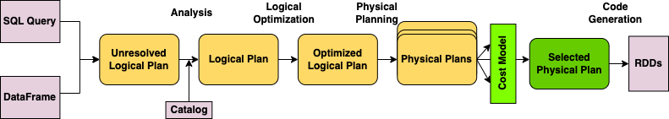

Spark SQL Catalyst AQE Stages

## Spark query optimization process in brief:

1. **Syntax validation**: Validates the syntax of the query.
2. **Analysis**: Converts the Unresolved Logical Plan to Resolved Logical Plan using Catalyst, validates columns with catalog.
3. **Optimization**: Converts Logical Plan into Optimized Logical Plan.
4. **Planner**: Creates one or more Physical Plans from an optimized Logical Plan.
5. **Cost Model**: Calculates the cost for each Physical Plan and selects the best Physical Plan.
6. **RDD Generation**: Generates RDD in Java bytecode.
7. **Execution**: Executes the transformations and action using the Spark execution engine.

The AQE optimizer in Spark provides the following benefits:

1. **Dynamic optimization**: The AQE optimizer is capable of dynamically changing the execution plan based on the data statistics. This approach enables Spark to optimize the data processing pipeline to provide better performance.
2. **Adaptive planning**: The AQE optimizer uses adaptive planning to change the execution plan during runtime. This feature helps to optimize the query execution plan based on the data characteristics, ensuring the most efficient processing plan.
3. **Cost-based optimization**: The AQE optimizer uses a cost-based optimization approach to determine the optimal query execution plan. This approach ensures that the query execution plan is optimized for the best performance and cost.
4. **Reduced overhead**: By optimizing the query execution plan, the AQE optimizer reduces the overhead associated with data processing. This approach helps to improve the overall performance of Spark and reduce the cost of running queries.
5. **Faster processing**: With the AQE optimizer, Spark can process queries faster and more efficiently, improving the overall performance of the system.

Here is a simple PySpark code snippet that demonstrates the use of Spark AQE optimizer:

from pyspark.sql.functions import sum  
from pyspark.sql.types import IntegerType  
  
# Enable AQE  
spark.conf.set("spark.sql.adaptive.enabled", "true")  
spark.conf.set("spark.sql.adaptive.optimizerEnabled", "true")  
  
# Read data from CSV  
df = spark.read.csv("data.csv", header=True, inferSchema=True)  
  
# Group by column 'A' and sum column 'B'  
df = df.groupBy("A").agg(sum("B").alias("B"))  
  
# Filter rows where 'B' is greater than 100  
df = df.filter(df.B > 100)  
  
# Cache the resulting DataFrame  
df.cache()  
  
# Count the number of rows in the DataFrame  
print(df.count())  
  
# Unpersist the DataFrame  
df.unpersist()

In this example, we first enable the AQE optimizer by setting the spark.sql.adaptive.enabled and spark.sql.adaptive.optimizerEnabled configuration properties to true. We then read data from a CSV file into a PySpark DataFrame and perform a group by operation on column 'A', summing the values in column 'B'. We then filter the resulting DataFrame to keep only the rows where 'B' is greater than 100, cache the DataFrame for faster subsequent computations, count the number of rows in the DataFrame, and finally unpersist the DataFrame to free up memory. The AQE optimizer works behind the scenes to optimize the execution plan of these operations for better performance.

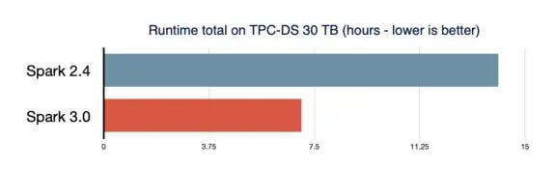

ADQ performance comparison (Source: Databricks)

In conclusion, the AQE optimizer in Apache Spark is an advanced optimization engine that dynamically tunes the execution plan for a given query, based on the runtime statistics of the data. It provides many benefits, including dynamic optimization, adaptive planning, cost-based optimization, reduced overhead, and faster processing. The AQE optimizer is an essential feature of Apache Spark and a significant advancement in big data processing technology.

Follow me now to stay up-to-date on the latest advances in distributed data processing and analytics technology and unlock the potential of your data.

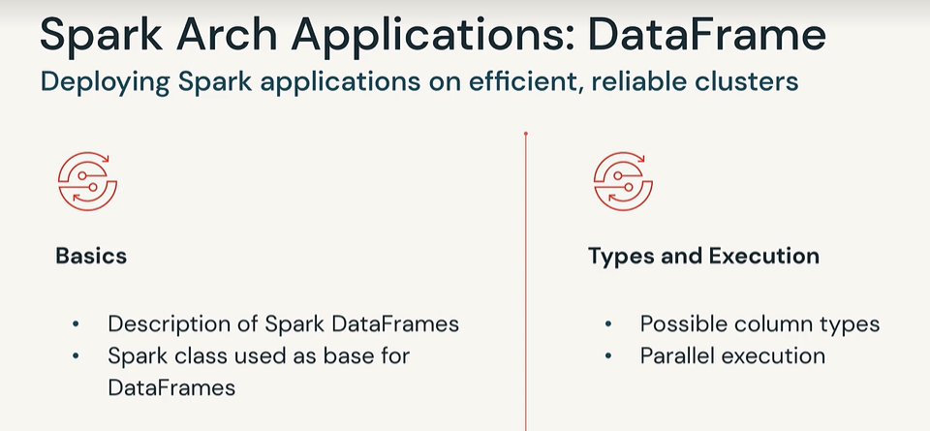

In [**Spark**](https://intellipaat.com/blog/what-is-apache-spark/), DataFrames are the distributed collections of data, organized into rows and columns. Each column in a DataFrame has a name and an associated type. DataFrames are similar to traditional database tables, which are structured and concise. We can say that DataFrames are relational databases with better optimization techniques.

Spark DataFrames can be created from various sources, such as Hive tables, log tables, external databases, or the existing [**RDDs**](https://intellipaat.com/blog/tutorial/spark-tutorial/programming-with-rdds/). DataFrames allow the processing of huge amounts of data.

When Apache Spark 1.3 was launched, it came with a new API called DataFrames that resolved the limitations of performance and scaling that occur while using RDDs.

When there is not much storage space in memory or on disk, RDDs do not function properly as they get exhausted. Besides, Spark RDDs do not have the concept of **schema**—the structure of a database that defines its objects. RDDs store both structured and unstructured data together, which is not very efficient.

RDDs cannot modify the system in such a way that it runs more efficiently. RDDs do not allow us to debug errors during the runtime. They store the data as a collection of Java objects.

RDDs use**serialization** (converting an object into a stream of bytes to allow faster processing) and **garbage collection** (an automatic memory management technique that detects unused objects and frees them from memory) techniques. This increases the overhead on the memory of the system as they are very lengthy.

This was when DataFrames were introduced to overcome the limitations Spark RDDs had. Now, what makes Spark DataFrames so unique? Let’s check out the features of Spark DataFrames that make them so popular.

### Features of DataFrames

Some of the unique features of DataFrames are:

* **Use of Input Optimization Engine**: DataFrames make use of the input optimization engines, e.g., **Catalyst Optimizer**, to process data efficiently. We can use the same engine for all Python, Java, Scala, and R DataFrame APIs.
* **Handling of Structured Data**: DataFrames provide a schematic view of data. Here, the data has some meaning to it when it is being stored.
* **Custom Memory Management**: In RDDs, the data is stored in memory, whereas DataFrames store data off-heap (outside the main Java Heap space, but still inside RAM), which in turn reduces the garbage collection overload.
* **Flexibility**: DataFrames, like RDDs, can support various formats of data, such as CSV, [Cassandra](https://intellipaat.com/blog/apache-cassandra-a-brief-intro/), etc.
* **Scalability**: DataFrames can be integrated with various other Big Data tools, and they allow processing megabytes to petabytes of data at once.

<https://phoenixnap.com/kb/spark-create-dataframe>

To get the data types of your DataFrame columns, you can use dtypes i.e :

df.dtypes

[('age', 'int'), ('name', 'string')]

df.schema

[df.printSchema()](https://spark.apache.org/docs/latest/api/python/reference/api/pyspark.sql.DataFrame.printSchema.html) to get a tree view of the schema, ex

df.schema[column_name].dataType

import spark.sqlContext.implicits._

val df = Seq((1,"Robert"), (2,"Julia")).toDF("id","name")

// Get All column names and it's types

df.dtypes.foreach(f=>println(f._1+","+f._2))

// Prints below column name & data type

// Id,IntegerType

// Name,StringType

// Get All column names and it's types

df.schema.fields.foreach(f=>f.name +","+f.dataType)

// Get data type of a specific column

println(df.schema("name").dataType)

// Prints data type of a "name" column

// StringType

// Get All column names from DataFrame

val allColumnNames=df.columns

println(allColumnNames.mkString(","))

// Print all column names in comma separated string

// Id,name

df.printSchema()

// root

// |-- id: integer (nullable = false)

// |-- name: string (nullable = true)

// Get Column Nullable Property & Metadata

print(df.schema("name").nullable)

val metaData=df.schema("name").metadata

print(df.schema.toDDL)

// `id` INT,`name` STRING

print(df.schema.prettyJson)

//{

// "type" : "struct",

// "fields" : [ {

// "name" : "id",

// "type" : "integer",

// "nullable" : false,

// "metadata" : { }

// }, {

// "name" : "name",

// "type" : "string",

// "nullable" : true,

// "metadata" : { }

// } ]

// }

# [**Should we parallelize a DataFrame like we parallelize a Seq before training**](https://stackoverflow.com/questions/37557014/should-we-parallelize-a-dataframe-like-we-parallelize-a-seq-before-training)

[Ask Question](https://stackoverflow.com/questions/ask)

Consider the code given here,

<https://spark.apache.org/docs/1.2.0/ml-guide.html>

import org.apache.spark.ml.classification.LogisticRegression

val training = sparkContext.parallelize(Seq(

LabeledPoint(1.0, Vectors.dense(0.0, 1.1, 0.1)),

LabeledPoint(0.0, Vectors.dense(2.0, 1.0, -1.0)),

LabeledPoint(0.0, Vectors.dense(2.0, 1.3, 1.0)),

LabeledPoint(1.0, Vectors.dense(0.0, 1.2, -0.5))))

val lr = new LogisticRegression()

lr.setMaxIter(10).setRegParam(0.01)

val model1 = lr.fit(training)

DataFrame is a distributed data structure. It is neither required nor possible to parallelize it. SparkConext.parallelize method is used only to distributed local data structures which reside in the driver memory. You shouldn't be used to distributed large datasets not to mention redistributing RDDs or higher level data structures (like you do in your previous question)

sc.parallelize(trainingData.collect())

If you want to convert between RDD / Dataframe (Dataset) use methods which are designed to do it:

1. from DataFrame to RDD:
2. import org.apache.spark.sql.DataFrame
3. import org.apache.spark.sql.Row
4. import org.apache.spark.rdd.RDD
5. val df: DataFrame = Seq(("foo", 1), ("bar", 2)).toDF("k", "v")
6. val rdd: RDD[Row] = df.rdd
7. form RDD to DataFrame:
8. val rdd: RDD[(String, Int)] = sc.parallelize(Seq(("foo", 1), ("bar", 2)))
9. val df1: DataFrame = rdd.toDF
10. // or

val df2: DataFrame = spark.createDataFrame(rdd) // From 1.x use sqlContext

To answer your question directly: A DataFrame is already optimized for parallel execution. You do not need to do anything and you can pass it to any spark estimators fit() method directly. The parallel executions are handled in the background.

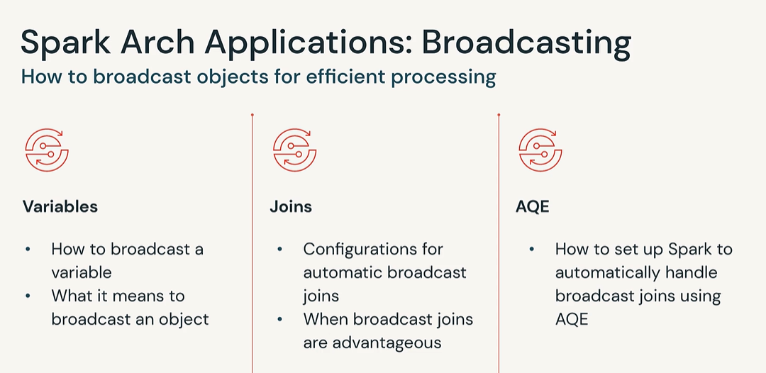

# Broadcast variables in spark work like they sound

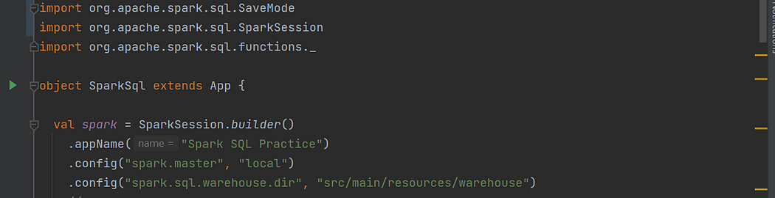

Let us first look at what broadcast variables are.

Broadcast variables as the name suggest are ‘broadacast’ to the nodes of the spark cluster to avoid shuffle operations. And they are read only.

Broadcast variables are an essential component of distributed computing frameworks, such as Apache Spark and Apache Flink. They serve as a mechanism to efficiently share immutable data structures across a cluster of machines, minimizing the need for redundant data transfers. Broadcast variables are read-only and are cached on each machine that participates in the distributed computation, ensuring quick and easy access.

What do they do ?

The primary purpose of broadcast variables is to address the challenge of data replication and distribution in distributed systems. Instead of replicating large datasets across multiple nodes, which can be both time-consuming and resource-intensive, broadcast variables enable the efficient transfer of data to all the machines in the cluster. By doing so, broadcast variables eliminate the need for repetitive data transfers and improve the performance of distributed computations.

**Benefits and Use Cases**

**1. Enhanced Performance:**Broadcast variables significantly enhance the performance of data-intensive applications by minimizing data transfer overhead. By distributing data to the machines beforehand, subsequent operations can access the data locally, eliminating the need for network communication and reducing latency.

**2. Memory Optimization:**Since broadcast variables are cached on each machine, they enable memory optimization by avoiding unnecessary duplication of data. This aspect becomes especially valuable when dealing with large datasets, as memory resources can be better utilized by storing data only once.

**3. Common Data Sharing:** Broadcast variables are useful in scenarios where multiple operations or tasks need to access the same data simultaneously. By broadcasting the data, it becomes readily available to all the tasks, ensuring consistency and avoiding redundant data transfers.

**4. Customizable Initialization:**Broadcast variables allow for customizable initialization, enabling developers to define the behavior of the variable during the distributed computation. This flexibility ensures that the data is appropriately prepared and ready for processing.

Example Usage

Let’s consider a practical example to illustrate the usefulness of broadcast variables. Suppose we have a distributed machine learning application that requires access to a pre-trained model. Instead of replicating the model across all the machines, which can consume a significant amount of network bandwidth and memory, we can broadcast the model as a variable. This approach allows each machine to access the model locally, reducing network overhead and improving overall performance.

Good, Now we have some idea about broadcast variables in spark.

Here is a code example of how to create a broadcast variable

import org.apache.spark.{SparkConf, SparkContext}  
object BroadcastExample {  
def main(args: Array[String]): Unit = {  
 val conf = new SparkConf().setAppName(“Broadcast Example”).setMaster(“local”)  
 val sc = new SparkContext(conf)  
 val broadcastVar = sc.broadcast(Array(1, 2, 3, 4, 5))  
 val rdd = sc.parallelize(Array(2, 3, 4, 5, 6))  
 val result = rdd.map(x => x * broadcastVar.value(0))  
result.foreach(println)  
sc.stop()  
 }  
}

Here, we initialize a broadcast variable broadcastVar with an array [1, 2, 3, 4, 5]. We then create an RDD rdd with elements [2, 3, 4, 5, 6] and use the broadcast variable to multiply each element of rdd. The result is printed, demonstrating how the broadcast variable enables the distribution and usage of data across multiple machines efficiently.

Some Real-Life Use Cases of using broadcast variables:

1. **Machine Learning Models:** Broadcasting pre-trained machine learning models, such as neural networks or decision trees, allows each machine in a cluster to access the model locally during the prediction phase. This avoids redundant transfers of the model and improves the inference performance.

import org.apache.spark.{SparkConf, SparkContext}  
import org.apache.spark.ml.classification.{LogisticRegression, LogisticRegressionModel}  
import org.apache.spark.ml.linalg.Vectors  
  
object BroadcastMachineLearningModel {  
 def main(args: Array[String]): Unit = {  
 val conf = new SparkConf().setAppName("Broadcast Machine Learning Model").setMaster("local")  
 val sc = new SparkContext(conf)  
  
 // Initialize and train the machine learning model  
 val model = new LogisticRegression().setMaxIter(10).fit(  
 Seq((0.0, Vectors.dense(1.0)), (1.0, Vectors.dense(2.0)), (1.0, Vectors.dense(3.0)))).toDF("label", "features")  
  
 // Broadcast the trained model  
 val broadcastModel = sc.broadcast(model)  
  
 // Simulate new data for prediction  
 val newData = Seq(Vectors.dense(4.0), Vectors.dense(5.0), Vectors.dense(6.0))  
 val rdd = sc.parallelize(newData)  
  
 // Make predictions using the broadcasted model  
 val predictions = rdd.map(broadcastModel.value.transform)  
  
 predictions.show()  
  
 sc.stop()  
 }  
}

In above example, we train a logistic regression model using the Spark MLlib API. Once the model is trained, we broadcast it using the sc.broadcast() method. Then, we simulate new data and make predictions using the broadcasted model. This approach allows each machine to access the trained model locally during the prediction phase, improving efficiency.

**2. Lookup Tables or Reference Data:** In data processing pipelines, there are often lookup tables or reference data that are used for enrichment or filtering operations. Broadcasting these tables allows all nodes to access them locally, reducing network overhead and improving query performance.

import org.apache.spark.{SparkConf, SparkContext}  
  
object BroadcastLookupTable {  
 def main(args: Array[String]): Unit = {  
 val conf = new SparkConf().setAppName("Broadcast Lookup Table").setMaster("local")  
 val sc = new SparkContext(conf)  
  
 // Create a lookup table  
 val lookupTable = Map("A" -> 1, "B" -> 2, "C" -> 3)  
  
 // Broadcast the lookup table  
 val broadcastTable = sc.broadcast(lookupTable)  
  
 // Simulate data with keys  
 val data = Seq("A", "B", "C", "B", "A")  
 val rdd = sc.parallelize(data)  
  
 // Use the broadcasted lookup table for value retrieval  
 val result = rdd.map(broadcastTable.value)  
  
 result.foreach(println)  
  
 sc.stop()  
 }  
}

Above we created a lookup table as a Scala Map containing key-value pairs. We then broadcast the lookup table using the sc.broadcast() method. Next, we simulate data with keys and create an RDD from the data. Finally, we use the broadcasted lookup table to retrieve the corresponding values for each key in the RDD. Broadcasting the lookup table allows all nodes to access the data locally, improving performance when performing operations based on the lookup table.

# Using Broadcast with spark SQL

Yes, broadcast variables can be used in Spark SQL as well. In fact, Spark SQL provides seamless integration with broadcast variables, allowing you to leverage their benefits in SQL queries and DataFrame operations.

To use broadcast variables in Spark SQL, you can follow these steps:

1. Create a broadcast variable using the `sparkContext.broadcast()` method and specify the data you want to broadcast. For example:

val broadcastVar = spark.sparkContext.broadcast(Array(1, 2, 3, 4, 5))

2. Register the broadcast variable as a temporary table or view in Spark SQL. This step allows you to reference the broadcast variable directly in SQL queries or DataFrame operations. For example:

spark.sql(s”CREATE OR REPLACE TEMPORARY VIEW broadcast_table AS SELECT * FROM table WHERE column IN (${broadcastVar.value.mkString(“,”)})”)

3. Use the broadcast variable in your SQL queries or DataFrame operations as needed. You can reference the broadcast variable directly in your SQL queries or use it within DataFrame transformations. For example:

val result = spark.sql(“SELECT * FROM table JOIN broadcast_table ON table.column = broadcast_table.column”)

By utilizing broadcast variables in Spark SQL, you can optimize your queries by broadcasting smaller datasets or lookup tables to all worker nodes, reducing network communication and improving query performance.

It’s worth noting that Spark SQL automatically optimizes queries involving broadcast variables by deciding whether to broadcast the variable or not based on the size of the data and the available resources. However, one can also use the spark.sql.broadcastTimeout configuration property to control the broadcast timeout threshold.

import org.apache.spark.sql.{SparkSession, DataFrame}  
  
object BroadcastStaticTable {  
 def main(args: Array[String]): Unit = {  
 val spark = SparkSession.builder()  
 .appName("Broadcast Static Table")  
 .master("local")  
 .getOrCreate()  
  
 // Create a static table DataFrame  
 val staticTableData = Seq(("A", 1), ("B", 2), ("C", 3))  
 val staticTableDF = spark.createDataFrame(staticTableData).toDF("key", "value")  
  
 // Broadcast the static table DataFrame  
 val broadcastStaticTable = spark.sparkContext.broadcast(staticTableDF)  
  
 // Use the broadcasted static table in a SQL query  
 val result = spark.sql("SELECT t1.*, t2.value FROM table1 t1 JOIN broadcast_table t2 ON t1.key = t2.key")  
  
 result.show()  
  
 spark.stop()  
 }  
}

In the above example, we create a static table DataFrame staticTableDF using the createDataFrame method and provide the data as a Seq. We then broadcast the static table DataFrame using spark.sparkContext.broadcast().

Next, we can use the broadcasted static table in a SQL query. In this case, we join table1 with the broadcasted table broadcast_table based on a common key column. The result is a DataFrame that includes the columns from table1 as well as the value column from the broadcasted static table.

By broadcasting the static table, Spark SQL ensures that the table data is efficiently distributed and accessible on each worker node. This helps in improving query performance by avoiding redundant data transfers and reducing network overhead.

Overall, using a static table as a broadcast variable in Spark SQL enables efficient data distribution and improves the performance of SQL queries involving lookup or reference data.

# Be careful when not to use broadcast variables !

Although broadcast variables are powerful tools for optimizing distributed computations, there are scenarios where using them may degrade performance instead. One such example is when the size of the broadcasted data exceeds the available memory on the worker nodes, leading to excessive memory consumption and potential performance issues.

below is an example where broadcasting a large dataset may not be an optimal solution:

import org.apache.spark.sql.SparkSession  
object BroadcastLargeDataset {  
 def main(args: Array[String]): Unit = {  
 val spark = SparkSession.builder()  
 .appName("Broadcast Large Dataset")  
 .master("local")  
 .getOrCreate()  
// Create a large dataset  
 val largeData = 1 to 1000000  
// Broadcast the large dataset  
 val broadcastLargeData = spark.sparkContext.broadcast(largeData)  
// Perform some operations using the broadcasted large dataset  
 // …  
spark.stop()  
 }  
}

In this example, we attempt to broadcast a large dataset with one million elements. However, if the worker nodes do not have sufficient memory to accommodate this dataset, it can lead to excessive memory consumption and potentially degrade performance.

Broadcasting large datasets can cause memory pressure on the worker nodes, as they need to store the entire dataset in memory. This may result in increased garbage collection overhead, longer task execution times, and even OutOfMemoryError exceptions if the available memory is exhausted.

In such cases, it’s recommended to explore alternative strategies for sharing data, such as leveraging data partitioning or using distributed caching mechanisms. These approaches can provide better performance and memory utilization by distributing the data across the cluster in a more scalable and efficient manner.

To configure Spark's automatic broadcast join, you can use the spark.sql.autoBroadcastJoinThreshold configuration in Spark SQL conf. This value sets the maximum size of a table that can be broadcast in bytes. The default value is 10485760, or 10 MB. You can disable autoBroadcastJoin by setting the value to -1

# Broadcast Joins in Apache Spark: an Optimization Technique

 6 minute read

This article is for the Spark programmers who know some fundamentals: how data is split, how Spark generally works as a computing engine, plus some essential DataFrame APIs.

## 1. Essentials[Permalink](https://blog.rockthejvm.com/spark-broadcast-joins/#1-essentials)

For this article, we use Spark 3.0.1, which you can either [download](https://spark.apache.org/downloads.html) as a standalone installation on your computer, or you can import as a library definition in your Scala project, in which case you’ll have to add the following lines to your build.sbt:

val sparkVersion = "3.0.1"

libraryDependencies ++= Seq(

"org.apache.spark" %% "spark-core" % sparkVersion,

"org.apache.spark" %% "spark-sql" % sparkVersion,

)

If you chose the standalone version, go ahead and start a Spark shell, as we will run some computations there. If you chose the library version, create a new Scala application and add the following tiny starter code:

import org.apache.spark.sql.SparkSession

val spark = SparkSession.builder()

.appName("Broadcast Joins")

.master("local")

.getOrCreate()

val sc = spark.sparkContext

For this article, we’ll be using the DataFrame API, although a very similar effect can be seen with the low-level RDD API.

## 2. A Tale of an Innocent Join[Permalink](https://blog.rockthejvm.com/spark-broadcast-joins/#2-a-tale-of-an-innocent-join)

Here’s the scenario. Let’s say we have a huge dataset - in practice, in the order of magnitude of billions of records or more, but here just in the order of a million rows so that we might live to see the result of our computations locally.

*// large table*

val table = spark.range(1, 100000000) *// column is "id"*

At the same time, we have a small dataset which can easily fit in memory. For some reason, we need to join these two datasets. Examples from real life include:

* tagging each row with one of n possible tags, where n is small enough for most 3-year-olds to count to
* finding the occurrences of some preferred values (so some sort of filter)
* doing a variety of lookups with the small dataset acting as a lookup table

Regardless, we join these two datasets. Let’s take a combined example and let’s consider a dataset that gives medals in a competition:

val rows = sc.parallelize(List(

Row(1, "gold"),

Row(2, "silver"),

Row(3, "bronze")

))

val rowsSchema = StructType(Array(

StructField("id", IntegerType),

StructField("medal", StringType)

))

*// small table*

val lookupTable: DataFrame = spark.createDataFrame(rows, rowsSchema)

Having these two DataFrames in place, we should have everything we need to run the join between them. It’s easy, and it should be quick, since the small DataFrame is really small:

val joined = table.join(lookupTable, "id")

joined.show()

Brilliant - all is well. Except it takes a bloody ice age to run.

## 3. The Large-Small Join Problem[Permalink](https://blog.rockthejvm.com/spark-broadcast-joins/#3-the-large-small-join-problem)

Why does the above join take so long to run?

If you ever want to debug performance problems with your Spark jobs, you’ll need to know how to [read query plans](https://blog.rockthejvm.com/reading-query-plans/), and that’s what we are going to do here as well. Let’s have a look at this job’s query plan so that we can see the operations Spark will perform as it’s computing our innocent join:

joined.explain()

This will give you a piece of text that looks very cryptic, but it’s information-dense:

== Physical Plan ==

*(5) Project [id#259L, medal#264]

+- *(5) SortMergeJoin [id#259L], [cast(id#263 as bigint)], Inner

:- *(2) Sort [id#259L ASC NULLS FIRST], false, 0

: +- Exchange hashpartitioning(id#259L, 200)

: +- *(1) Range (1, 10000000, step=1, splits=6)

+- *(4) Sort [cast(id#263 as bigint) ASC NULLS FIRST], false, 0

+- Exchange hashpartitioning(cast(id#263 as bigint), 200)

+- *(3) Filter isnotnull(id#263)

+- Scan ExistingRDD[id#263,order#264]

In this query plan, we read the operations in dependency order from top to bottom, or in computation order from bottom to top. Let’s read it top-down:

* the final computation of the id and the medal obtained after the join of the two DataFrames, which requires
* a sort-merge join on the columns id and id (with different identifiers under the hash tag), which requires
  + a sort of the big DataFrame, which comes after
  + **a shuffle of the big DataFrame**
* and a sort + shuffle + small filter on the small DataFrame

The shuffle on the big DataFrame - the one at the middle of the query plan - is required, because a join requires matching keys to stay on the same Spark executor, so Spark needs to redistribute the records by hashing the join column. This is a shuffle. But as you may already know, a shuffle is a massively expensive operation. On billions of rows it can take hours, and on more records, it’ll take… more.

## 4. Enter Broadcast Joins[Permalink](https://blog.rockthejvm.com/spark-broadcast-joins/#4-enter-broadcast-joins)

Fundamentally, Spark needs to somehow guarantee the correctness of a join. Normally, Spark will redistribute the records on both DataFrames by hashing the joined column, so that the same hash implies matching keys, which implies matching rows.

There is another way to guarantee the correctness of a join in this situation (large-small joins) by simply duplicating the small dataset on all the executors. In this way, each executor has all the information required to perform the join at its location, without needing to redistribute the data. This is called a broadcast.

val joinedSmart = table.join(broadcast(lookupTable), "id")

joinedSmart.show()

Much to our surprise (or not), this join is pretty much instant. The query plan explains it all:

== Physical Plan ==

*(2) Project [id#294L, order#299]

+- *(2) BroadcastHashJoin [id#294L], [cast(id#298 as bigint)], Inner, BuildRight

:- *(2) Range (1, 100000000, step=1, splits=6)

+- BroadcastExchange HashedRelationBroadcastMode(List(cast(input[0, int, false] as bigint)))

+- *(1) Filter isnotnull(id#298)

+- Scan ExistingRDD[id#298,order#299]

It looks different this time. No more shuffles on the big DataFrame, but a BroadcastExchange on the small one. Because the small one is tiny, the cost of duplicating it across all executors is negligible.

## 5. Automatic Detection[Permalink](https://blog.rockthejvm.com/spark-broadcast-joins/#5-automatic-detection)

In many cases, Spark can automatically detect whether to use a broadcast join or not, depending on the size of the data. If Spark can detect that one of the joined DataFrames is small (10 MB by default), Spark will automatically broadcast it for us. The code below:

val bigTable = spark.range(1, 100000000)

val smallTable = spark.range(1, 10000) *// size estimated by Spark - auto-broadcast*

val joinedNumbers = smallTable.join(bigTable, "id")

produces the following query plan:

== Physical Plan ==

*(2) Project [id#14L]

+- *(2) BroadcastHashJoin [id#14L], [id#12L], Inner, BuildLeft

:- BroadcastExchange HashedRelationBroadcastMode(List(input[0, bigint, false])), [id=#88]

: +- *(1) Range (1, 10000, step=1, splits=1)

+- *(2) Range (1, 100000000, step=1, splits=1)

which looks very similar to what we had before with our manual broadcast.

However, in the previous case, Spark did not detect that the small table could be broadcast. How come? The reason is that Spark will not determine the size of a local collection because it might be big, and evaluating its size may be an O(N) operation, which can defeat the purpose before any computation is made.

Spark will perform auto-detection when

* it constructs a DataFrame from scratch, e.g. spark.range
* it reads from files with schema and/or size information, e.g. Parquet

## 6. Configuring Broadcast Join Detection[Permalink](https://blog.rockthejvm.com/spark-broadcast-joins/#6-configuring-broadcast-join-detection)

The threshold for automatic broadcast join detection can be tuned or disabled. The configuration is spark.sql.autoBroadcastJoinThreshold, and the value is taken in bytes. If you want to configure it to another number, we can set it in the SparkSession:

spark.conf.set("spark.sql.autoBroadcastJoinThreshold", 104857600)

or deactivate it altogether by setting the value to -1.

spark.conf.set("spark.sql.autoBroadcastJoinThreshold", -1)

This is also a good tip to use while testing your joins in the absence of this automatic optimization. We also use this in our [Spark Optimization course](https://rockthejvm.com/p/spark-optimization) when we want to test other optimization techniques.

## 7. Conclusion[Permalink](https://blog.rockthejvm.com/spark-broadcast-joins/#7-conclusion)

Broadcast joins are one of the first lines of defense when your joins take a long time and you have an intuition that the table sizes might be disproportionate. It’s one of the cheapest and most impactful performance optimization techniques you can use. Broadcast joins may also have other benefits (e.g. mitigating OOMs), but that’ll be the purpose of another article.

Broadcast join is an optimization technique in Spark SQL that reduces data shuffling between a large and small dataframe during traditional joins. This improves performance and prevents out of memory errors, which can save costs for users. Broadcast join distributes the join over cluster nodes, which is useful when the left side of the join is small (up to several tens of MBs). When broadcasting a dataframe, a copy of the entire dataframe is inside each executor, allowing joins to be performed inside each executor without the need to shuffle.

Adaptive Query Execution (AQE) is a query re-optimization that occurs during query execution. AQE supports a variety of optimizations, including dynamically switching join strategies, dynamically coalescing shuffle partitions, and dynamically handling skew joins. AQE can dynamically change join strategies from SortMergeJoin (SMJ) to BroadCastHashJoin (BHJ) or to ShuffleHashJoin (SHJ). AQE also detects and optimizes skew joins by splitting the skewed partition into smaller tasks, allowing for more parallelism and less resource contention.

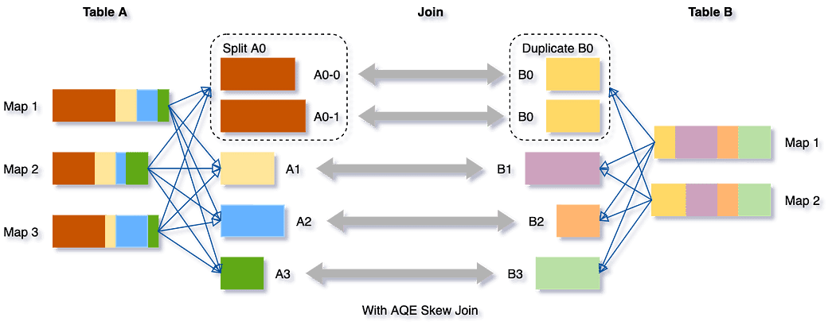

Adaptive Query Execution (AQE) is an optimization technique in Spark SQL that makes use of the runtime statistics to choose the most efficient query execution plan, which is enabled by default since Apache Spark 3.2.0.  
  
As of Spark 3.0, there are three major features in AQE:  
1. coalescing post-shuffle partitions,  
2. converting sort-merge join to broadcast join  
3. skew join optimization.  
  
Let me explain all of these with examples —  
consider you have  
- orders data which is 5 Gb in size (consider this as big data, I am taking a smaller number for easy calculations)  
- customers data which is 1 GB (this is a smaller dataset)  
  
both of the above datasets have customer_id as the common column, but we want to get the join results only for the state “california”  
  
if we join the above 2 dataframes based on customer_id then we get 200 shuffle partitions if AQE is not enabled. But let’s see what happens when AQE is enabled.  
  
scenario 1: coalescing post-shuffle partitions —  
lets assume that there are just 10 different customers then shuffle partitions would be 200 for orders, and 200 for customers..  
but only 10 of them are having data, 190 are empty.  
This means that 200 tasks will run unnecessarily and this will put load on job scheduler, and there is some overhead.  
If AQE is enabled then spark will automatically decide the number of shuffle partitions and will decide it to be 10 (may be), this makes sure that all the partitions are almost equally full.  
It might also combine 2 partitions with smaller data into one bigger partition with an intent that all partitions are nearly of same size.  
  
scenario 2: converting sort-merge join to broadcast join  
orders dataset is 5 gb  
customers is 1 gb  
if we join the above 2 then it will go for shuffle sort merge join. (shuffle and sort are costly operation)  
Now we know that we need to have just the data for state “california”, which is a highly selective filter and after that the customers data will be roughly 8 mb.  
So, if AQE is enabled it will calculate the runtime statistics during the shuffle, and then it will detect that since we have put the filter condition the customers dataset is reduced to 8 mb and it can go for broadcast hash join.  
This will be really efficient.  
  
scenario 3: skew join optimization  
lets say there is one customer who has placed a lot of orders.  
so in orders dataframe out of 5 gb , 2 gb is just by one customer.  
Now if AQE is not enabled this will result in a partition skew and can later lead to out of memory errors as well.  
But when AQE is enabled it will calculate runtime stats and detect this.  
It will split this into multiple smaller partitions.

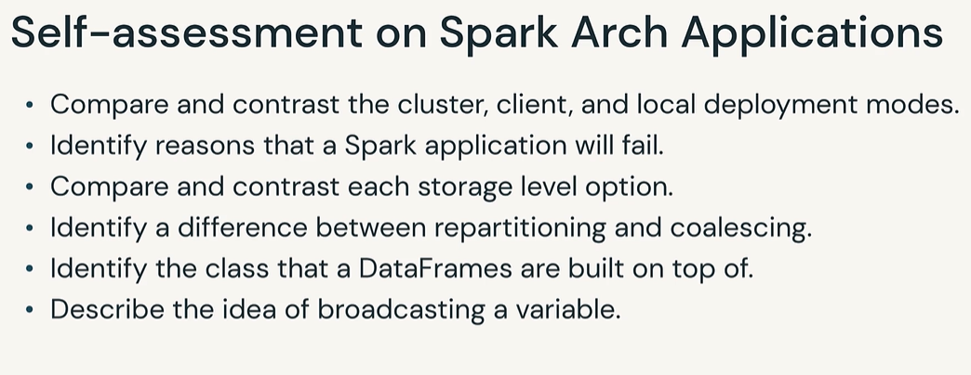

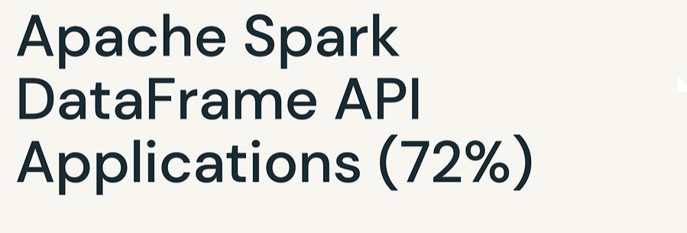

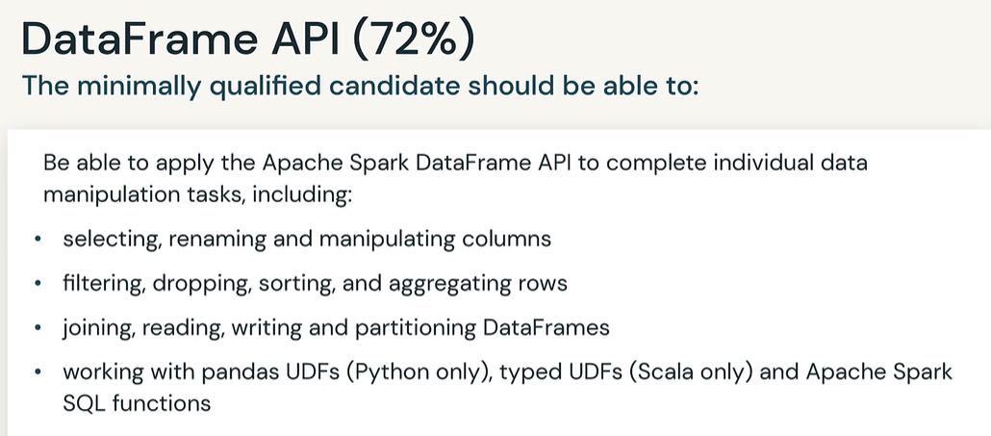

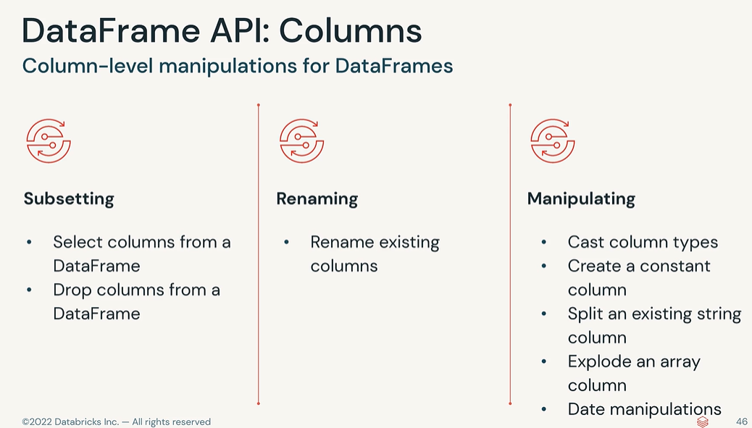

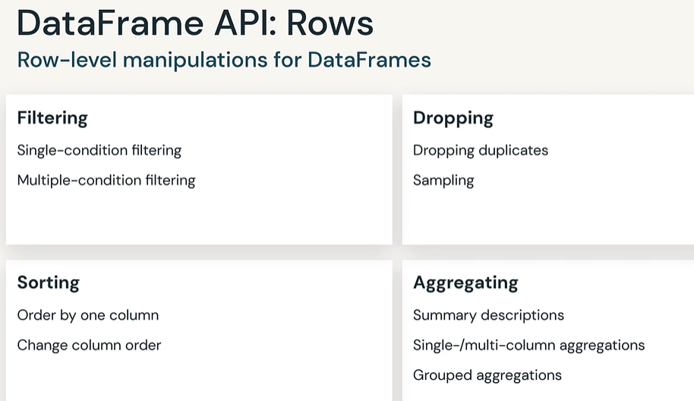

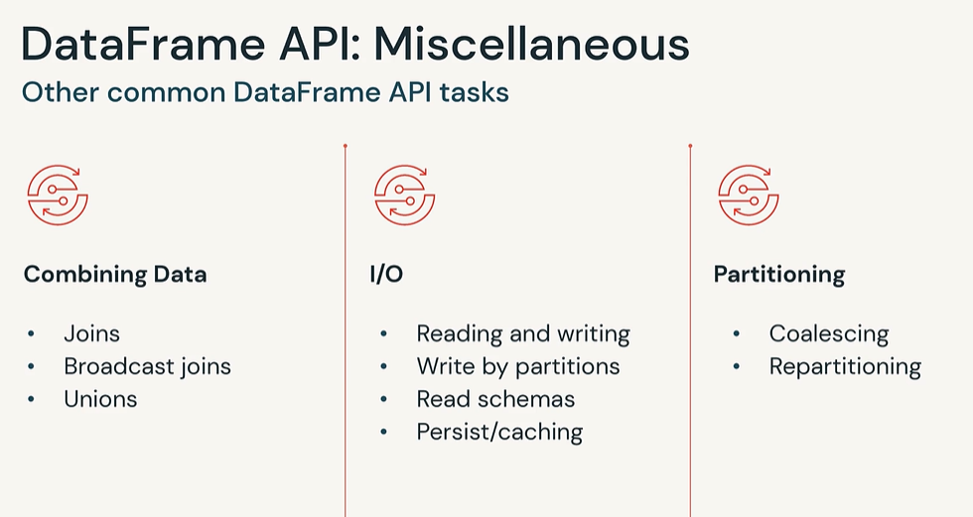

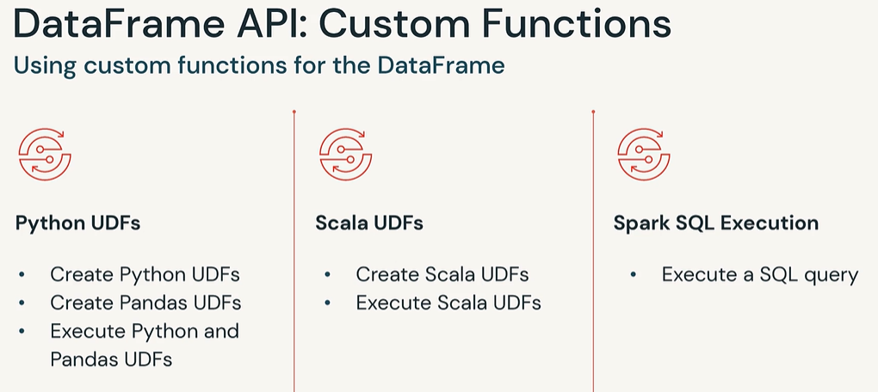

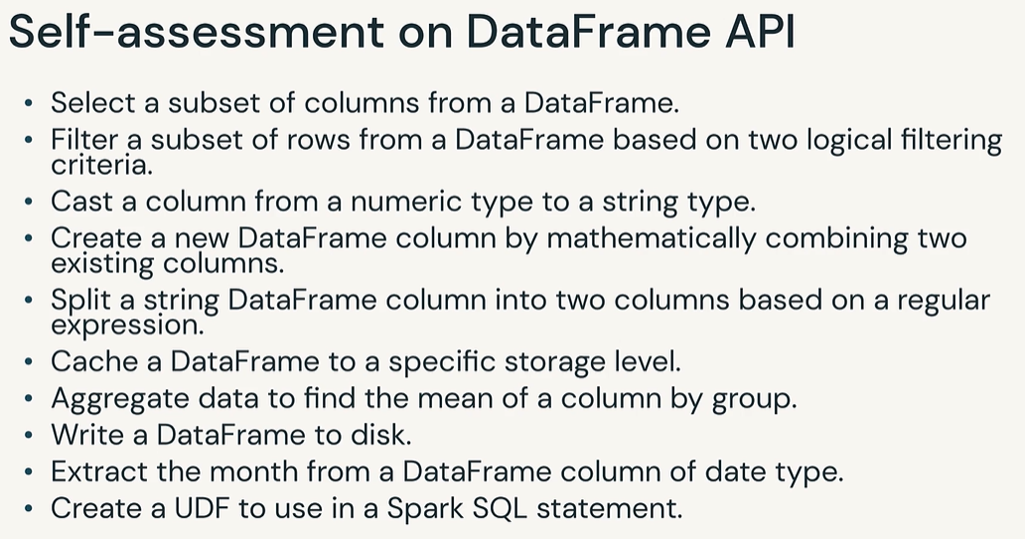

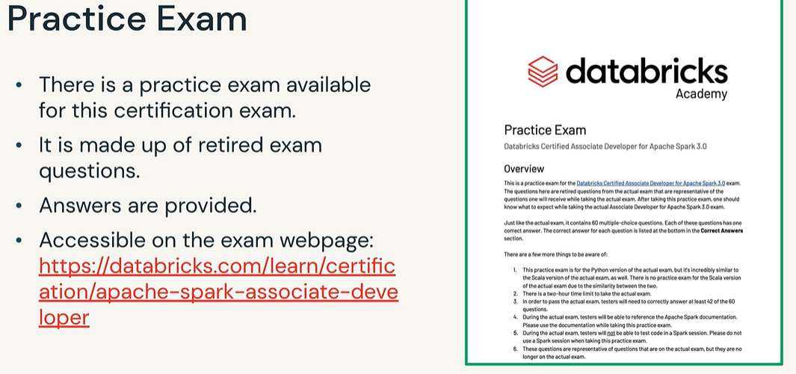

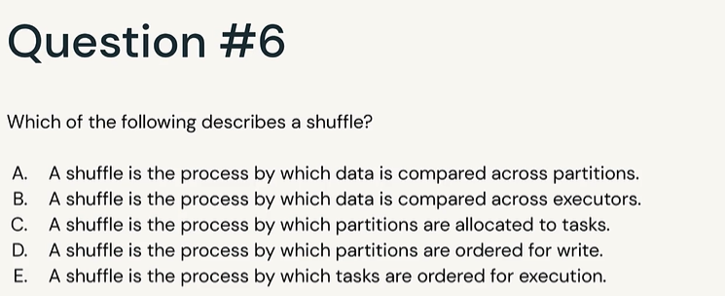

Answer A

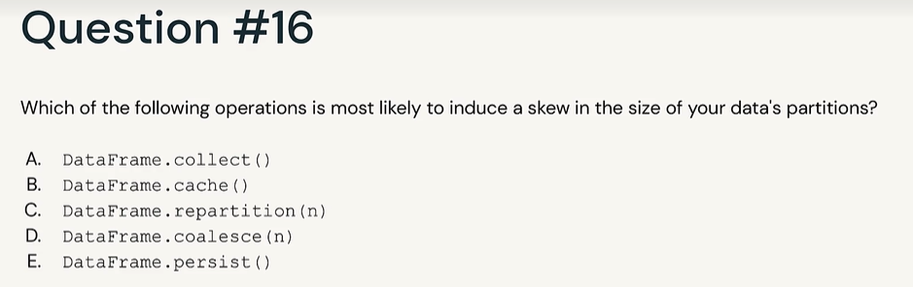

Answer D

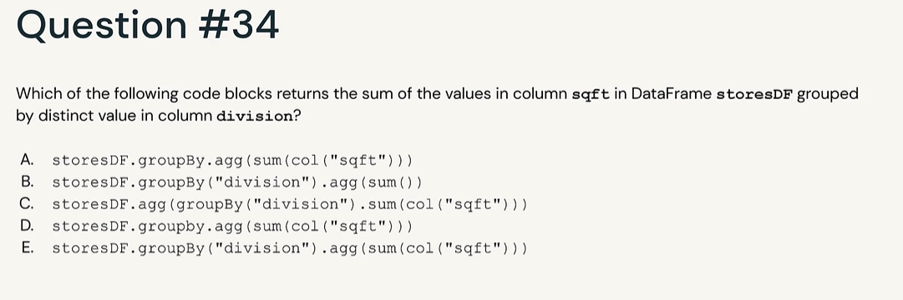

Answer E

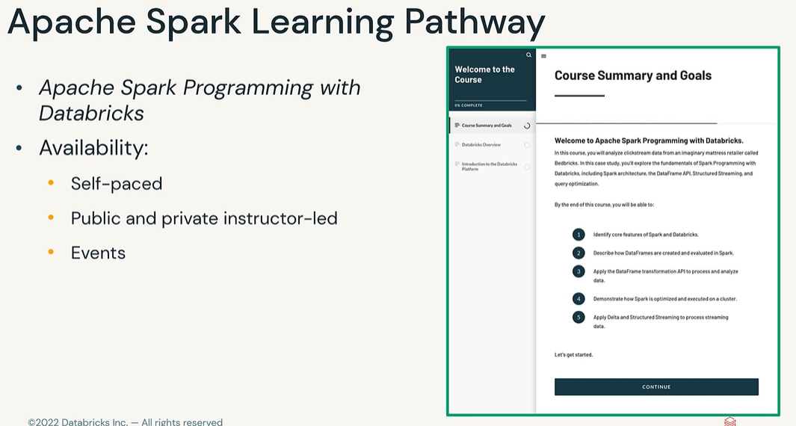

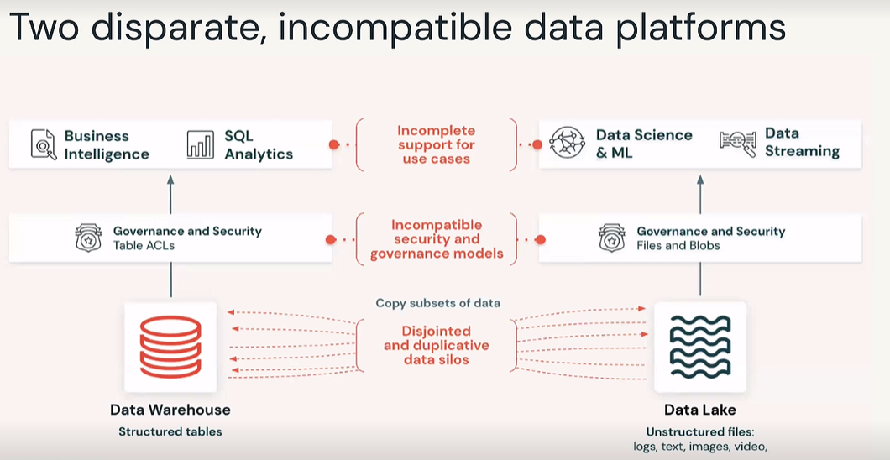

Web_logs etc

Two platforms combined

Databricks = Best of above two platforms

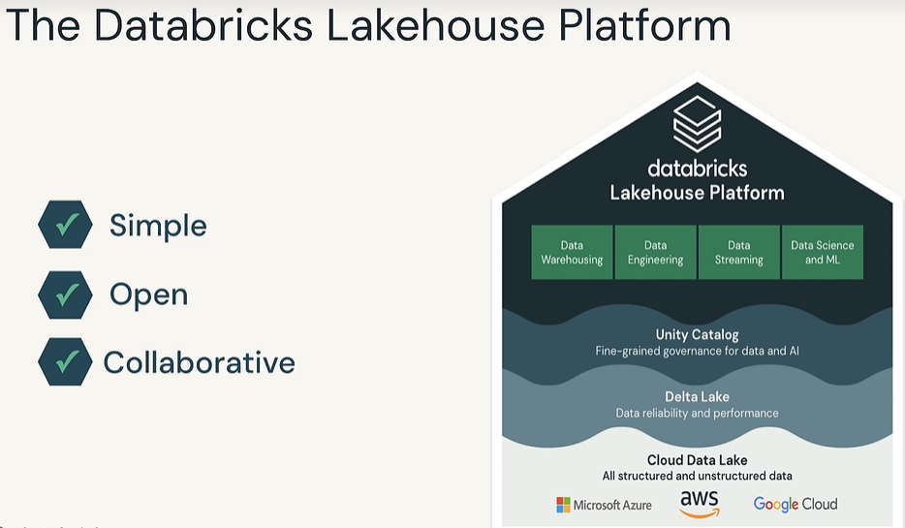

SQL adhoc queries = Data Warehousing

Pipelines = Data Engineering

Near realtime streaming = Data Streaming

Predictions = DS and ML

Regardless of activity you can this this one platform

Unity Catalog = DBRX version of keeping track of Access control list

Delta Lake = DBRX version of reading and writing files to get best performance

DBRX lake house platform = Best things out of data lake and best things out of data ware housing

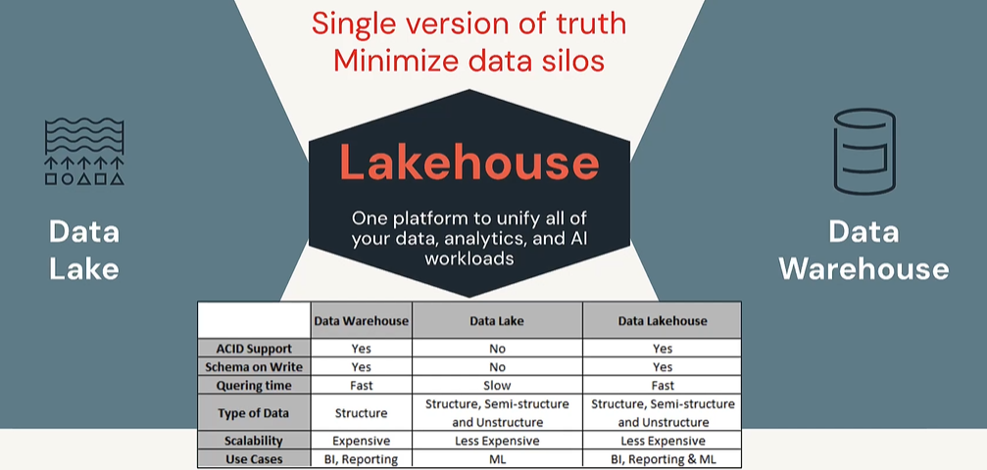

To run the queries use Apache Spark

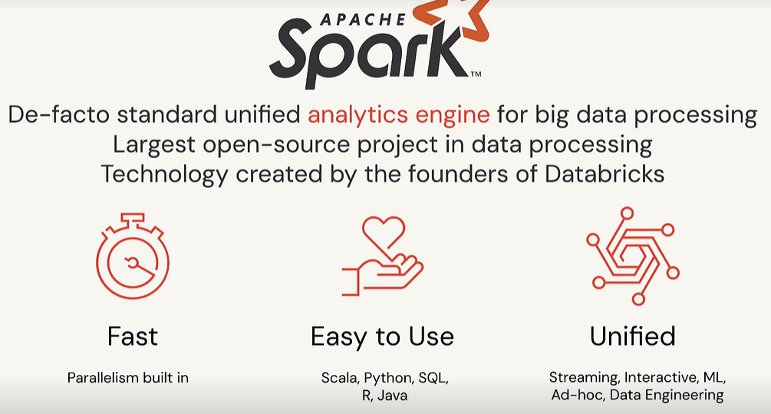

Spark executes like divide and conquer strategy

Action is something that kicks off processing eg: display

Job spuns one or more stages. One stage spuns one or more tasks

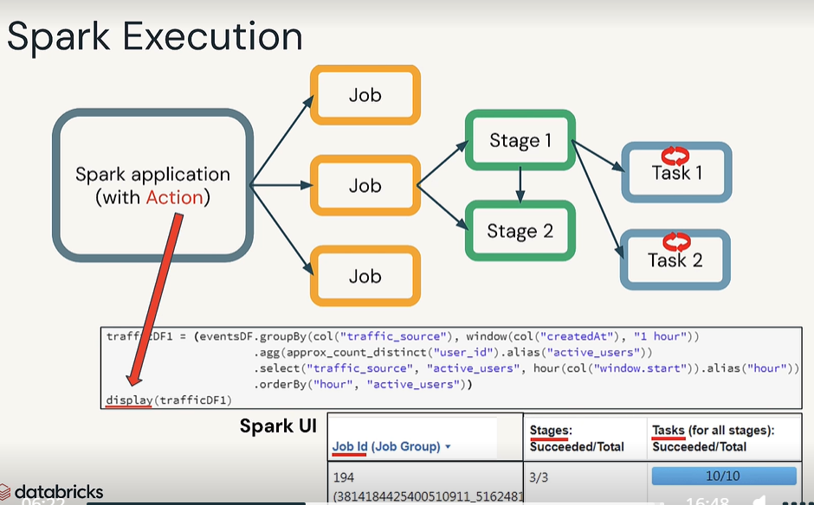

Cluster is bunch of virtual machines

Cluster = One driver(brain) and one or more worker nodes

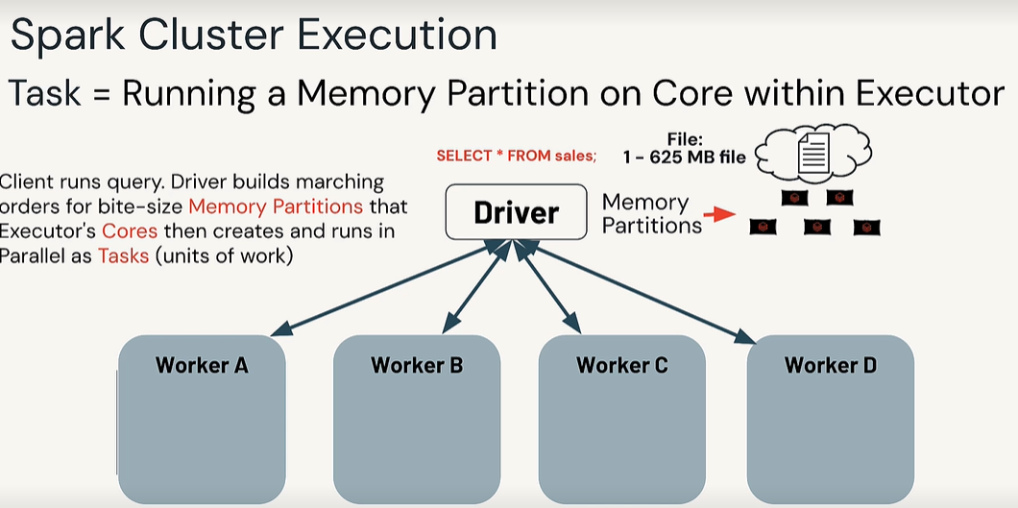

Driver takes files and puts it in ram. Because that is always faster. This is my automatic parallelism. Take one file and put it into 5 pieces in RAM and they are handed out to executor cores.

Each worker/JVM calls executor and each inside executor we have cores. These cores are nothing but threads of execution. Take 5 memory partitions, build them inside these cores where they can run tasks. Now I am running 5 times faster. It is automatic. Driver is going to take care of all that scheduling under the covers.

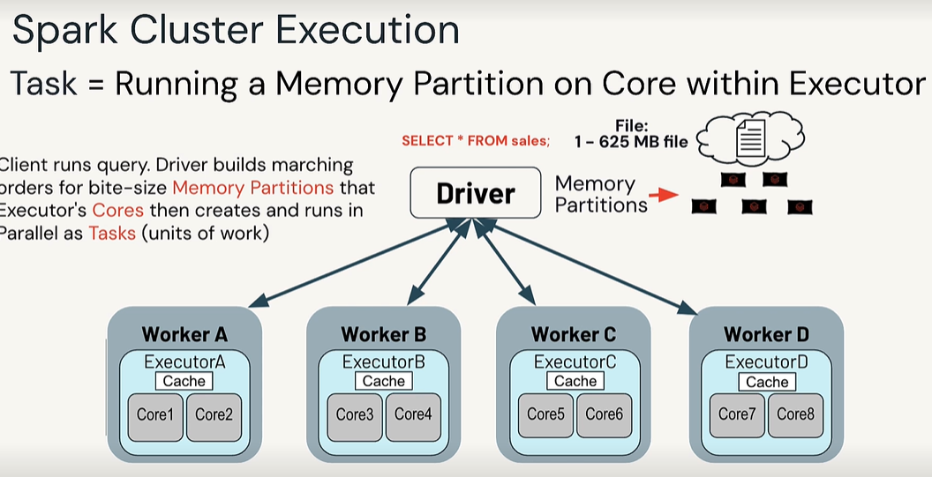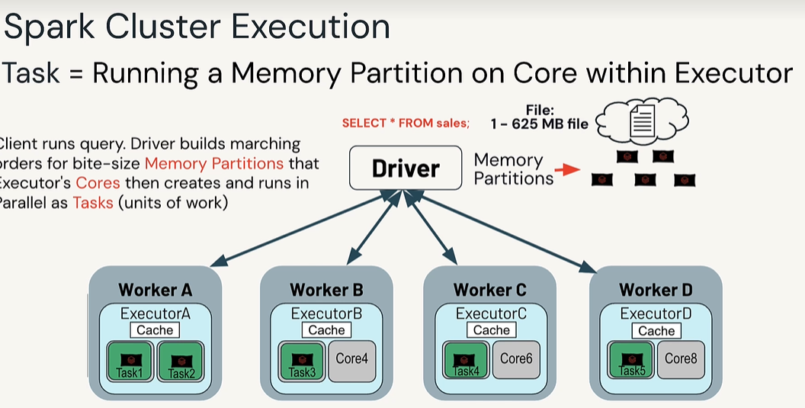

Spark is multi lingual

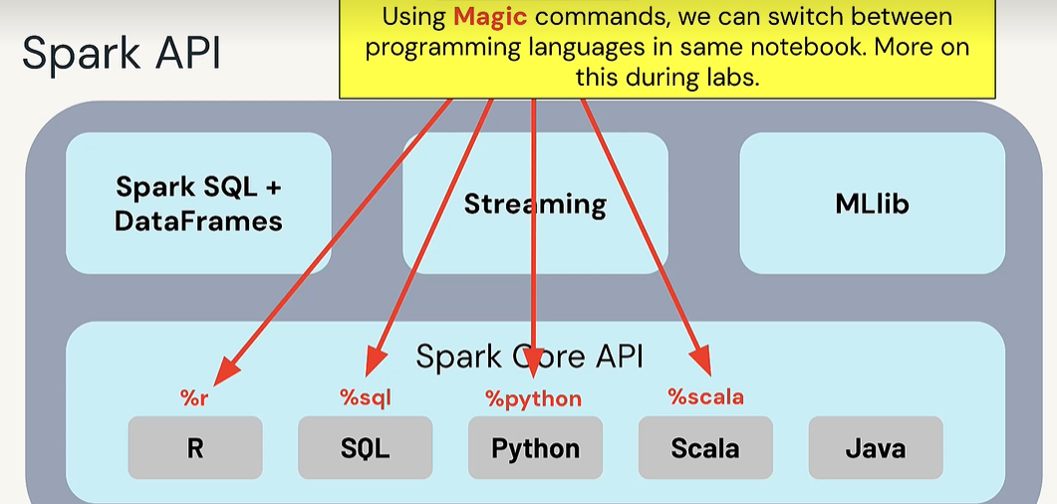

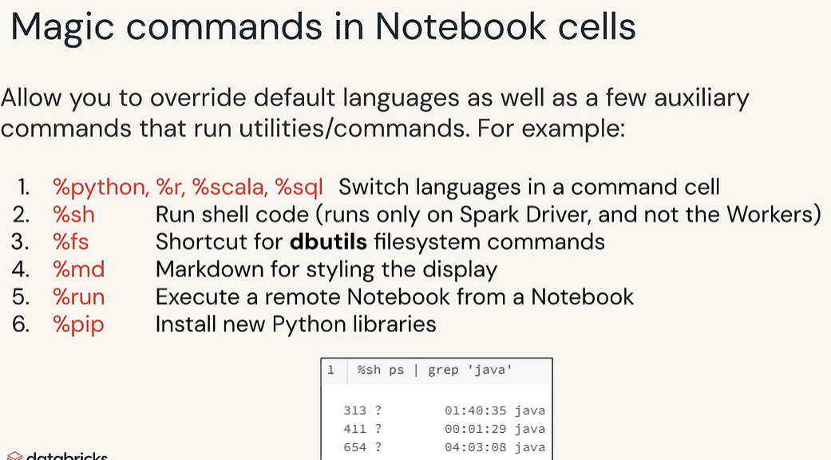

When we create sql views and tables you have to store metadata somewhere. What is the name of the tables, columns, data types etc managed or external. You use Hive or Unity Catalog.

Unity Catalog has its own metastore.

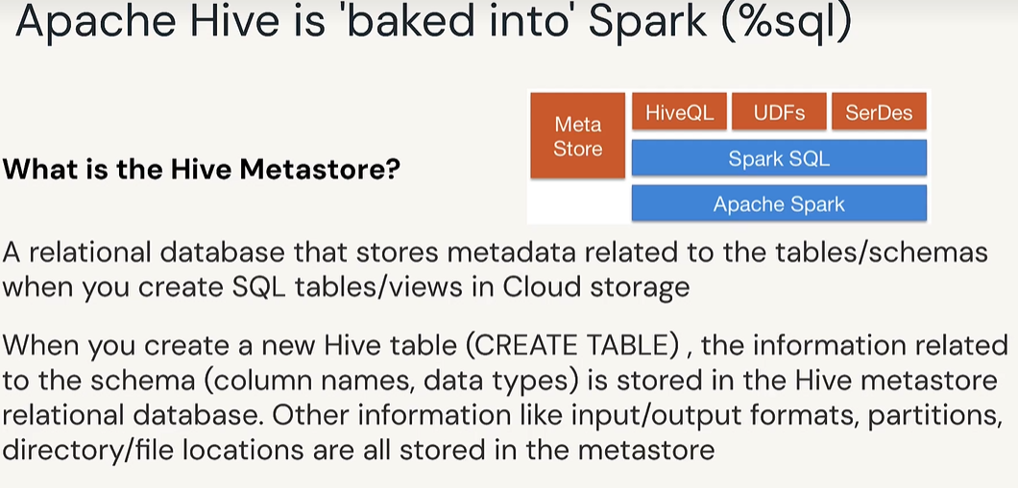

Spark is not a data warehouse, not a relational database, not a table based. Technically file based. Under Hive tables, we are pointed files only.

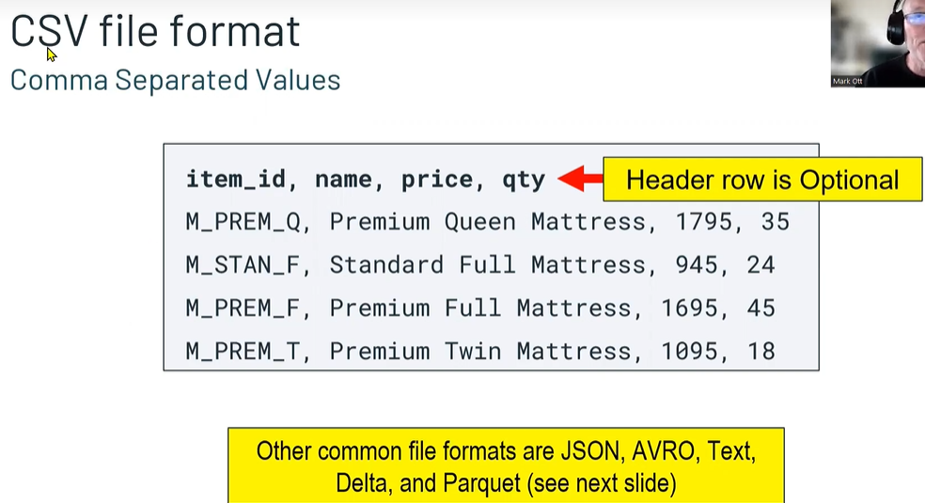

Two types of file formats

Row oriented like CSV, AVRO (Store things based on row wise basis)

Column oriented like parquet, Delta, ORC. (Store all names first, scores seconds all ids third). If I have 1000 columns in a file and I only need 3 columns in this case column oriented gives better performance.

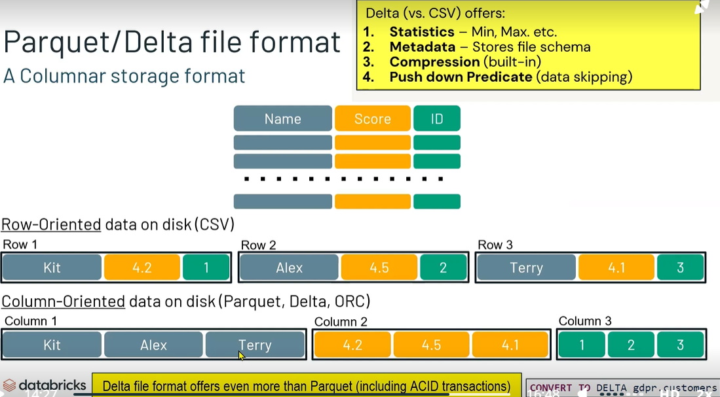

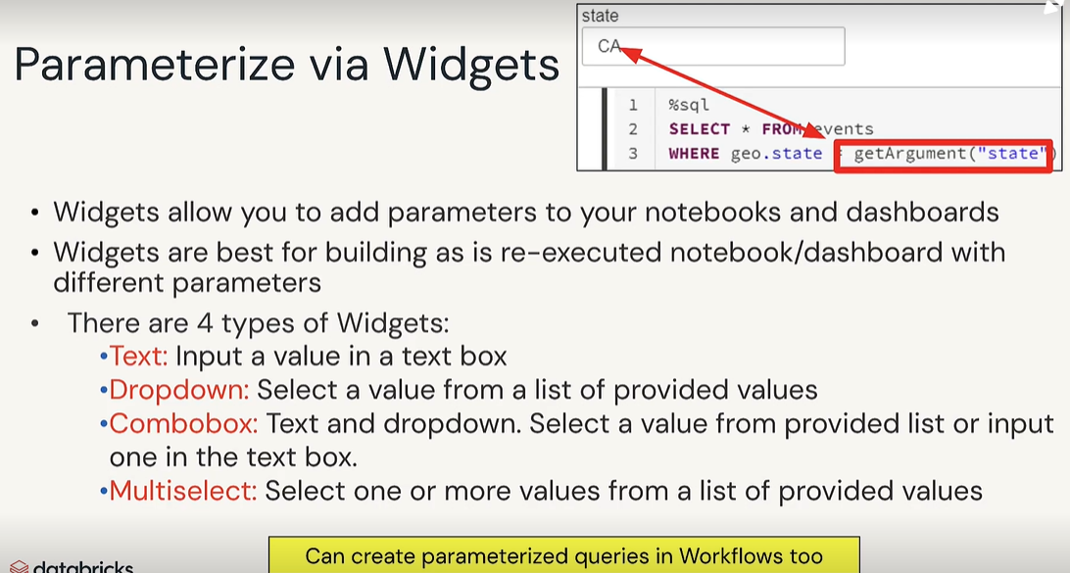

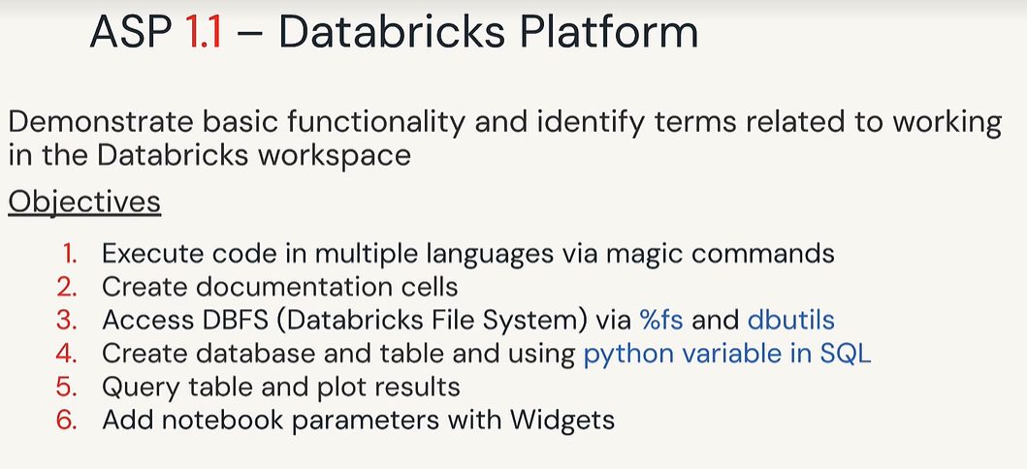

Spark SQL is a module inside spark. There are number of modules in spark. Streaming, ML, Spark SQL.

Spark SQL includes SQL table, Scala, Python languages, Dataframes

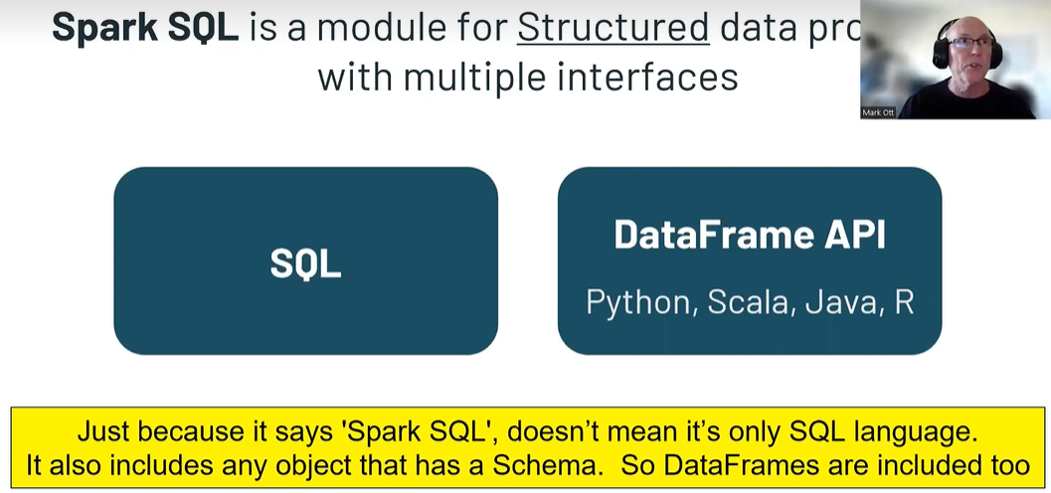

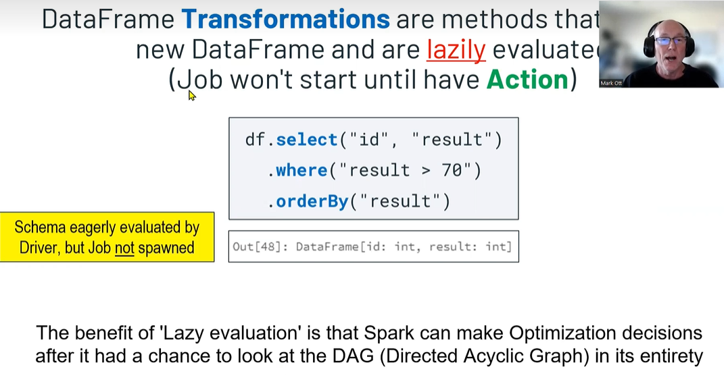

Green are actions

Blue words are transformations.

Transformations are nothing but manipulations of my object or dataframe to transform into something different. Creates new df

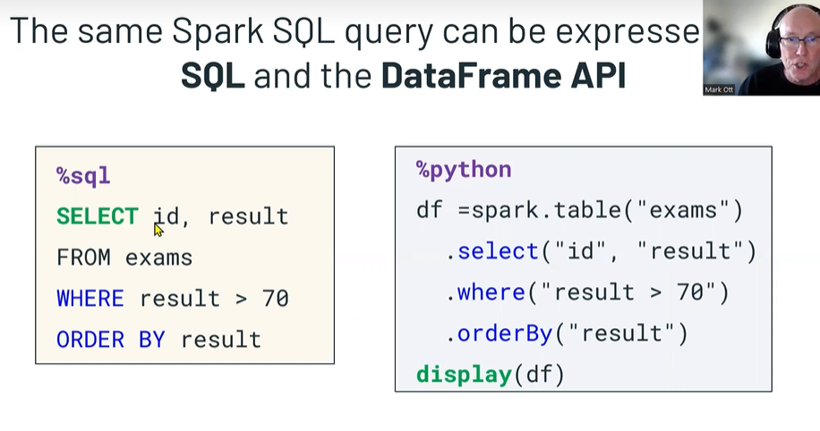

Actions are functions that start a job

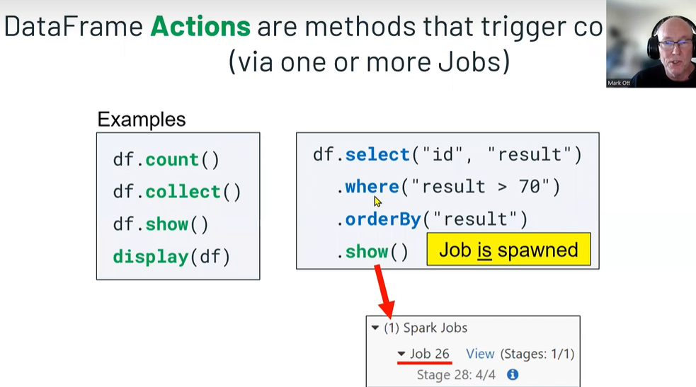

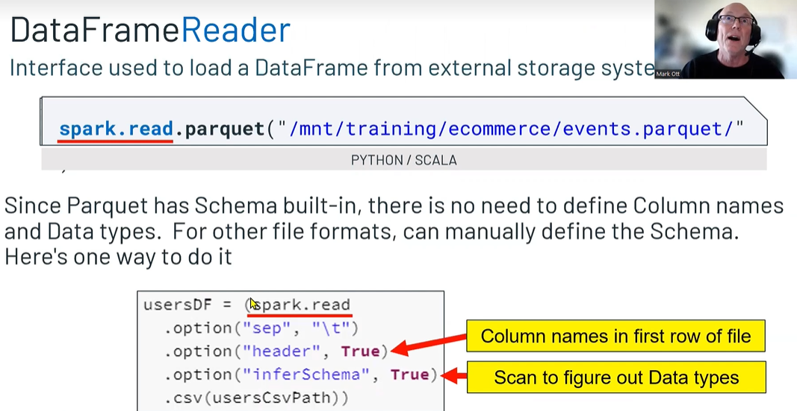

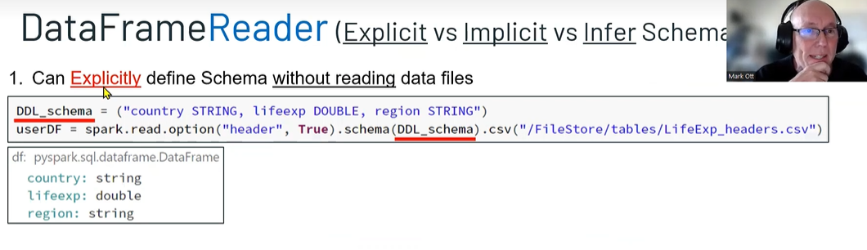

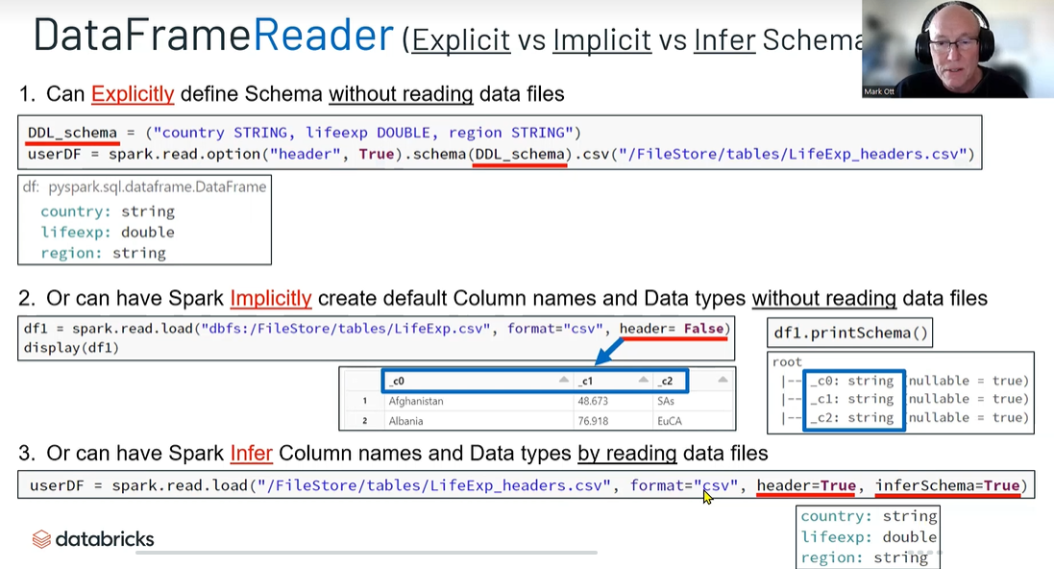

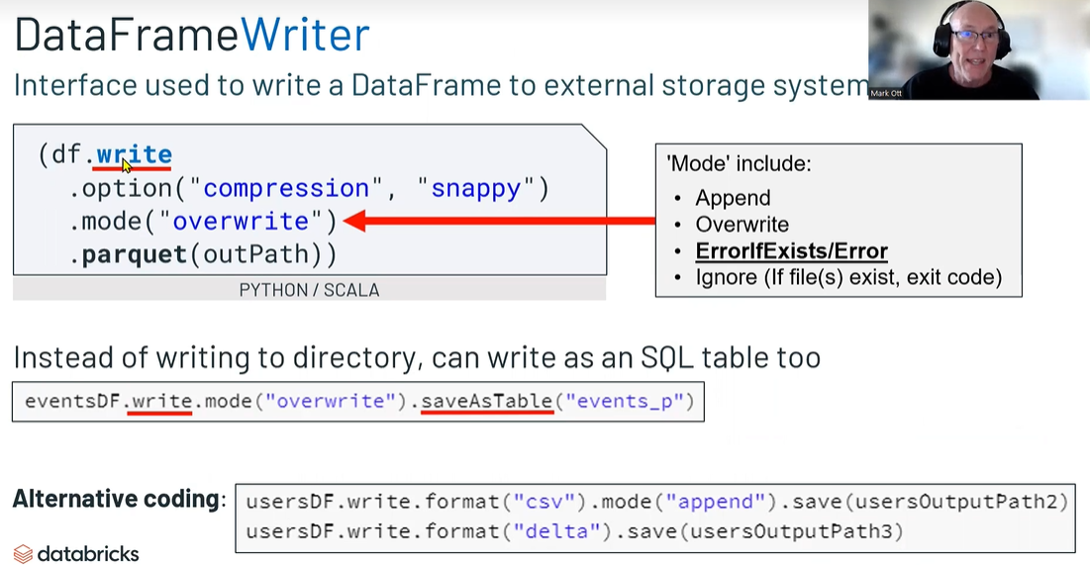

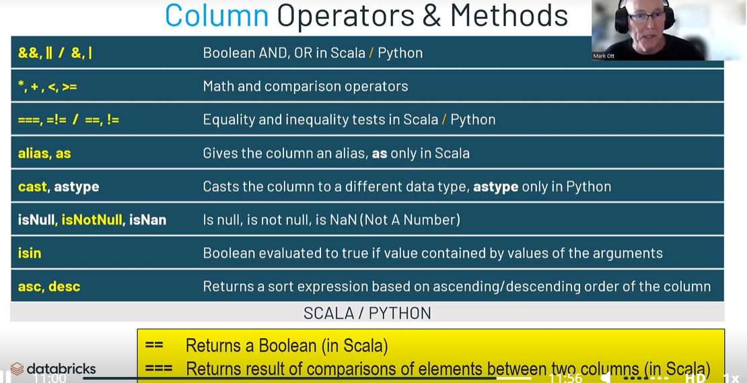

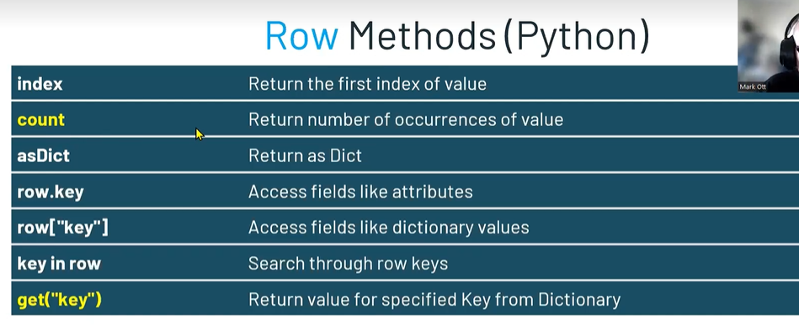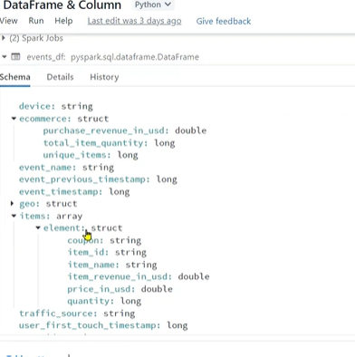

**Structs are nothing but parent and child column names**

**They are curley brackets**

**Array are in square brackets**

**3 Options how to code a column**

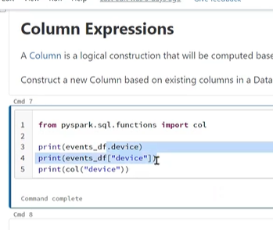

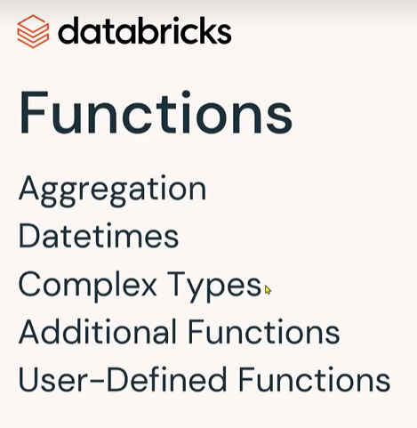

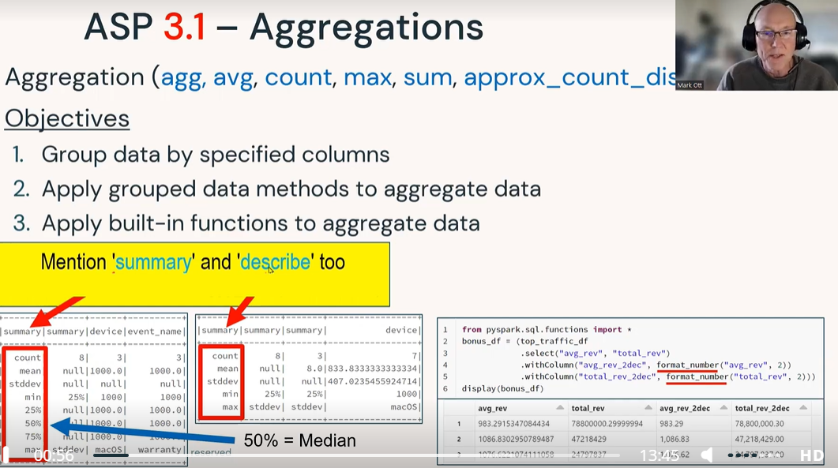

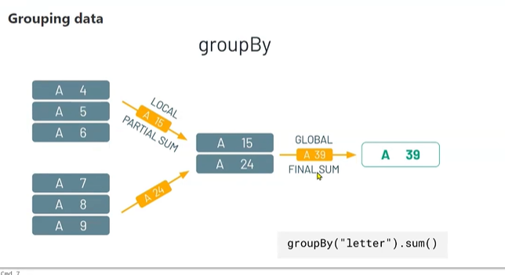

groupBy

**Use the DataFrame groupBy method to create a grouped data object.**

**This grouped data object is called RelationalGroupedDataset in Scala and GroupedData in Python.**

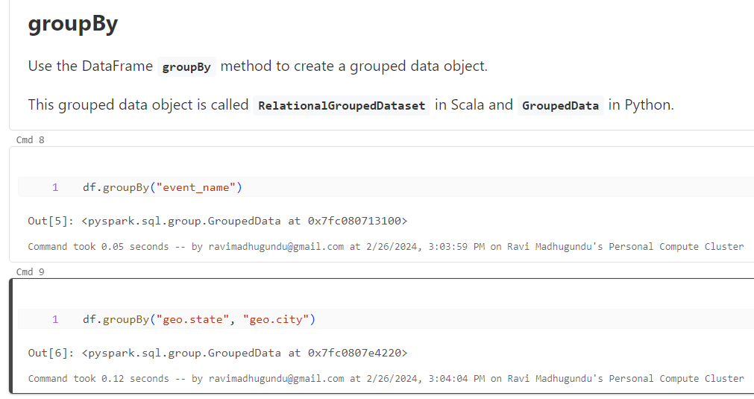

Grouped data methods

**Various aggregation methods are available on the** [**GroupedData**](https://spark.apache.org/docs/latest/api/python/reference/pyspark.sql/grouping.html) **object.**

|  |  |
| --- | --- |
| **Method** | **Description** |
| **agg** | **Compute aggregates by specifying a series of aggregate columns** |
| **avg** | **Compute the mean value for each numeric columns for each group** |
| **count** | **Count the number of rows for each group** |
| **max** | **Compute the max value for each numeric columns for each group** |
| **mean** | **Compute the average value for each numeric columns for each group** |
| **min** | **Compute the min value for each numeric column for each group** |
| **pivot** | **Pivots a column of the current DataFrame and performs the specified aggregation** |
| **sum** | **Compute the sum for each numeric columns for each group** |

**Group by aggreation always causes two stages. One is local and another one is Global.**

**Aggreation makes shuffle to happen**

**event_counts_df = df.groupBy("event_name").count()**

**display(event_counts_df)**

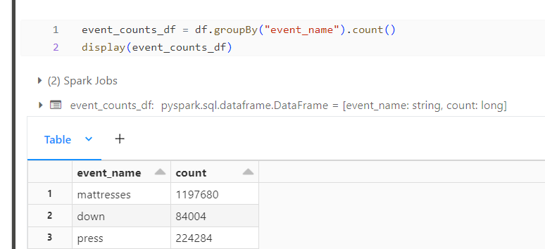

**Here, we're getting the average purchase revenue for each.**

**avg_state_purchases_df = df.groupBy("geo.state").avg("ecommerce.purchase_revenue_in_usd")**

**display(avg_state_purchases_df)**

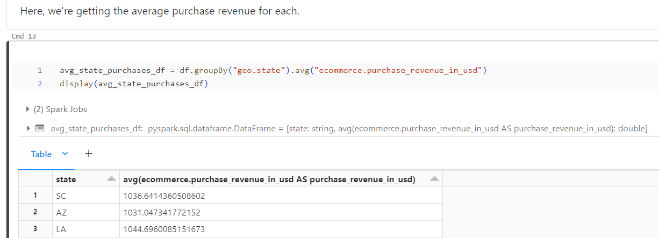

**And here the total quantity and sum of the purchase revenue for each combination of state and city.**

**city_purchase_quantities_df = df.groupBy("geo.state", "geo.city").sum("ecommerce.total_item_quantity", "ecommerce.purchase_revenue_in_usd")**

**display(city_purchase_quantities_df)**

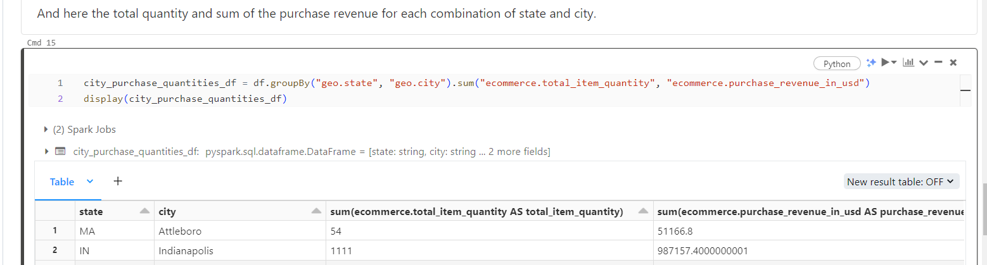

**from pyspark.sql.functions import sum**

**state_purchases_df = df.groupBy("geo.state").agg(sum("ecommerce.total_item_quantity").alias("total_purchases"))**

**display(state_purchases_df)**

**from pyspark.sql.functions import sum**

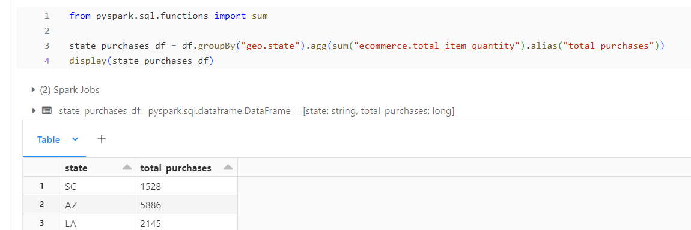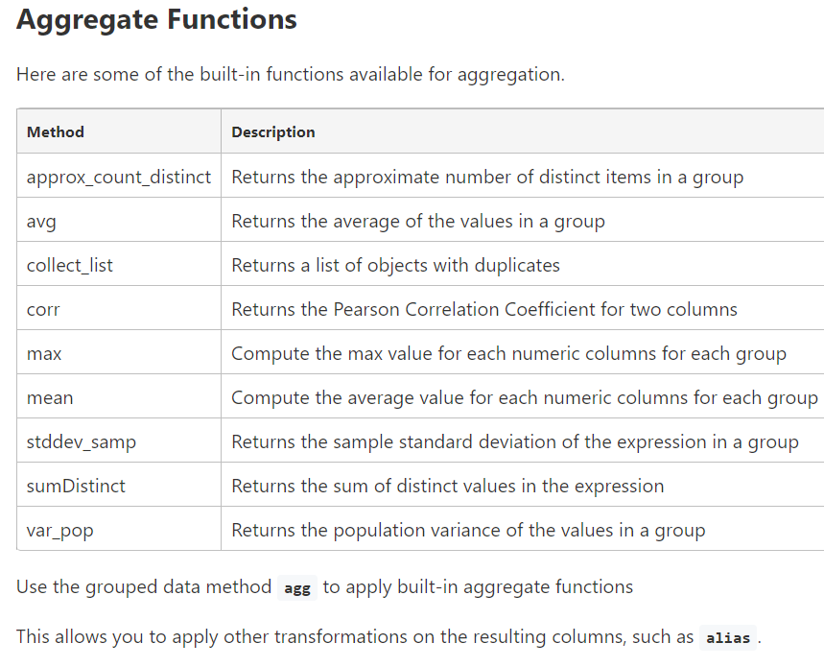

**Apply multiple aggregate functions on grouped data**

**from pyspark.sql.functions import avg, approx_count_distinct**

**state_aggregates_df = (df**

**.groupBy("geo.state")**

**.agg(avg("ecommerce.total_item_quantity").alias("avg_quantity"),**

**approx_count_distinct("user_id").alias("distinct_users"))**

**)**

**display(state_aggregates_df)**

**Agg is required because you used an alias method. Otherwise it is not required. Agg is also required when you do sum on one column and avg on other column. Agg is also required when you use collect_set and collect_list**

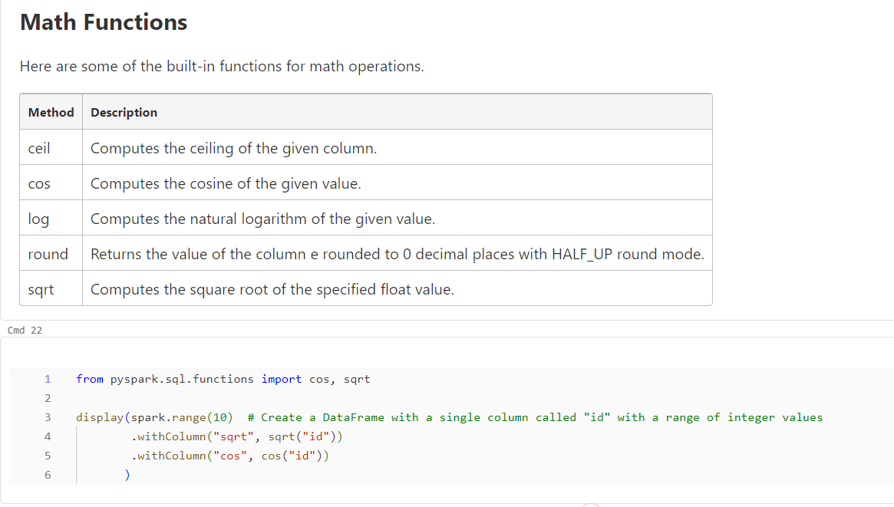

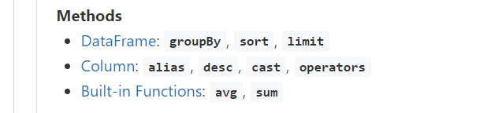

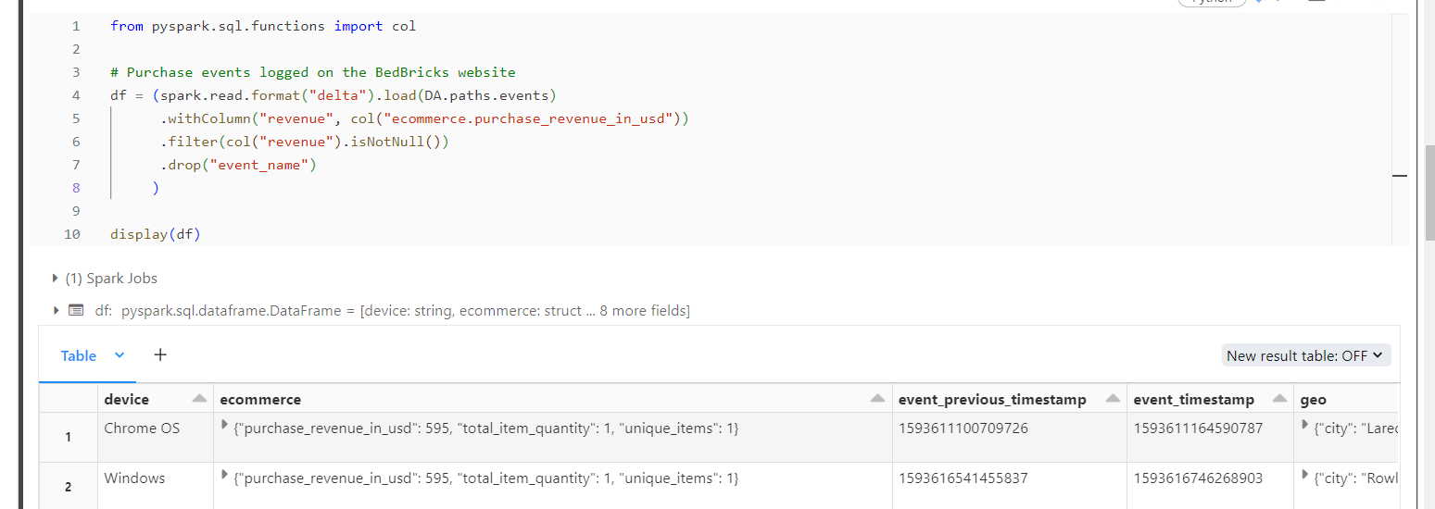

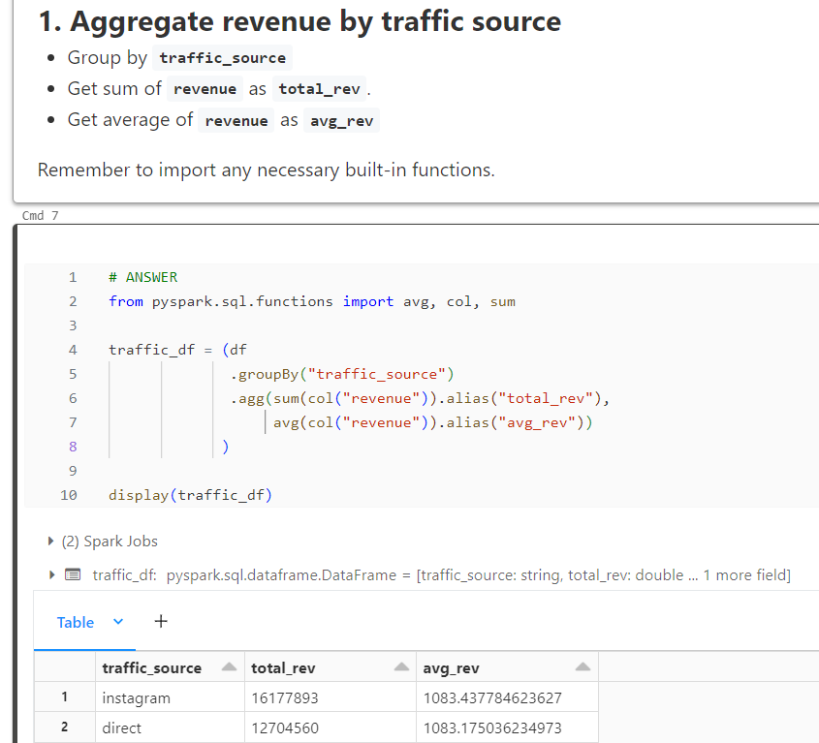

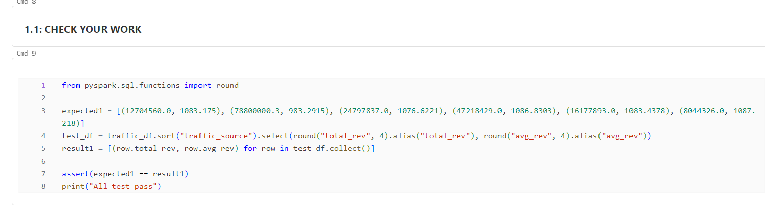

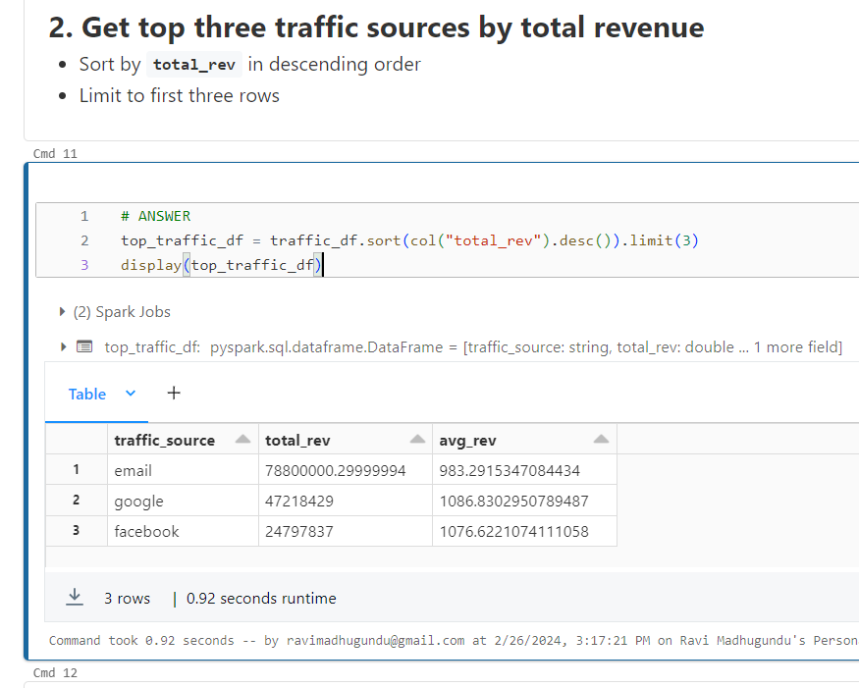

**CHECK YOUR WORK**

**expected2 = [(78800000.3, 983.2915), (47218429.0, 1086.8303), (24797837.0, 1076.6221)]**

**test_df = top_traffic_df.select(round("total_rev", 4).alias("total_rev"), round("avg_rev", 4).alias("avg_rev"))**

**result2 = [(row.total_rev, row.avg_rev) for row in test_df.collect()]**

**assert(expected2 == result2)**

**print("All test pass")**

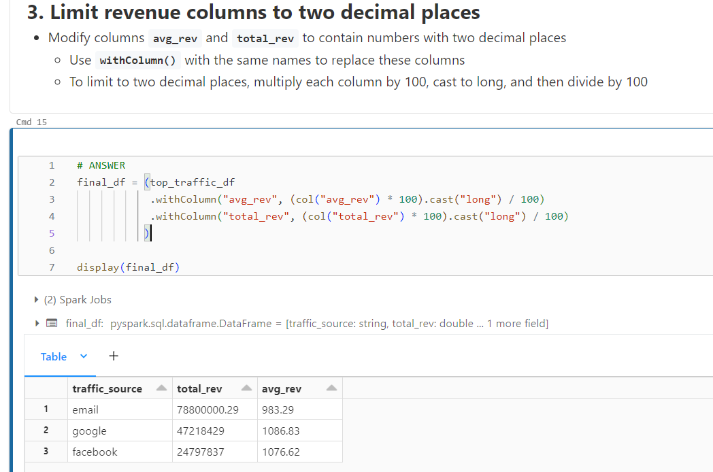

**CHECK YOUR WORK**

**expected3 = [(78800000.29, 983.29), (47218429.0, 1086.83), (24797837.0, 1076.62)]**

**result3 = [(row.total_rev, row.avg_rev) for row in final_df.collect()]**

**assert(expected3 == result3)**

**print("All test pass")**

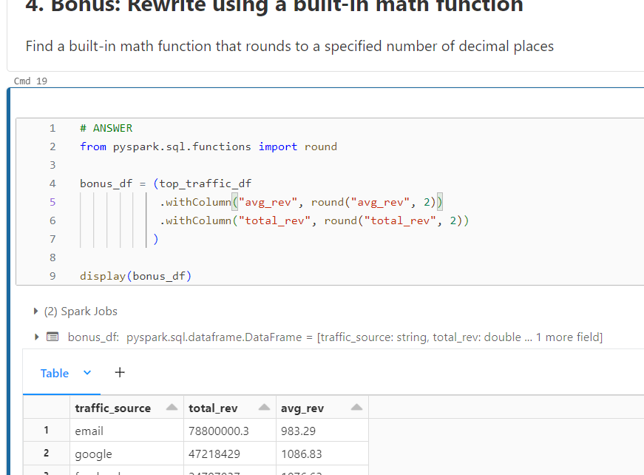

**CHECK YOUR WORK**

**expected4 = [(78800000.3, 983.29), (47218429.0, 1086.83), (24797837.0, 1076.62)]**

**result4 = [(row.total_rev, row.avg_rev) for row in bonus_df.collect()]**

**assert(expected4 == result4)**

**print("All test pass")**

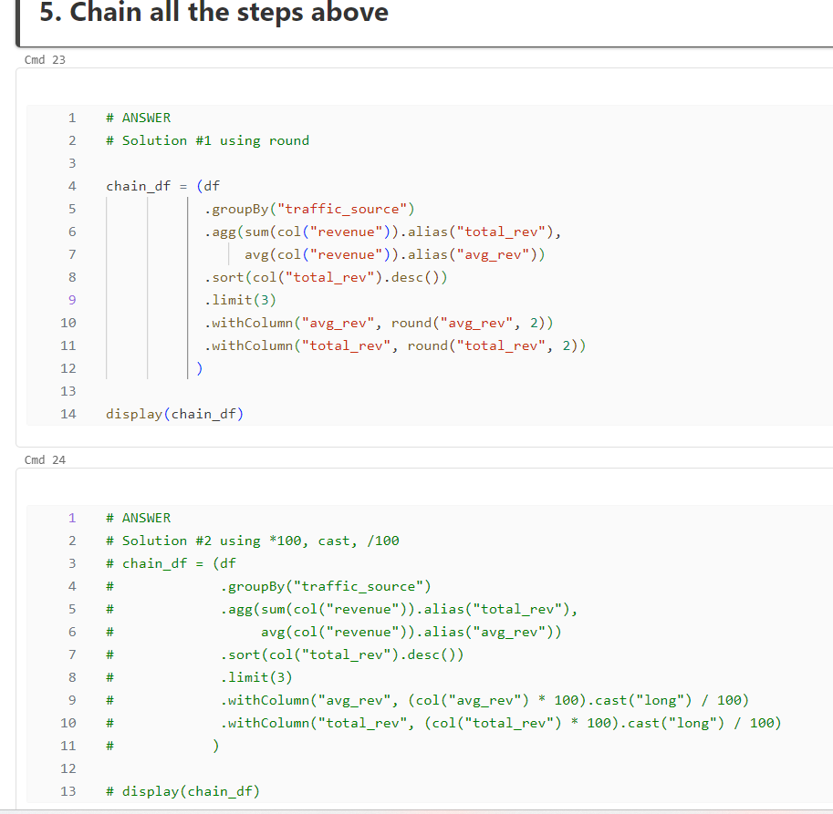

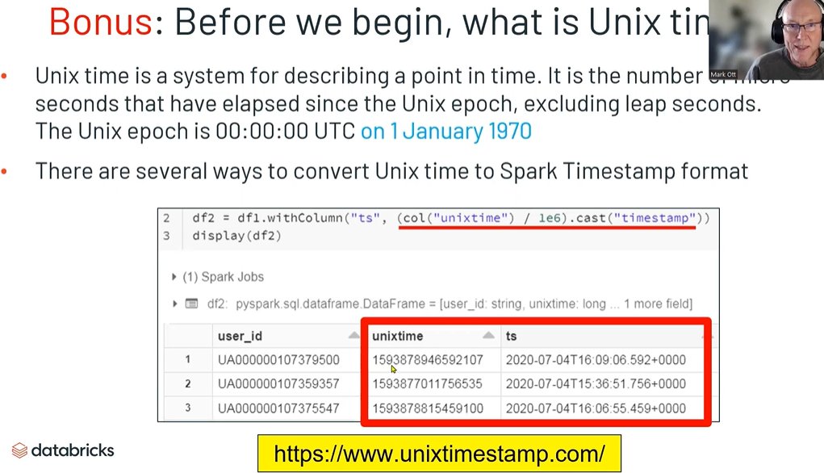

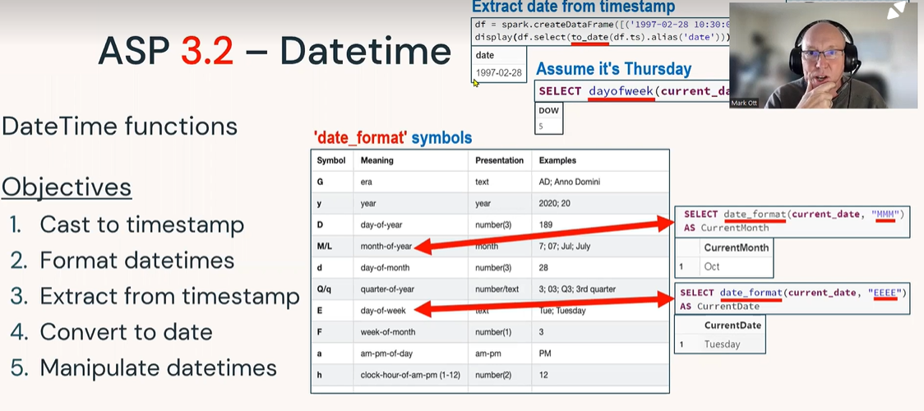

Methods

* [**Column**](https://spark.apache.org/docs/latest/api/python/reference/pyspark.sql/column.html)**: cast**
* [**Built-In Functions**](https://spark.apache.org/docs/latest/api/python/reference/pyspark.sql/functions.html#datetime-functions)**: date_format, to_date, date_add, year, month, dayofweek, minute, second**

**from pyspark.sql.functions import col**

**df = spark.read.format("delta").load(DA.paths.events).select("user_id", col("event_timestamp").alias("timestamp"))**

**display(df)**

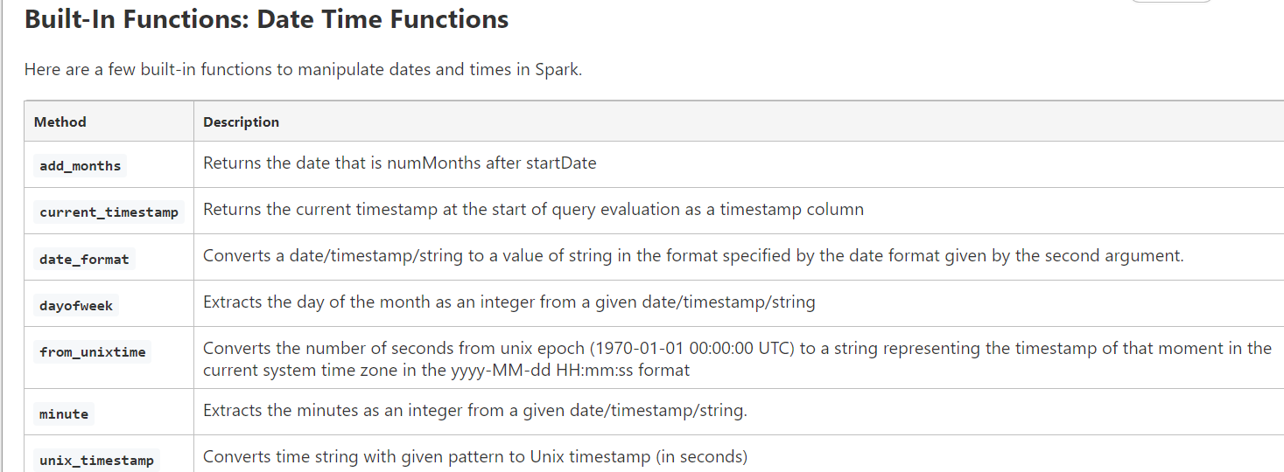

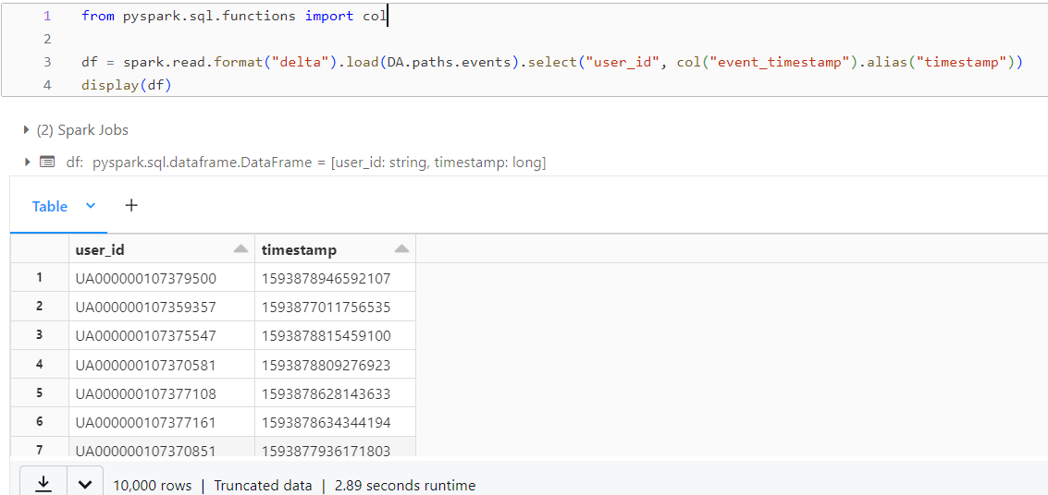

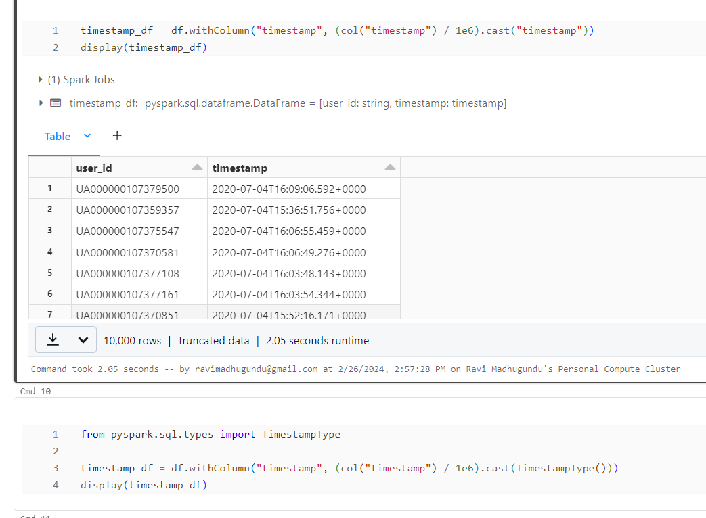

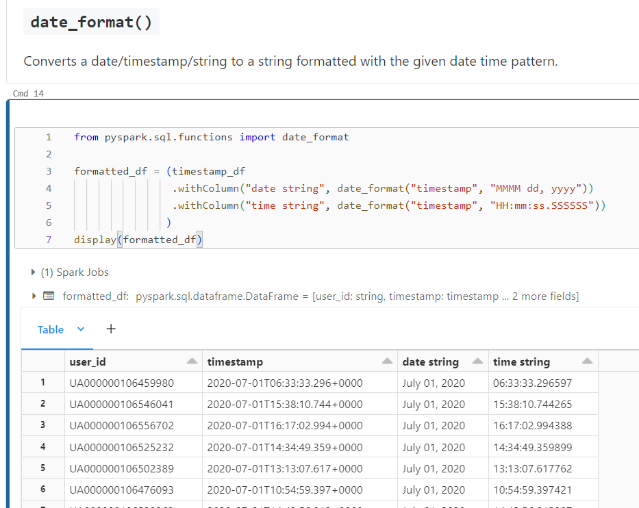

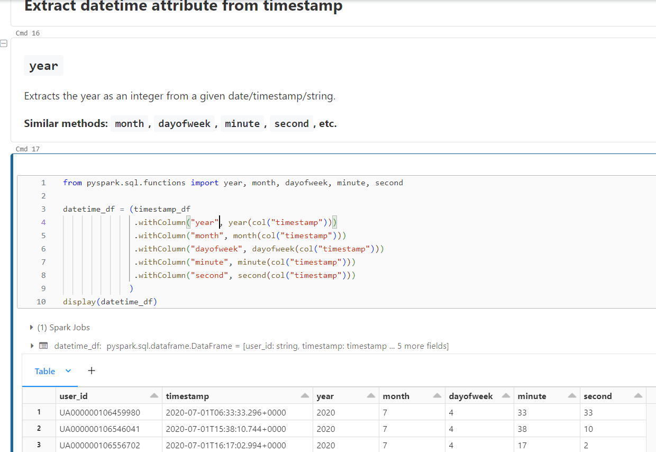

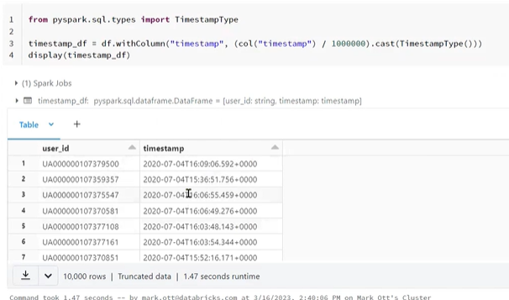

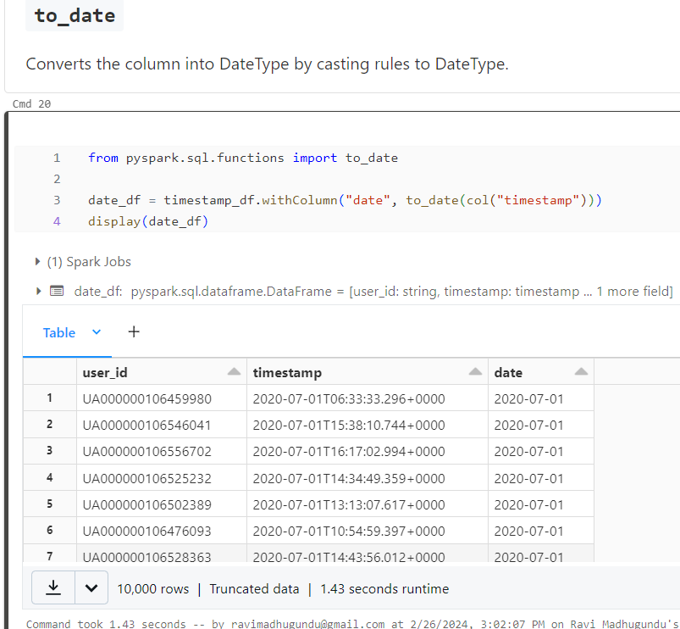

**from pyspark.sql.functions import date_add**

**plus_2_df = timestamp_df.withColumn("plus_two_days", date_add(col("timestamp"), 2))**

**display(plus_2_df)**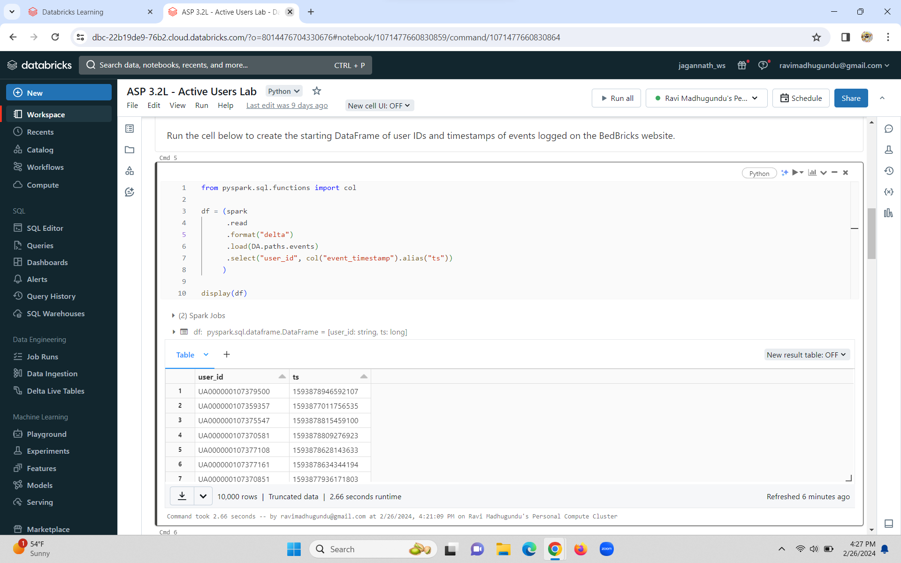

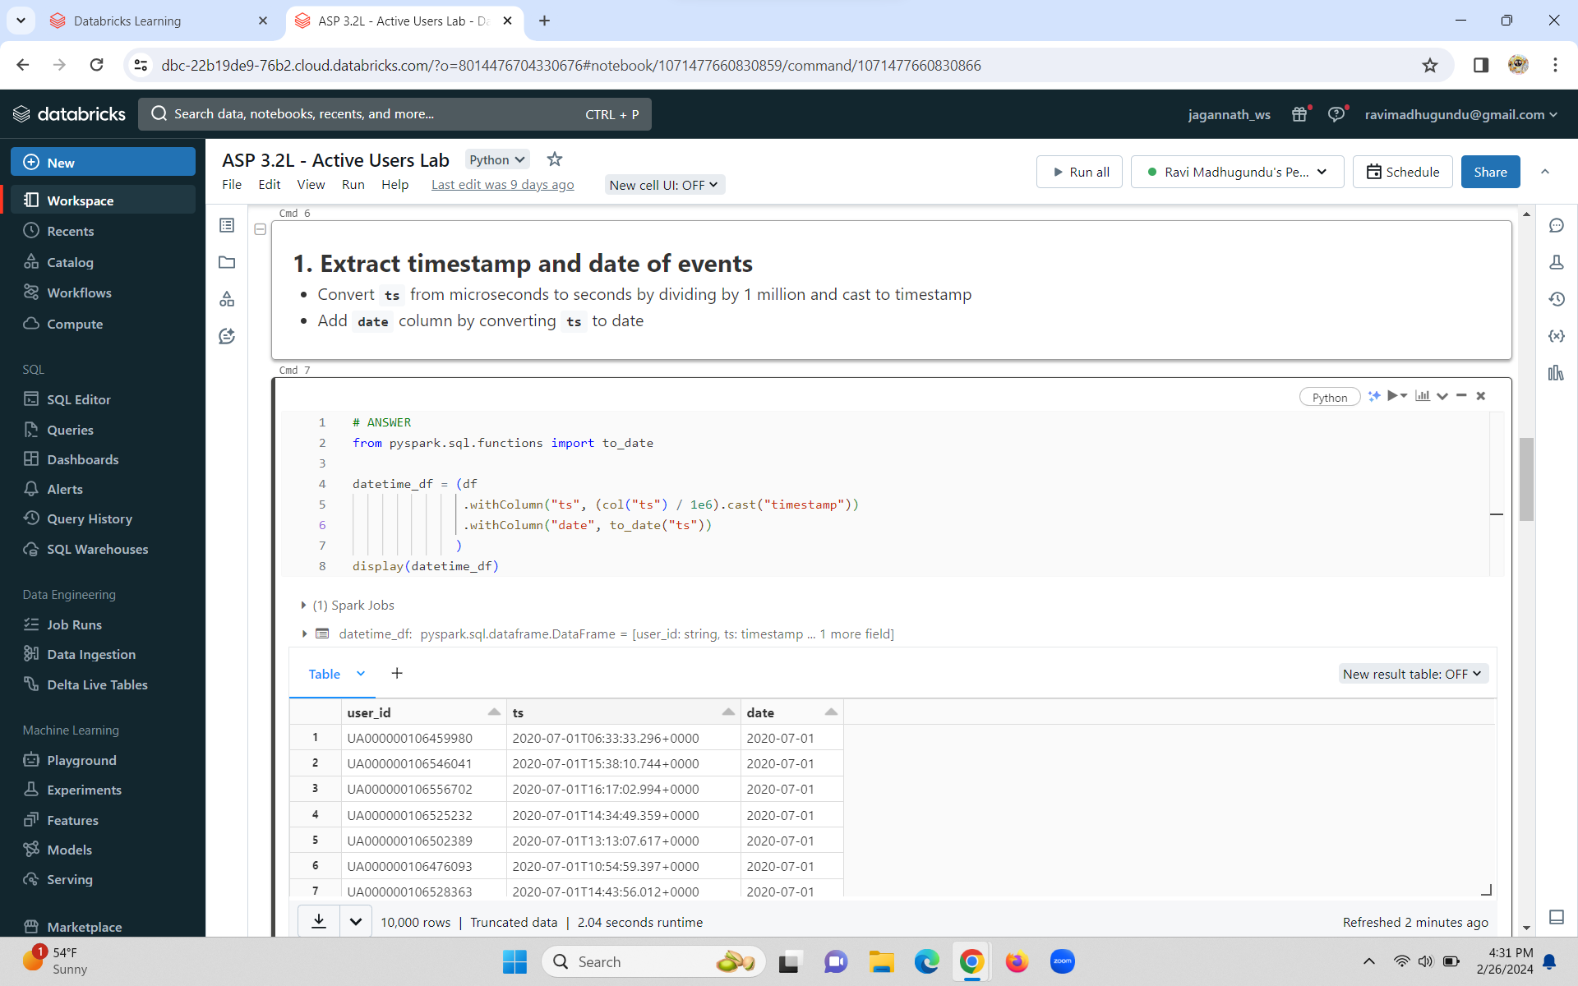

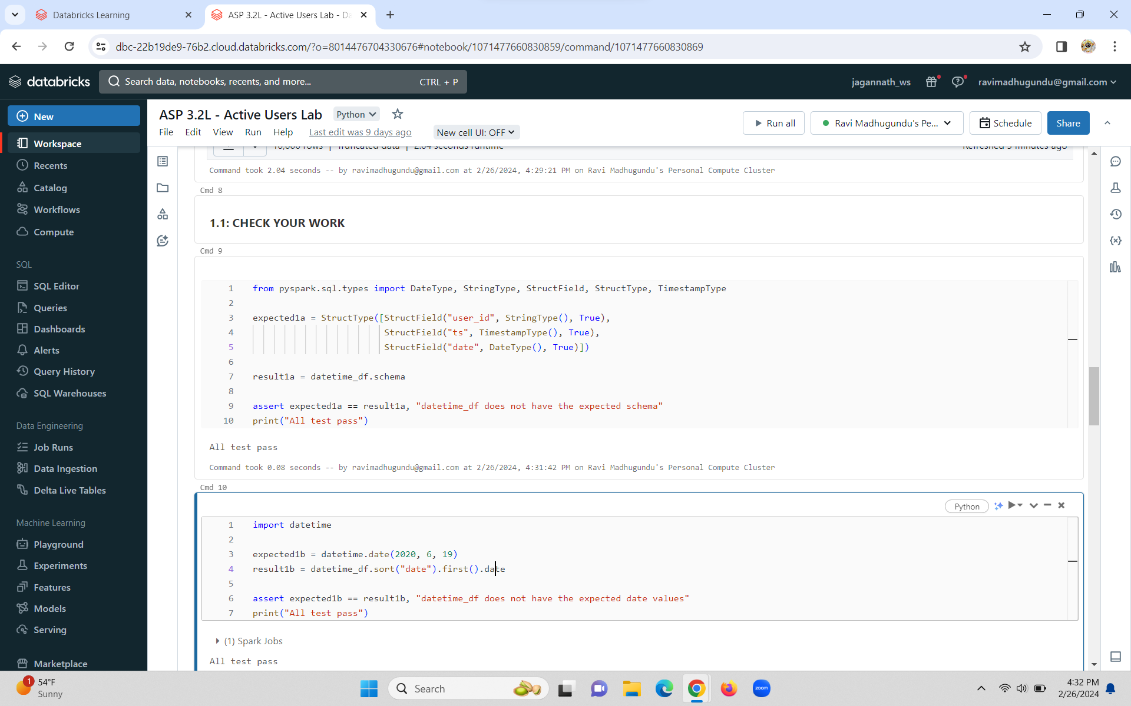

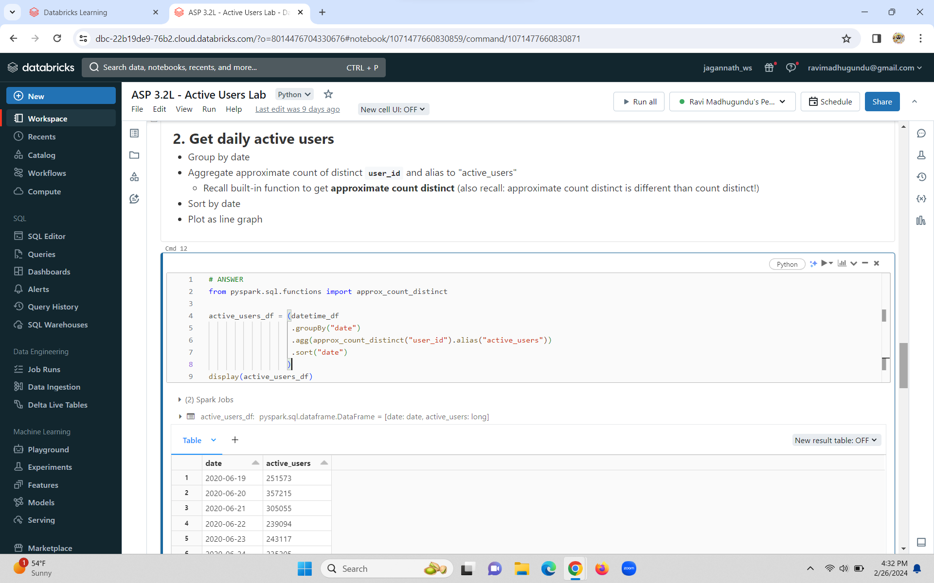

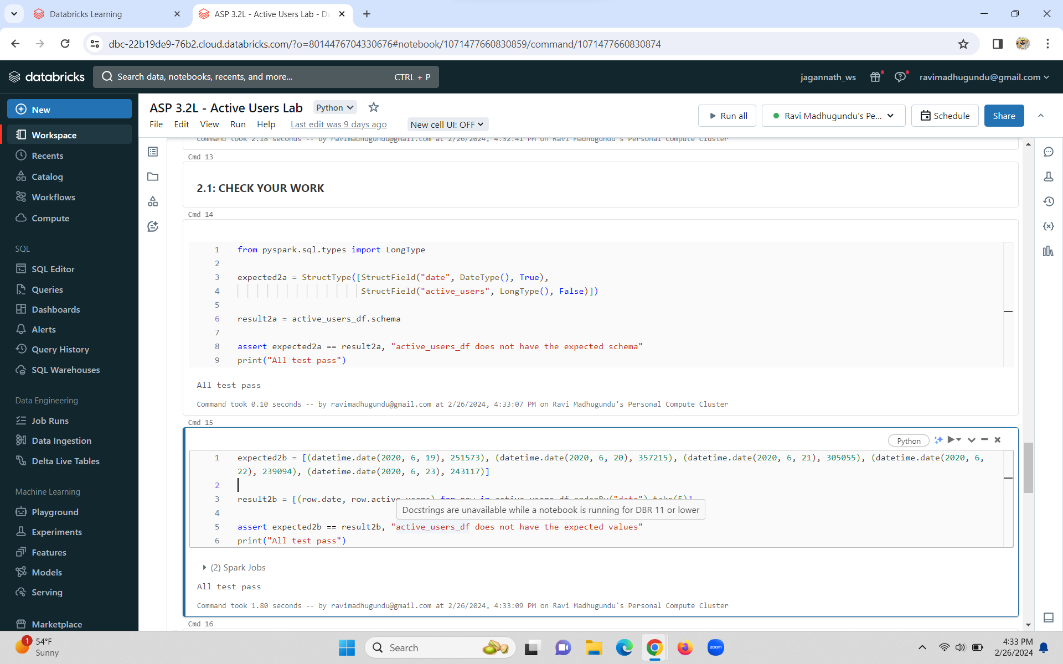

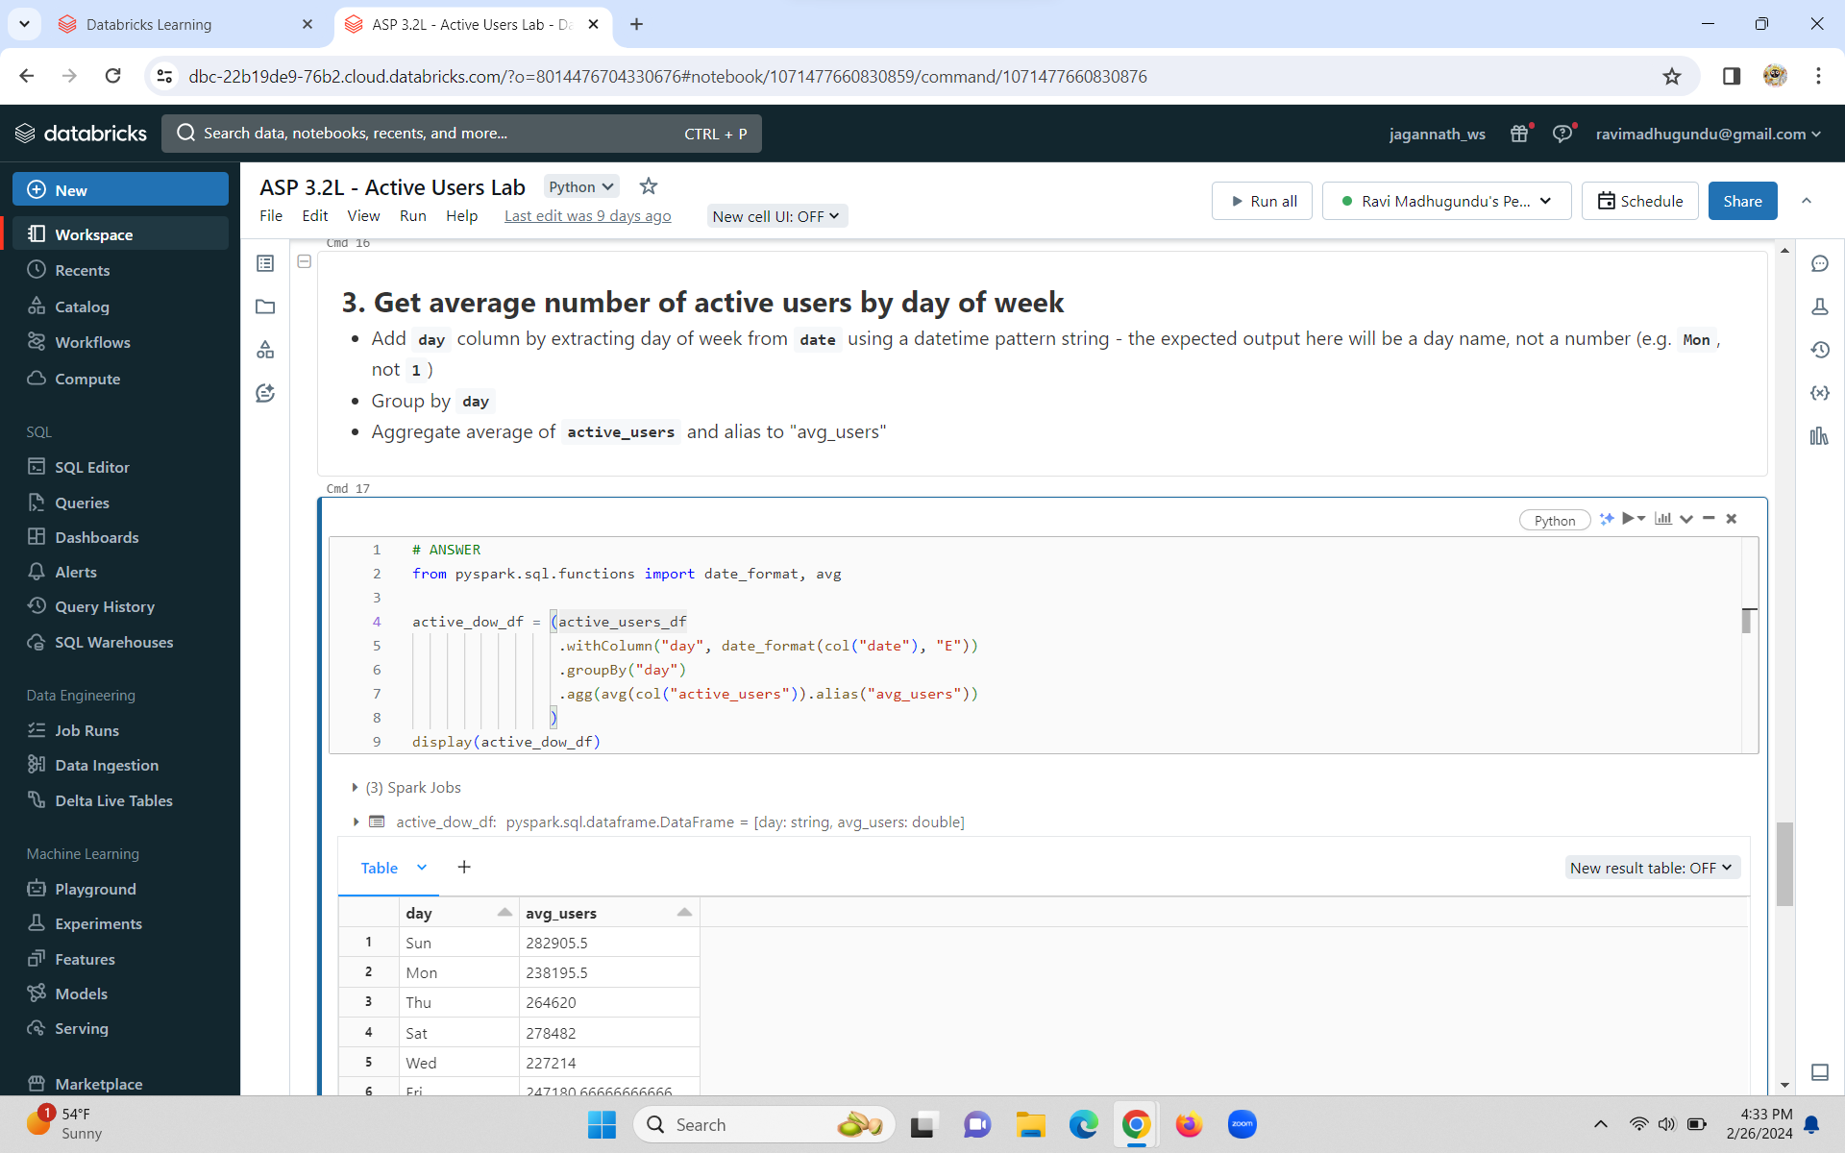

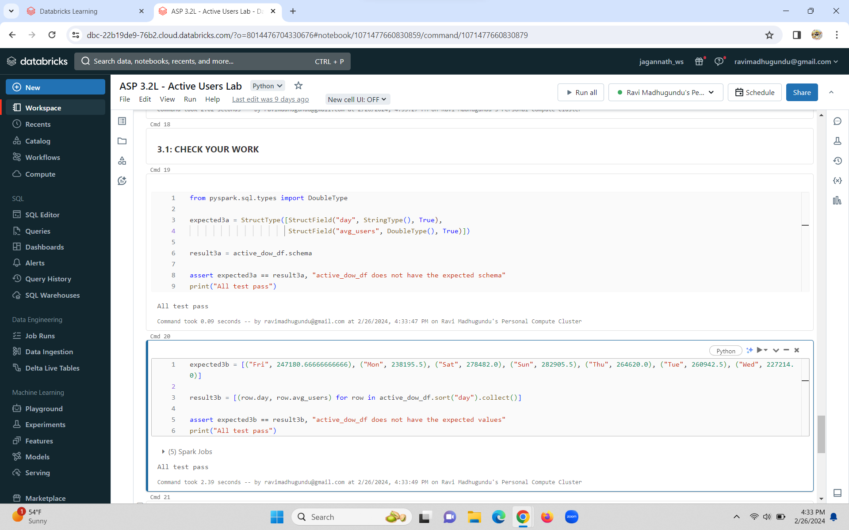

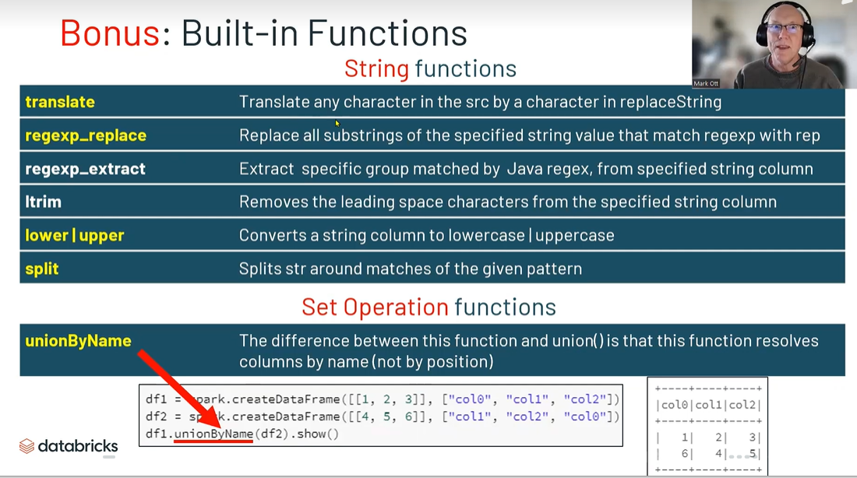

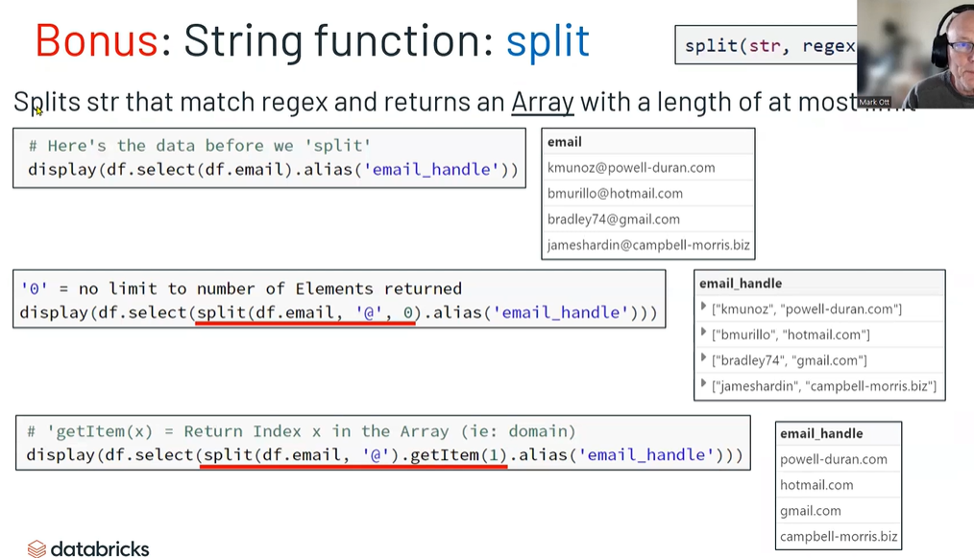

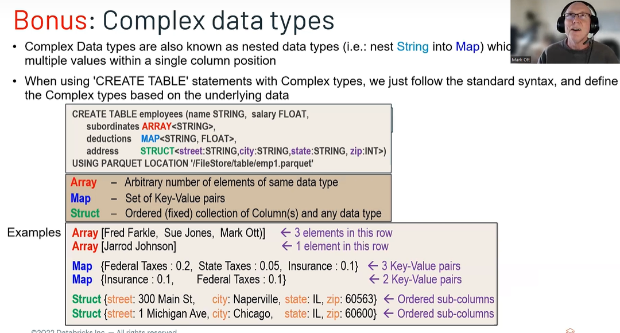

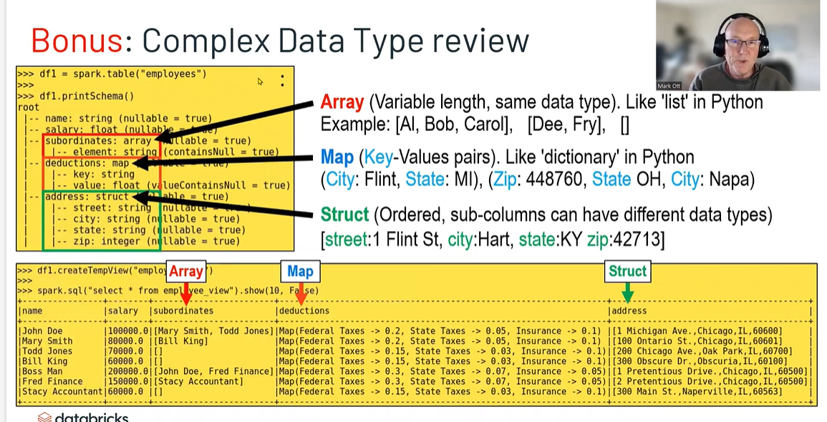

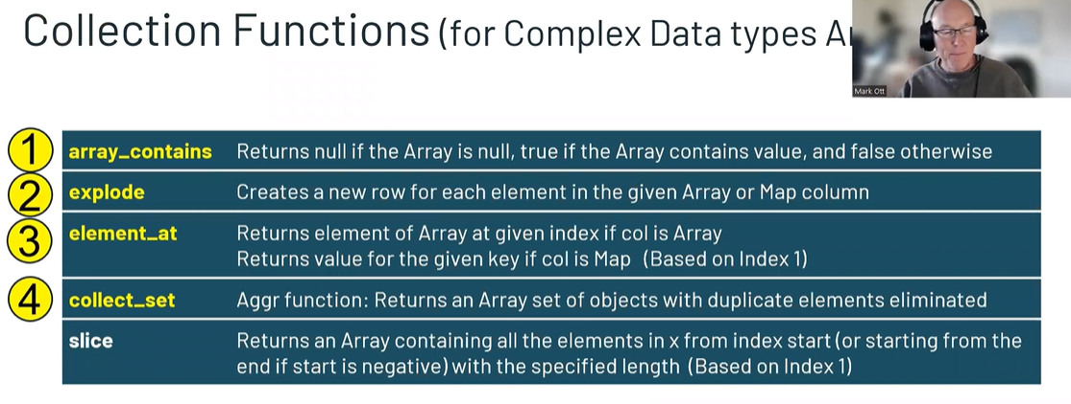

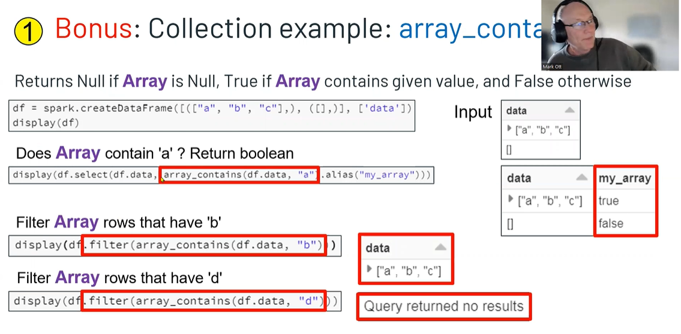

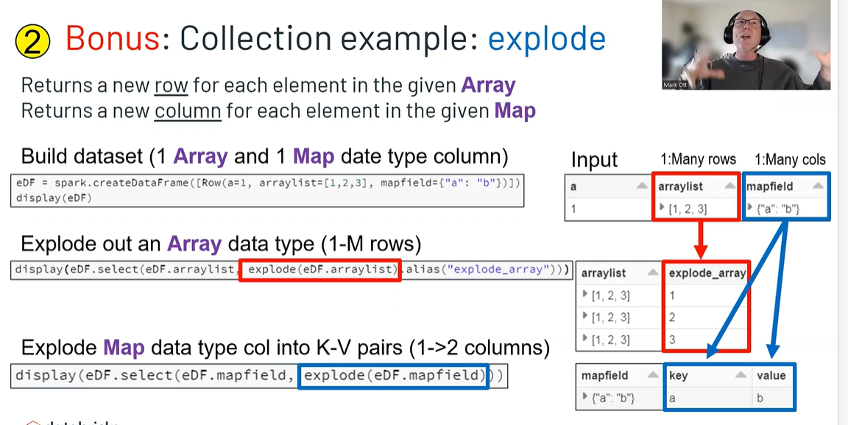

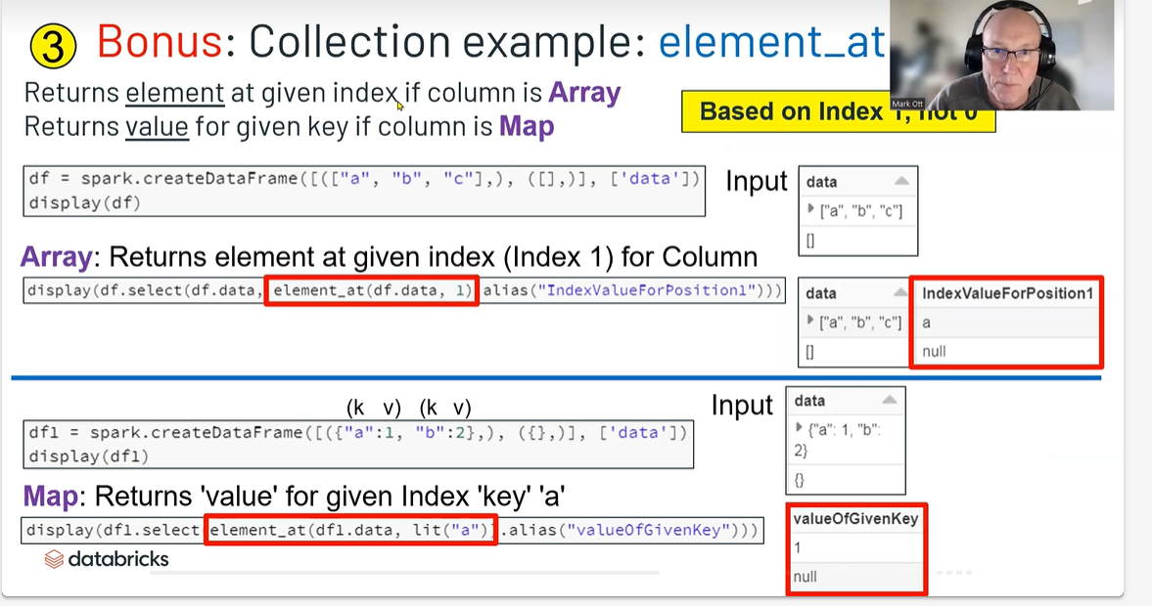

Complex Types

**Explore built-in functions for working with collections and strings.**

Objectives

1. **Apply collection functions to process arrays**
2. **Union DataFrames together**

Methods

* [**DataFrame**](https://spark.apache.org/docs/latest/api/python/reference/pyspark.sql/dataframe.html)**:union, unionByName**
* [**Built-In Functions**](https://spark.apache.org/docs/latest/api/python/reference/pyspark.sql/functions.html)**:**
  + **Aggregate: collect_set**
  + **Collection: array_contains, element_at, explode**
  + 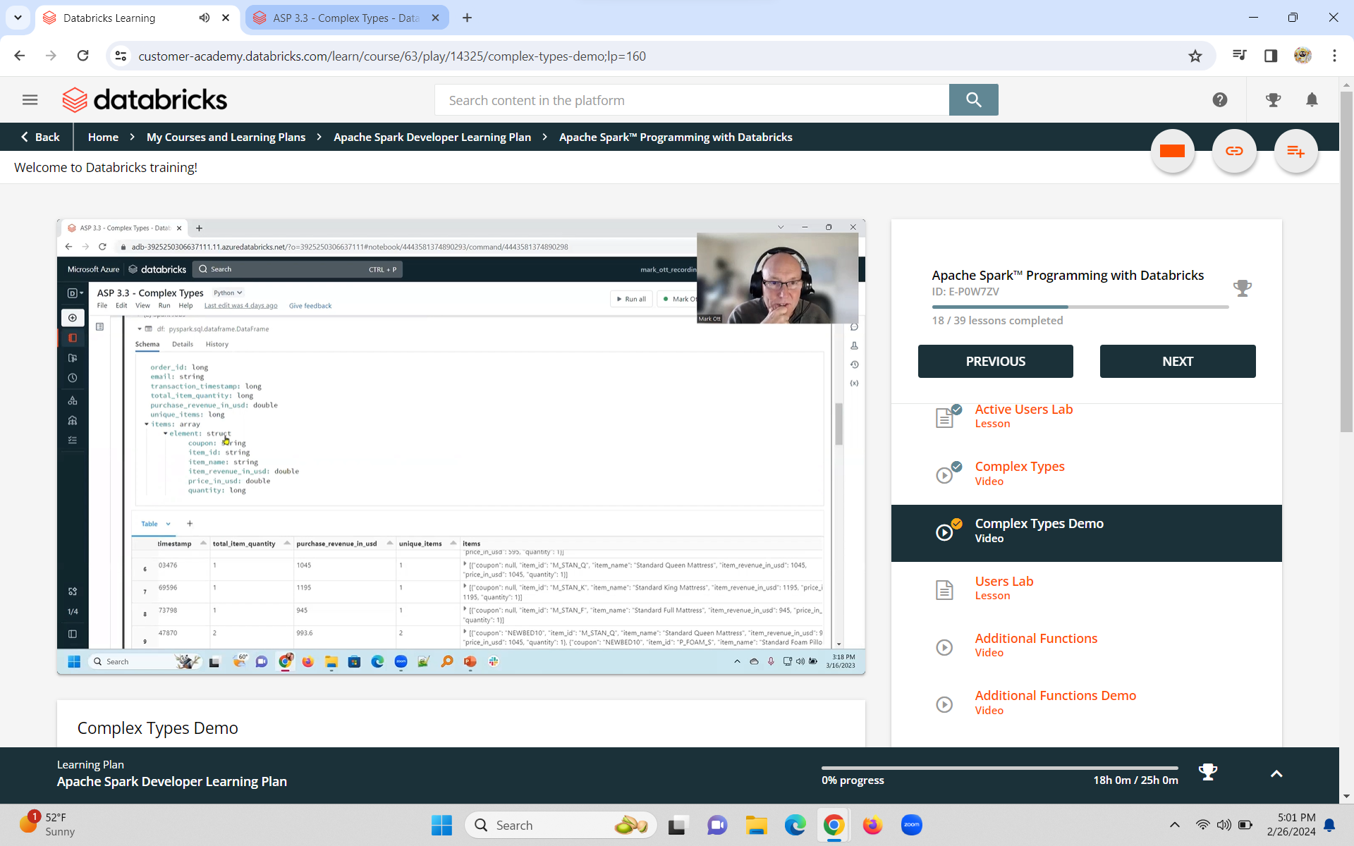**String: split**
  + 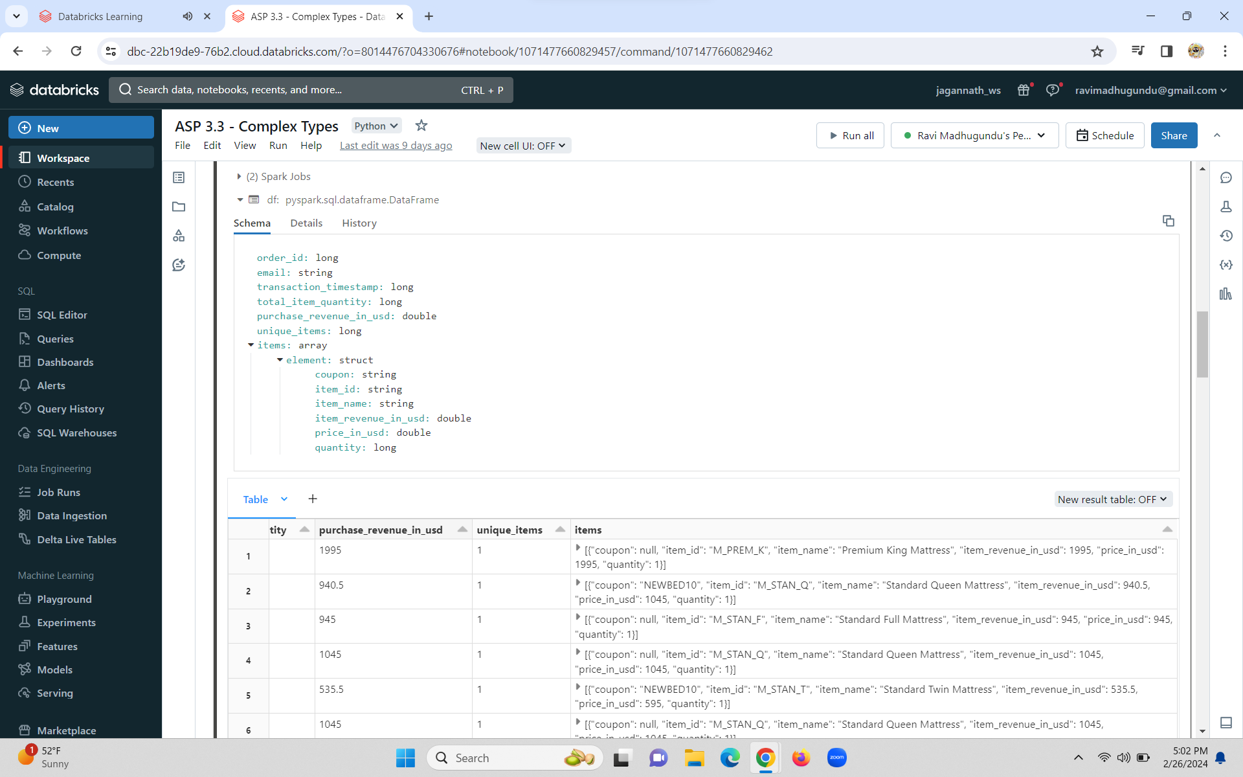
  + 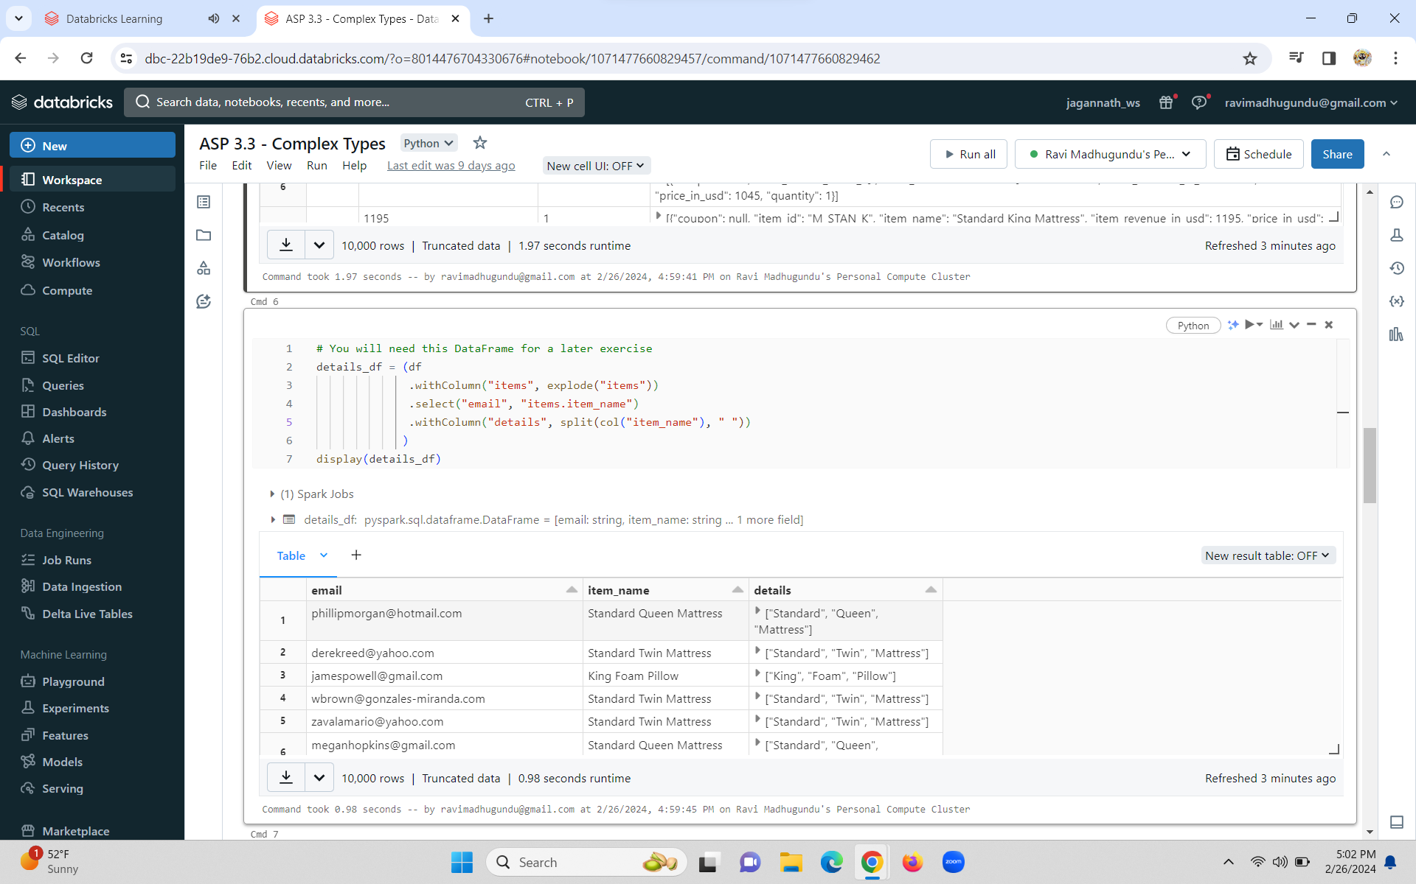
  + String Functions
  + **Here are some of the built-in functions available for manipulating strings.**

|  |  |
| --- | --- |
| **Method** | **Description** |
| **translate** | **Translate any character in the src by a character in replaceString** |
| **regexp_replace** | **Replace all substrings of the specified string value that match regexp with rep** |
| **regexp_extract** | **Extract a specific group matched by a Java regex, from the specified string column** |
| **ltrim** | **Removes the leading space characters from the specified string column** |
| **lower** | **Converts a string column to lowercase** |
| **split** | **Splits str around matches of the given pattern** |

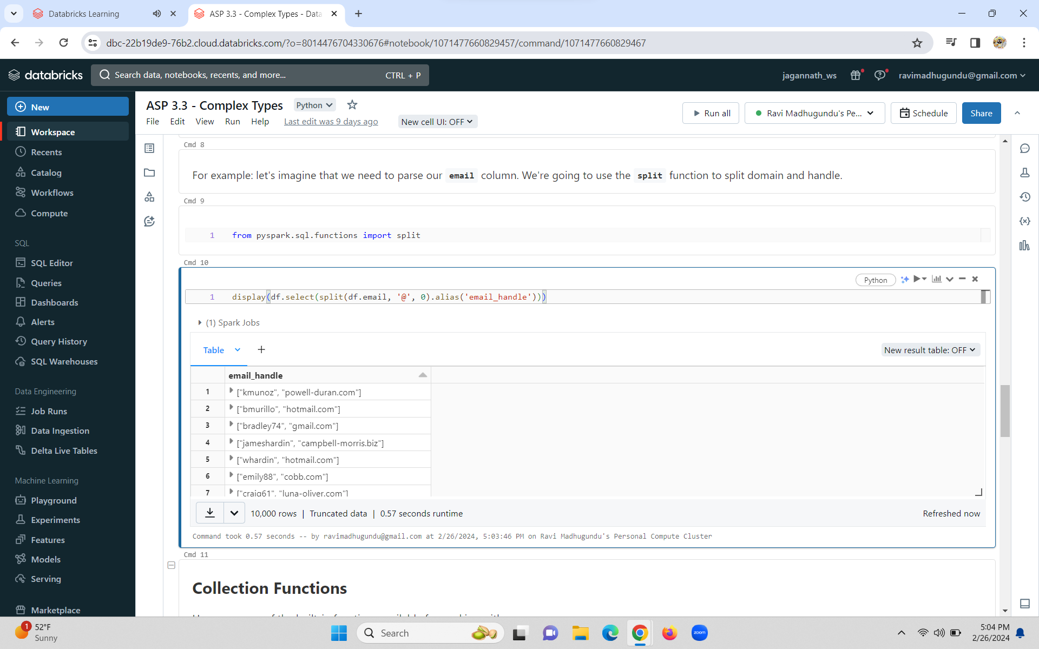

Collection Functions

**Here are some of the built-in functions available for working with arrays.**

|  |  |
| --- | --- |
| **Method** | **Description** |
| **array_contains** | **Returns null if the array is null, true if the array contains value, and false otherwise.** |
| **element_at** | **Returns element of array at given index. Array elements are numbered starting with 1.** |
| **explode** | **Creates a new row for each element in the given array or map column.** |
| **collect_set** | **Returns a set of objects with duplicate elements eliminated.** |

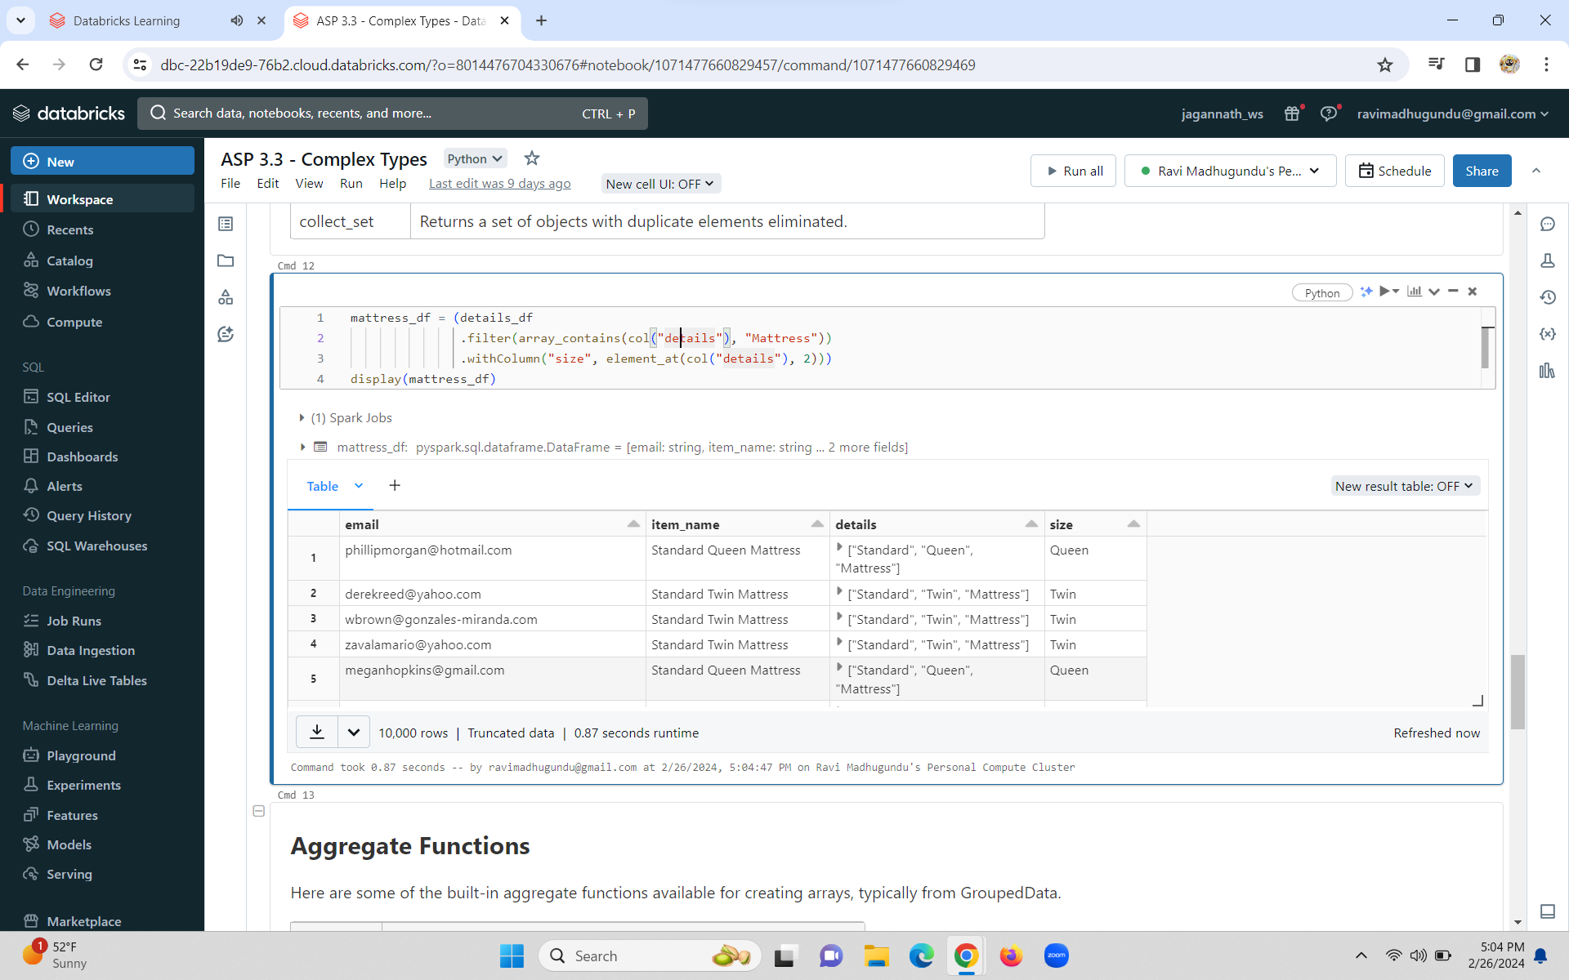

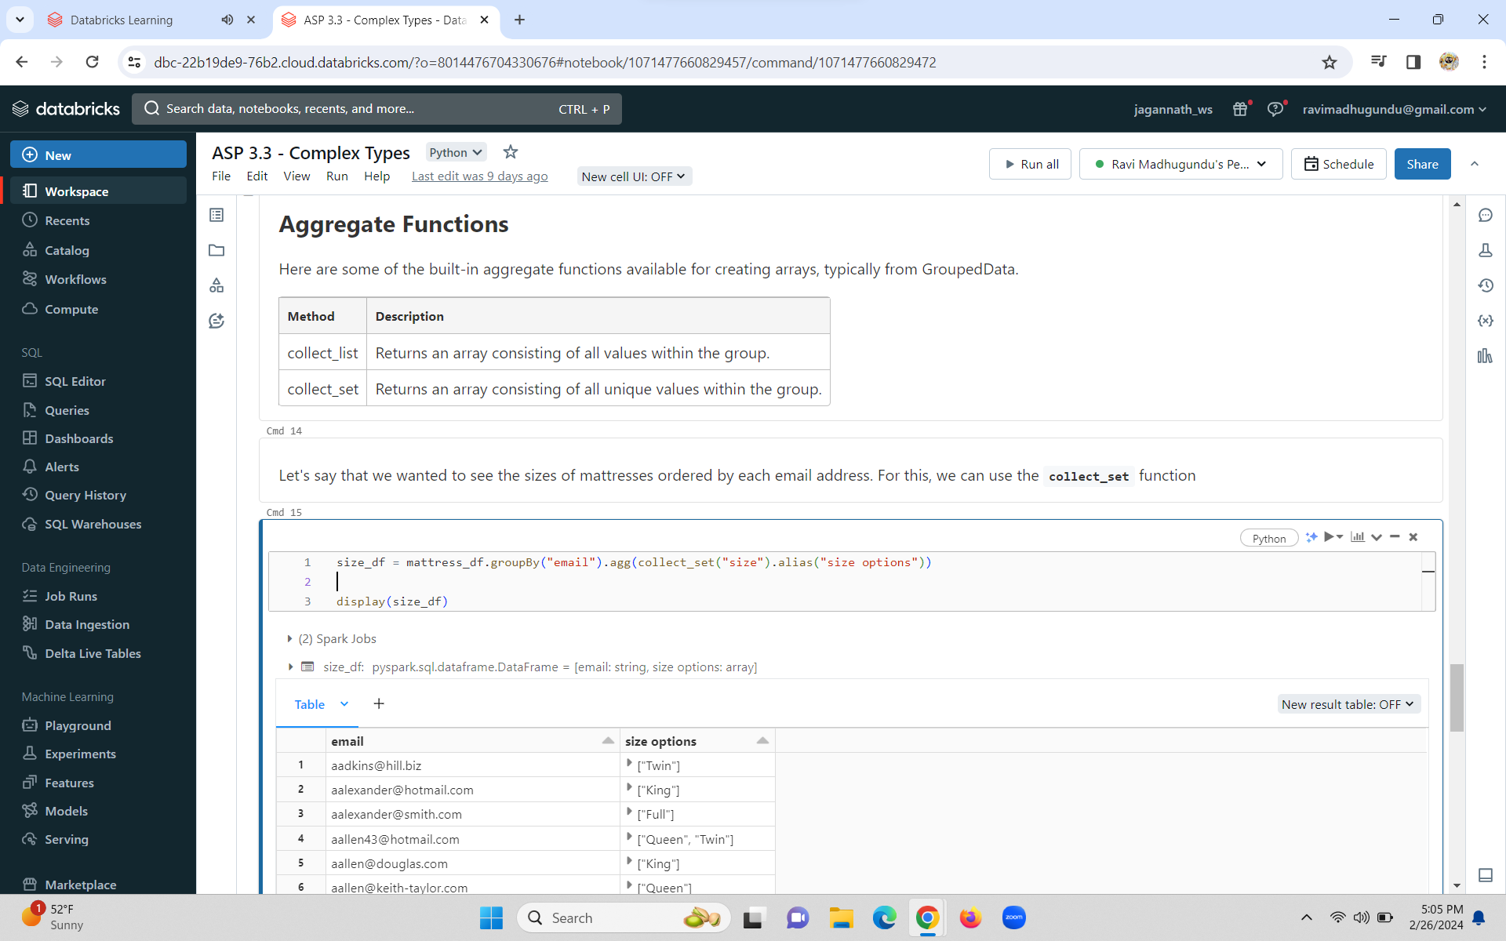

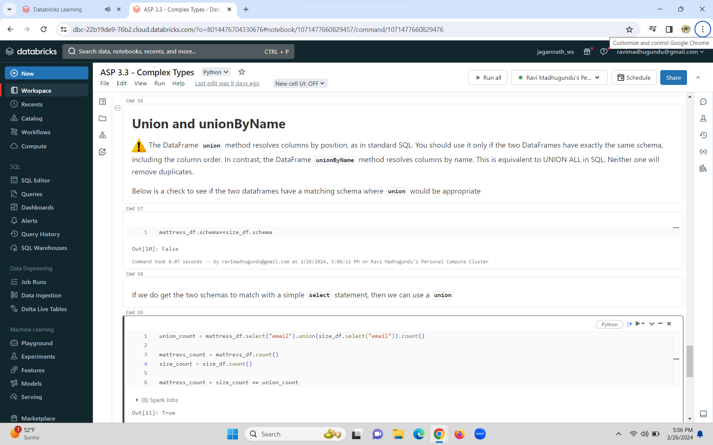

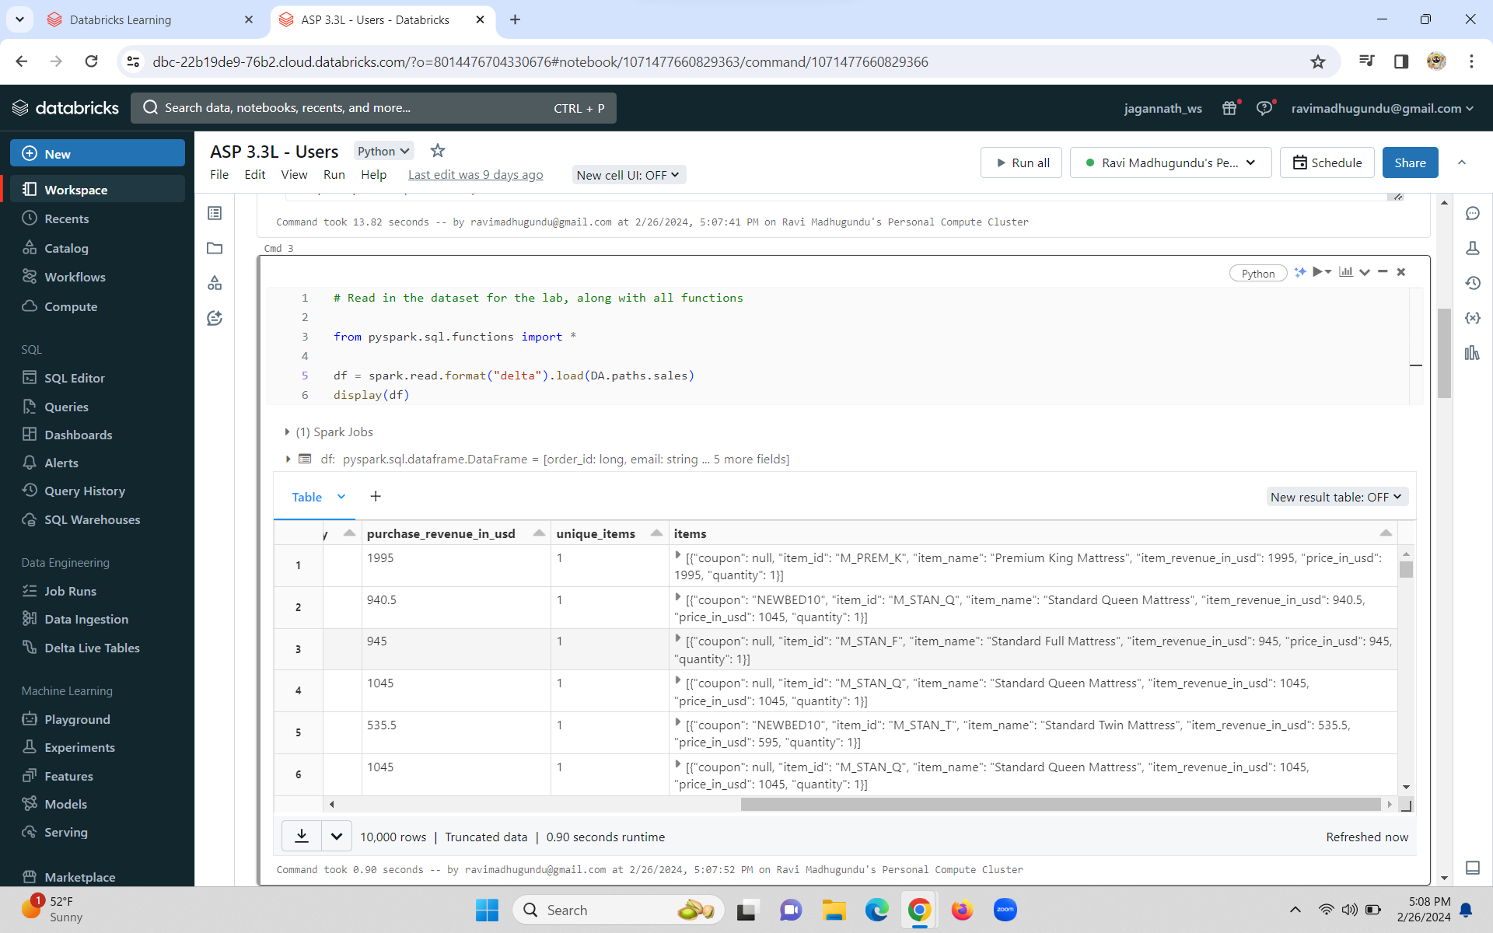

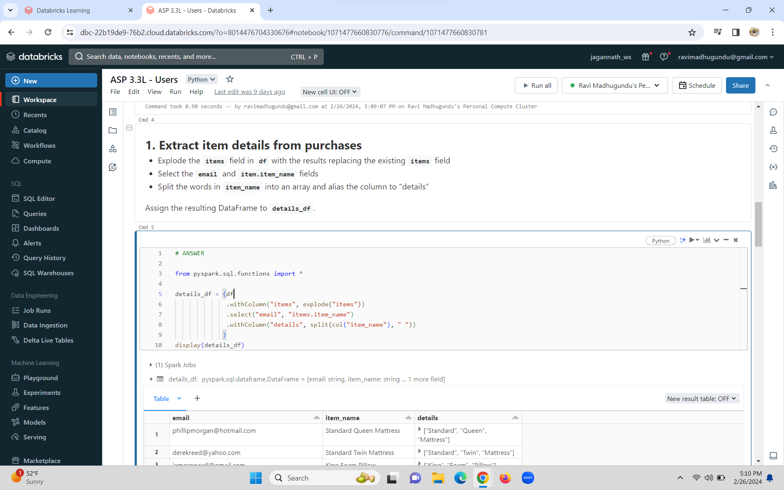

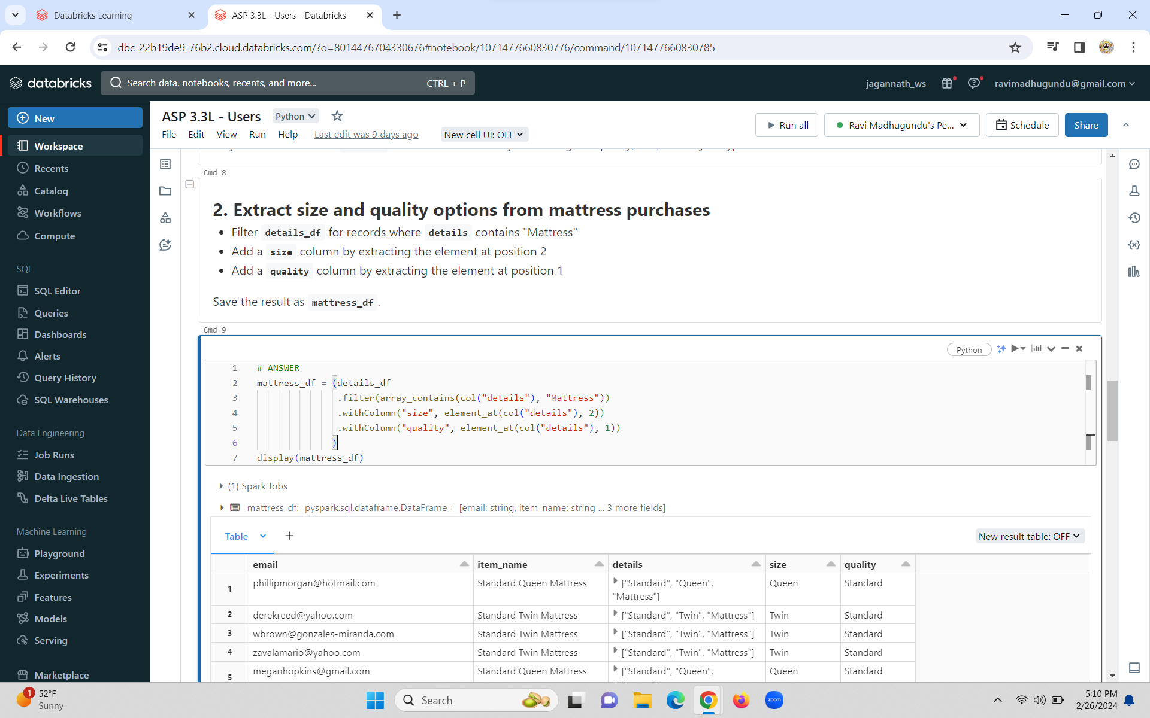

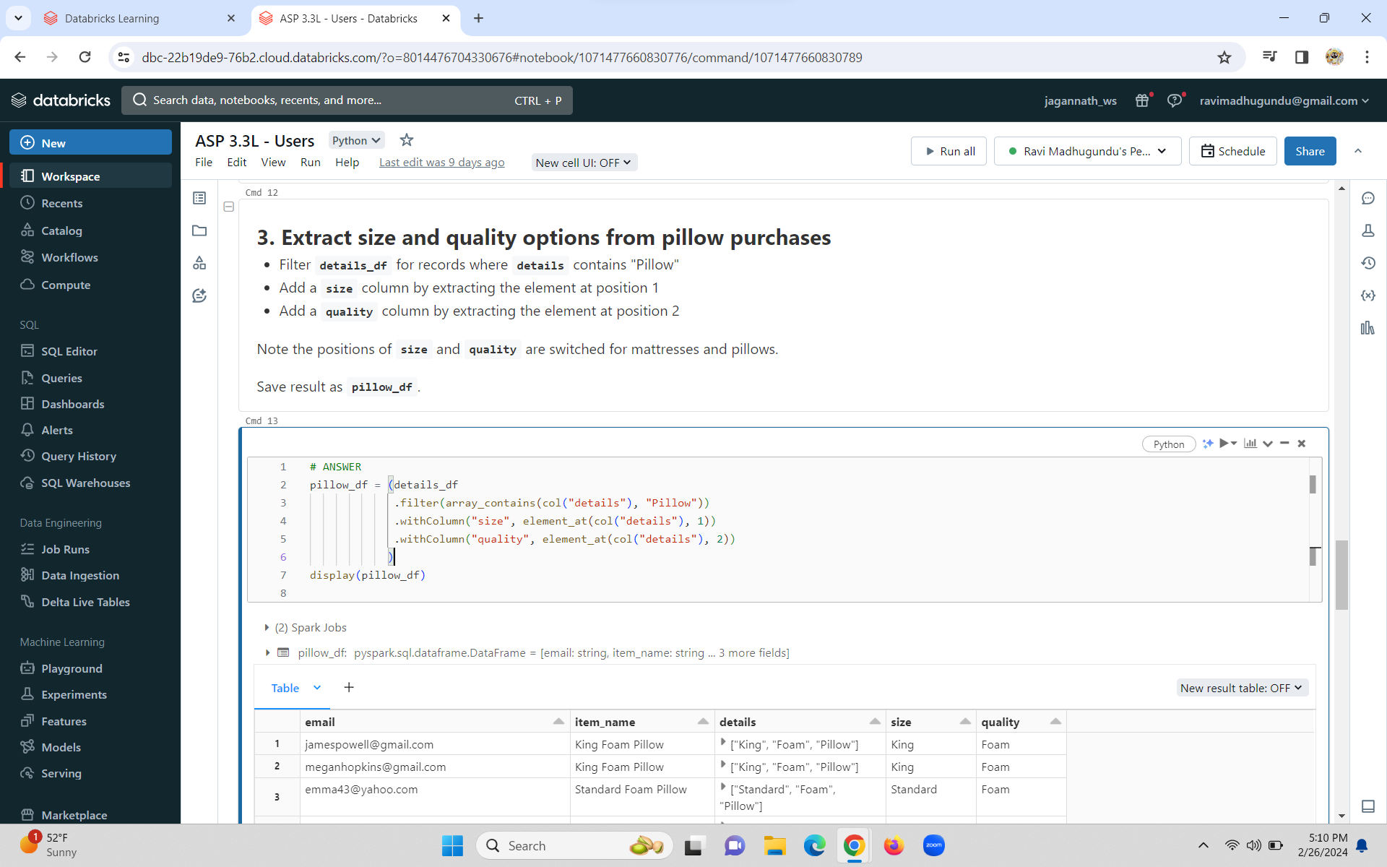

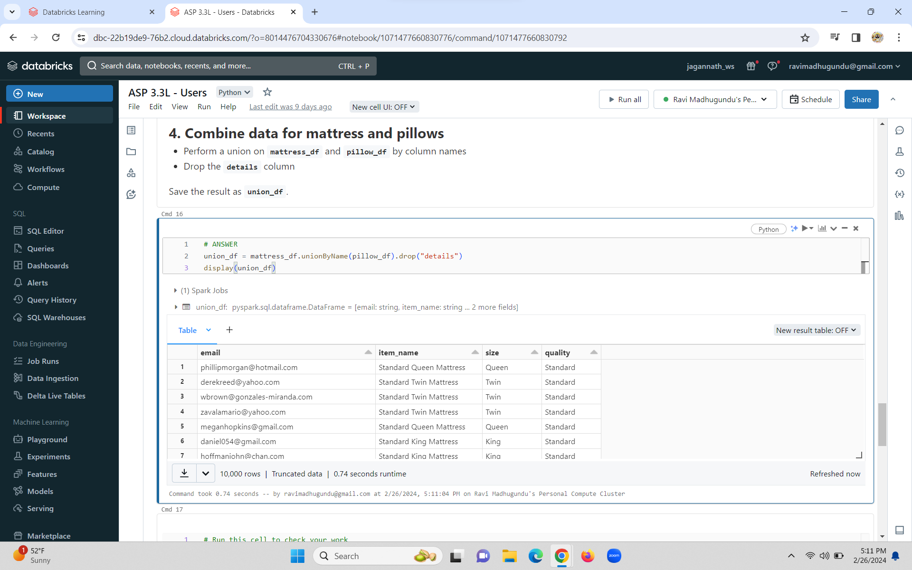

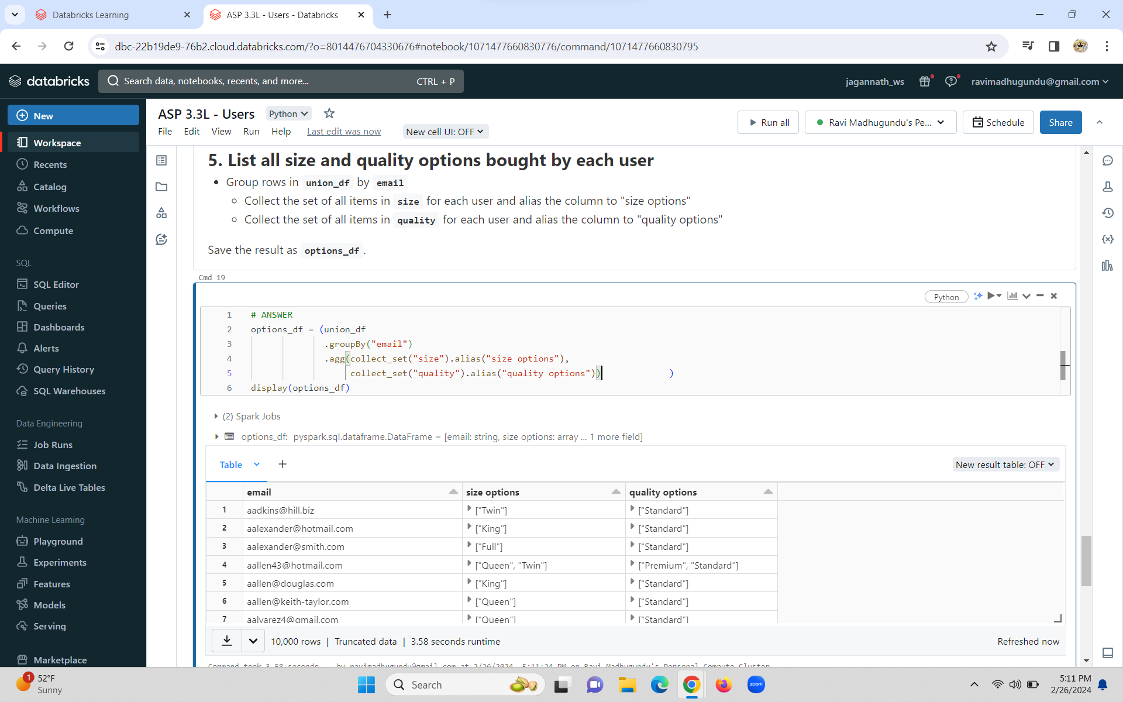

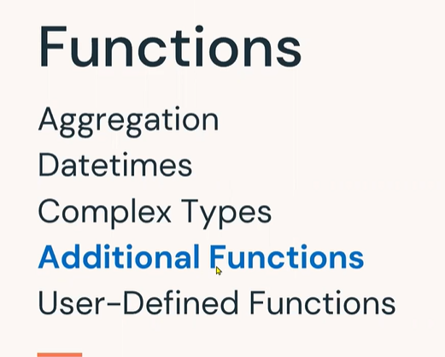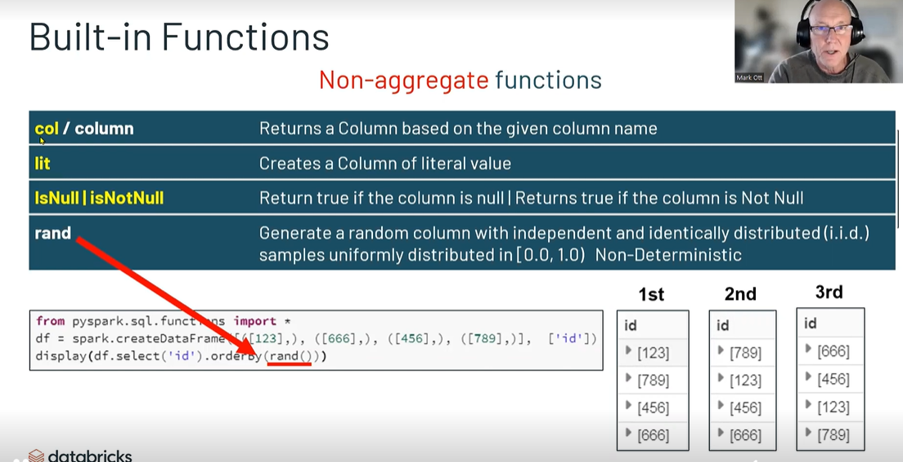

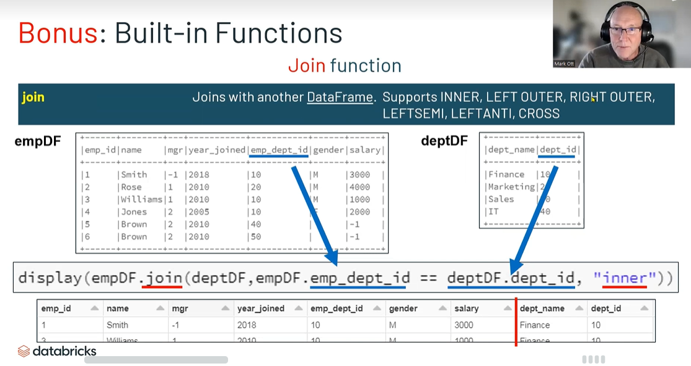

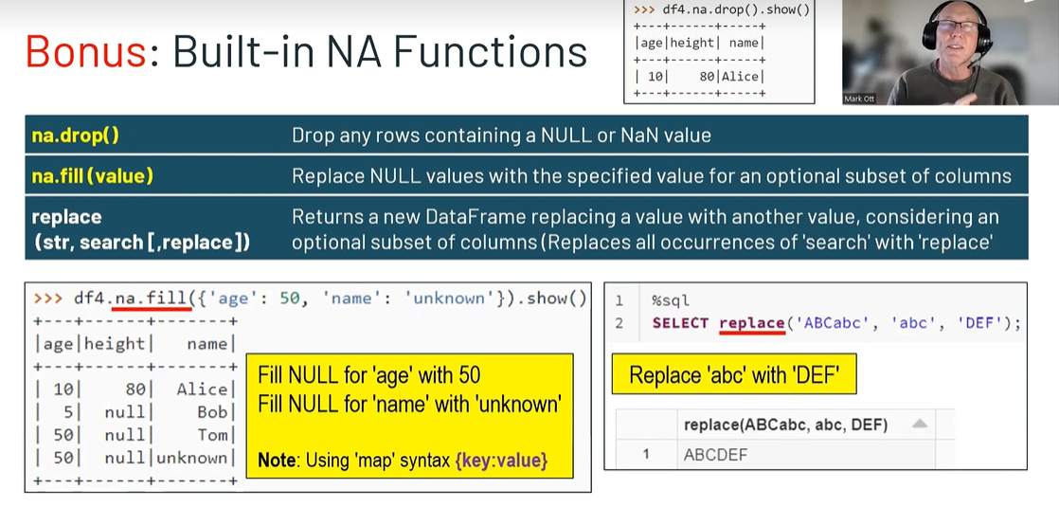

Additional Functions

Objectives

1. **Apply built-in functions to generate data for new columns**
2. **Apply DataFrame NA functions to handle null values**
3. **Join DataFrames**

Methods

* [**DataFrame Methods**](https://spark.apache.org/docs/latest/api/python/reference/pyspark.sql/api/pyspark.sql.DataFrame.join.html#pyspark.sql.DataFrame.join) **: join**
* [**DataFrameNaFunctions**](https://spark.apache.org/docs/latest/api/python/reference/pyspark.sql/api/pyspark.sql.DataFrameNaFunctions.html#pyspark.sql.DataFrameNaFunctions)**: fill, drop**
* [**Built-In Functions**](https://spark.apache.org/docs/latest/api/python/reference/pyspark.sql/functions.html)**:**
  + **Aggregate: collect_set**
  + **Collection: explode**
  + **Non-aggregate and miscellaneous: col, lit**

Non-aggregate and Miscellaneous Functions

**Here are a few additional non-aggregate and miscellaneous built-in functions.**

|  |  |
| --- | --- |
| **Method** | **Description** |
| **col / column** | **Returns a Column based on the given column name.** |
| **lit** | **Creates a Column of literal value** |
| **isnull** | **Return true iff the column is null** |
| **rand** | **Generate a random column with independent and identically distributed (i.i.d.) samples uniformly distributed in [0.0, 1.0)** |

**We could select a particular column using the col function**

* + 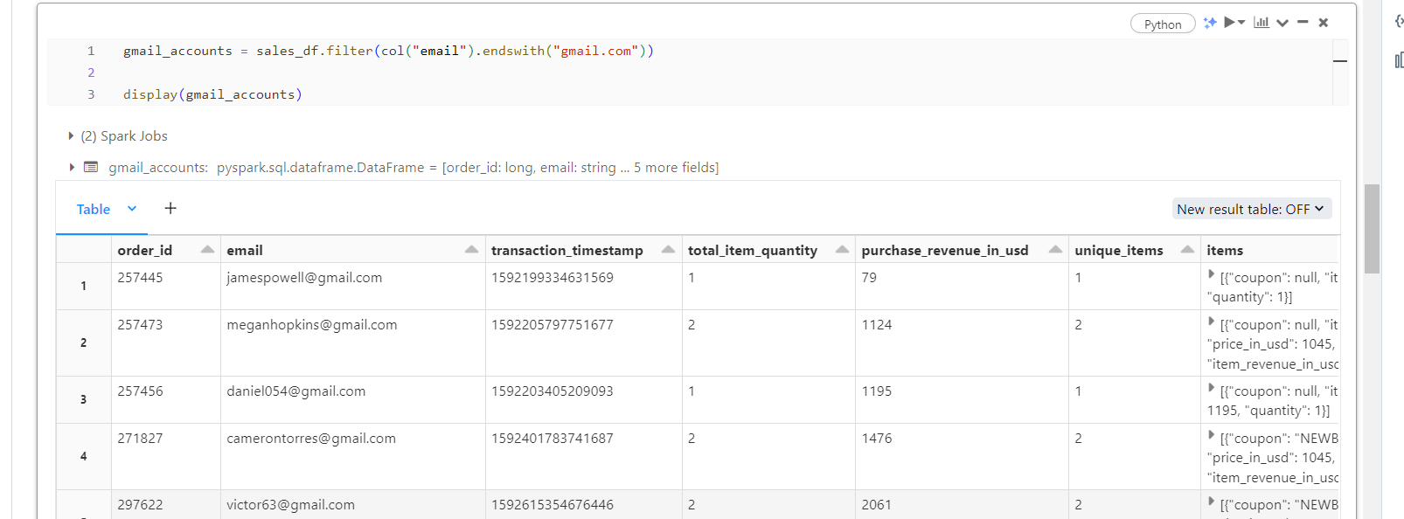

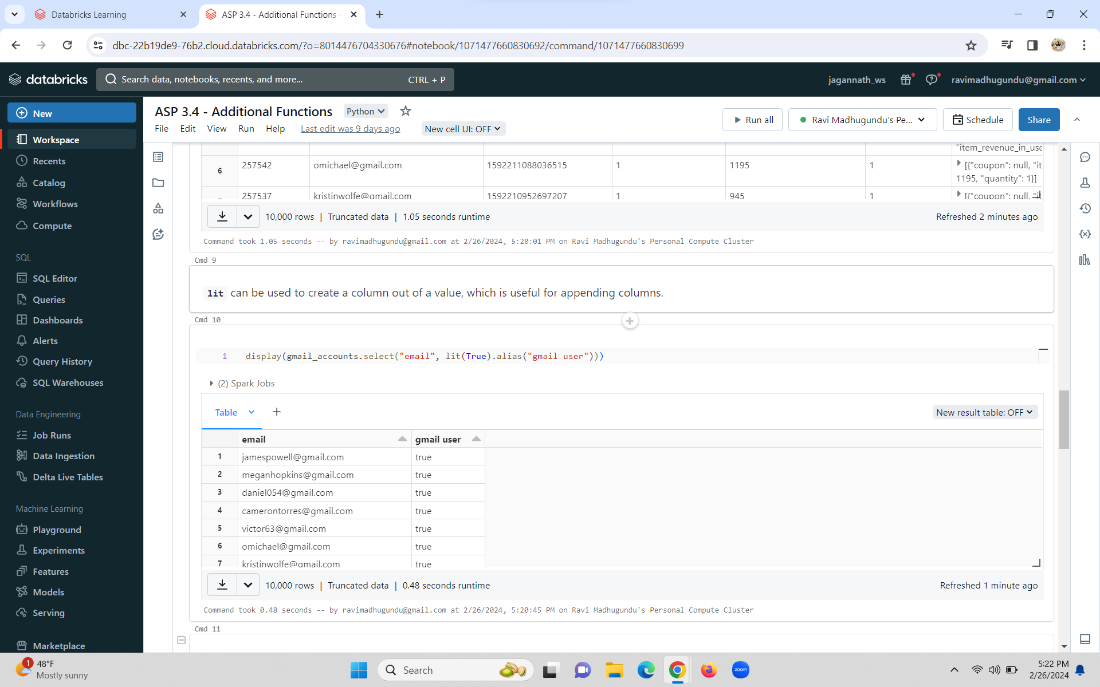

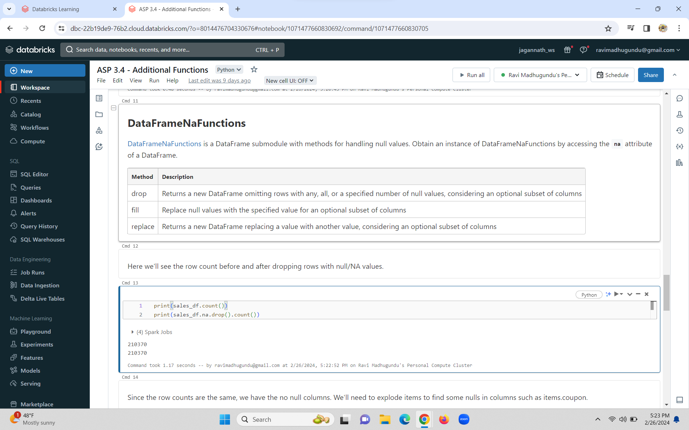

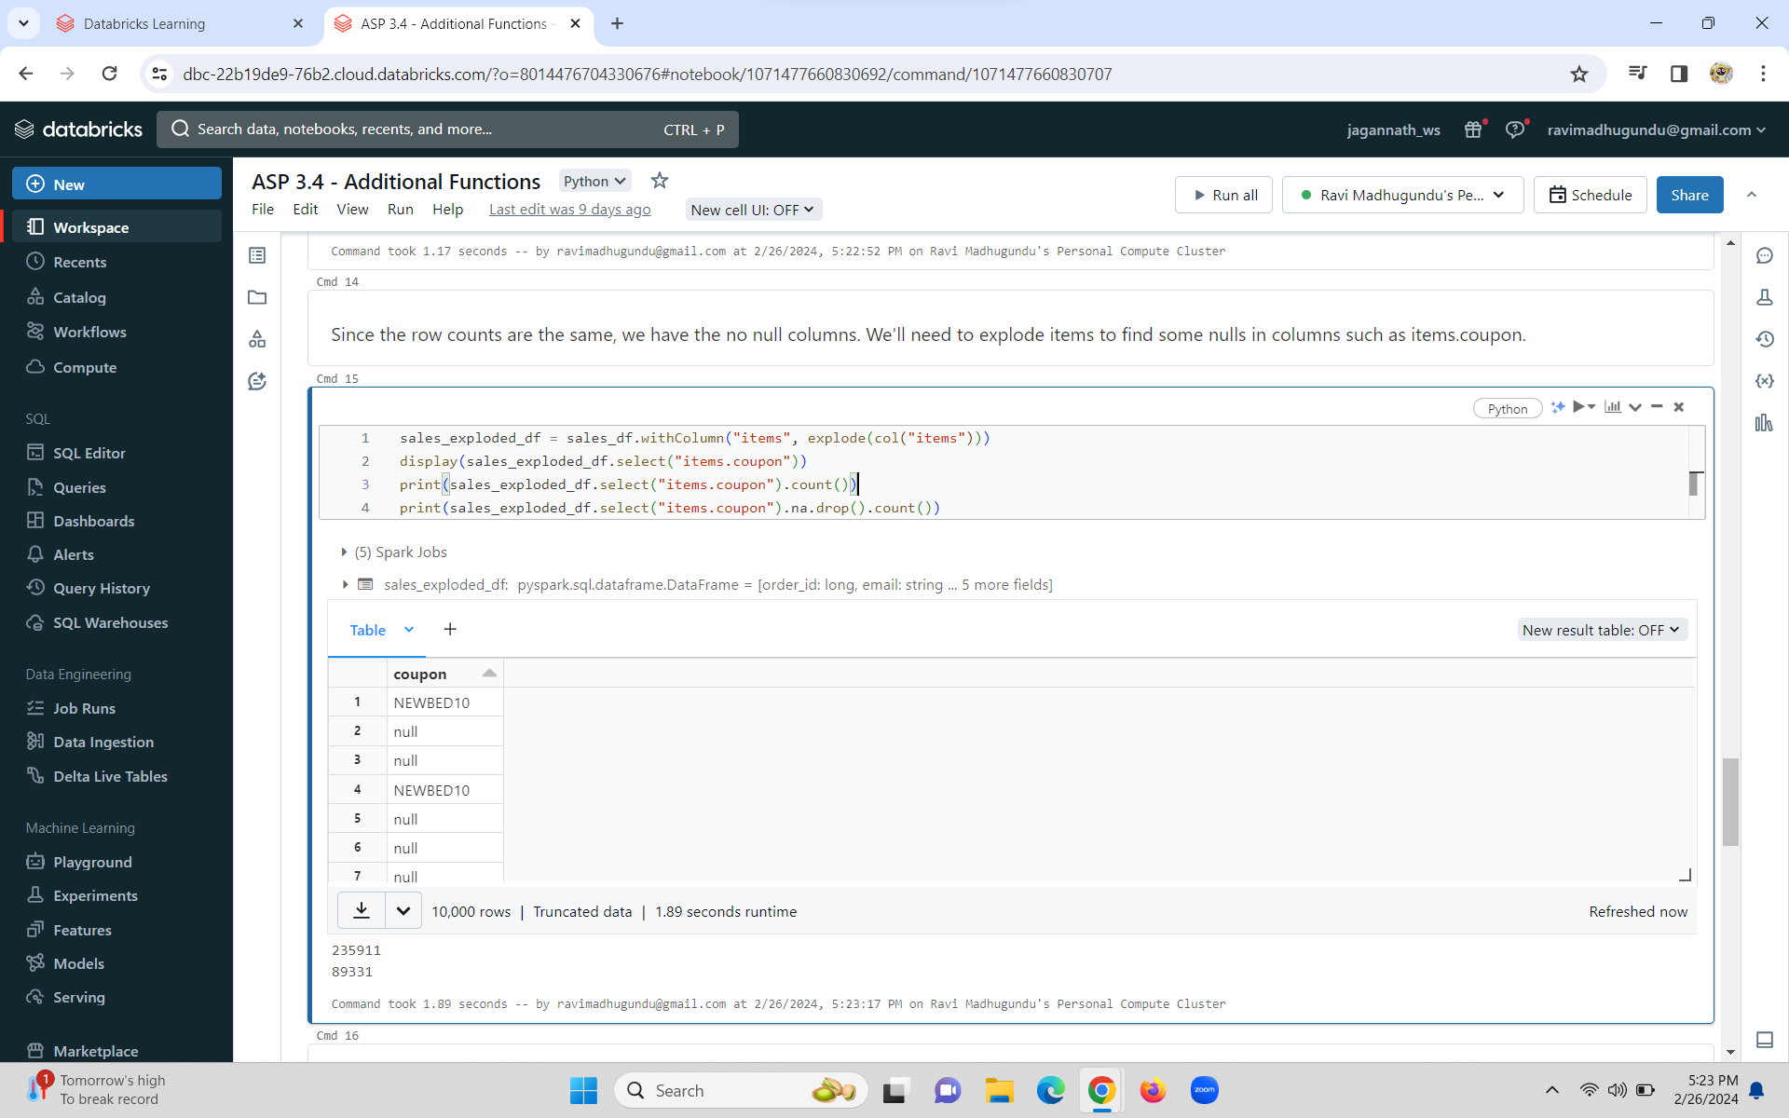

**We can fill in the missing coupon codes with na.fill**

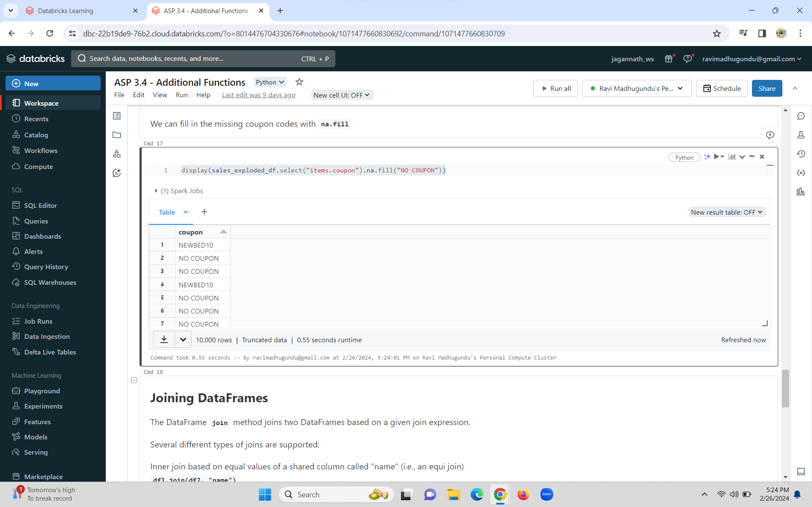

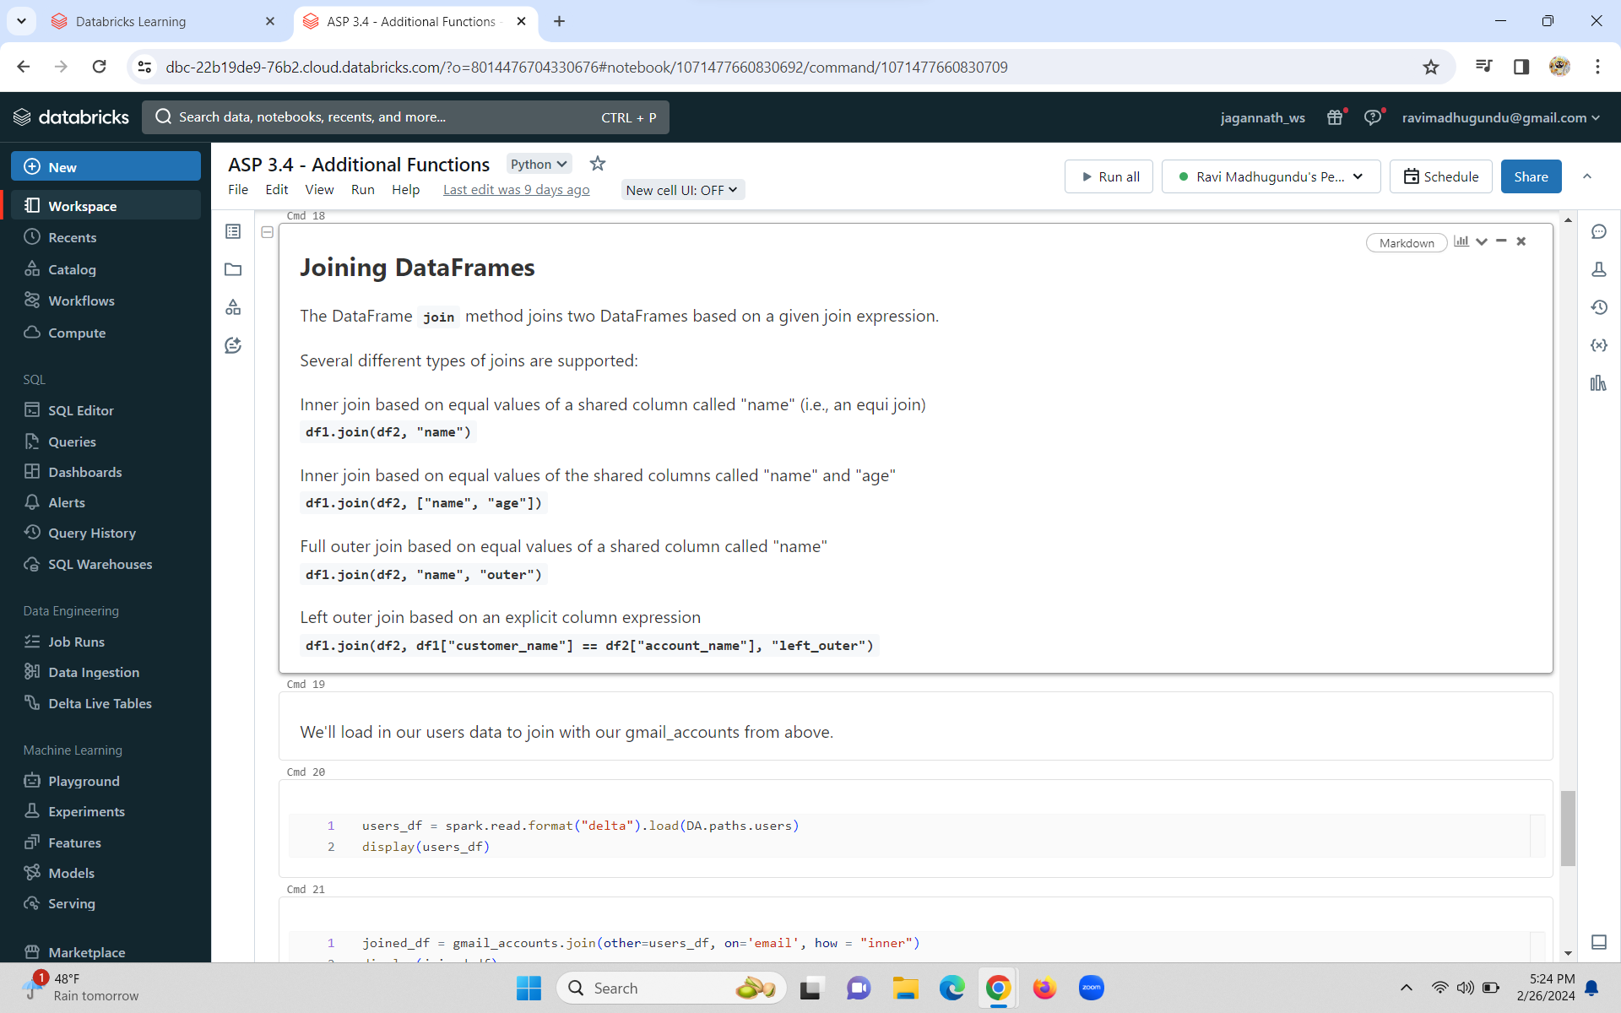

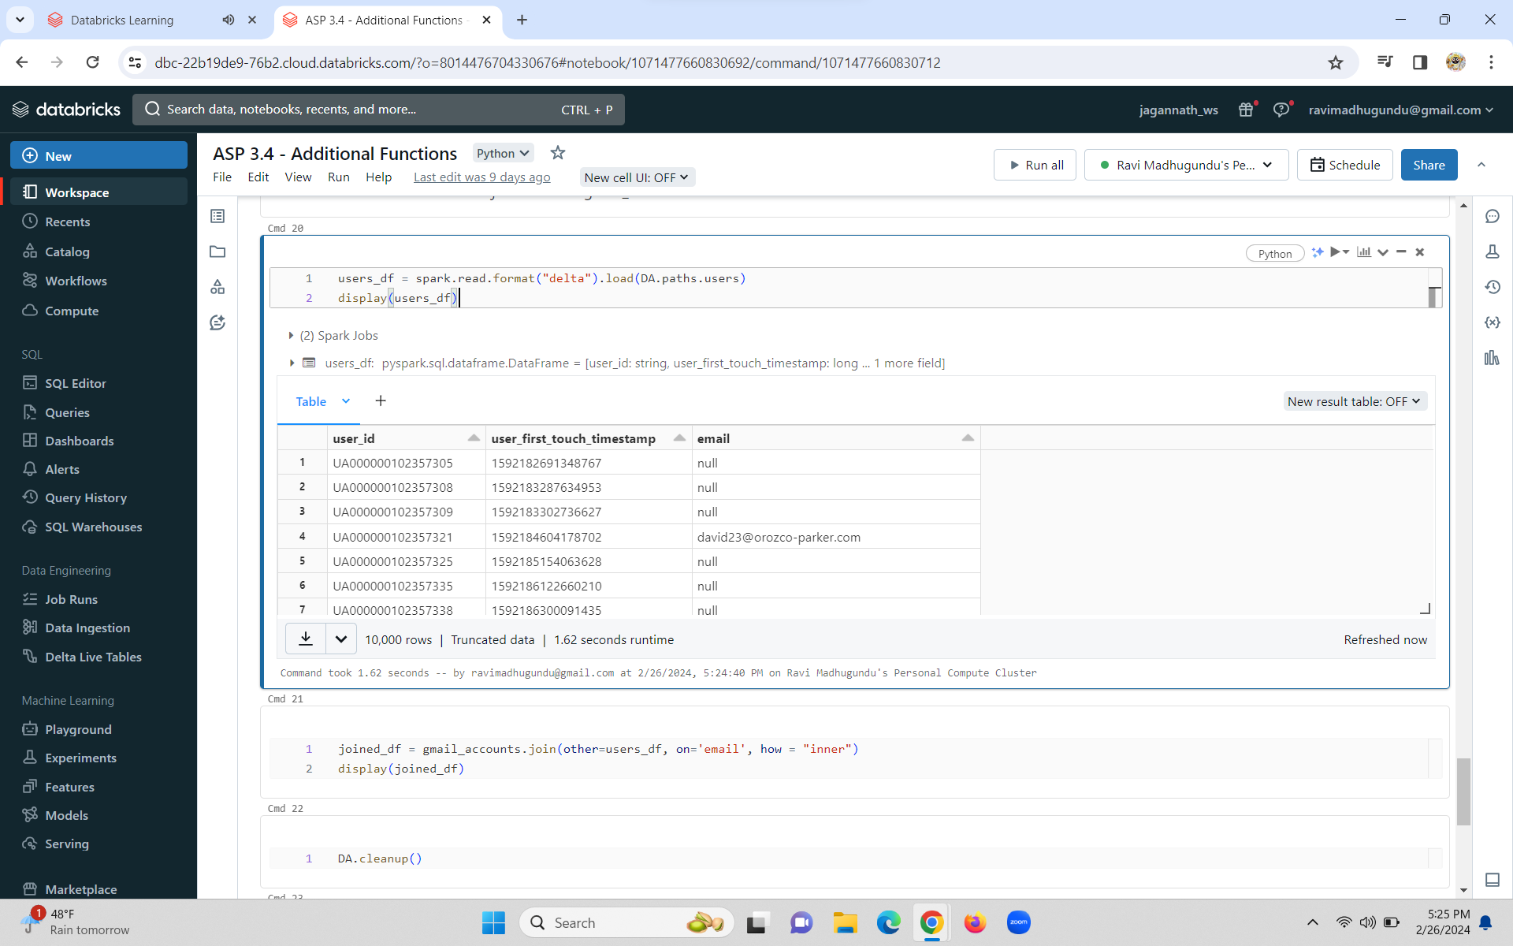

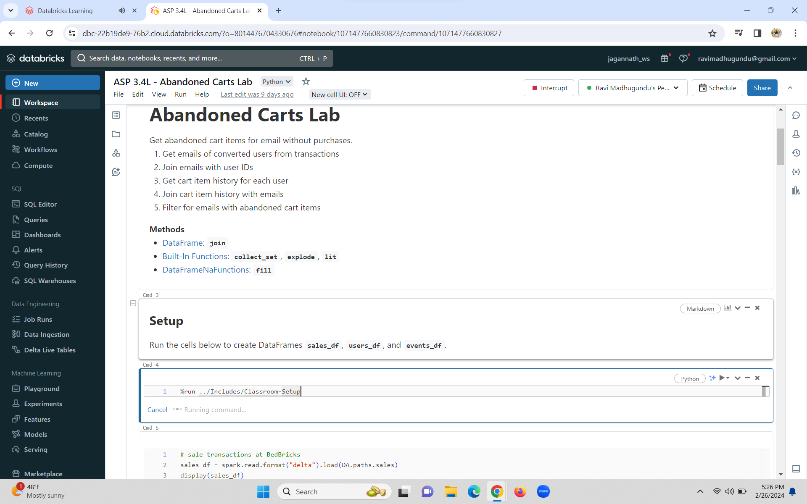

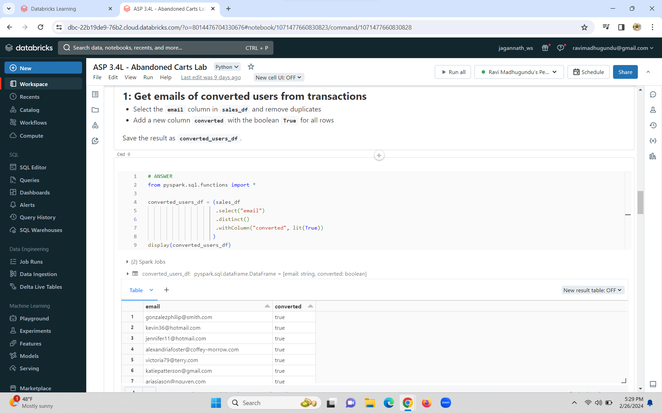

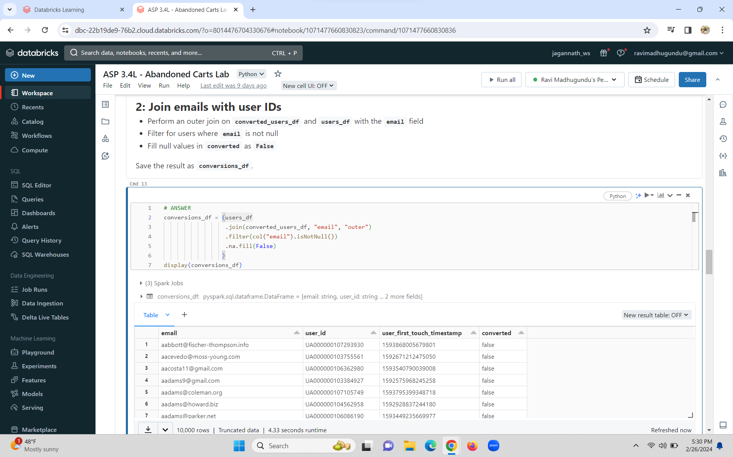

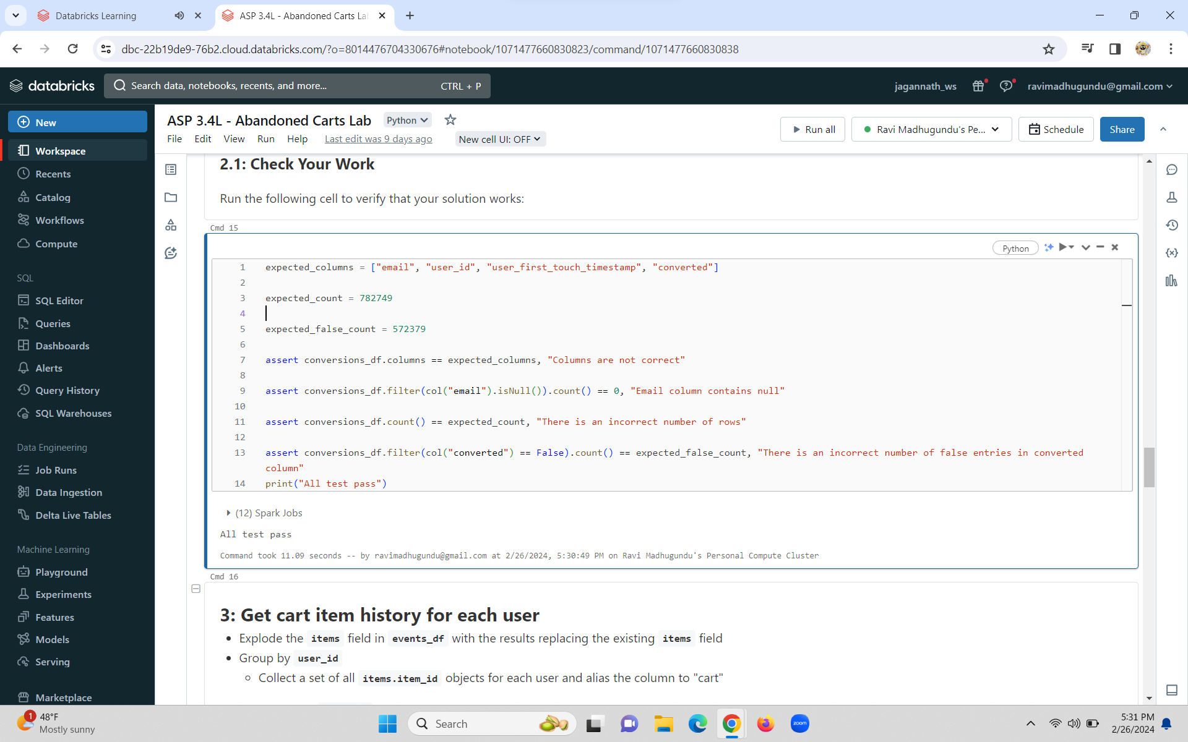

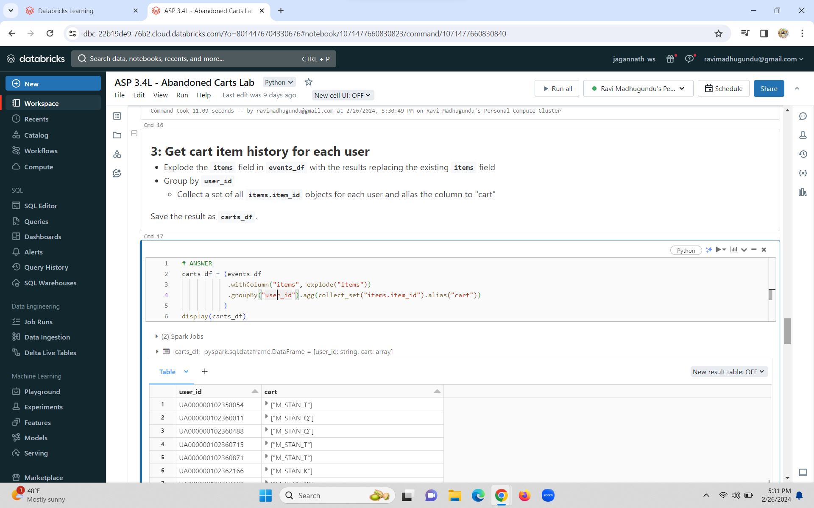

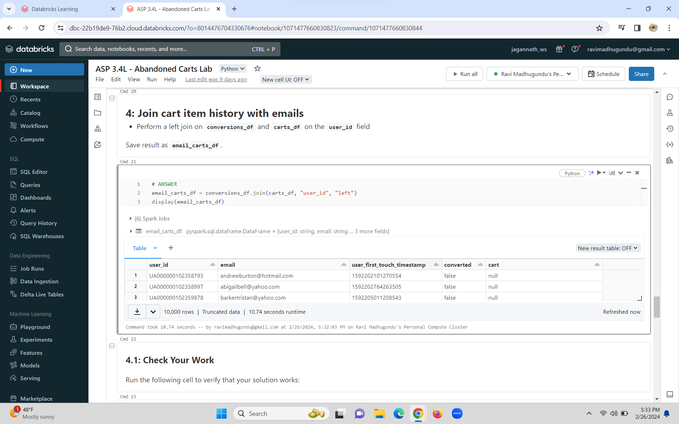

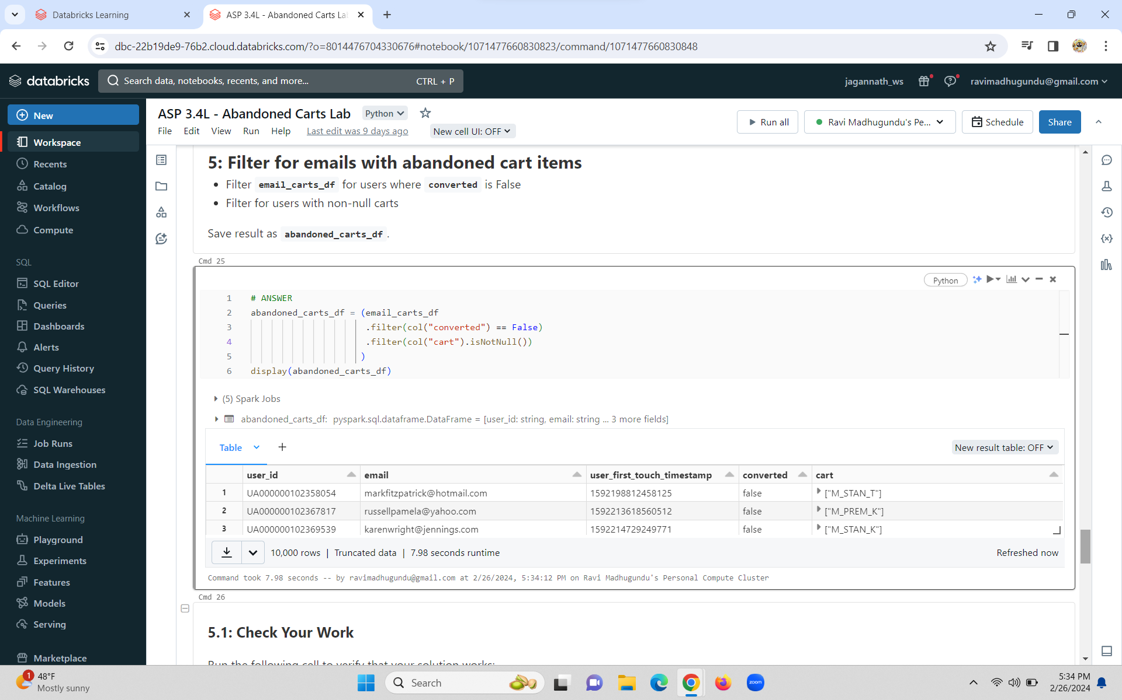

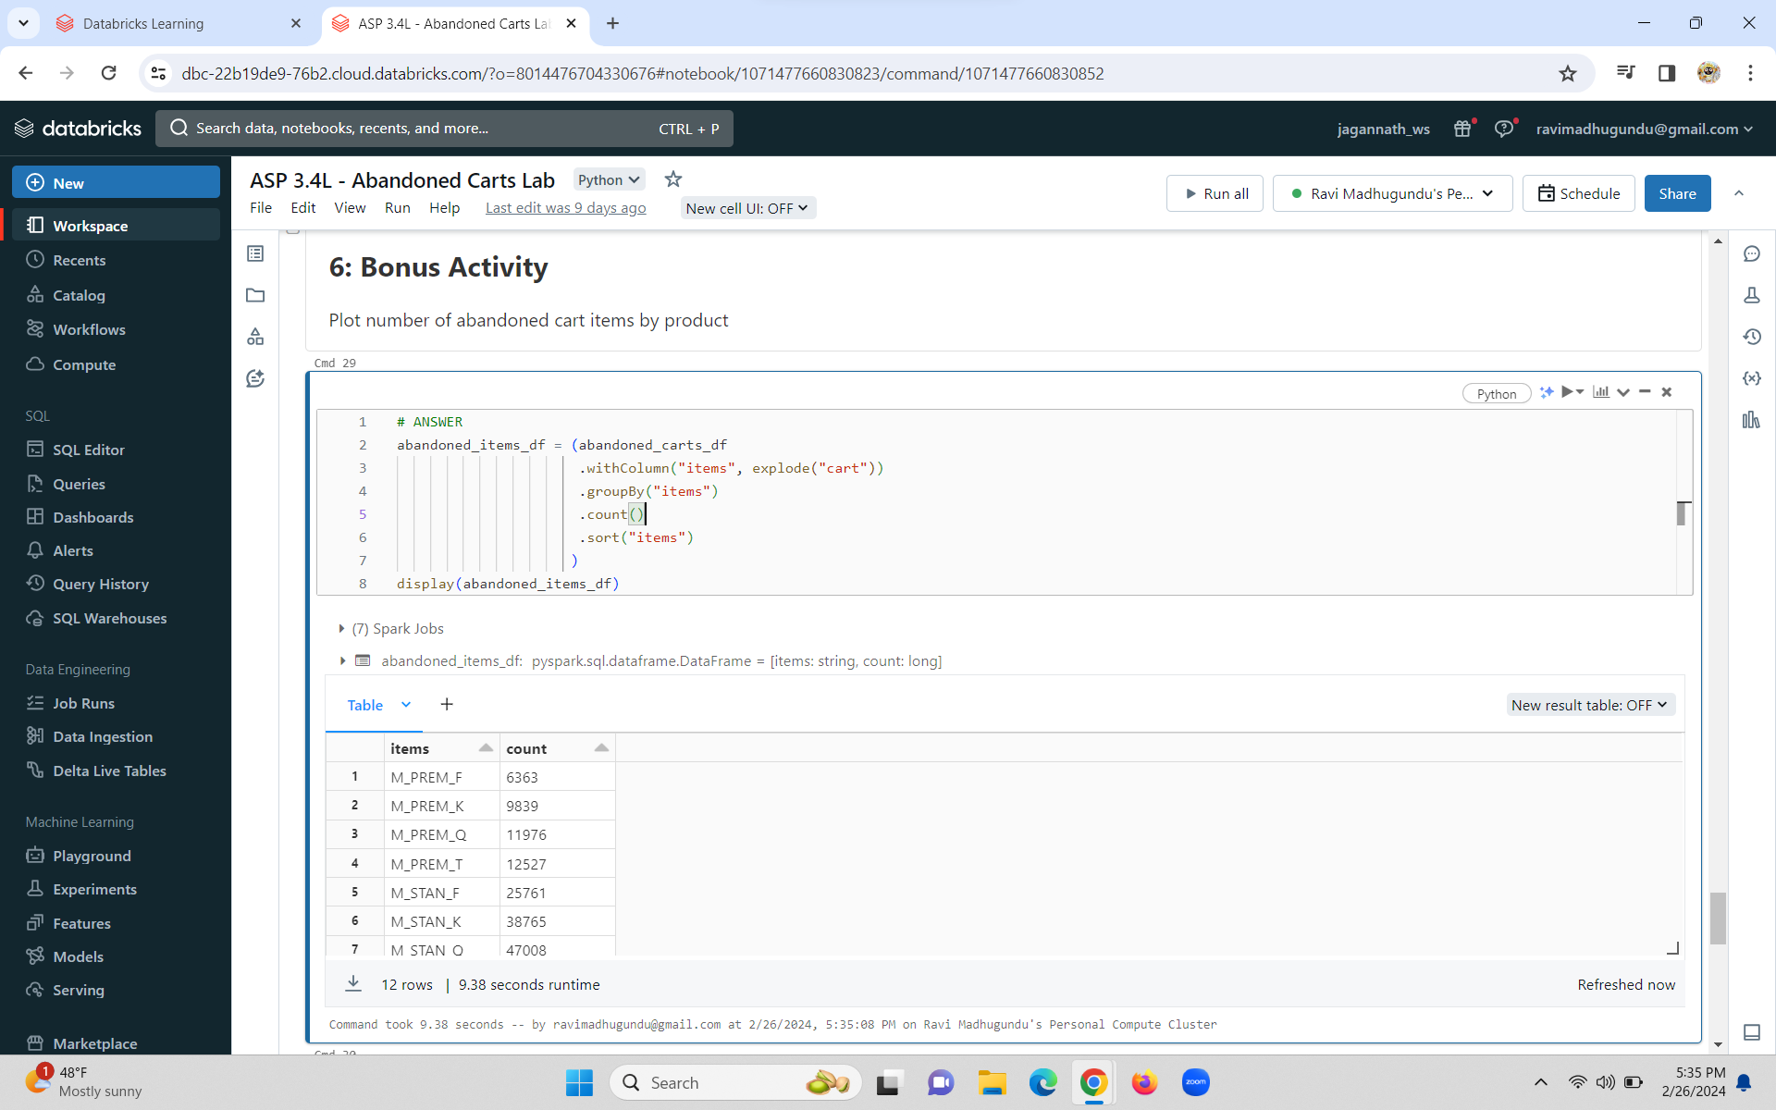

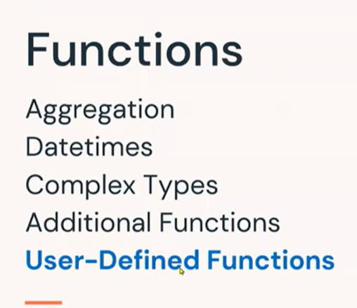

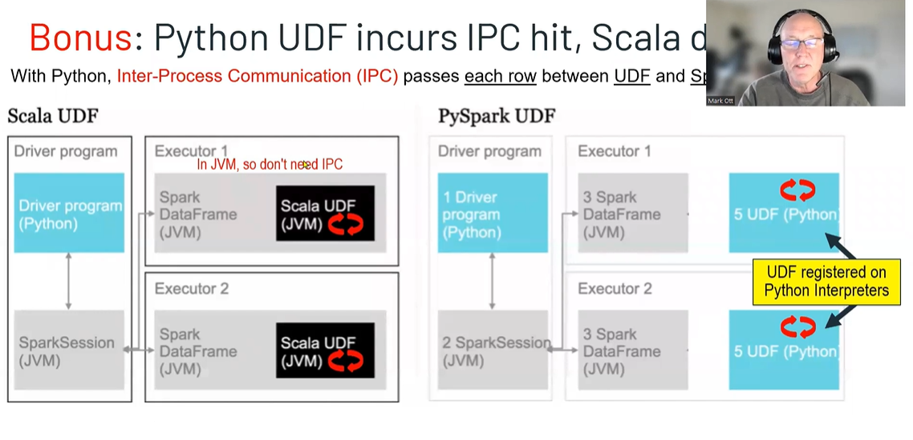

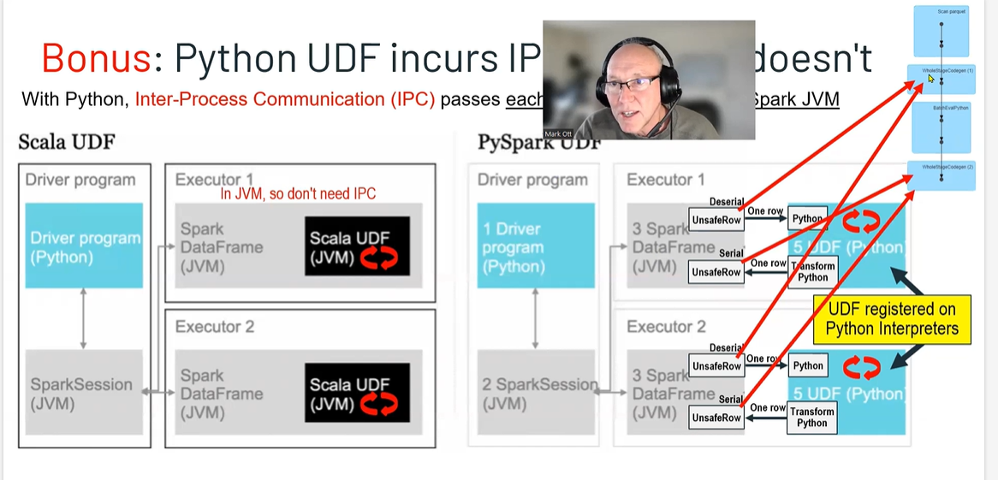

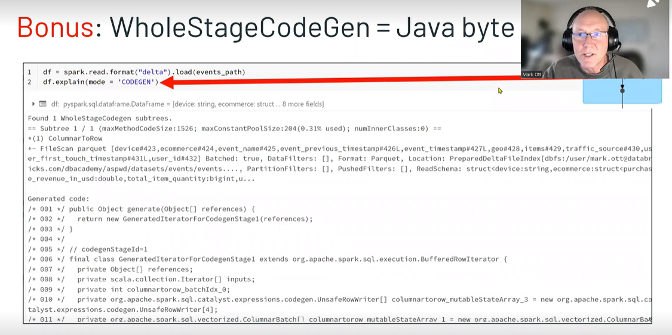

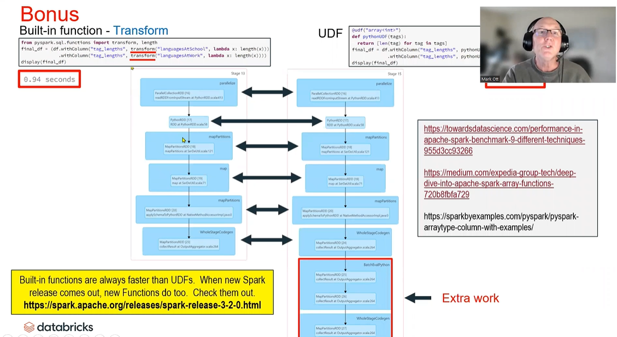

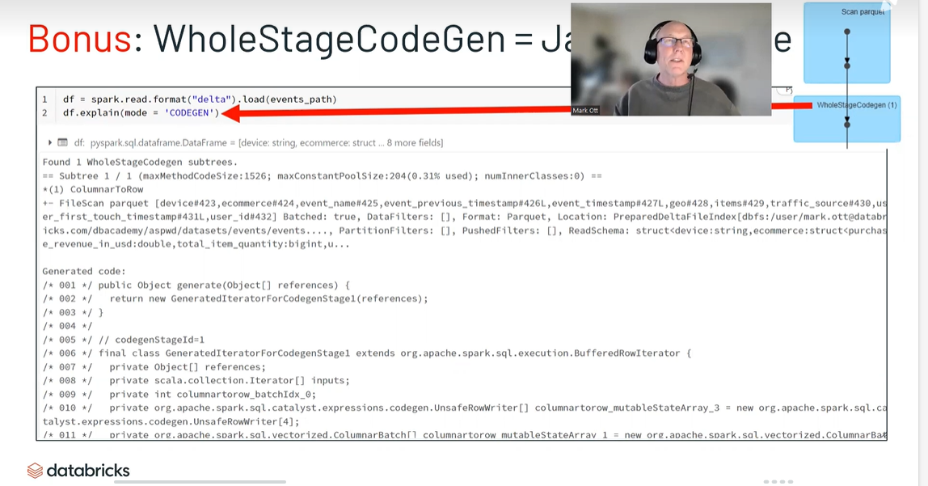

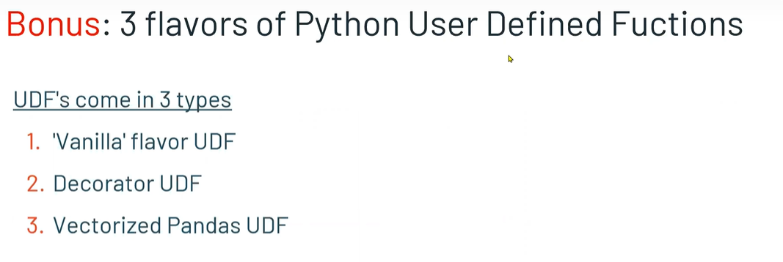

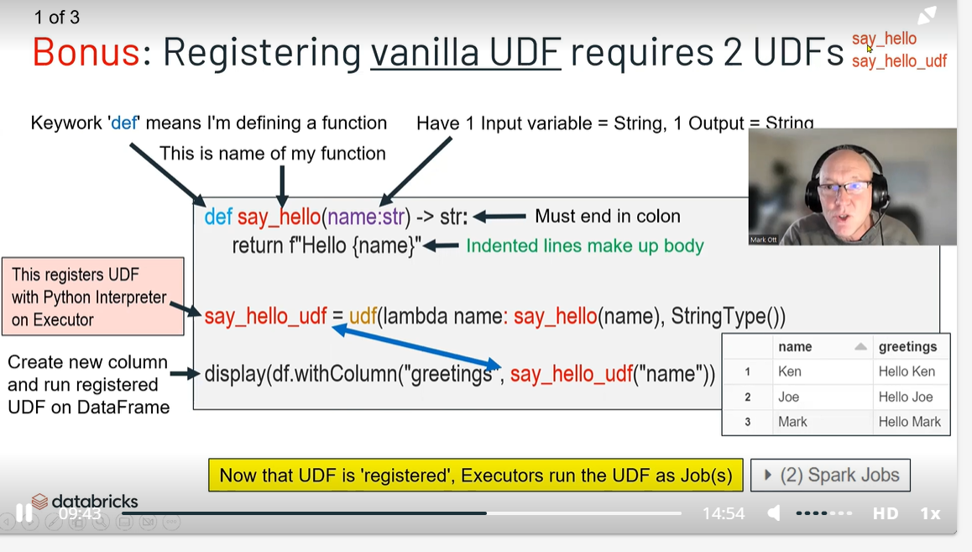

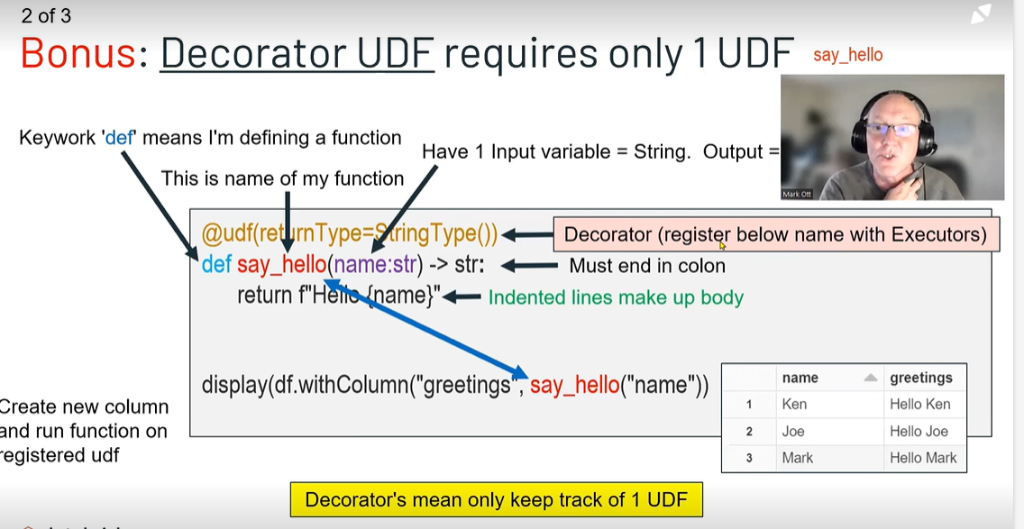

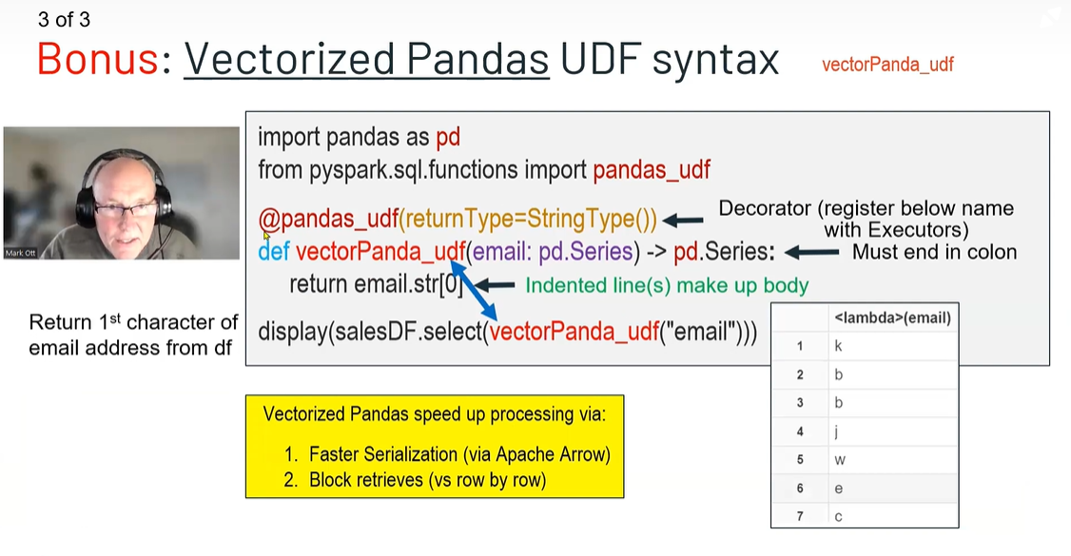

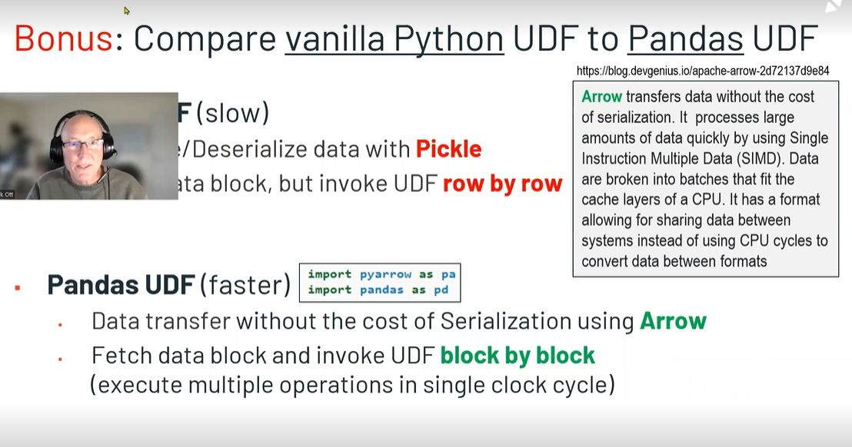

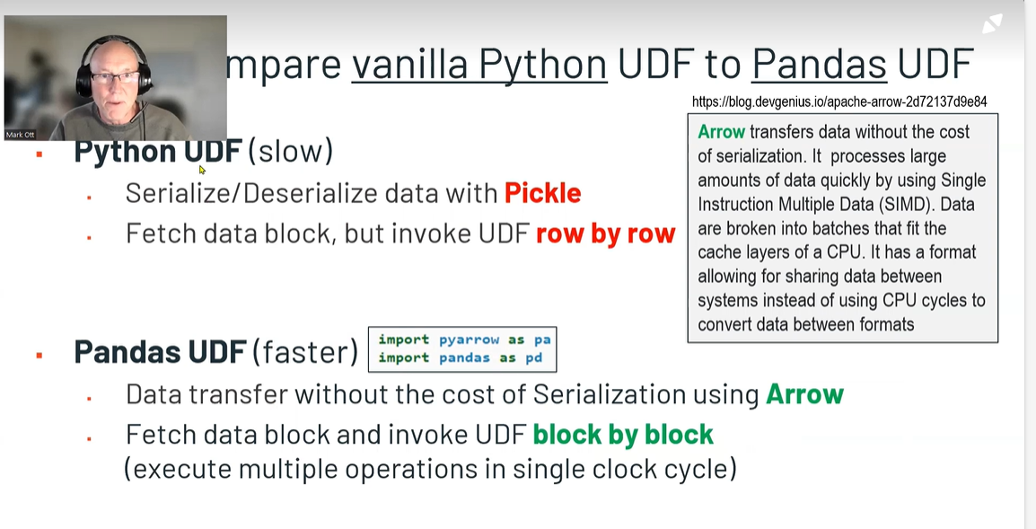

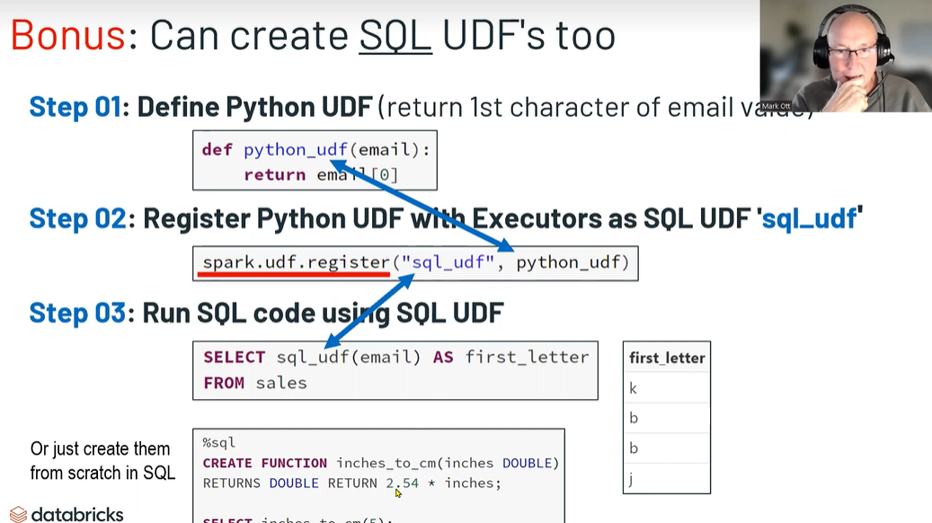

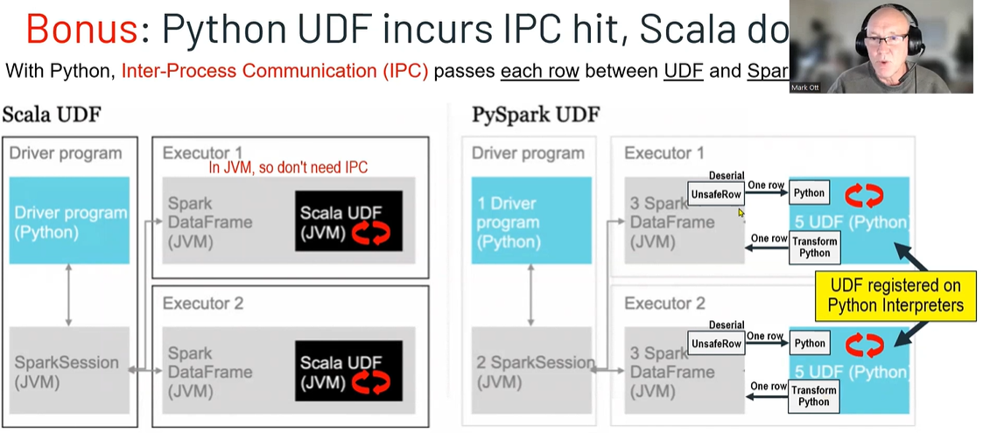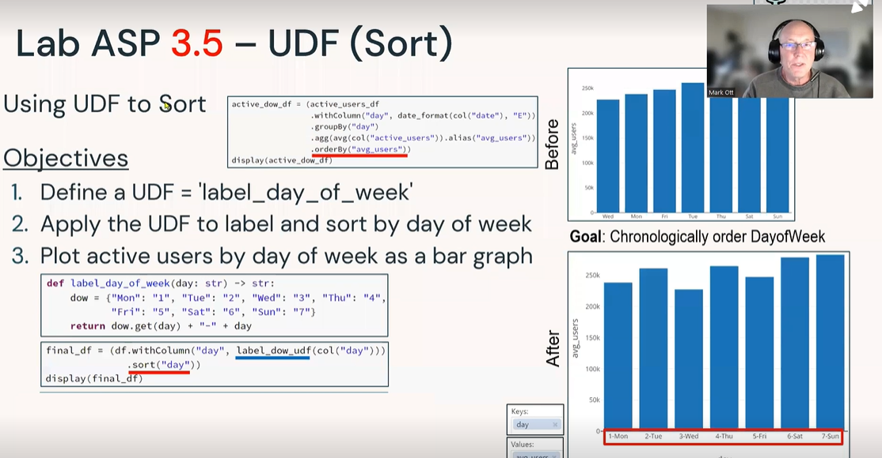

User-Defined Functions

Objectives

1. **Define a function**
2. **Create and apply a UDF**
3. **Register the UDF to use in SQL**
4. **Create and register a UDF with Python decorator syntax**
5. **Create and apply a Pandas (vectorized) UDF**

Methods

* [**UDF Registration (spark.udf)**](https://docs.databricks.com/spark/latest/spark-sql/udf-python.html)**: register**
* [**Built-In Functions**](https://spark.apache.org/docs/latest/api/python/reference/pyspark.sql/api/pyspark.sql.functions.udf.html?highlight=udf#pyspark.sql.functions.udf)**: udf**
* [**Python UDF Decorator**](https://spark.apache.org/docs/3.1.3/api/python/reference/api/pyspark.sql.functions.udf.html)**: @udf**
* [**Pandas UDF Decorator**](https://spark.apache.org/docs/3.1.3/api/python/reference/api/pyspark.sql.functions.pandas_udf.html)**: @pandas_udf**

User-Defined Function (UDF)

**A custom column transformation function**

* **Can’t be optimized by Catalyst Optimizer**
* **Function is serialized and sent to executors**
* **Row data is deserialized from Spark's native binary format to pass to the UDF, and the results are serialized back into Spark's native format**
* **For Python UDFs, additional interprocess communication overhead between the executor and a Python interpreter running on each worker node**

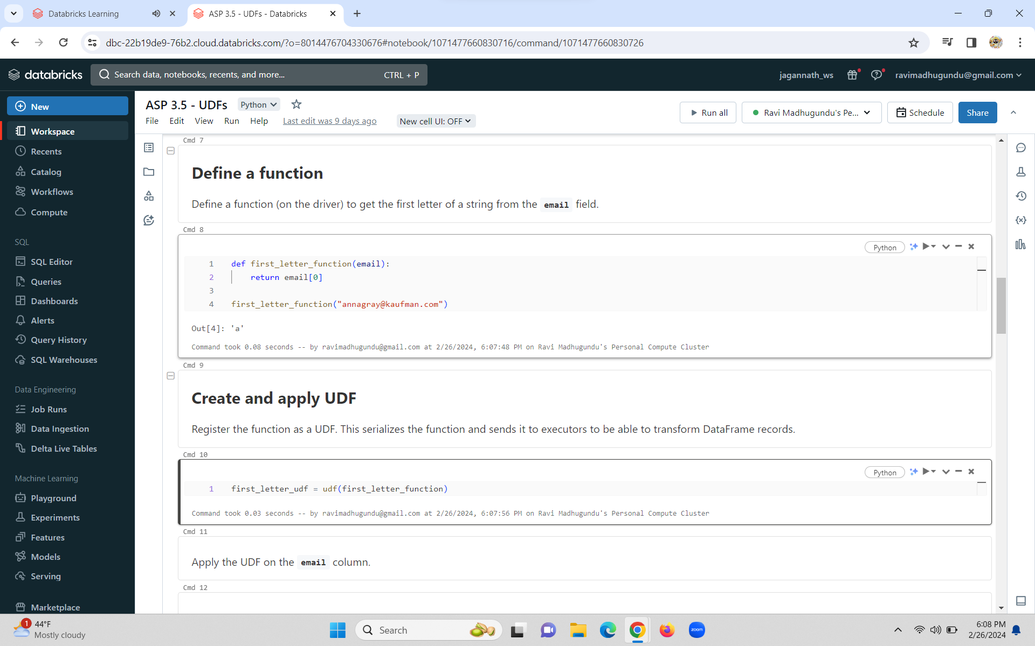

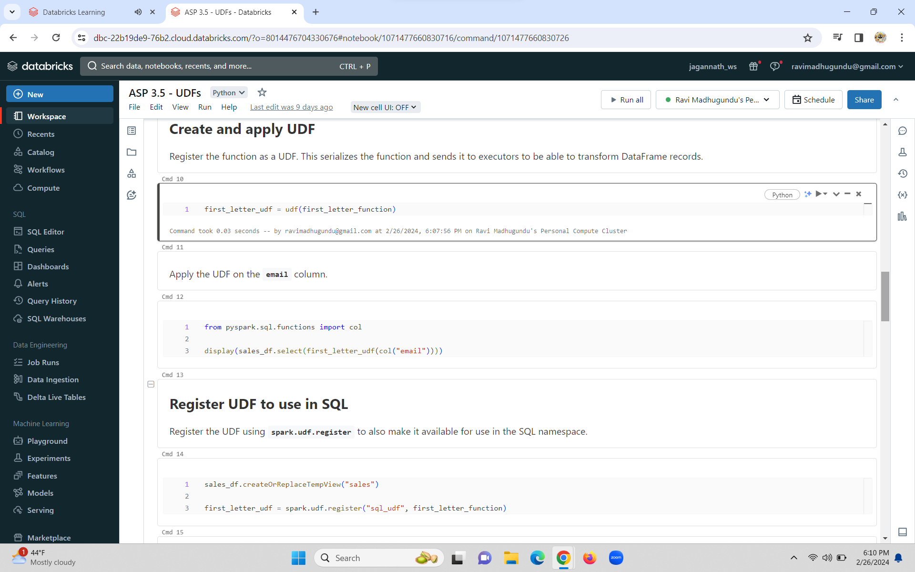

**wholestageCodeGEn is always overhead**

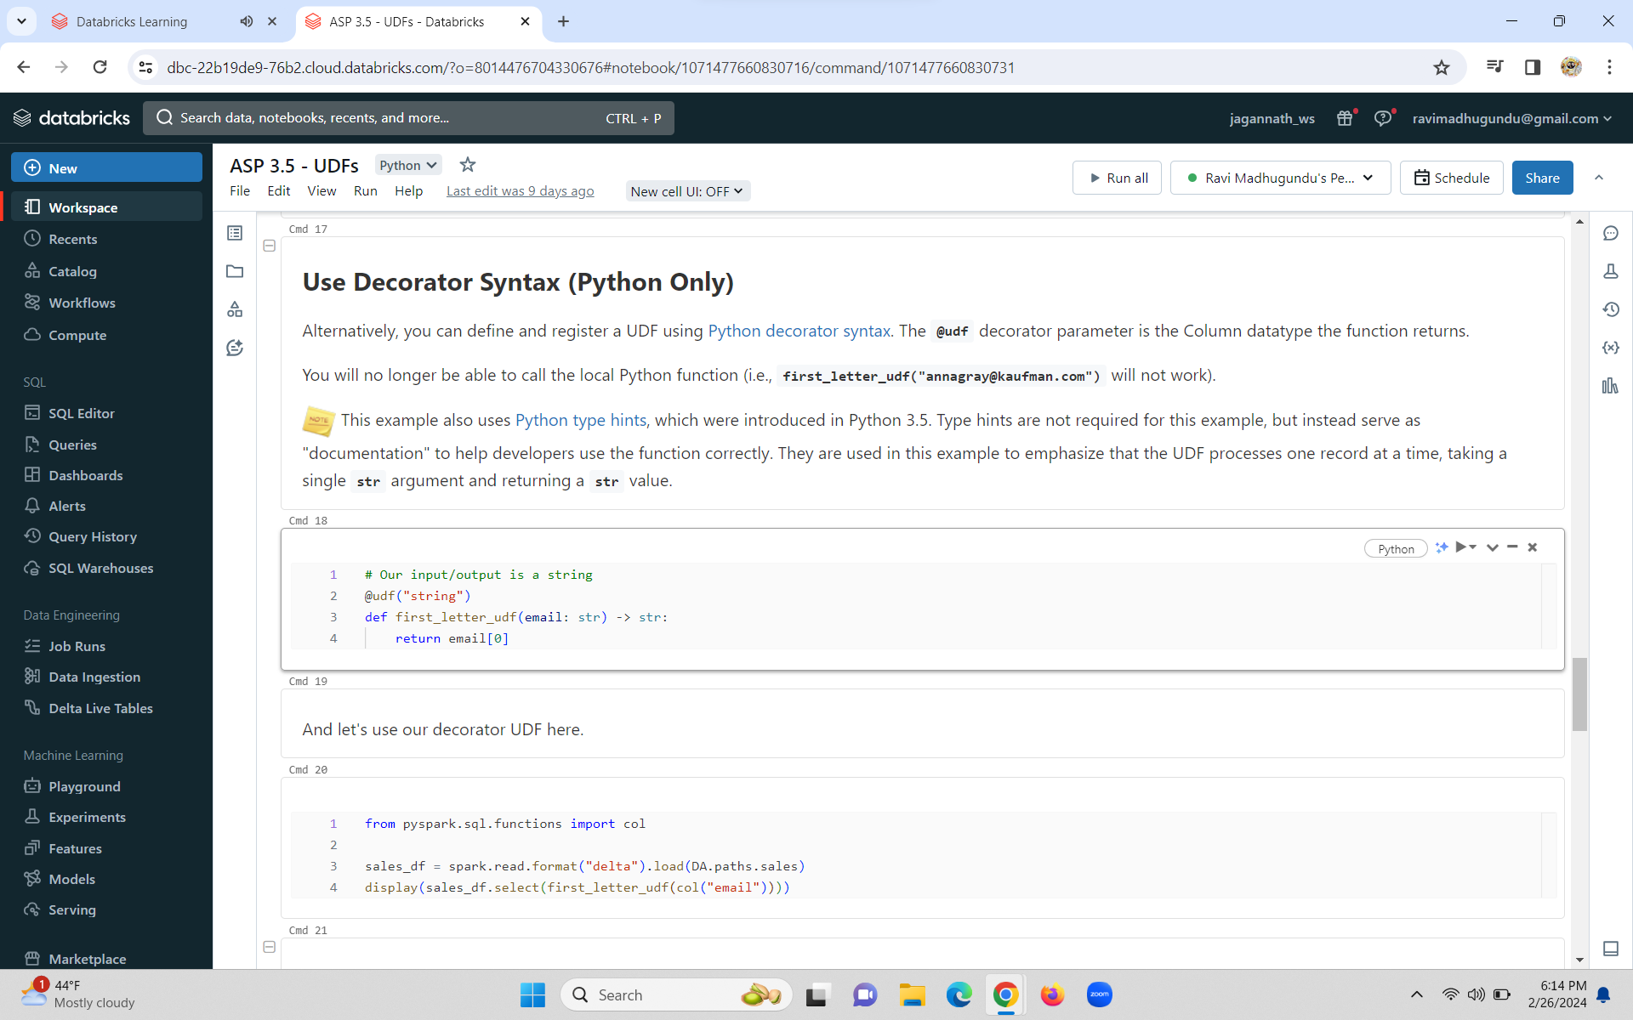

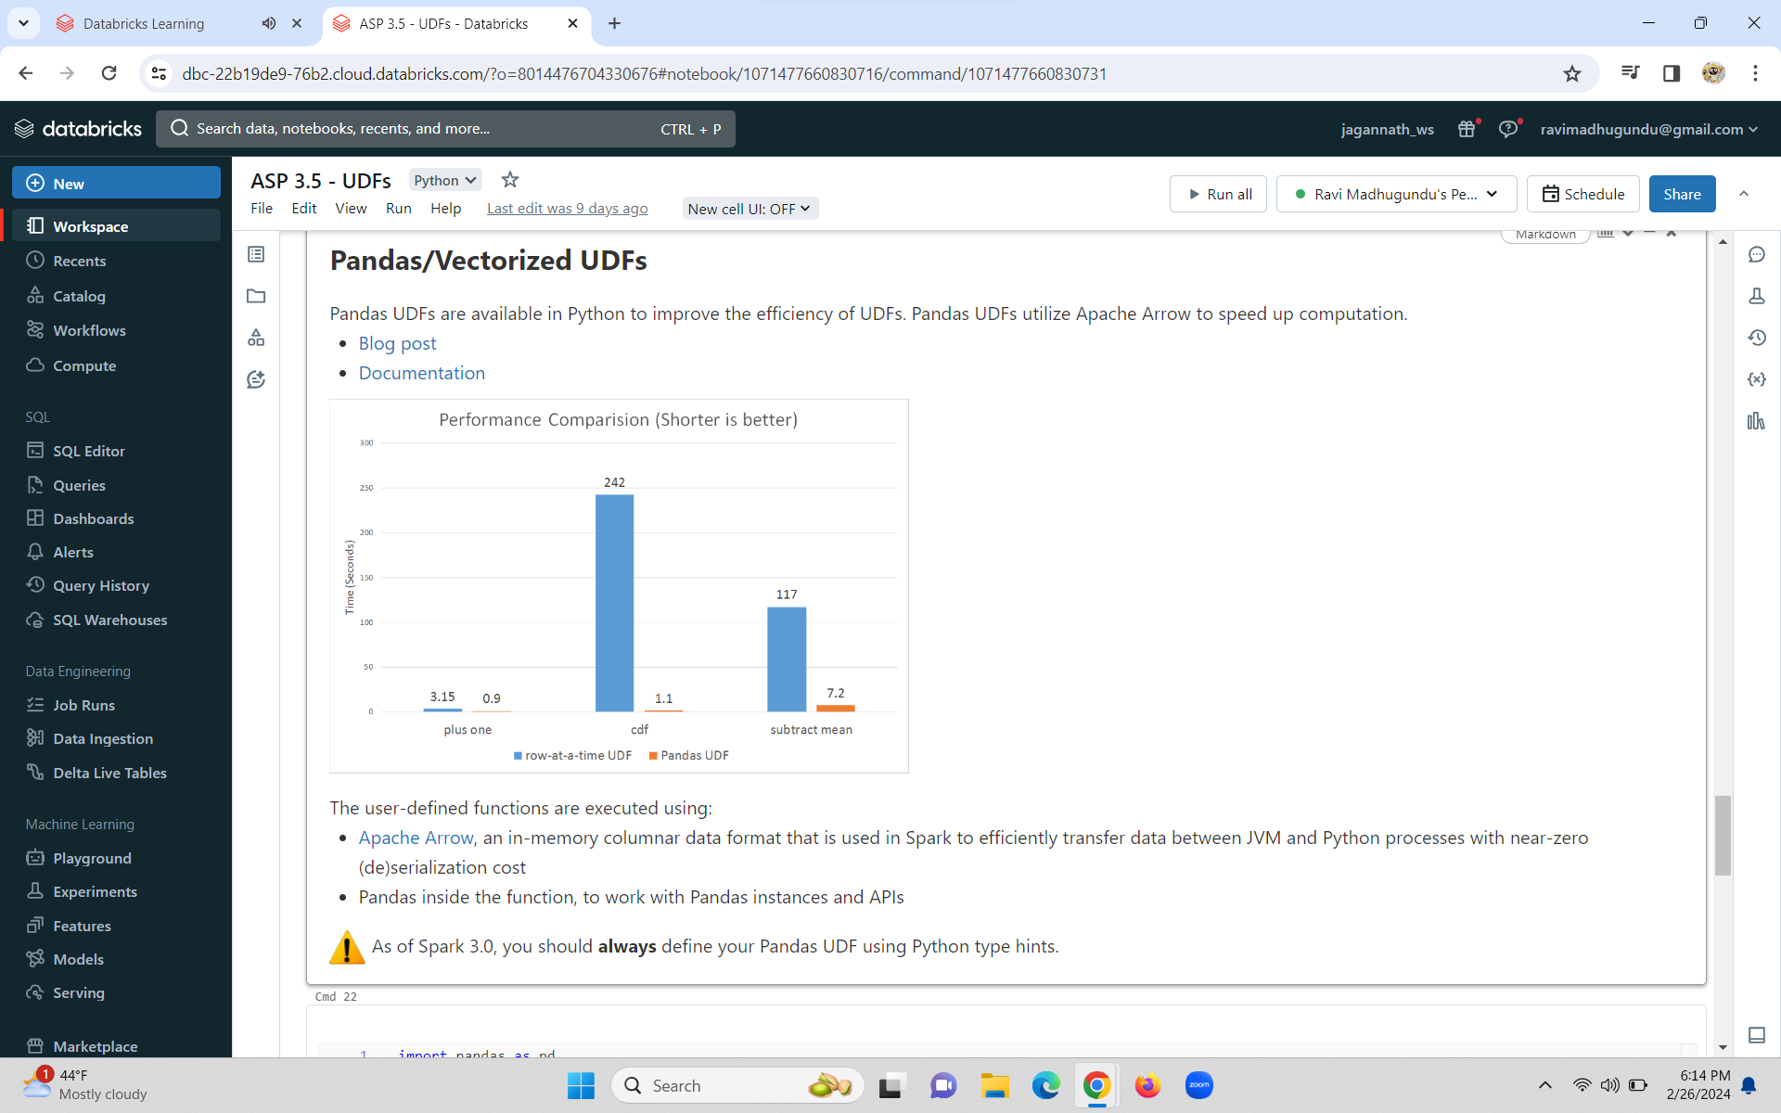

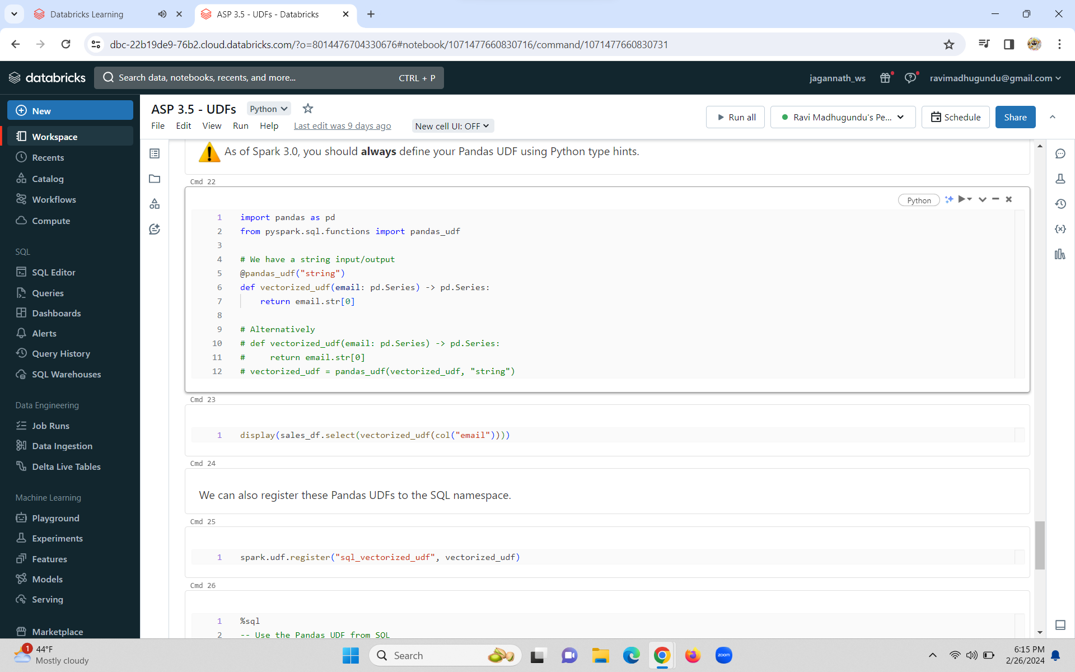

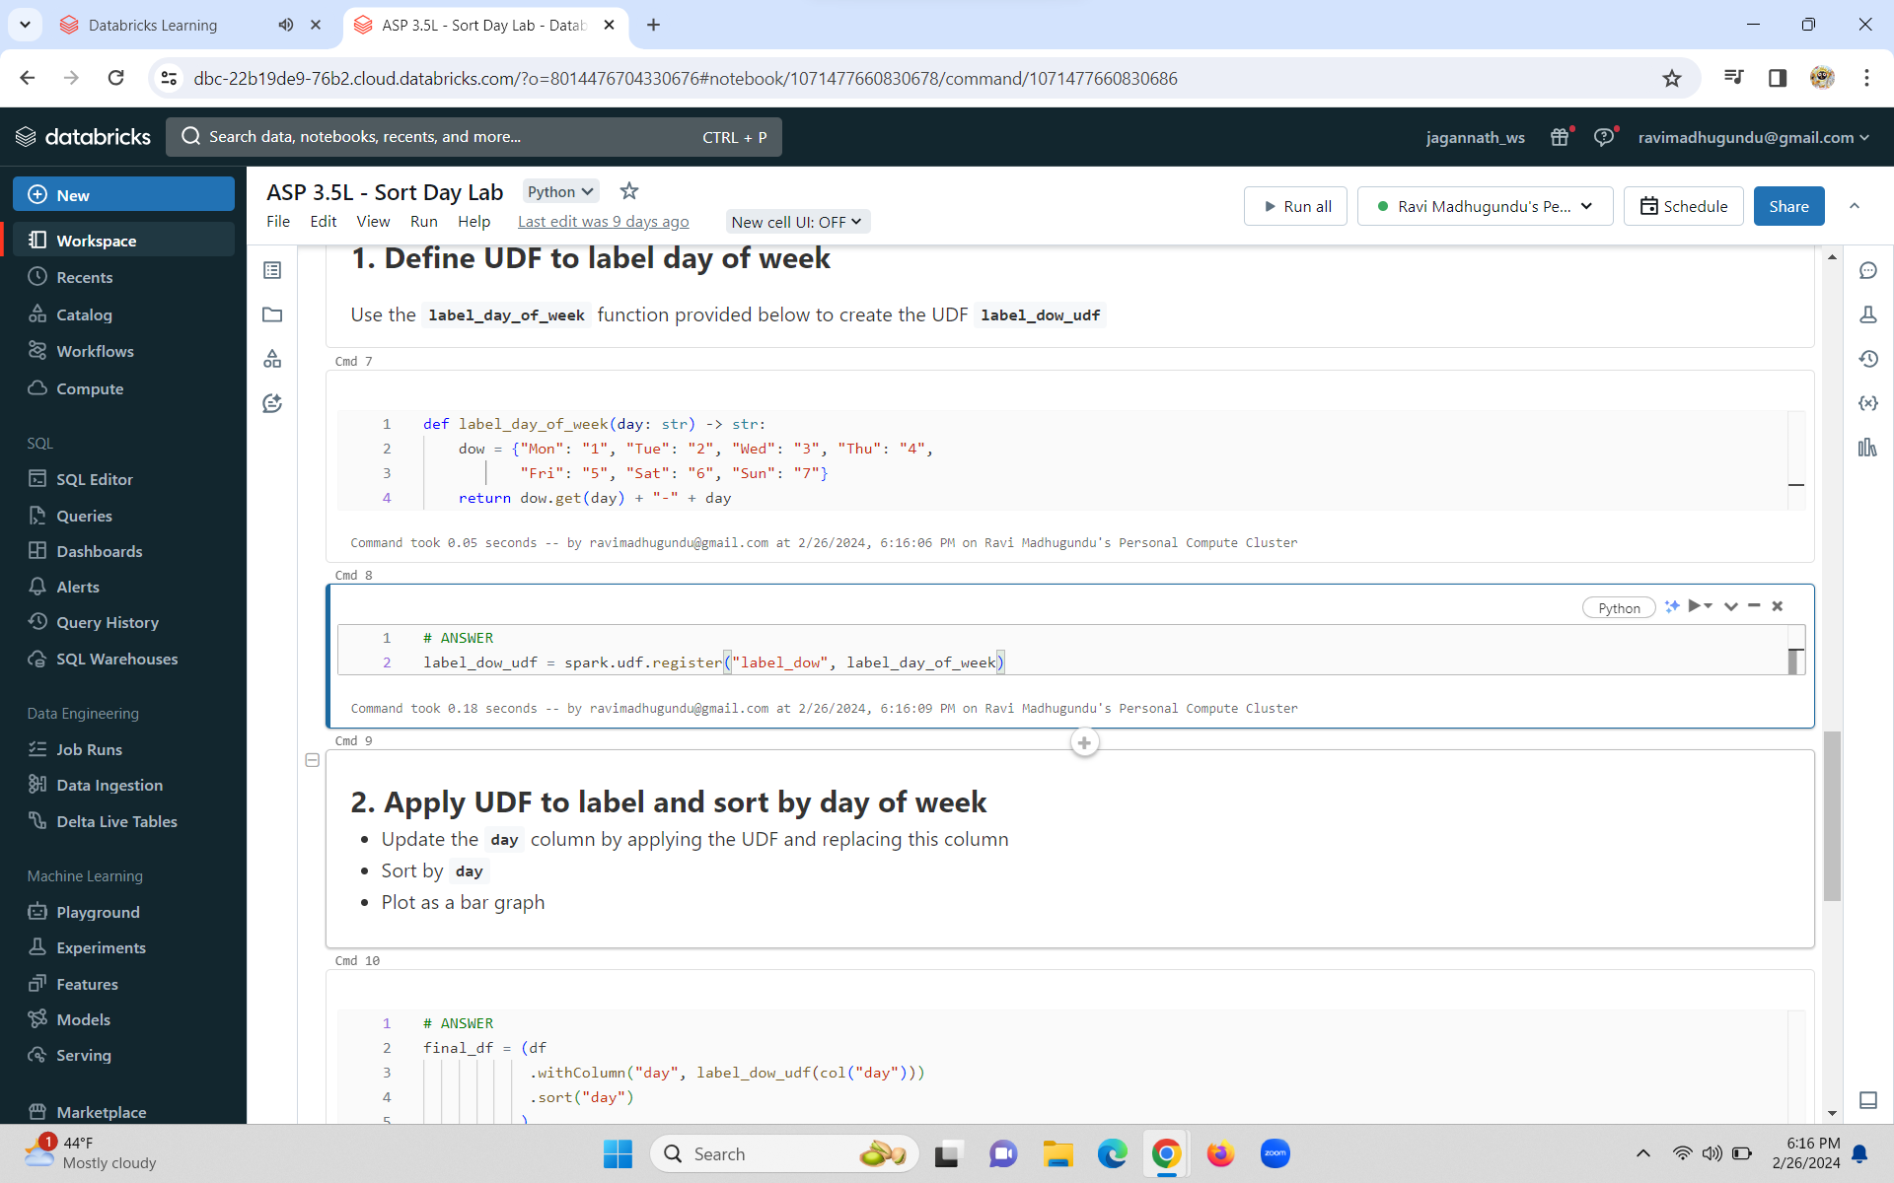

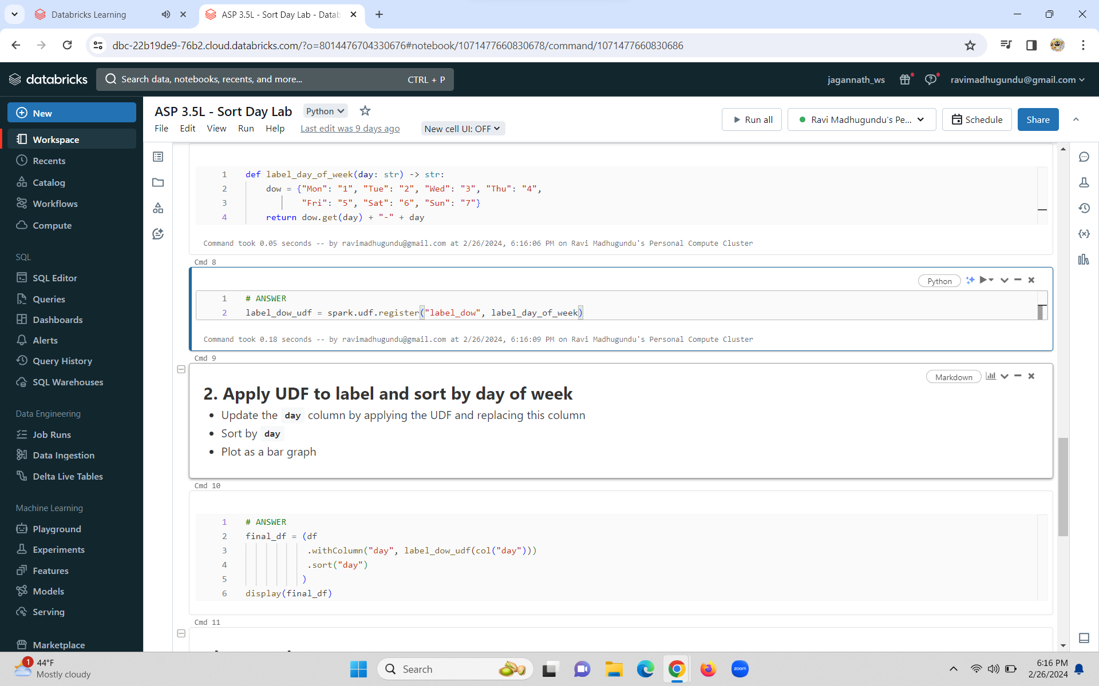

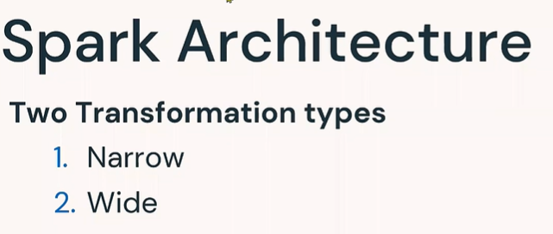

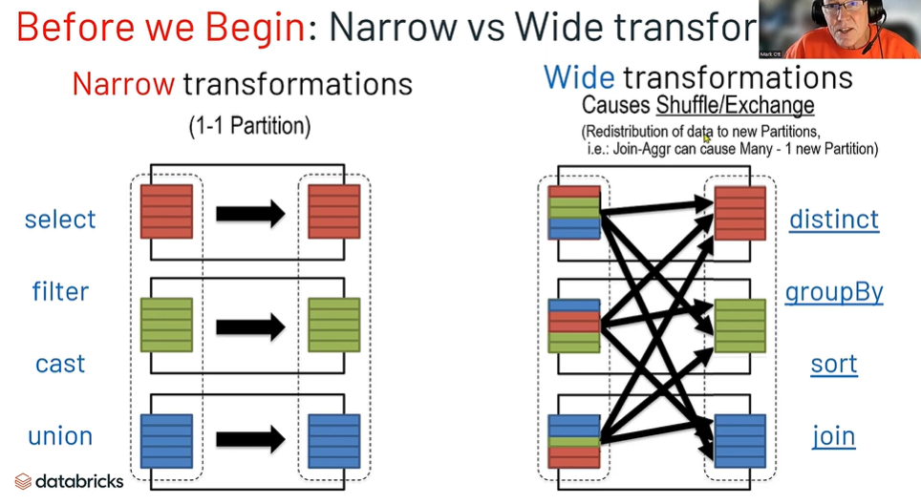

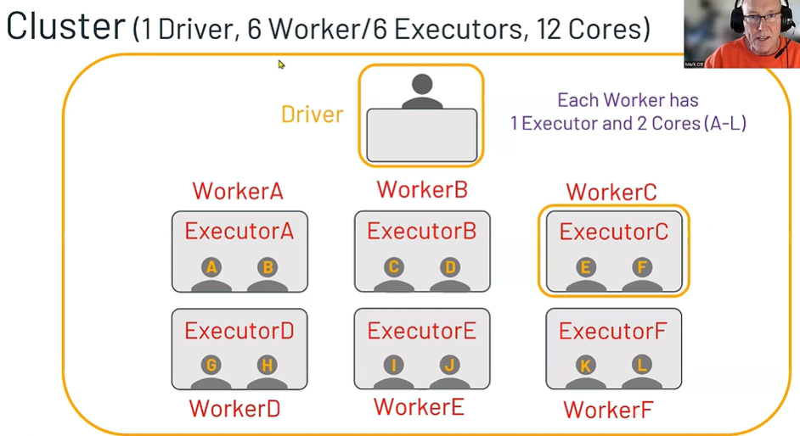 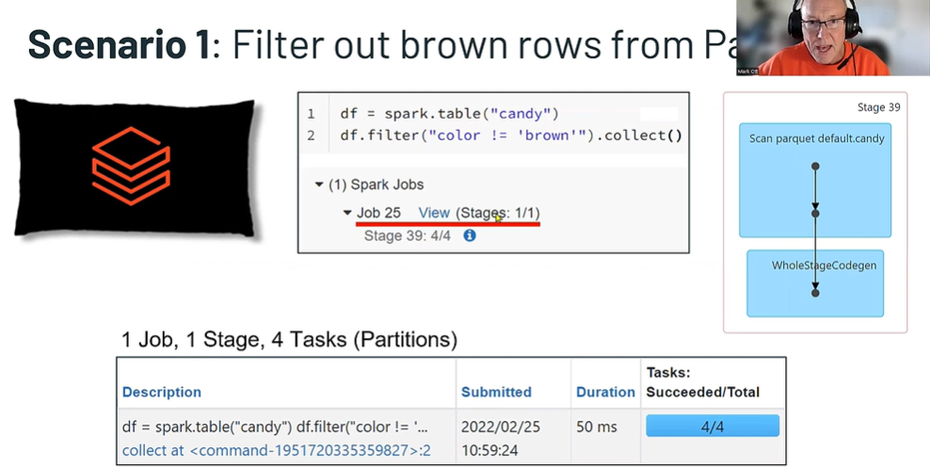

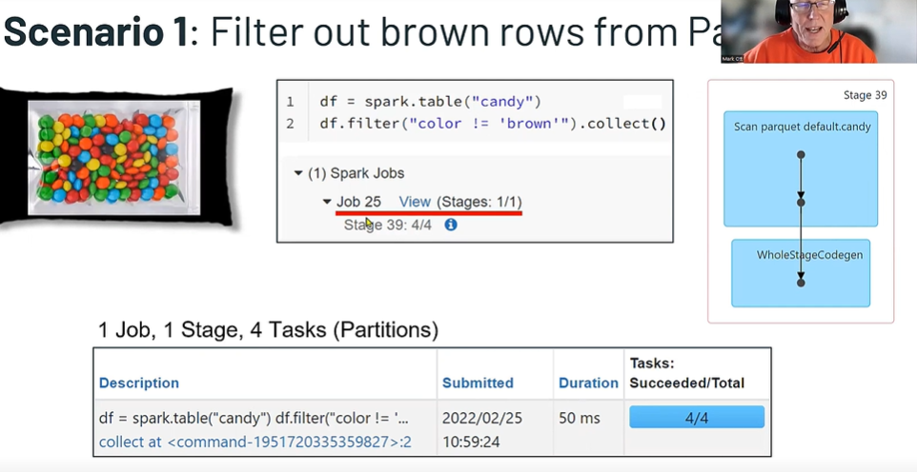

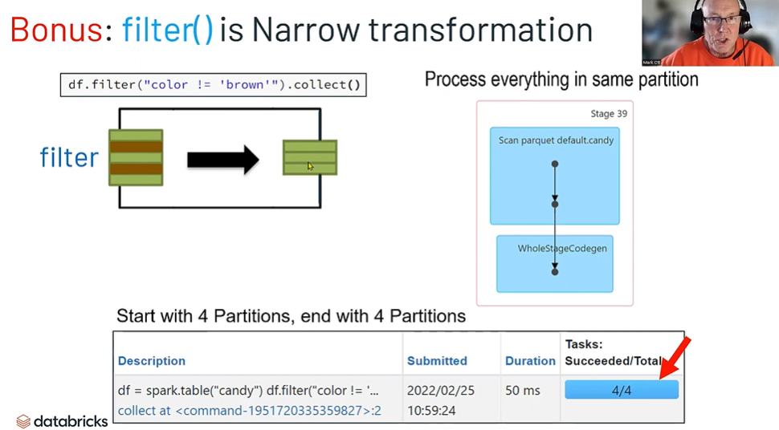

**Inside each task there is one memory partitions**

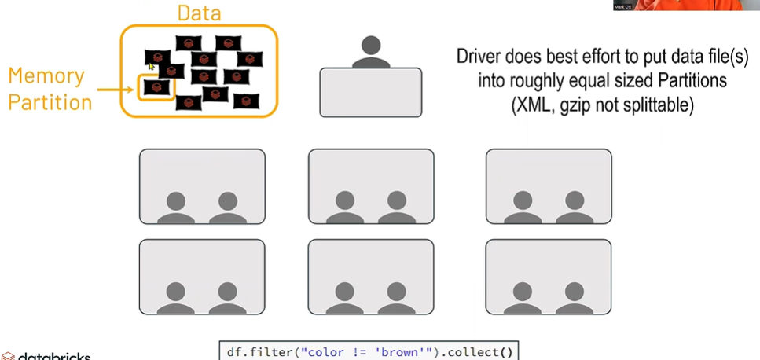

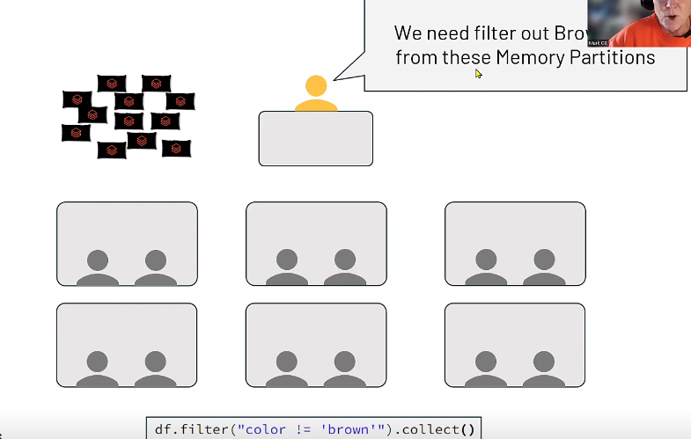

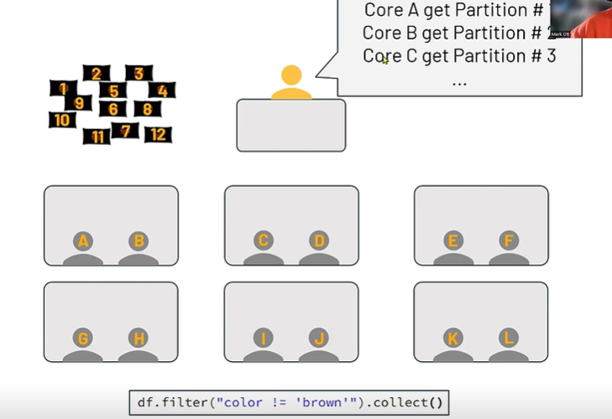

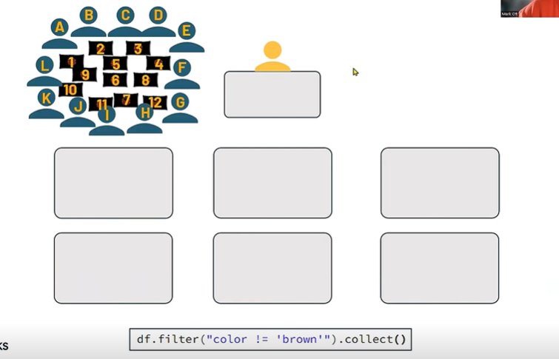

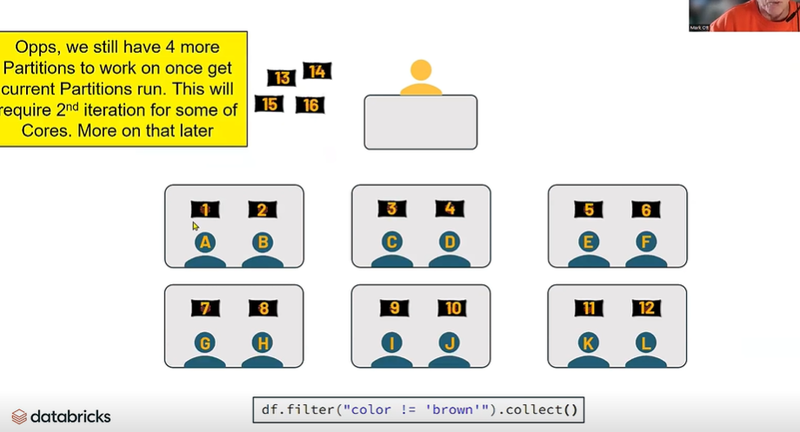

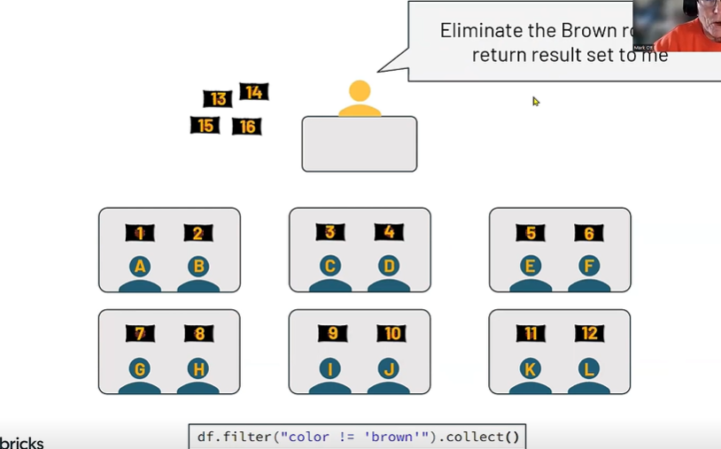

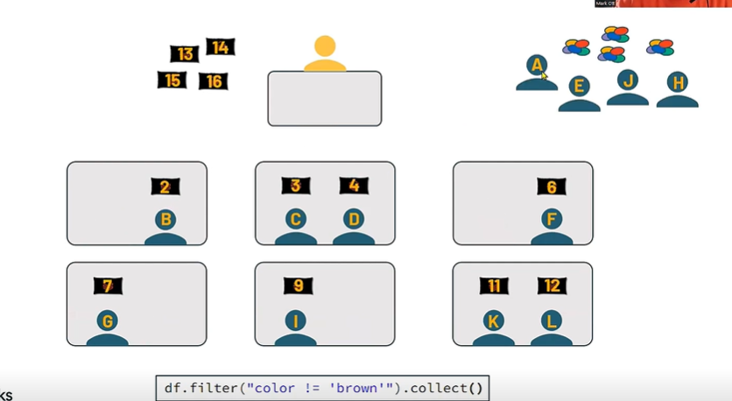

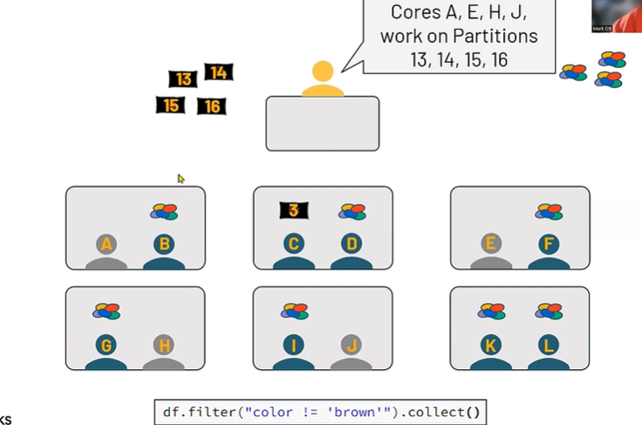

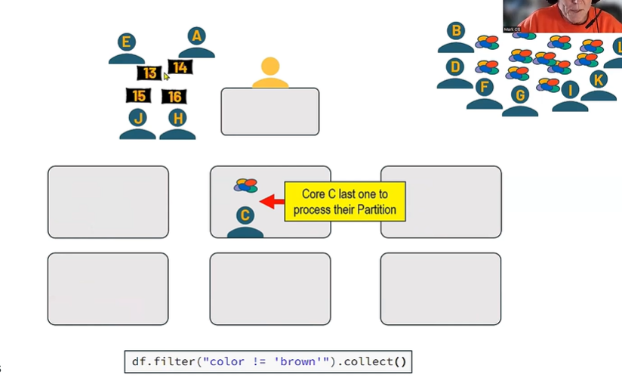

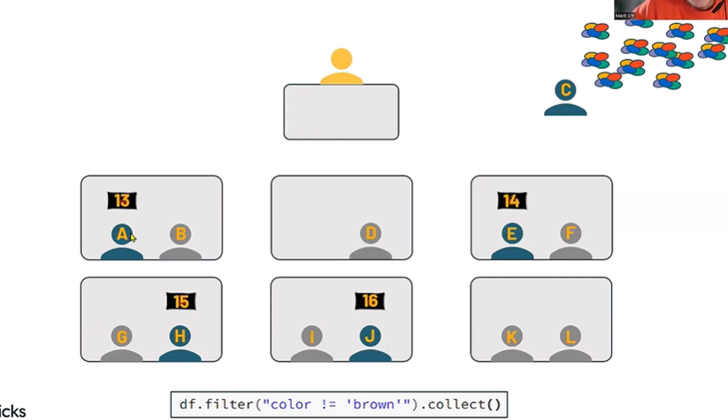

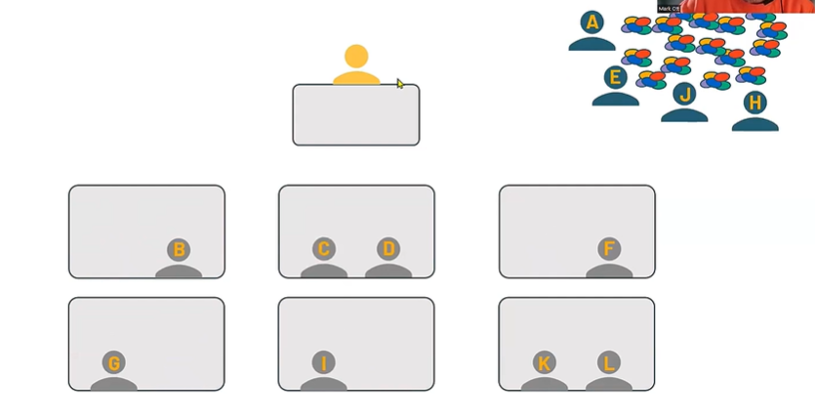

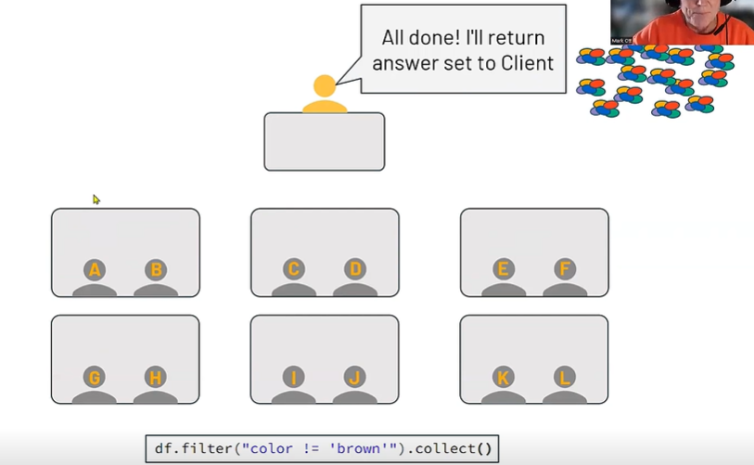

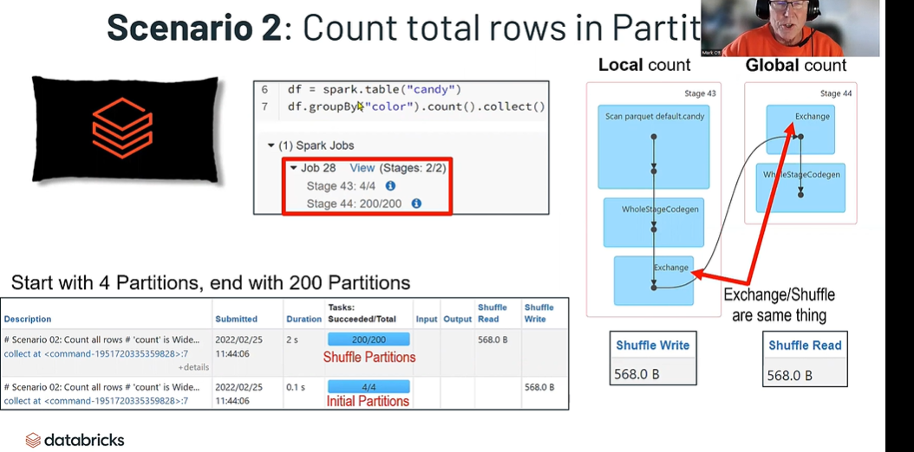

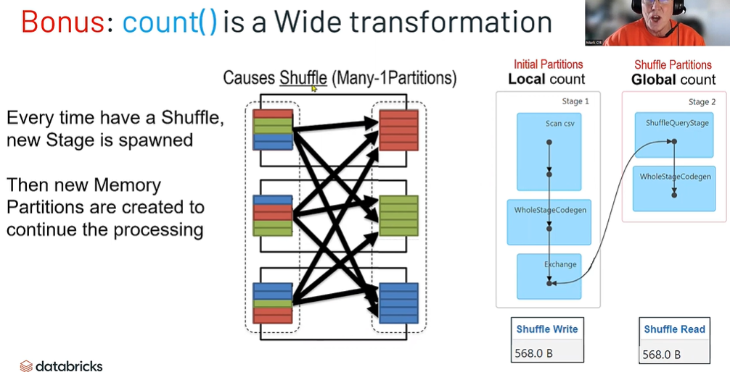

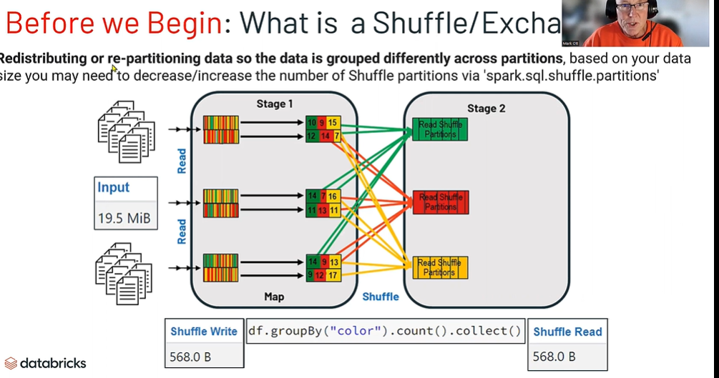

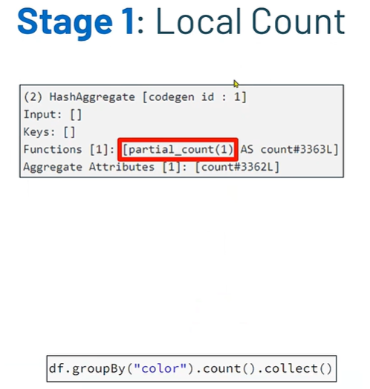

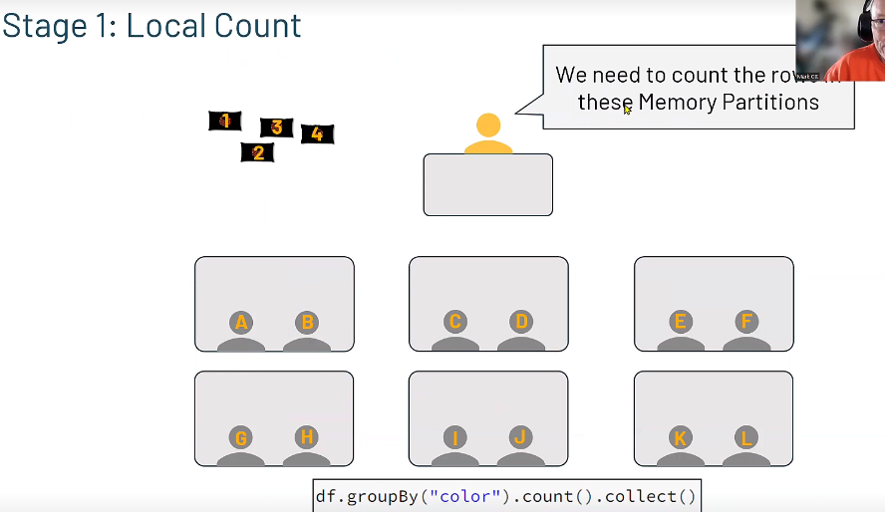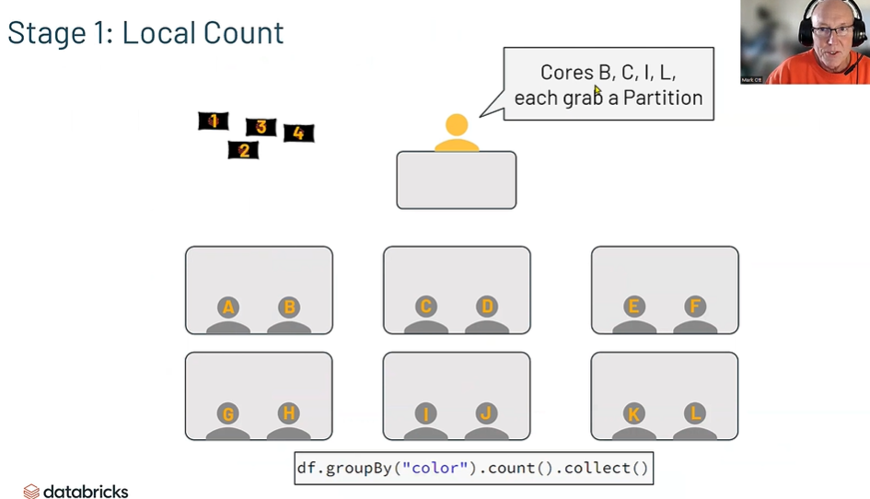

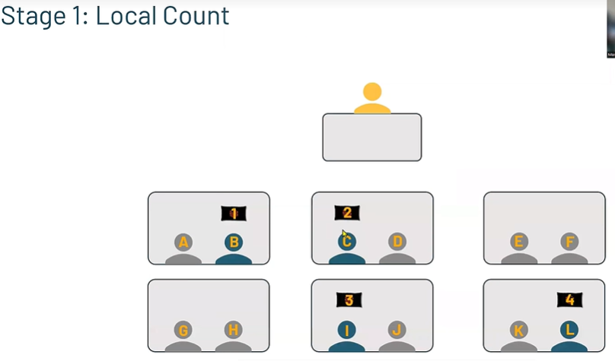

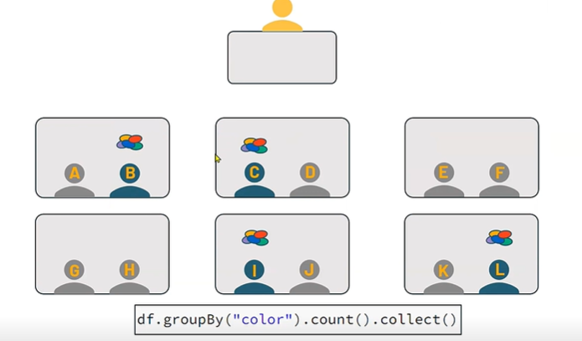

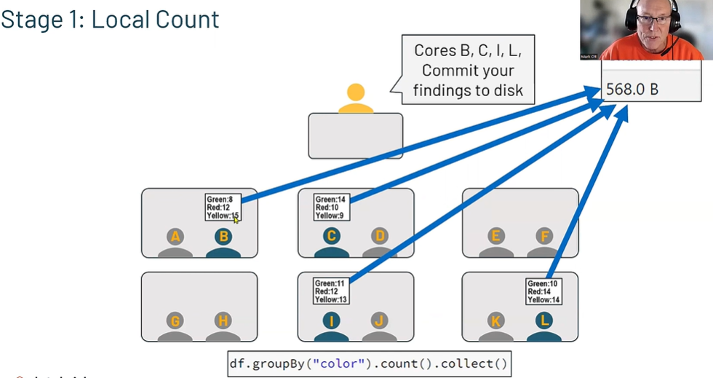

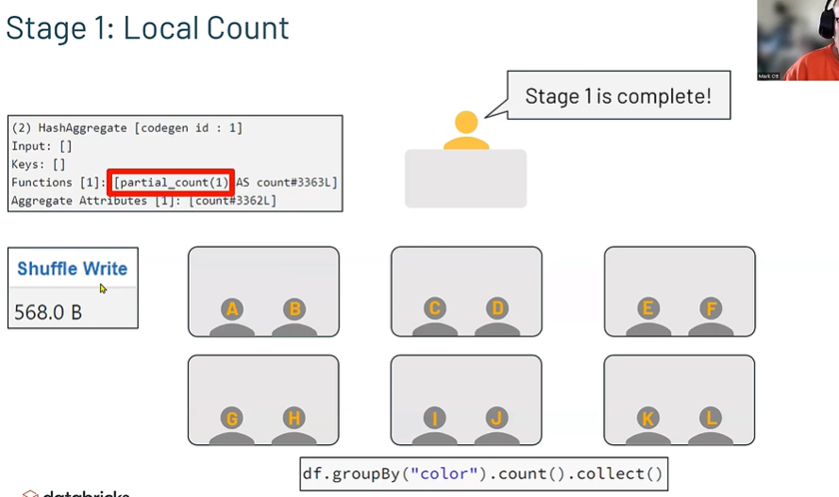

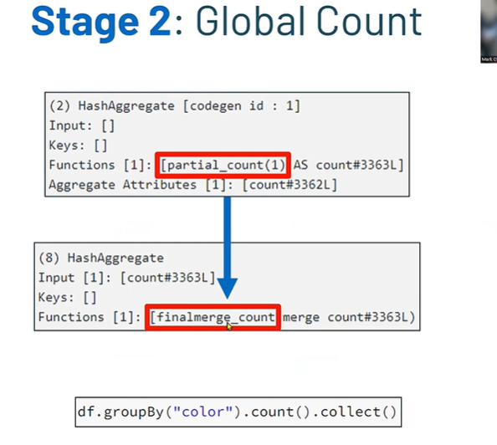

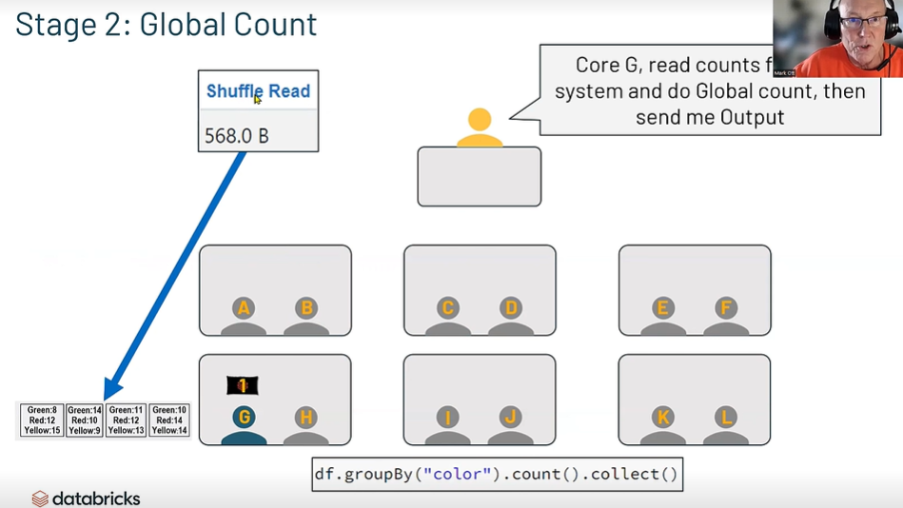

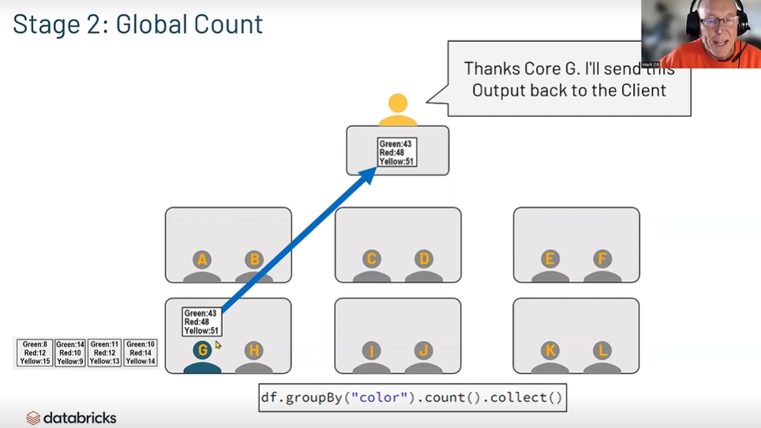

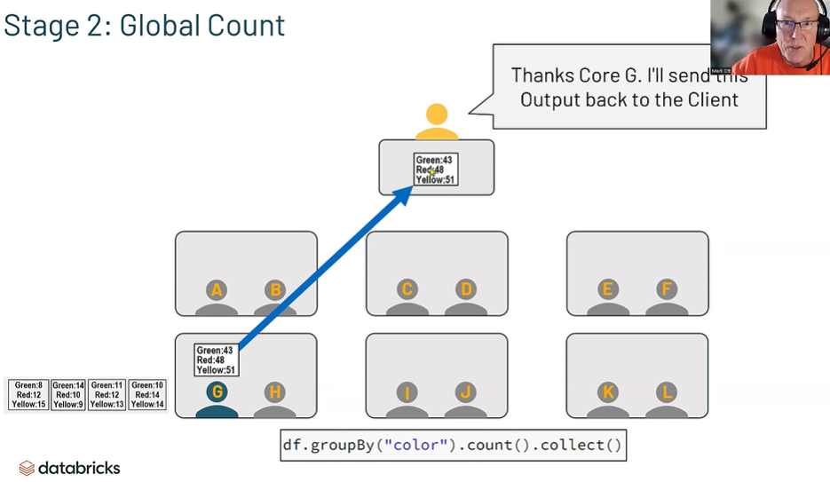

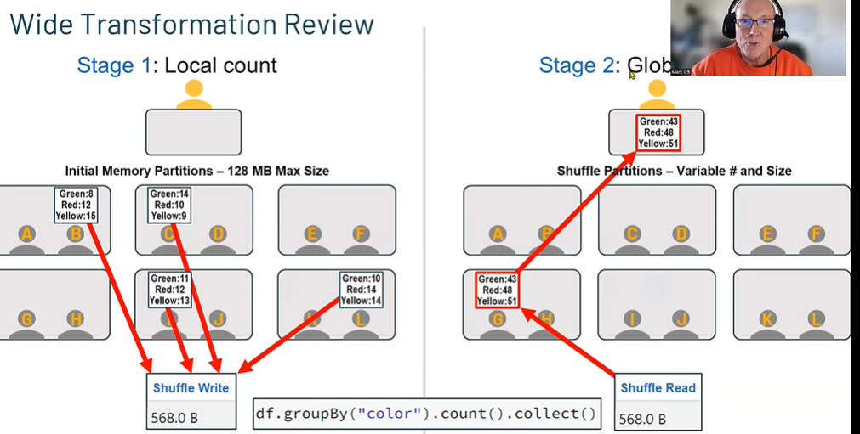

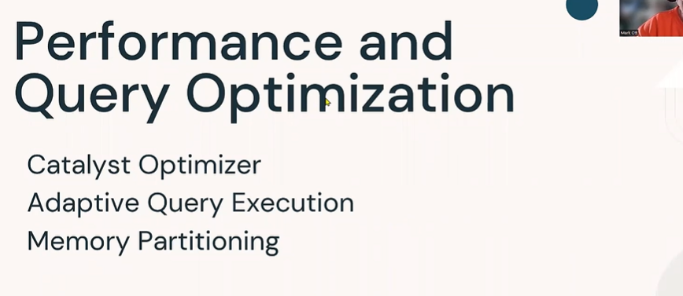

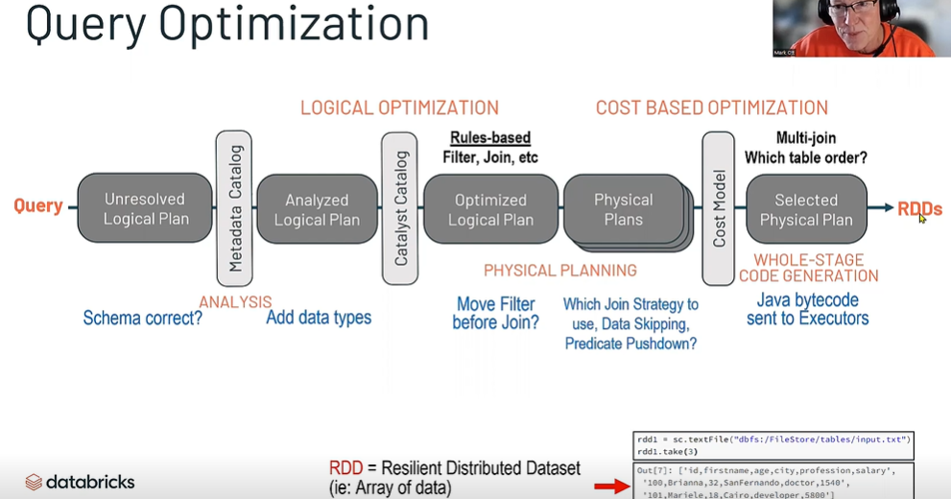

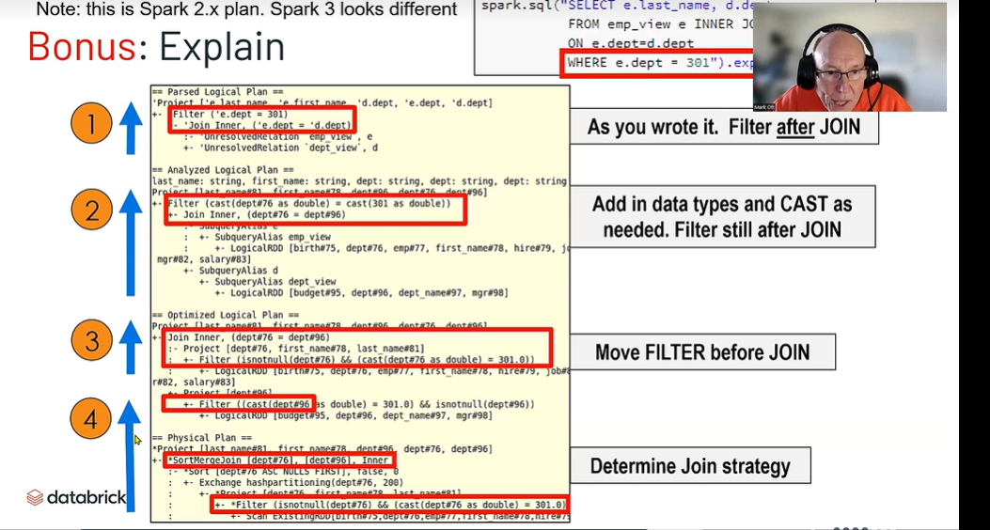

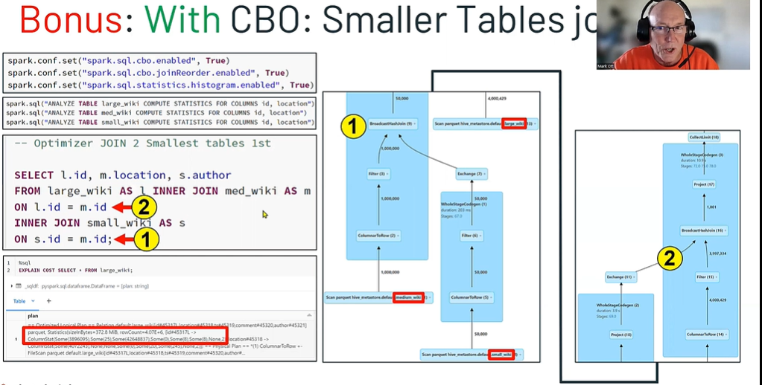

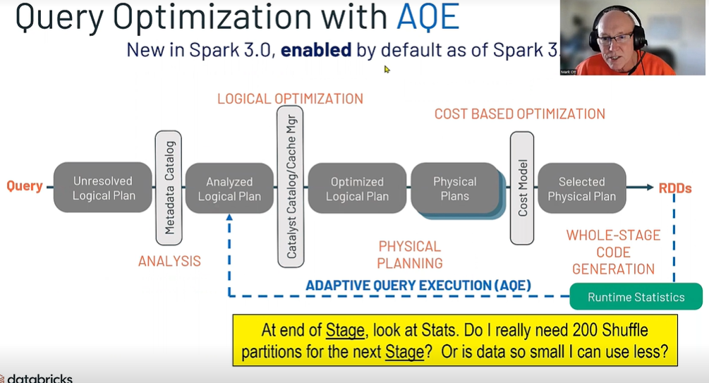

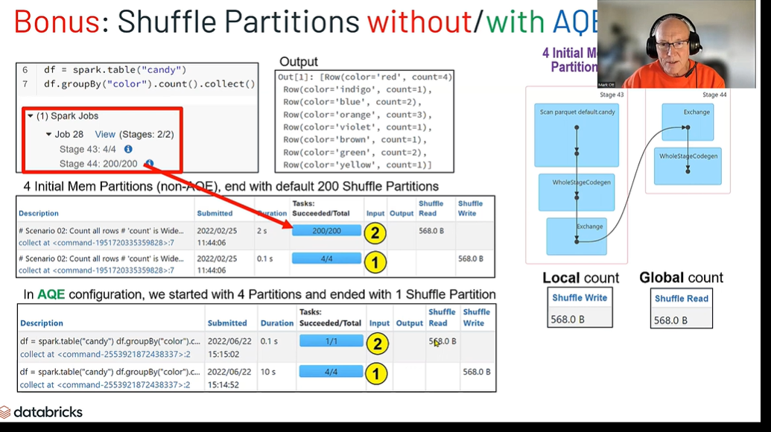

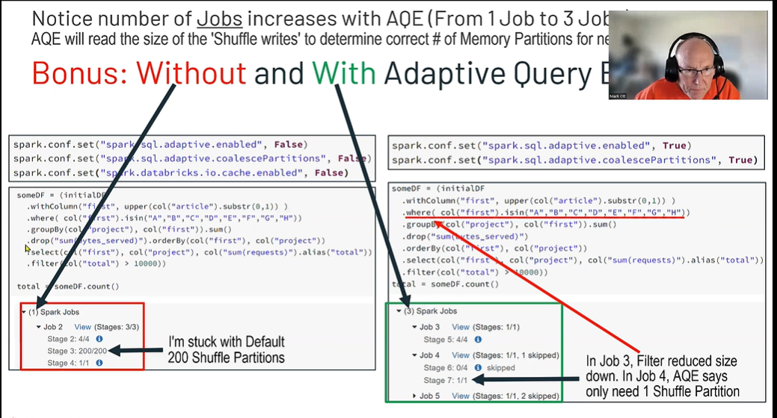

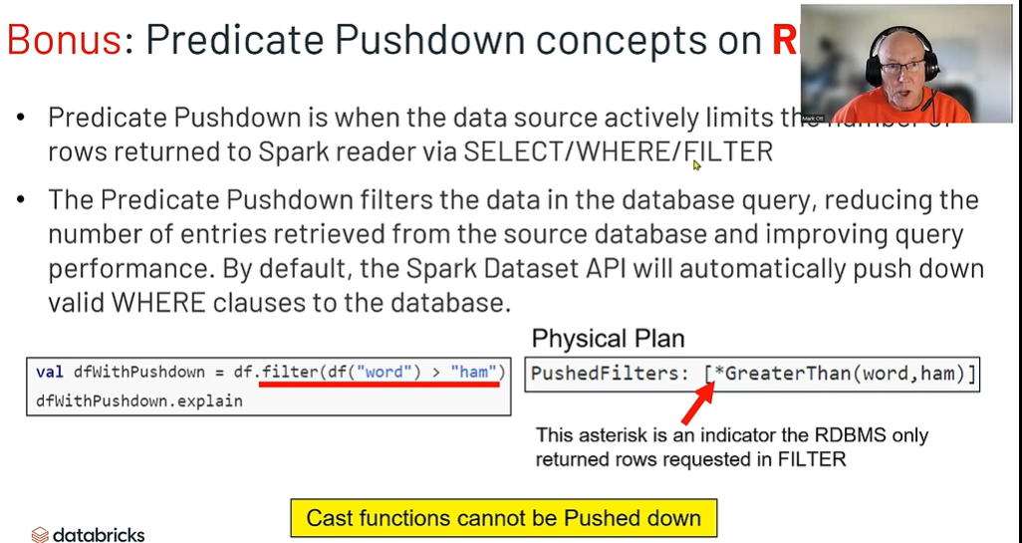

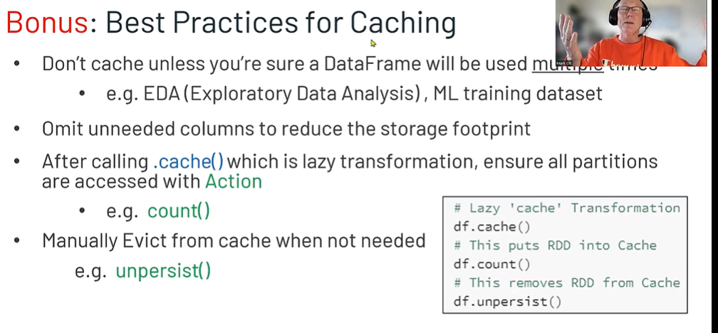

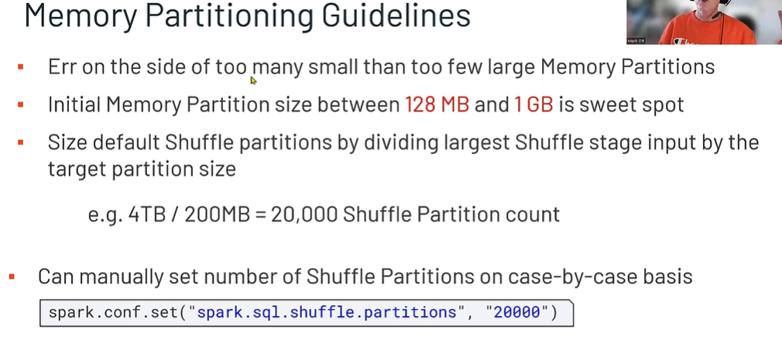

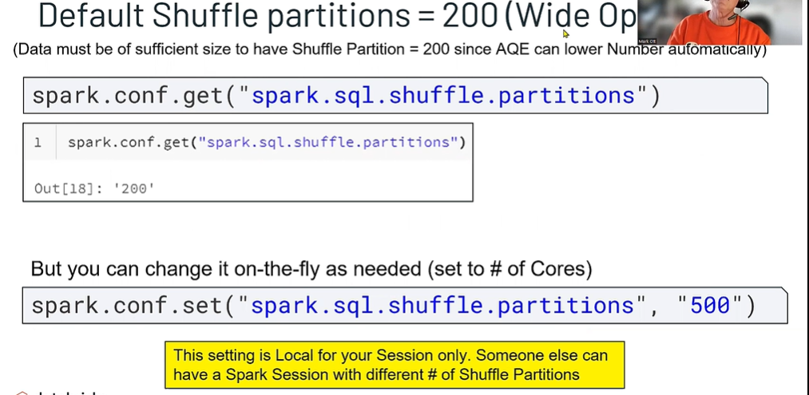

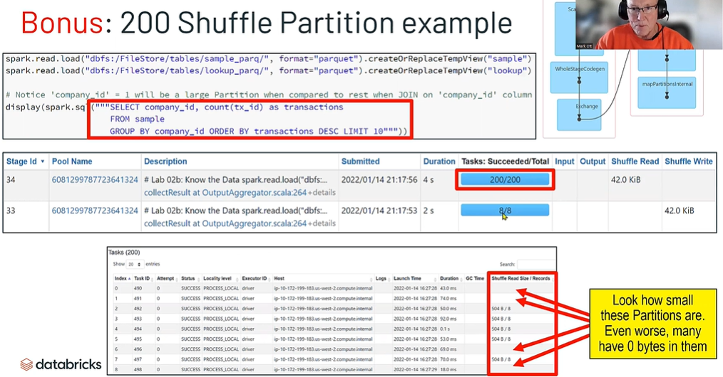

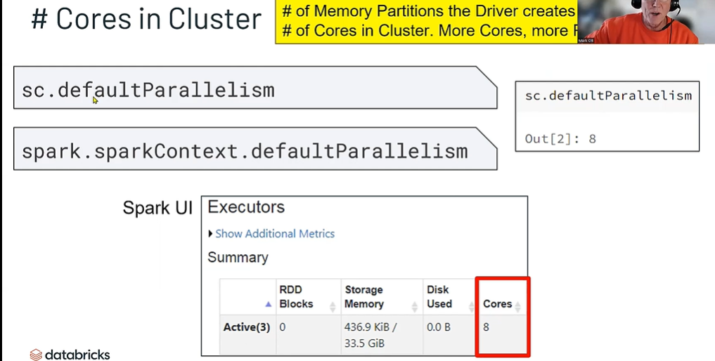

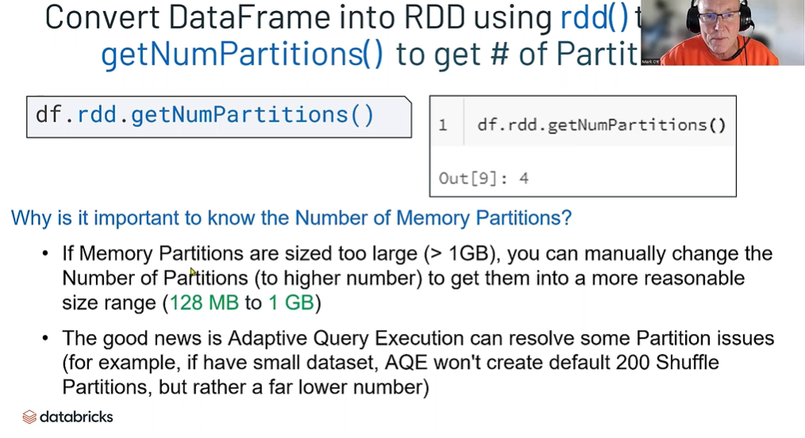

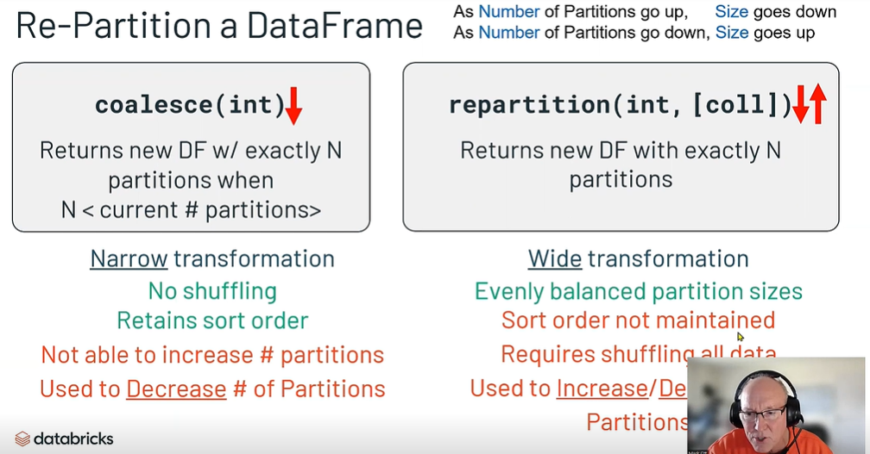

Query Optimization

**We'll explore query plans and optimizations for several examples including logical optimizations and exanples with and without predicate pushdown.**

Objectives

1. **Logical optimizations**
2. **Predicate pushdown**
3. **No predicate pushdown**

Methods

* [**DataFrame**](https://spark.apache.org/docs/3.1.3/api/python/reference/api/pyspark.sql.DataFrame.explain.html#pyspark.sql.DataFrame.explain)**: explain**

Logical Optimization

**explain(..) prints the query plans, optionally formatted by a given explain mode. Compare the following logical plan & physical plan, noting how Catalyst handled the multiple filter transformations.**

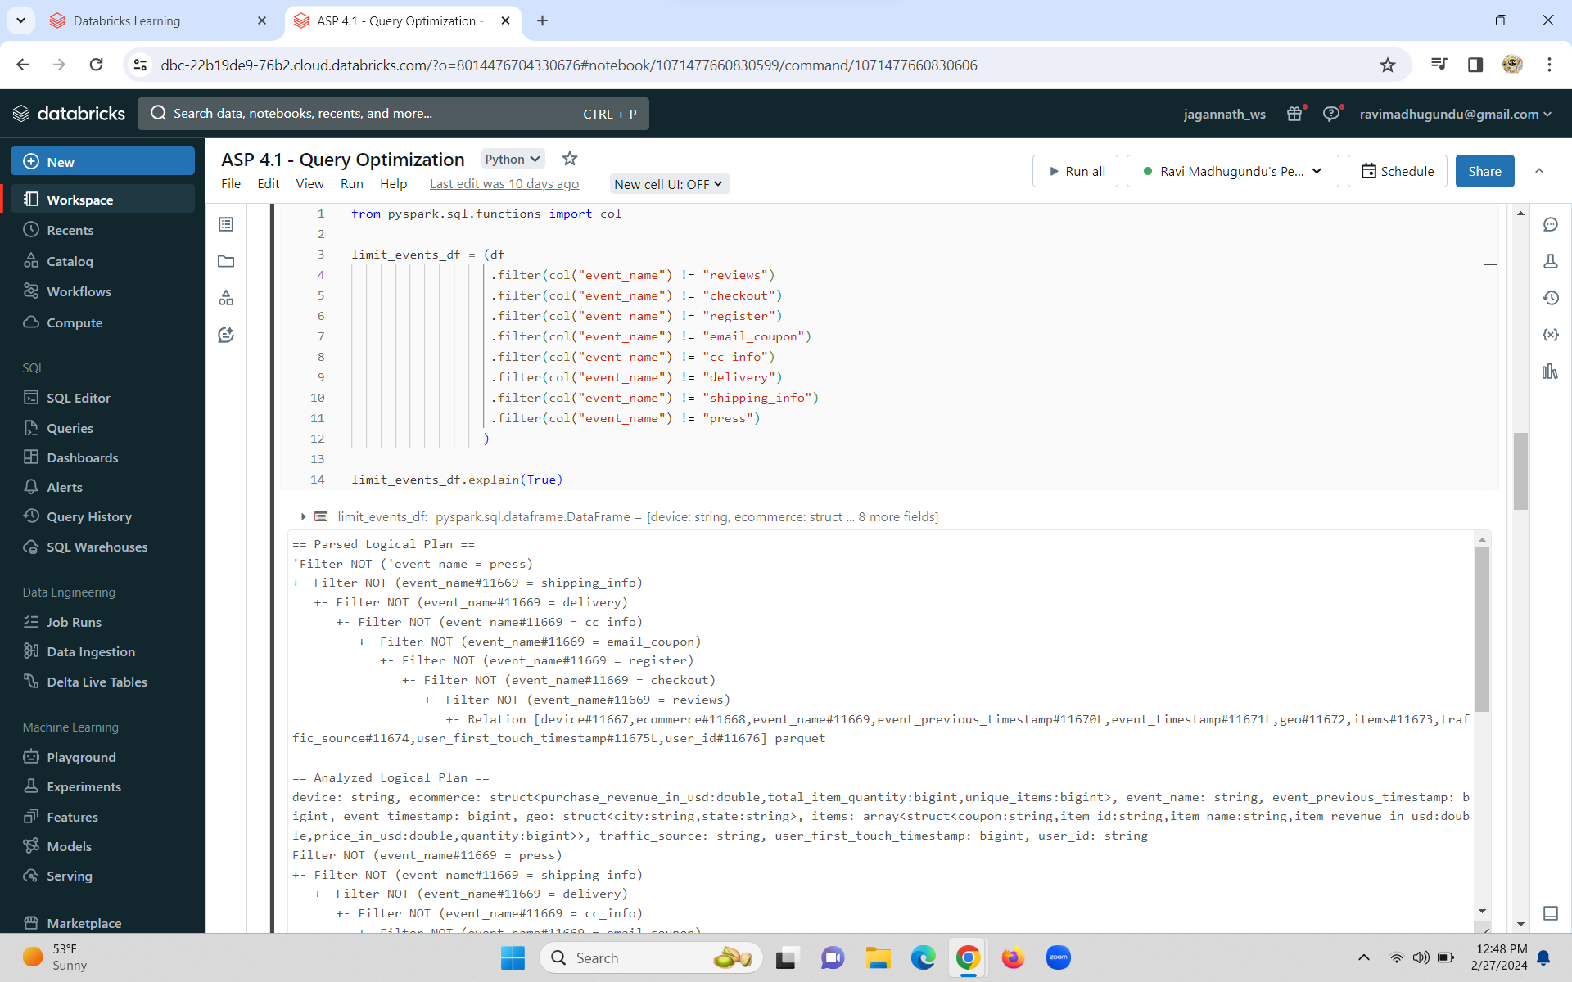

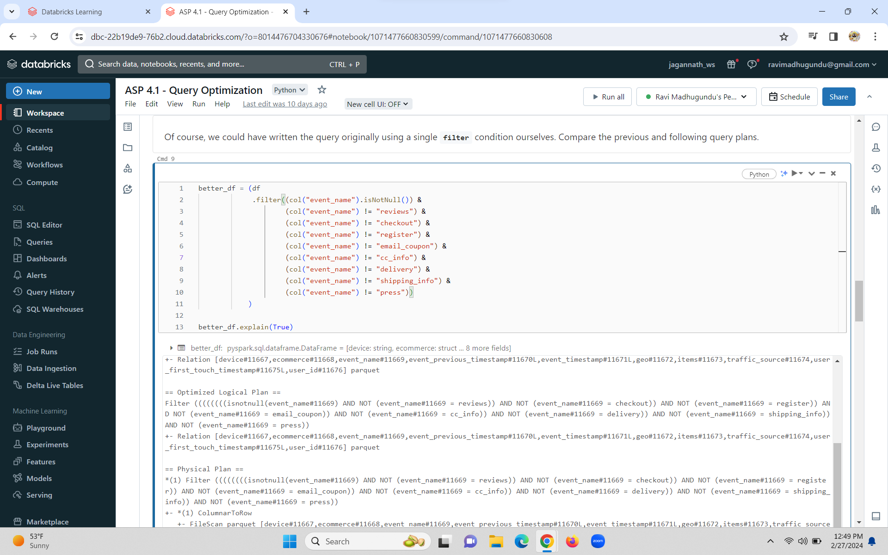

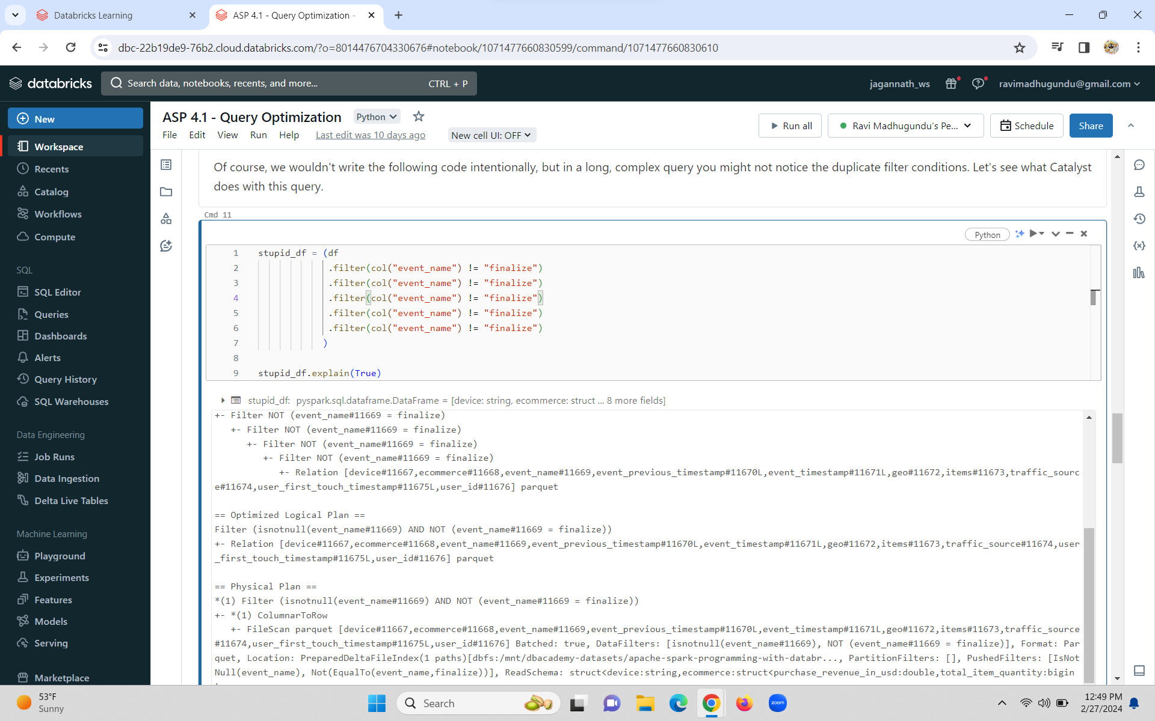

Caching

**By default the data of a DataFrame is present on a Spark cluster only while it is being processed during a query -- it is not automatically persisted on the cluster afterwards. (Spark is a data processing engine, not a data storage system.) You can explicity request Spark to persist a DataFrame on the cluster by invoking its cache method.**

**If you do cache a DataFrame, you should always explictly evict it from cache by invoking unpersist when you no longer need it.**

** Caching a DataFrame can be appropriate if you are certain that you will use the same DataFrame multiple times, as in:**

* **Exploratory data analysis**
* **Machine learning model training**

** Aside from those use cases, you should not cache DataFrames because it is likely that you'll *degrade* the performance of your application.**

* **Caching consumes cluster resources that could otherwise be used for task execution**
* **Caching can prevent Spark from performing query optimizations, as shown in the next example**

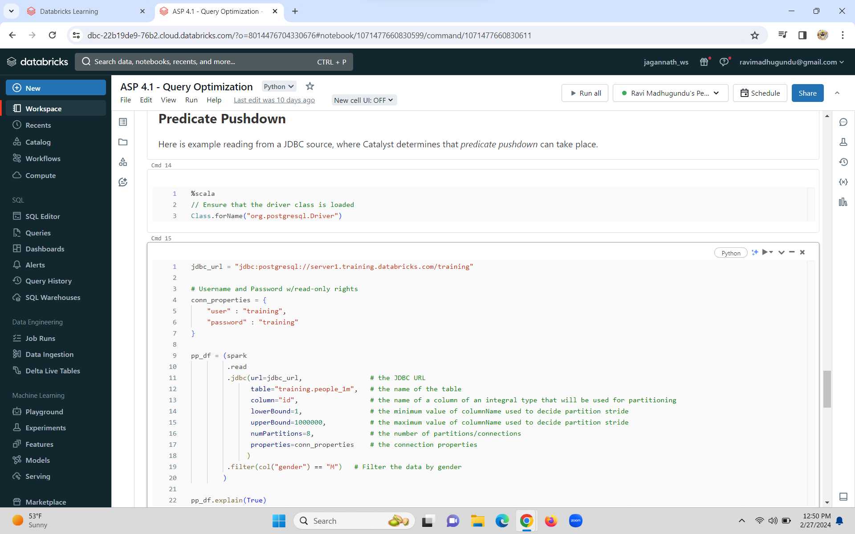

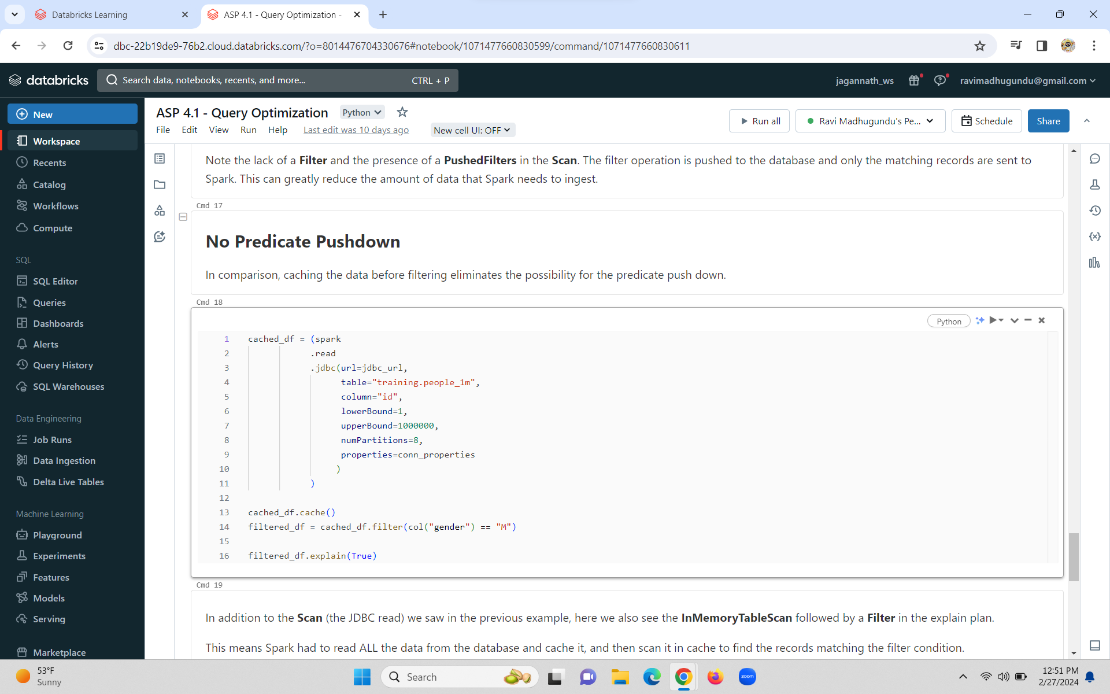

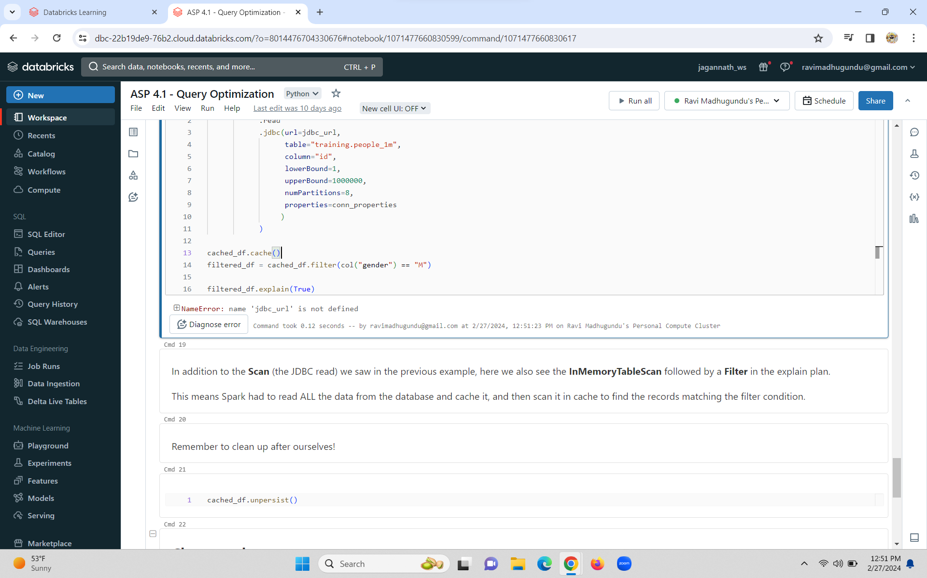

Partitioning

Objectives

1. **Get partitions and cores**
2. **Repartition DataFrames**
3. **Configure default shuffle partitions**

Methods

* [**DataFrame**](https://spark.apache.org/docs/latest/api/python/reference/pyspark.sql/dataframe.html)**: repartition, coalesce, rdd.getNumPartitions**
* [**SparkConf**](https://spark.apache.org/docs/latest/api/python/reference/api/pyspark.SparkConf.html)**: get, set**
* [**SparkSession**](https://spark.apache.org/docs/latest/api/python/reference/pyspark.sql/api/pyspark.sql.SparkSession.html)**: spark.sparkContext.defaultParallelism**

SparkConf Parameters

* **spark.sql.shuffle.partitions, spark.sql.adaptive.enabled**

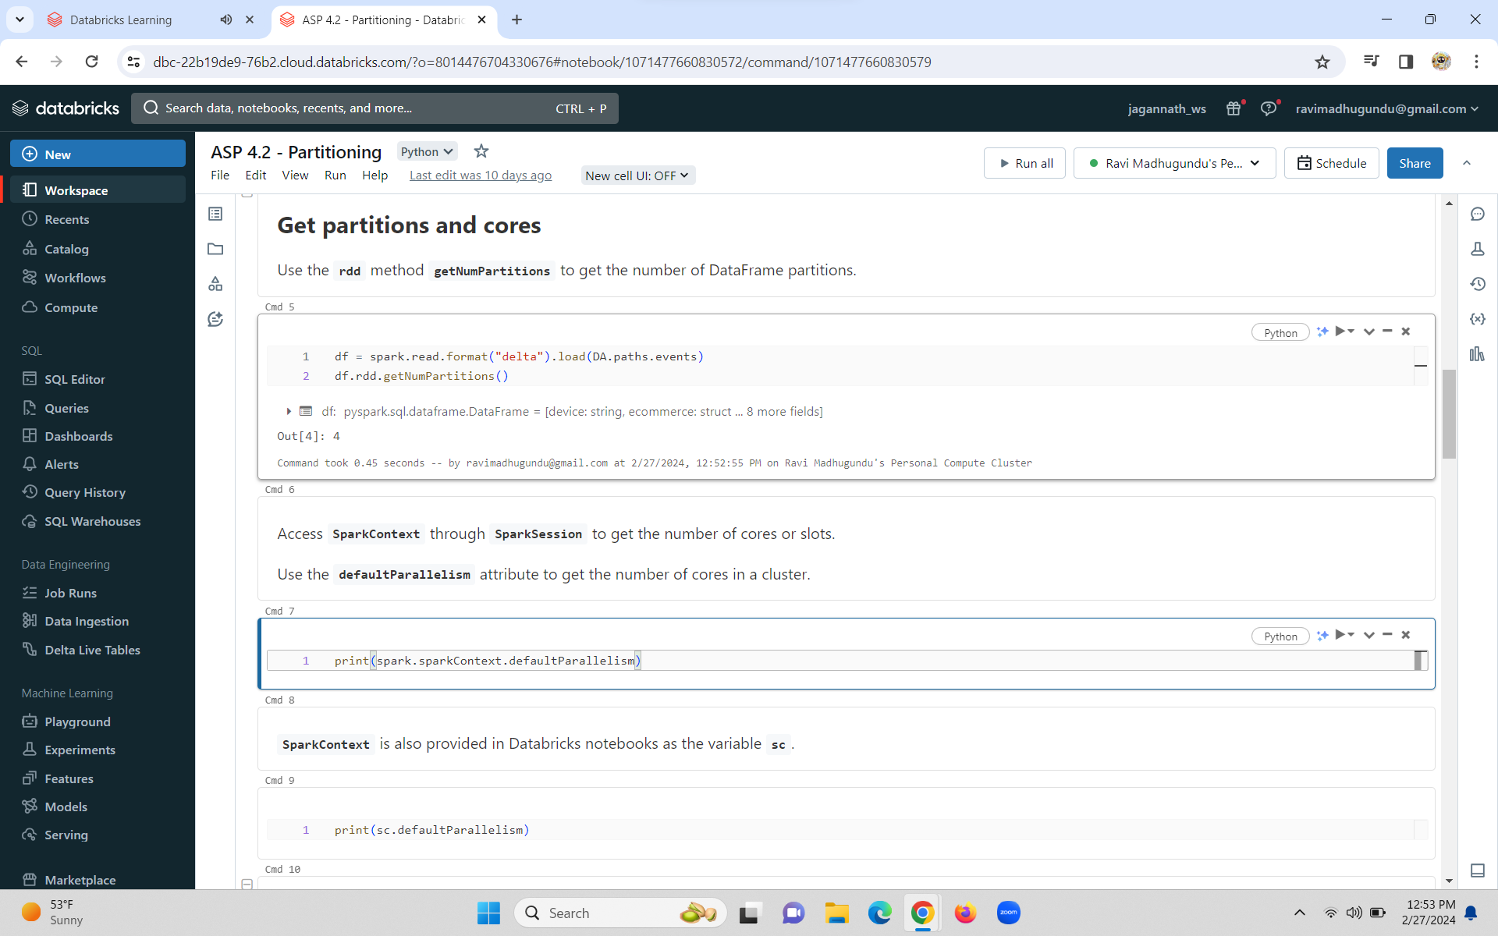

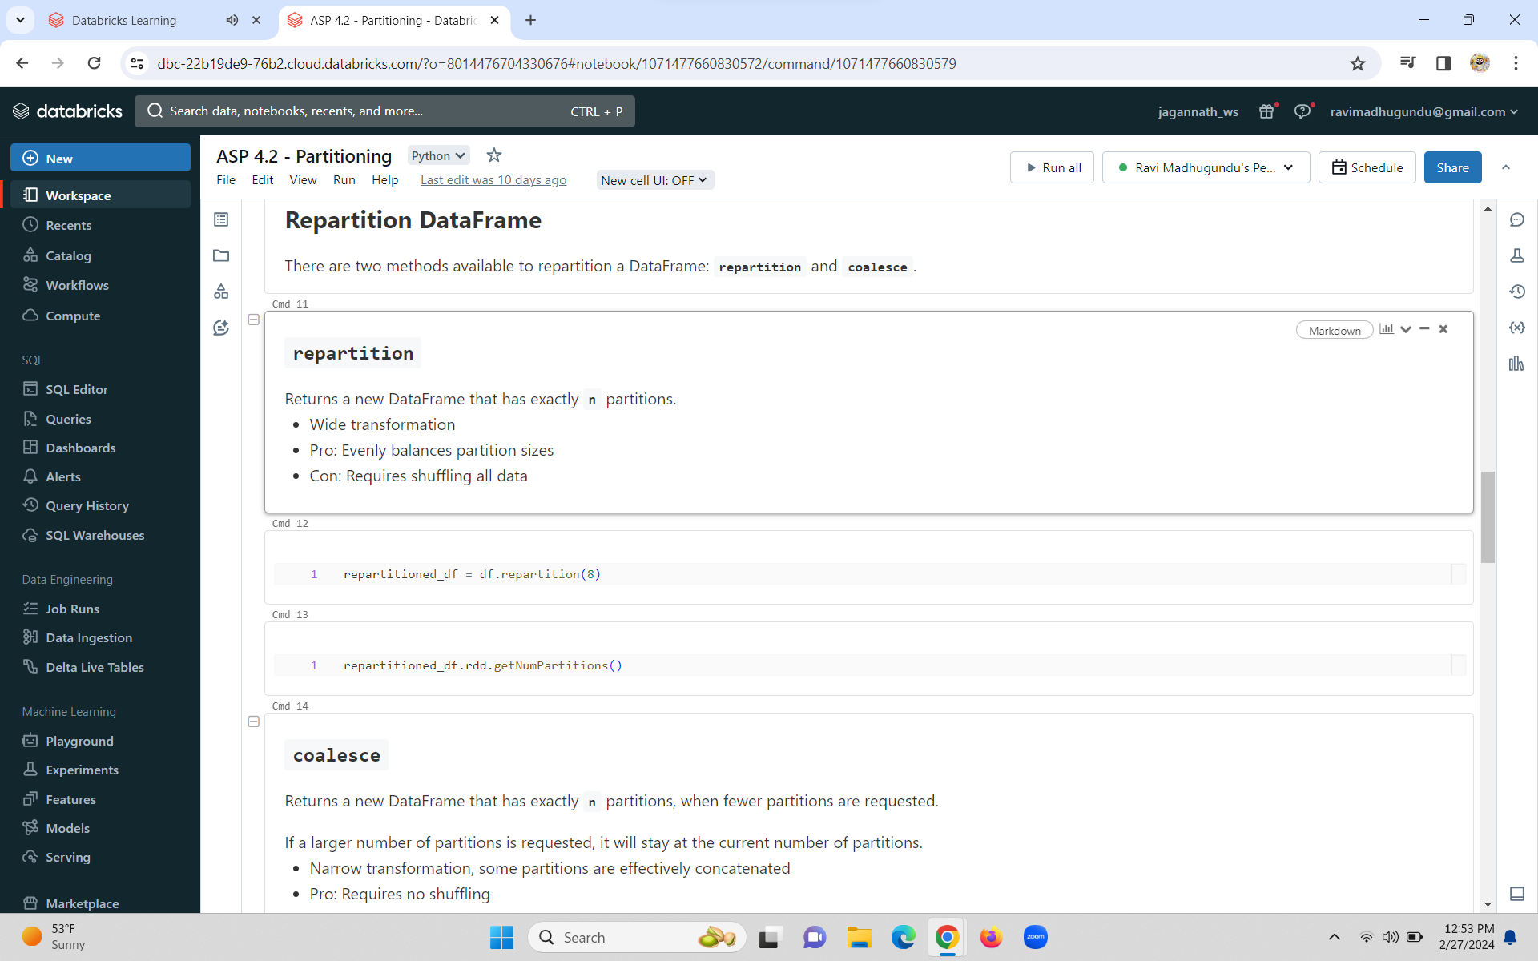

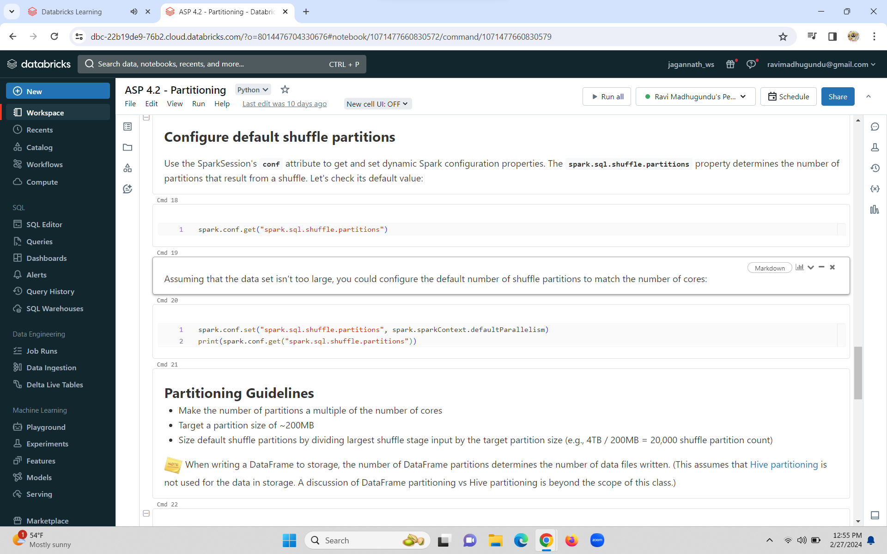

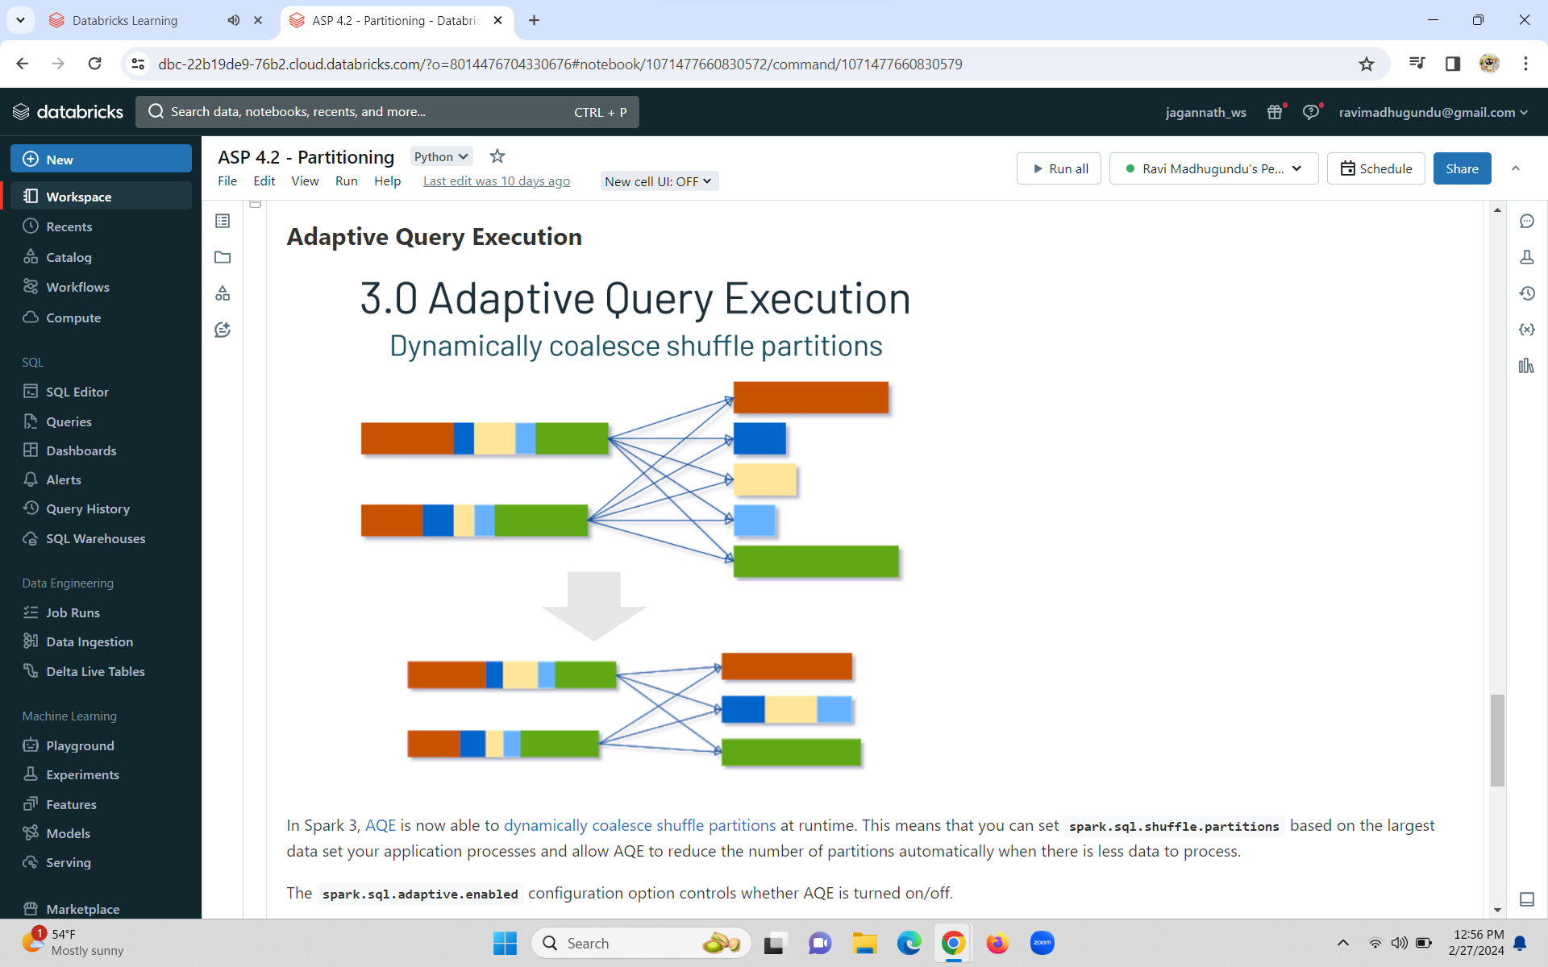

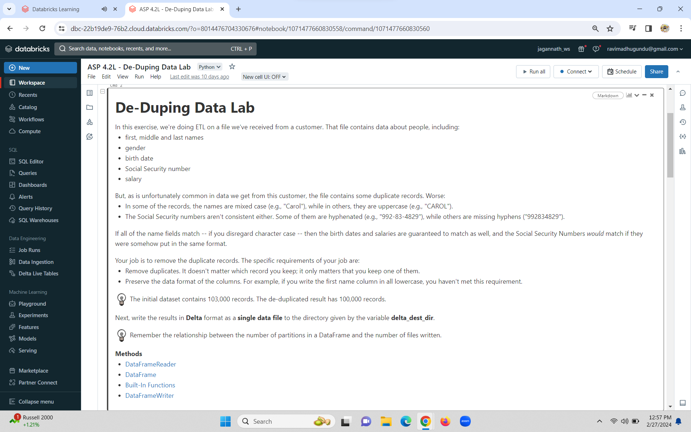

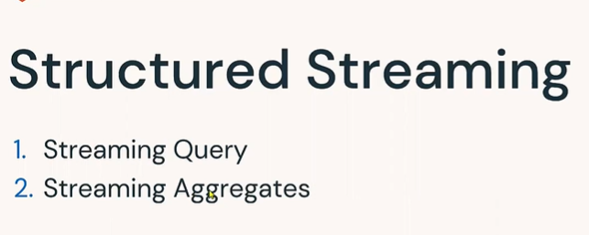

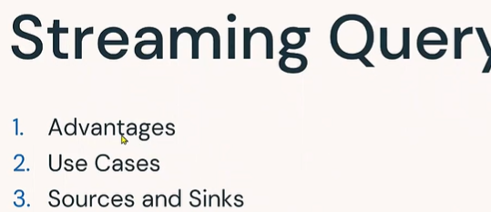

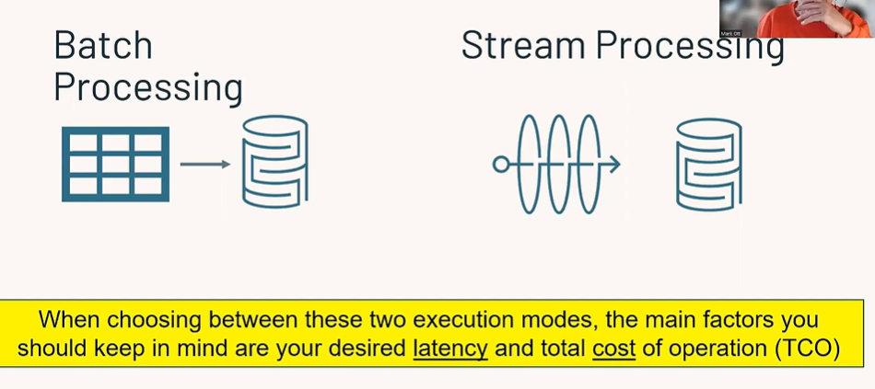

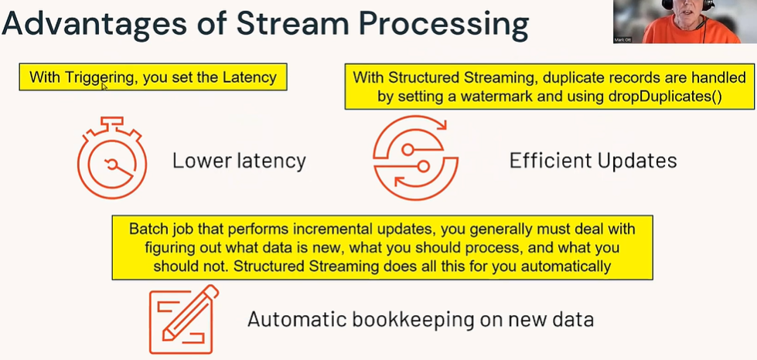

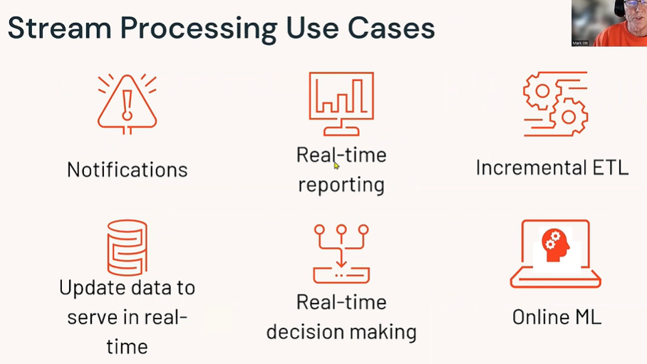

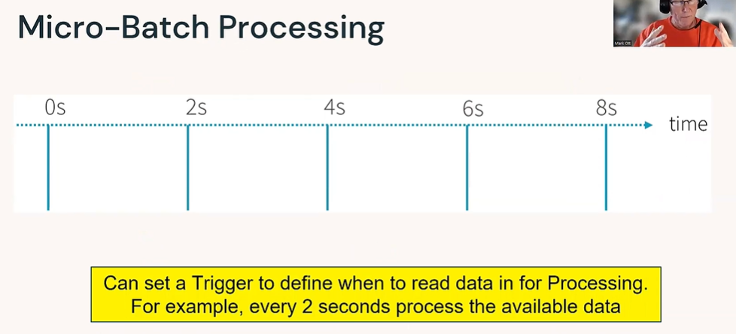

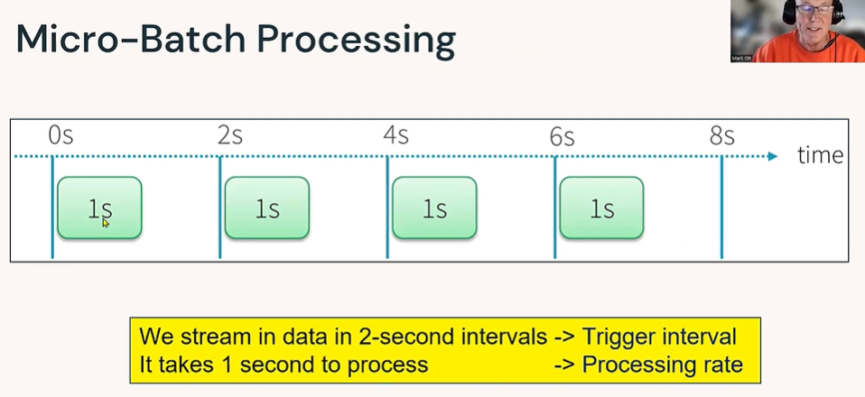

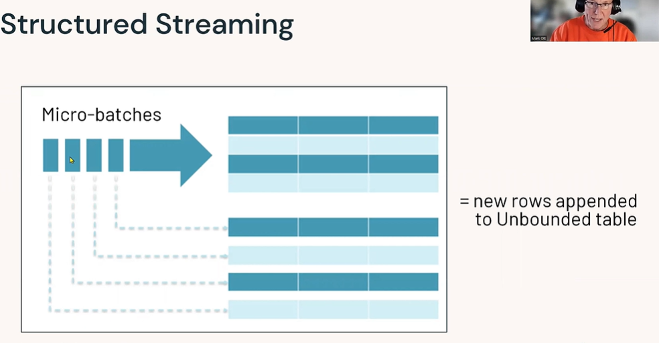

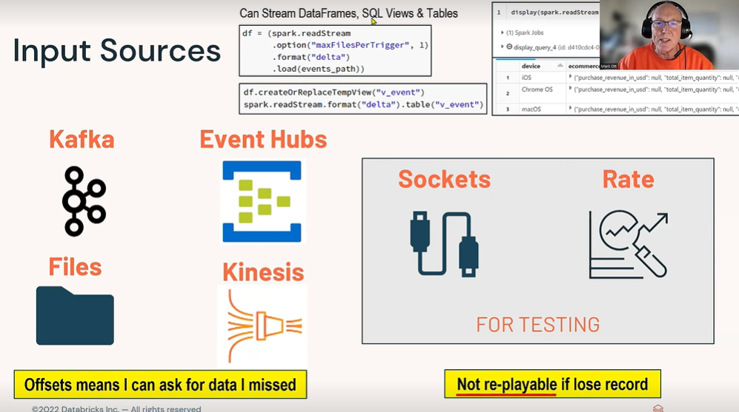

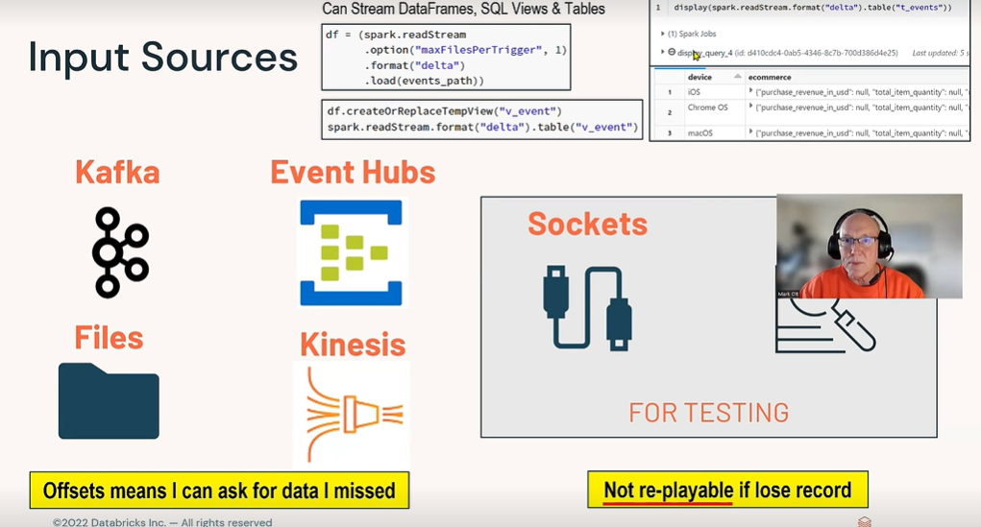

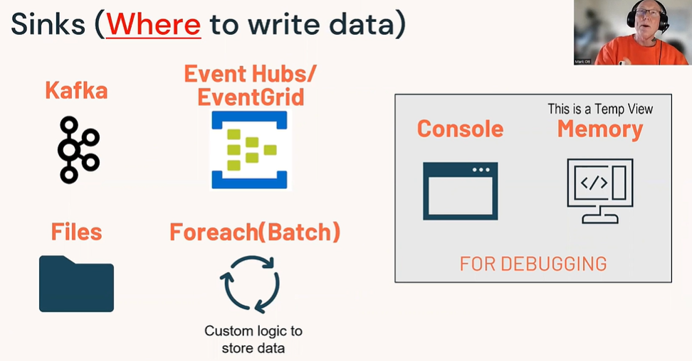

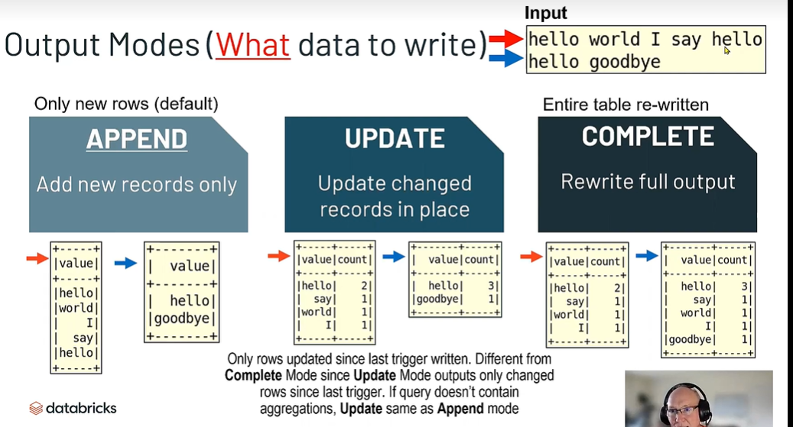

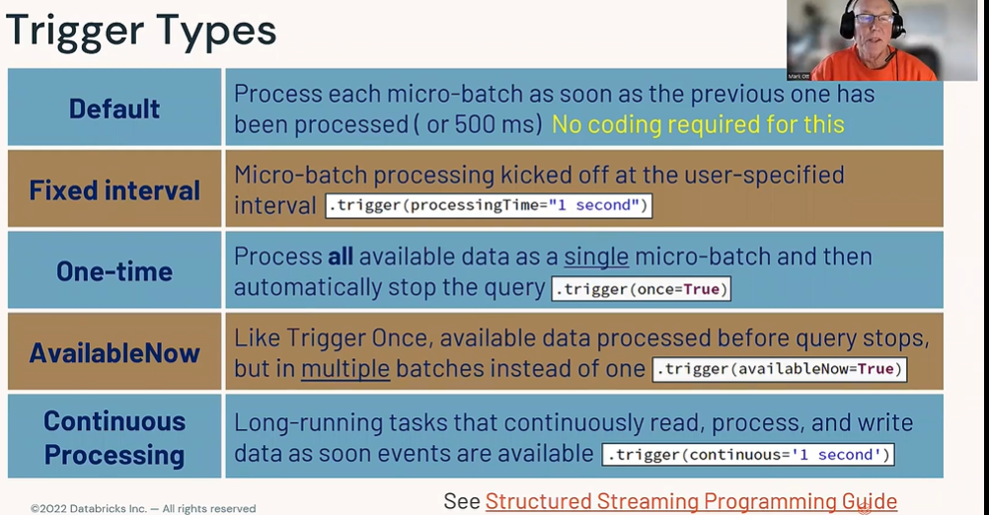

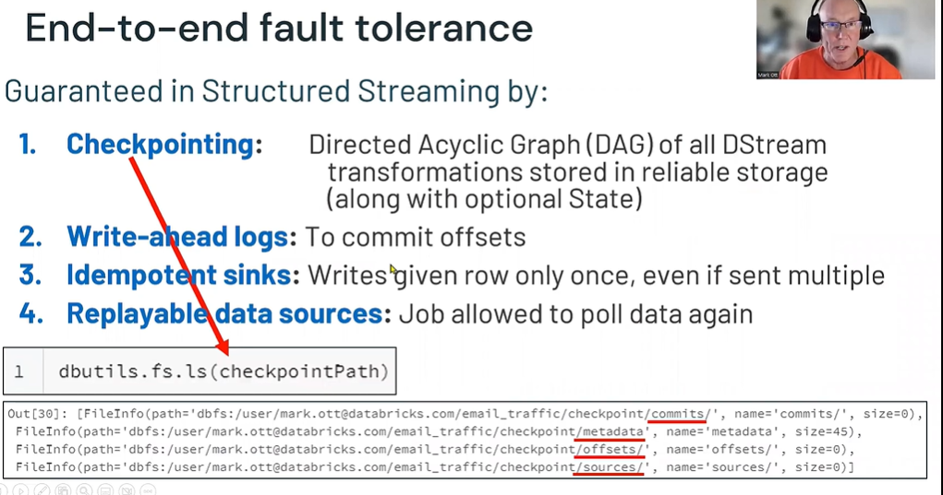

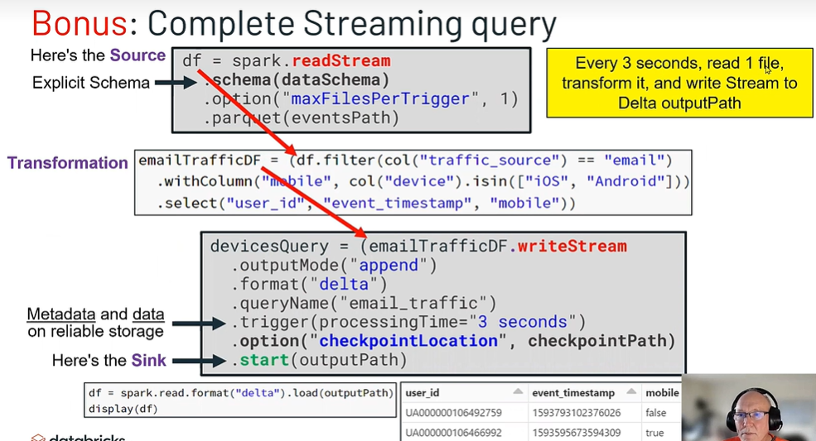

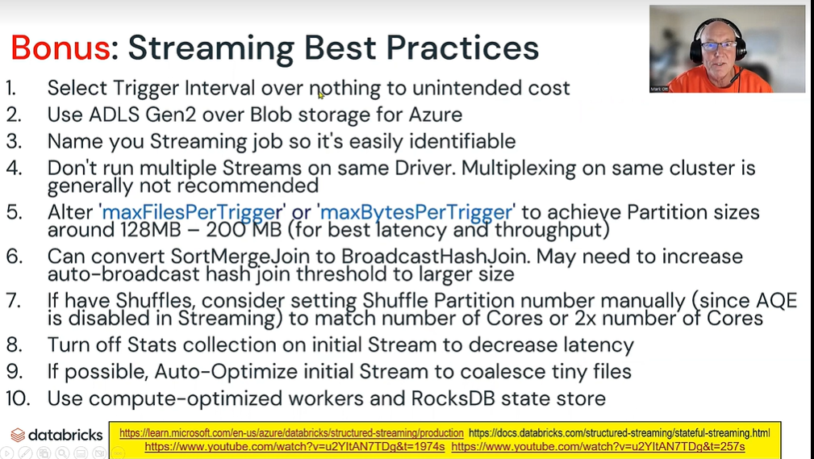**.**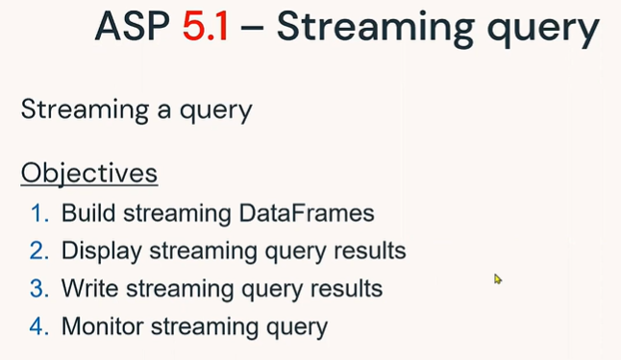

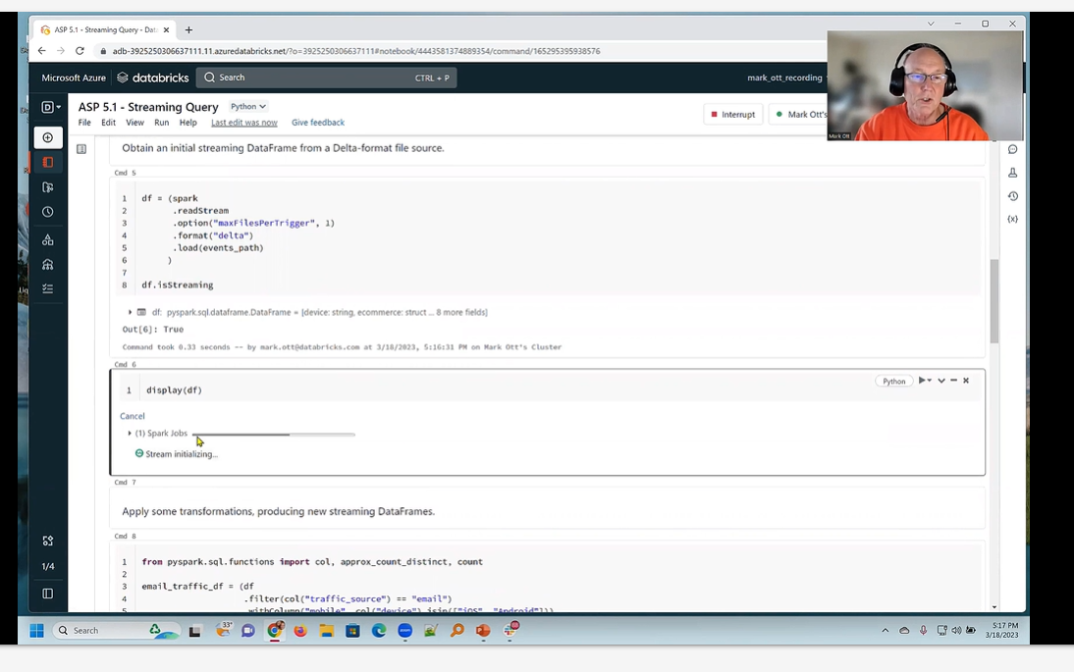

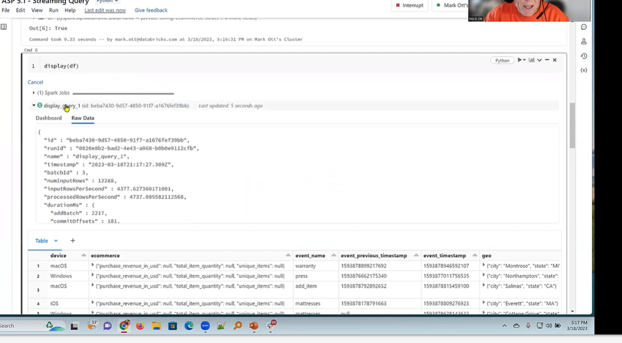**.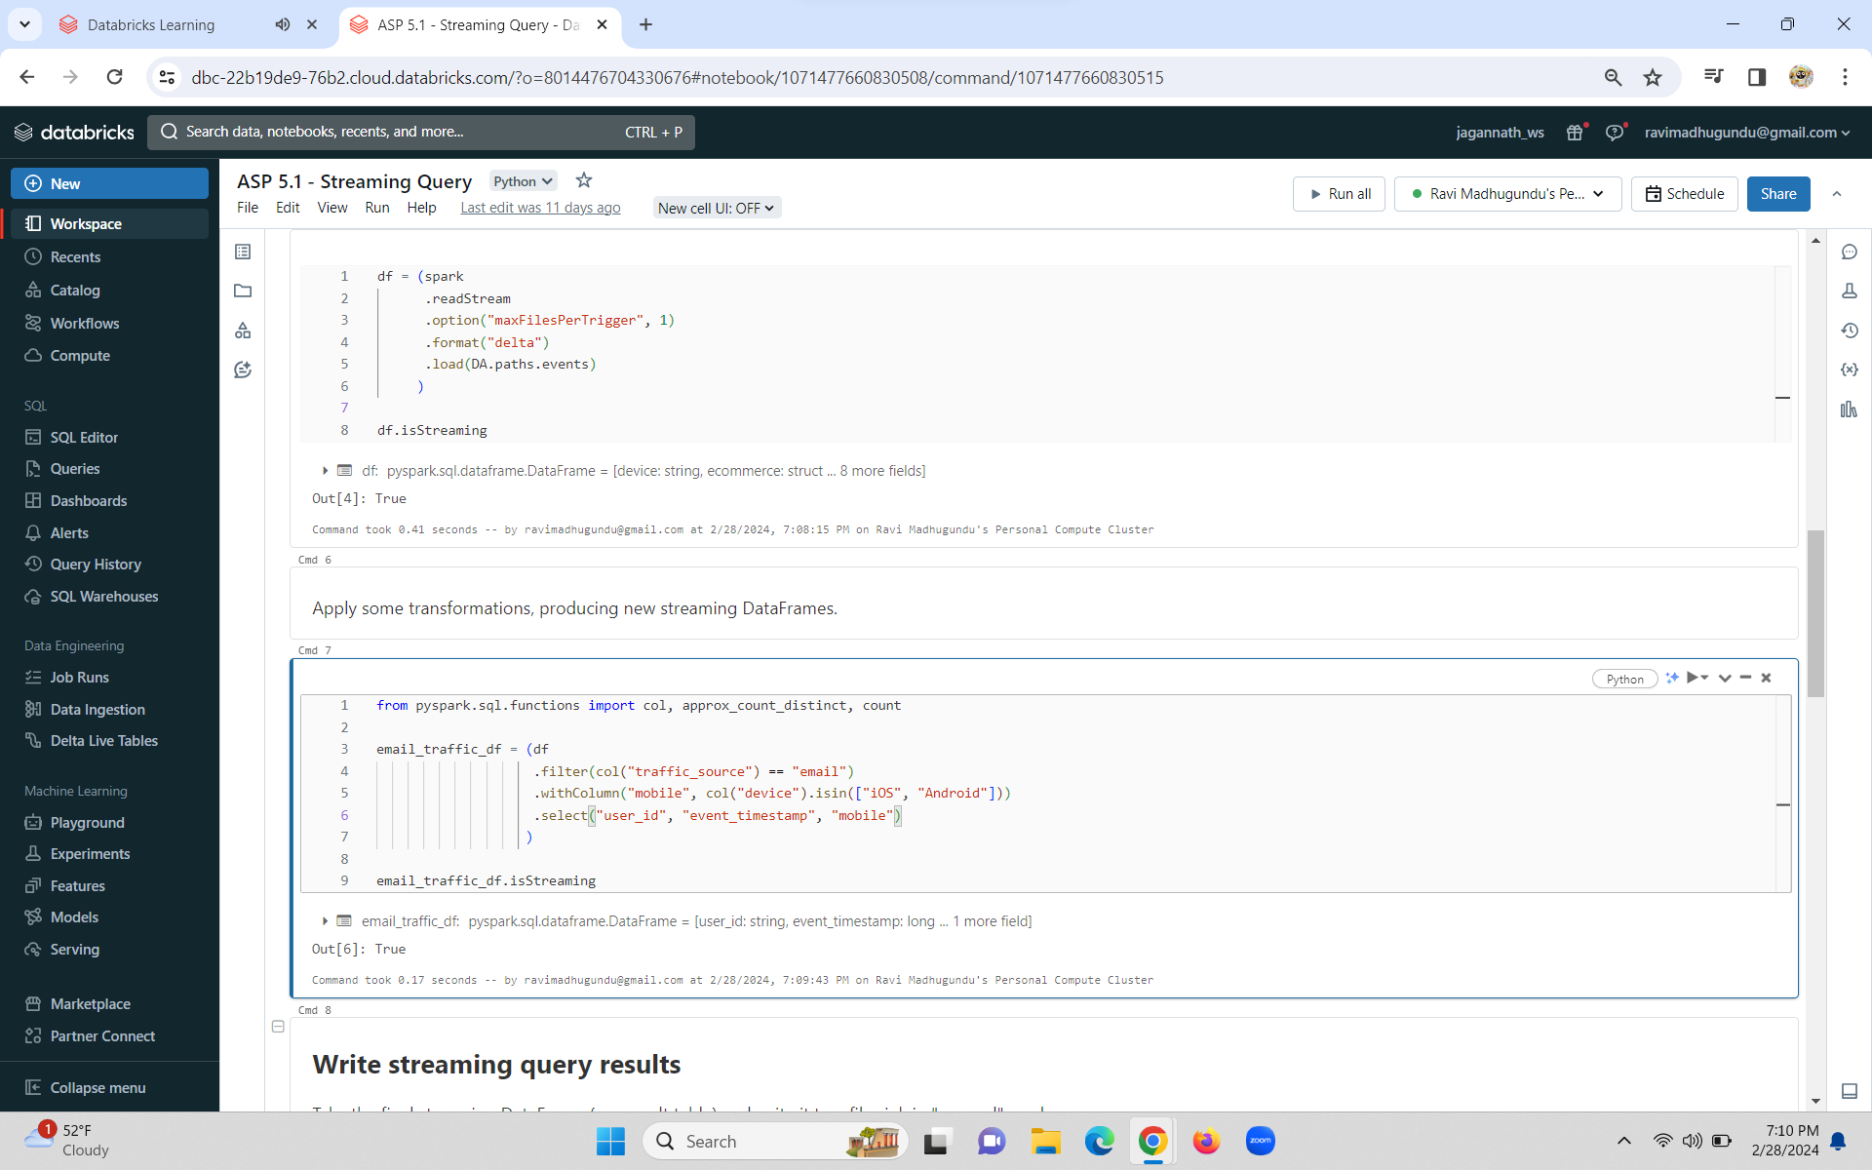.**

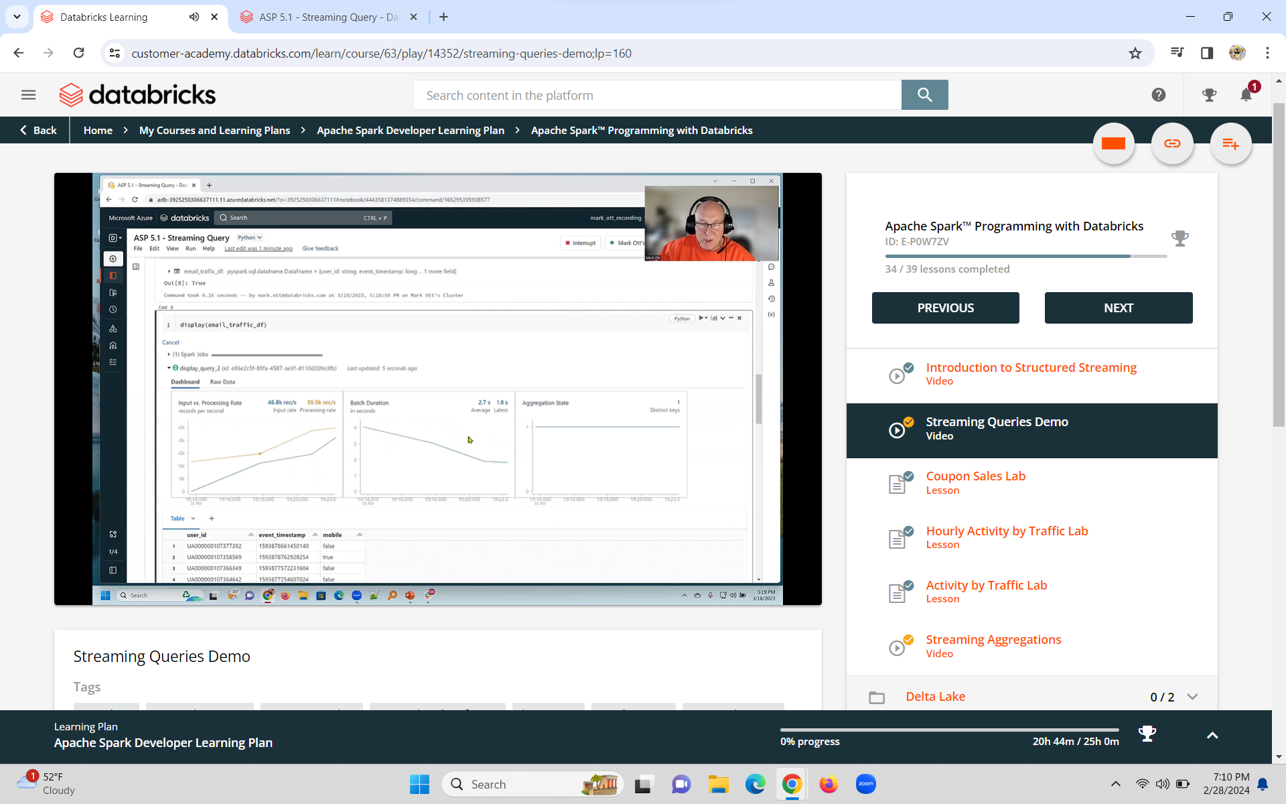

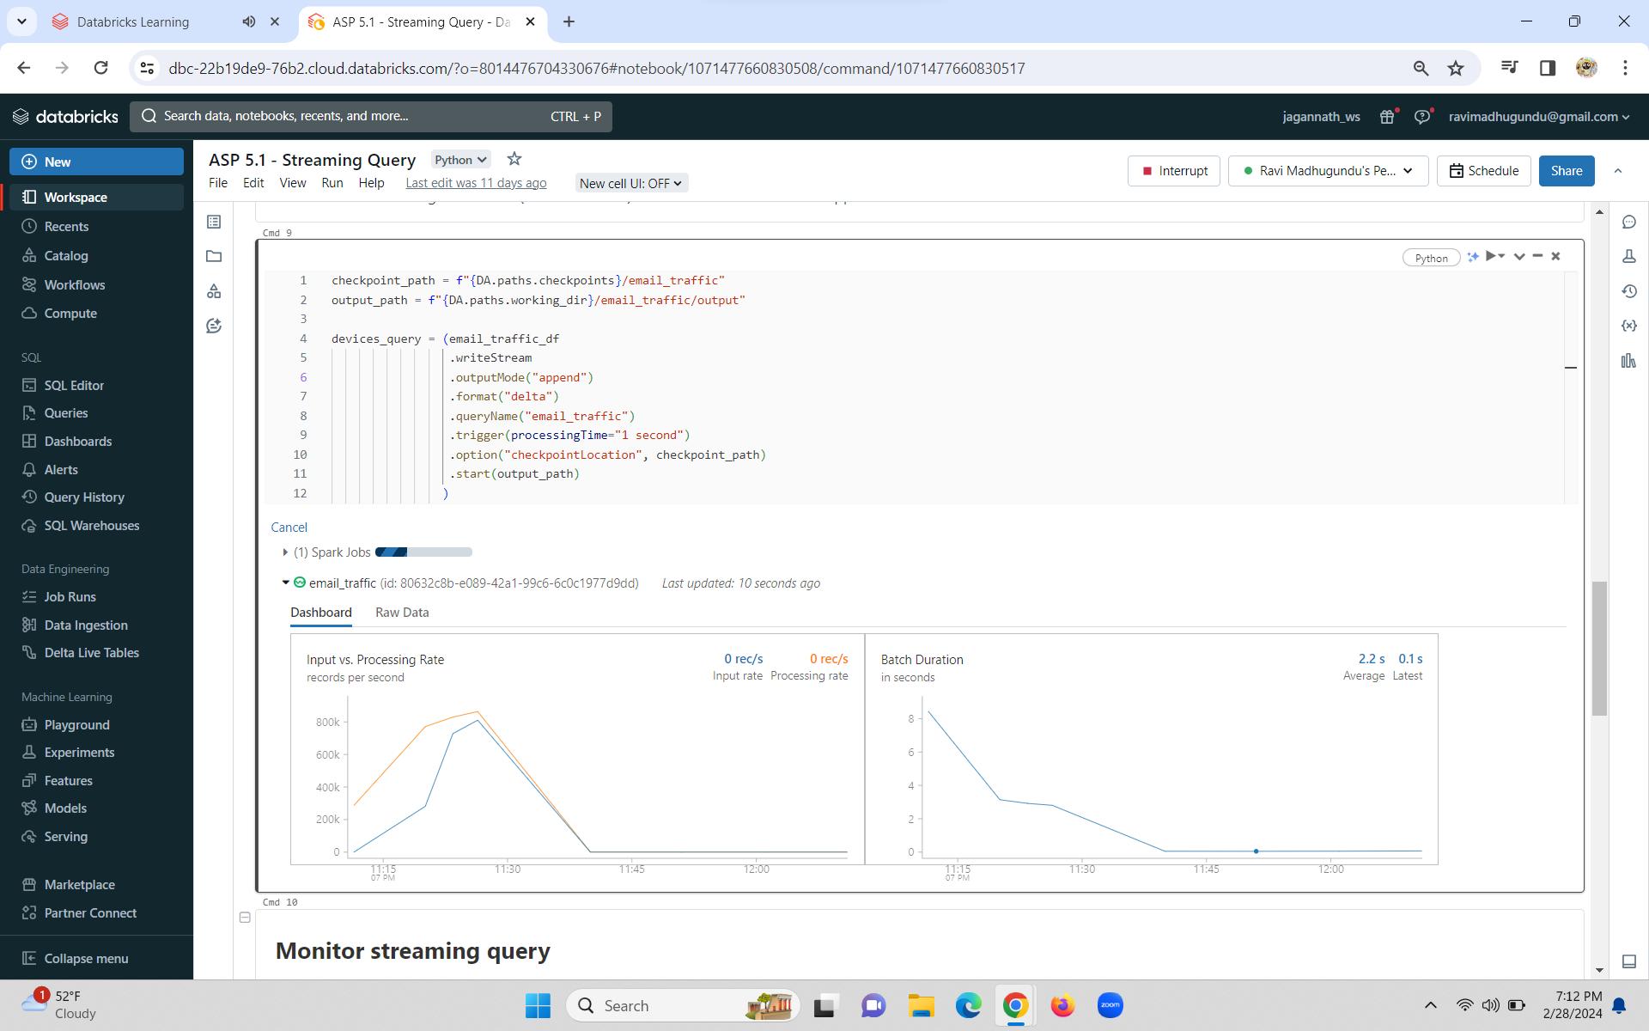

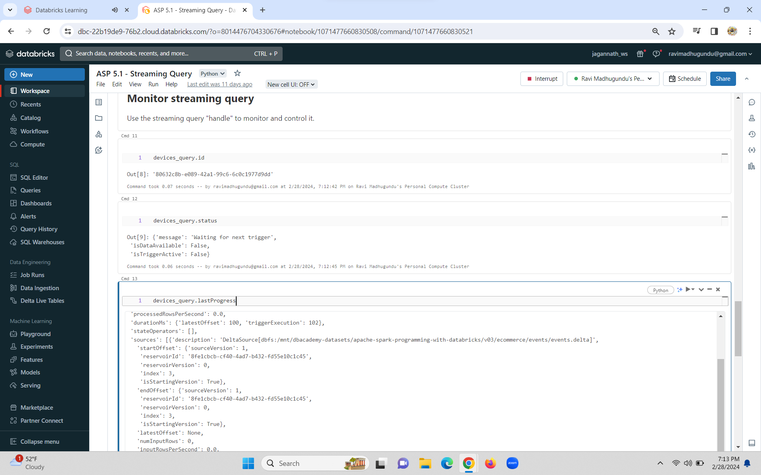

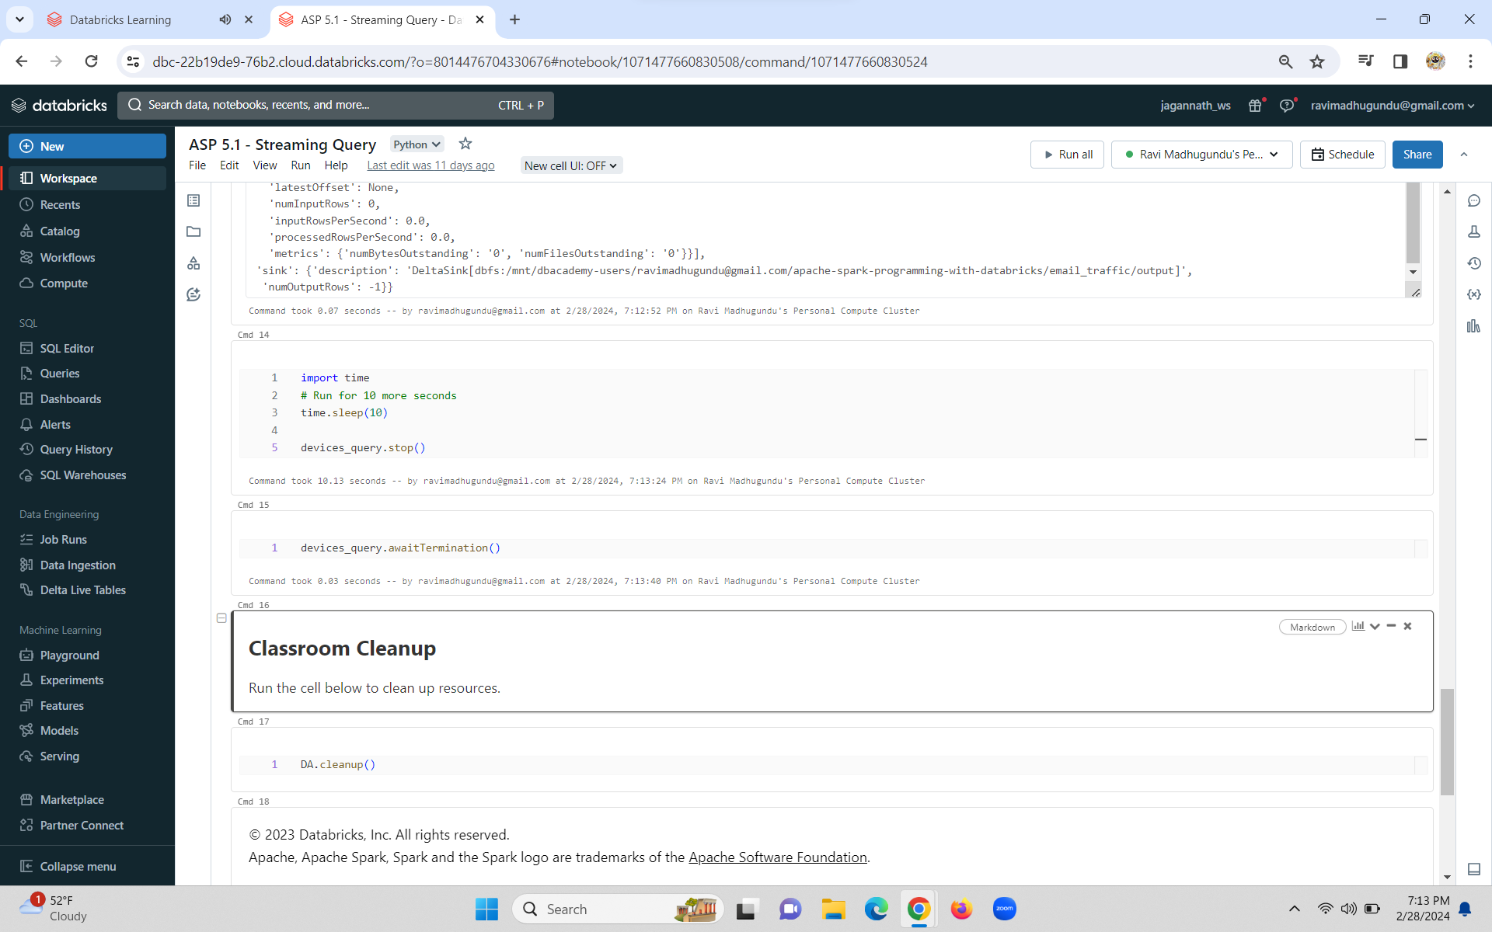

Coupon Sales Lab

**Process and append streaming data on transactions using coupons.**

1. **Read data stream**
2. **Filter for transactions with coupons codes**
3. **Write streaming query results to Delta**
4. **Monitor streaming query**
5. **Stop streaming query**

Classes

* [**DataStreamReader**](https://spark.apache.org/docs/latest/api/python/reference/pyspark.ss/api/pyspark.sql.streaming.DataStreamReader.html)
* [**DataStreamWriter**](https://spark.apache.org/docs/latest/api/python/reference/pyspark.ss/api/pyspark.sql.streaming.DataStreamWriter.html)
* [**StreamingQuery**](https://spark.apache.org/docs/latest/api/python/reference/pyspark.ss/api/pyspark.sql.streaming.StreamingQuery.html)

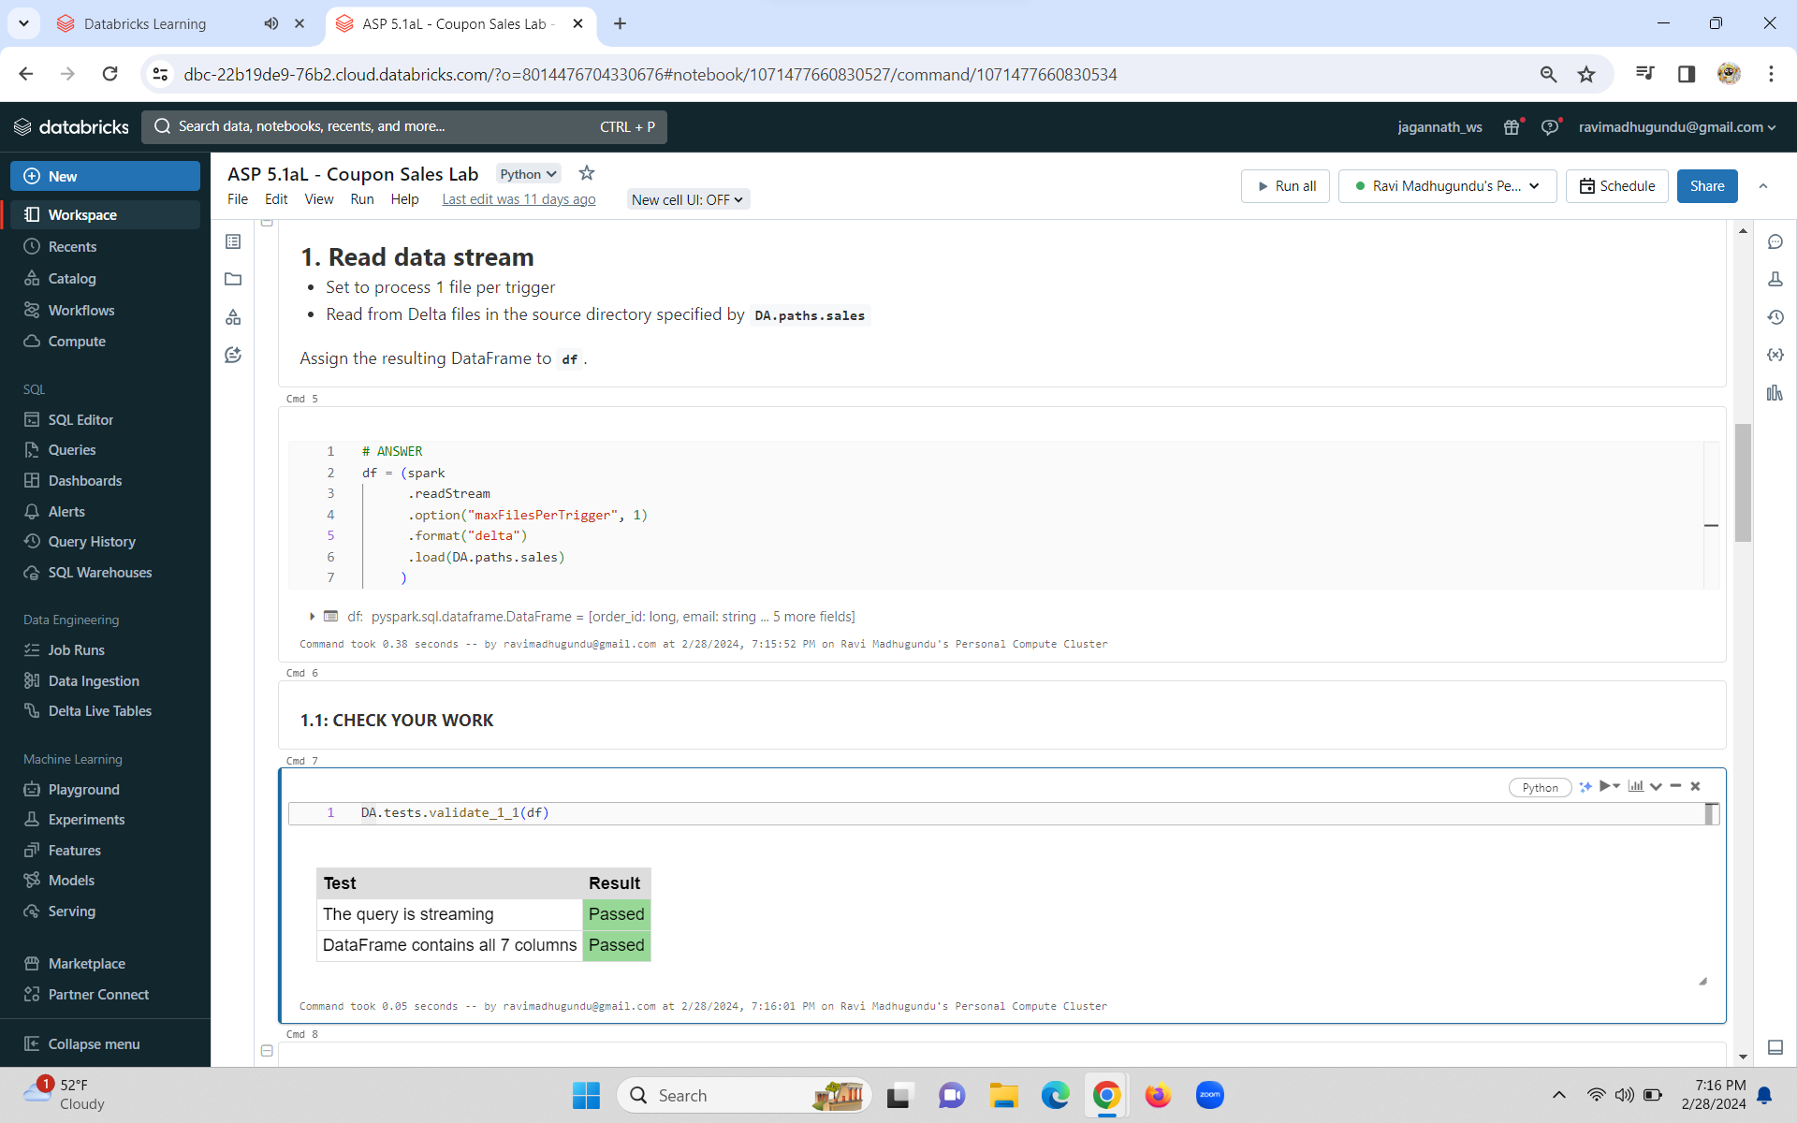

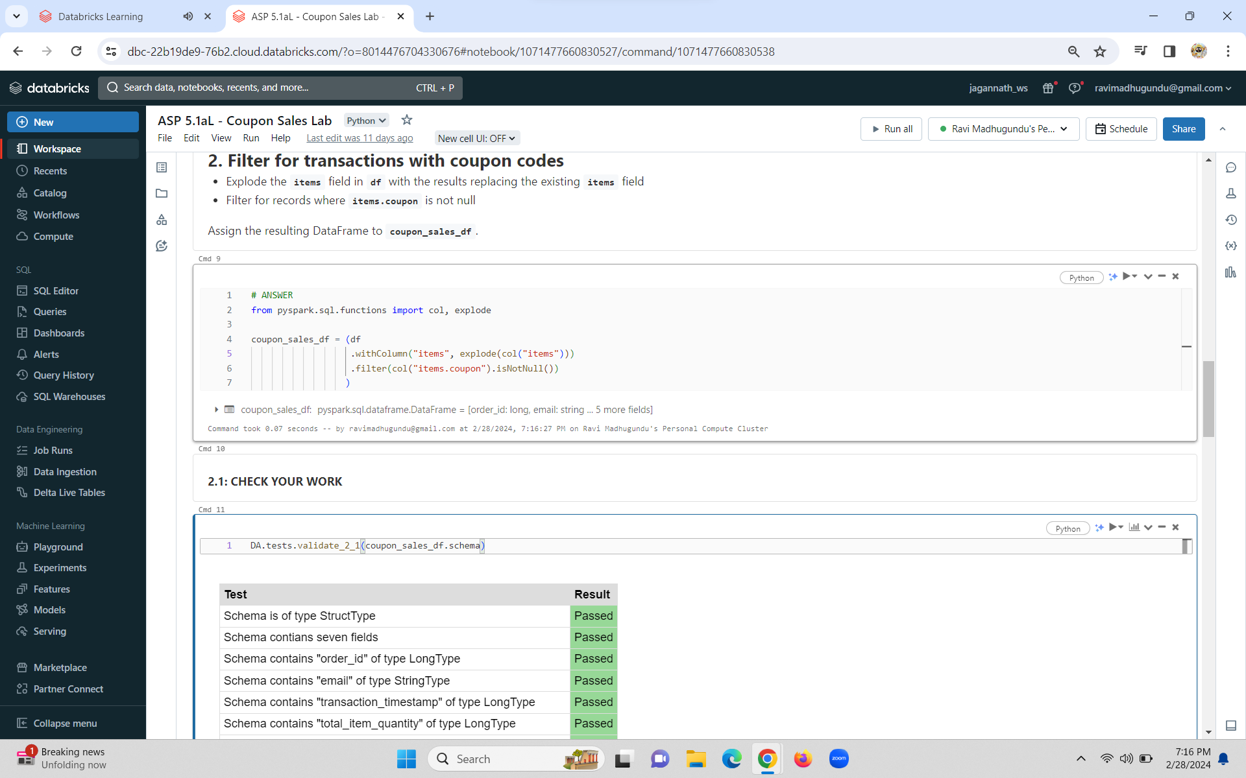

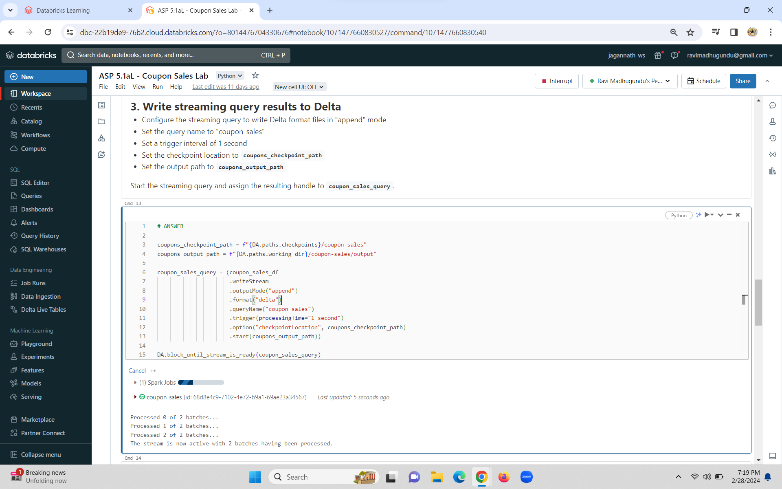

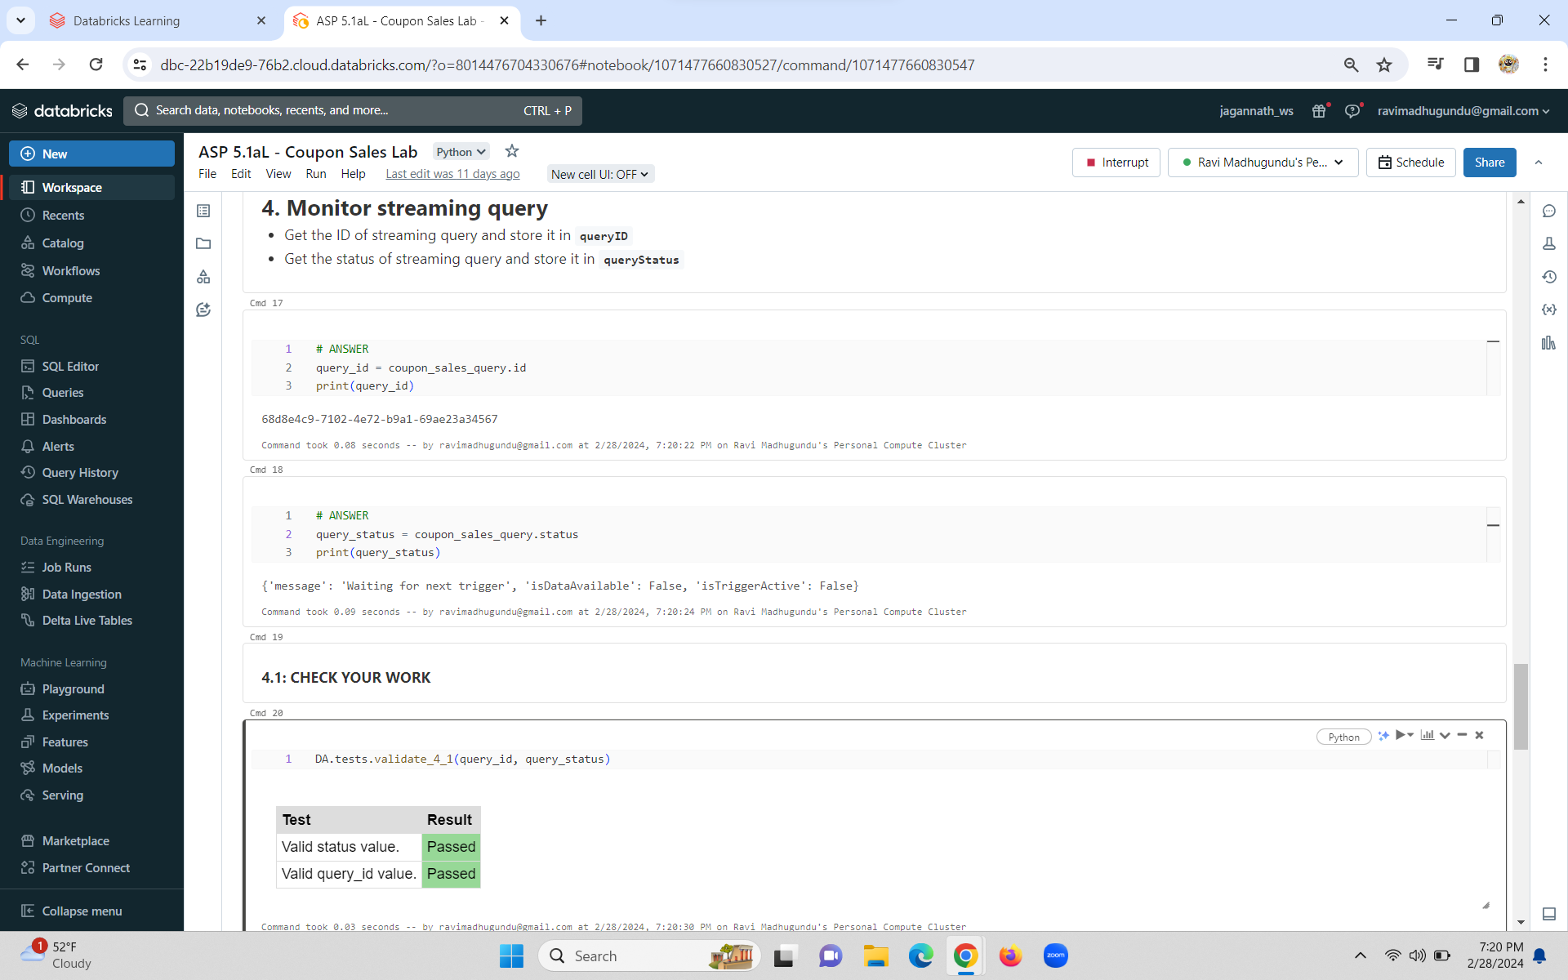

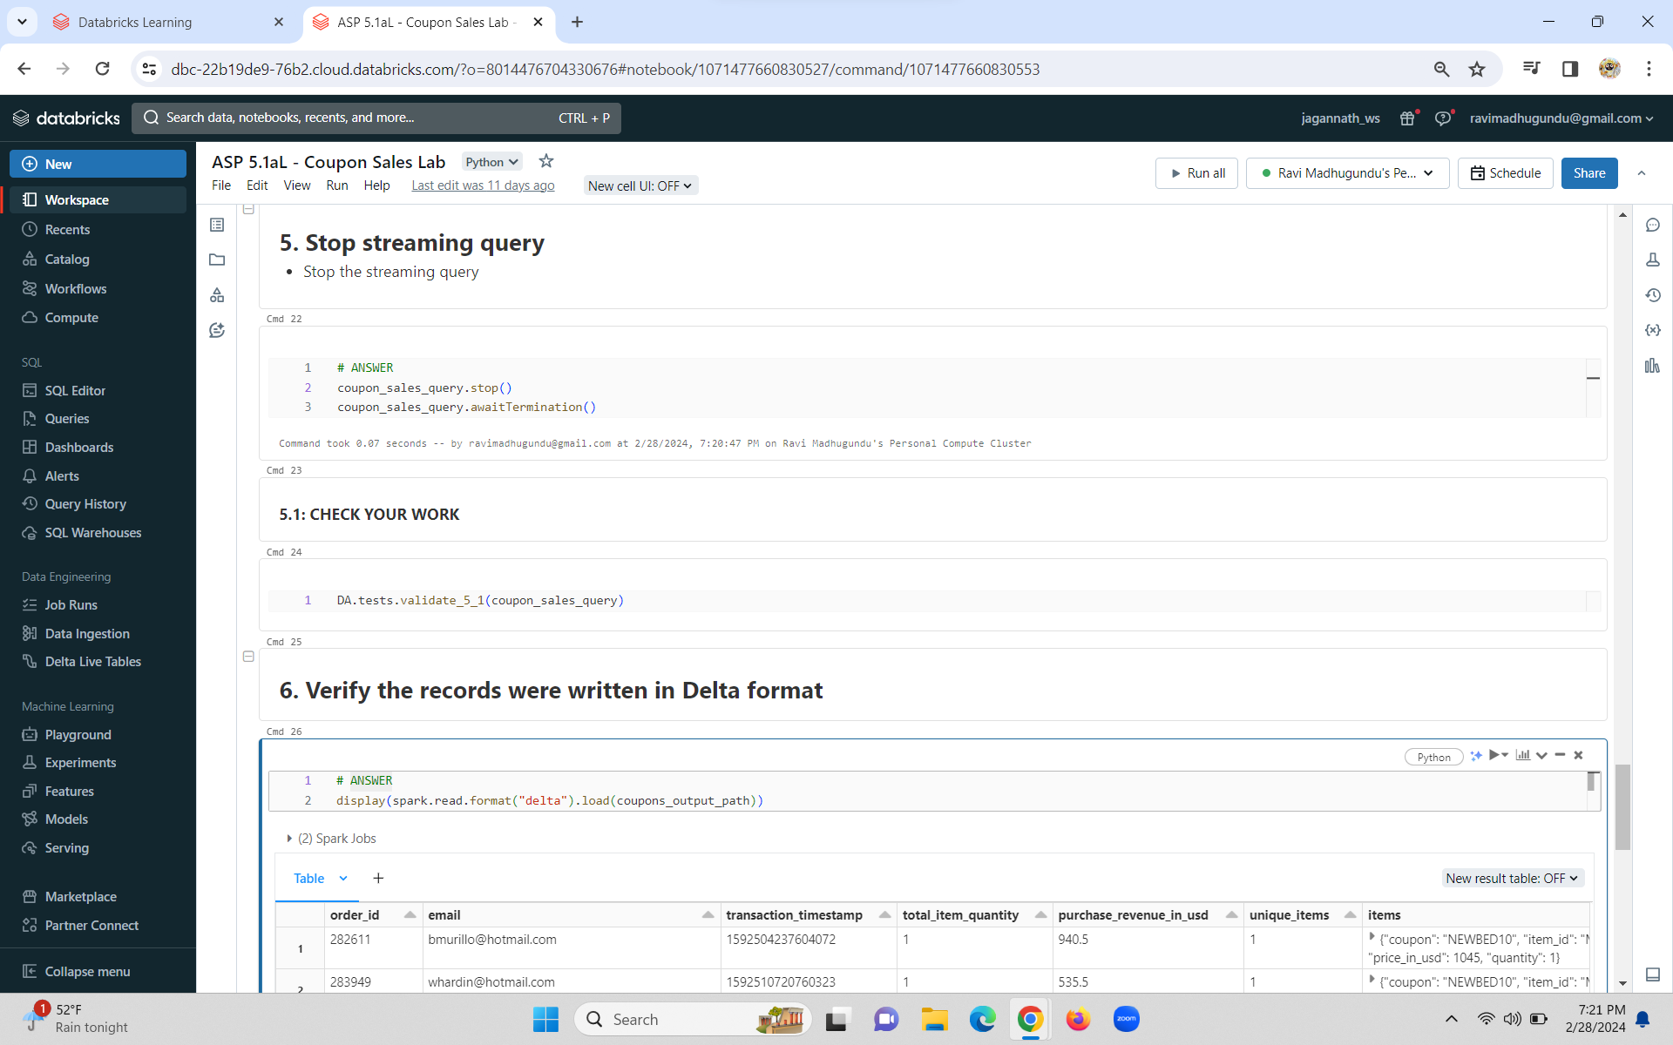

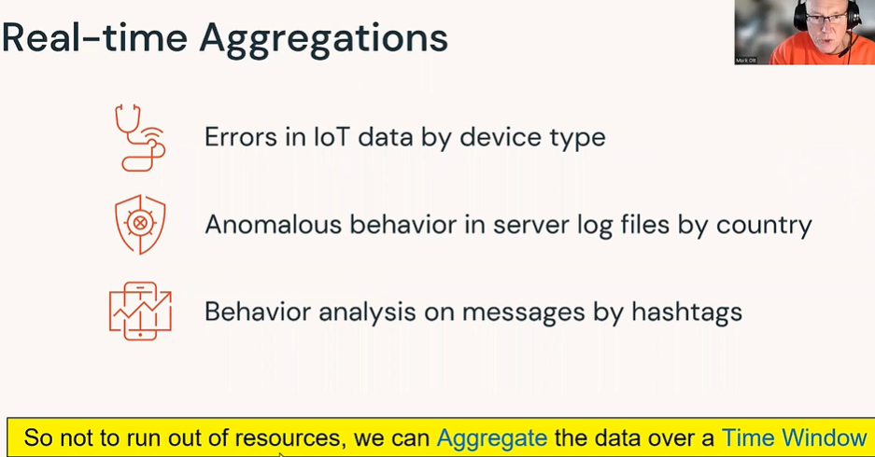

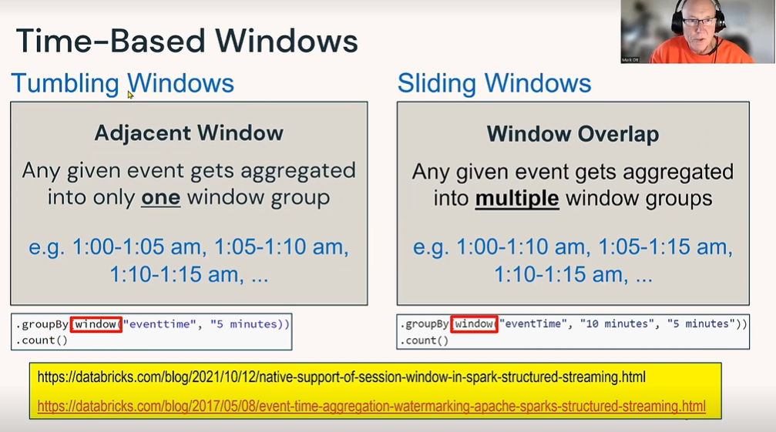

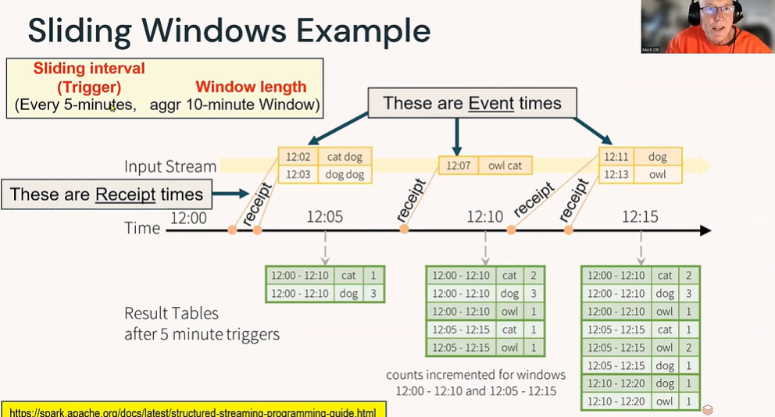**\**

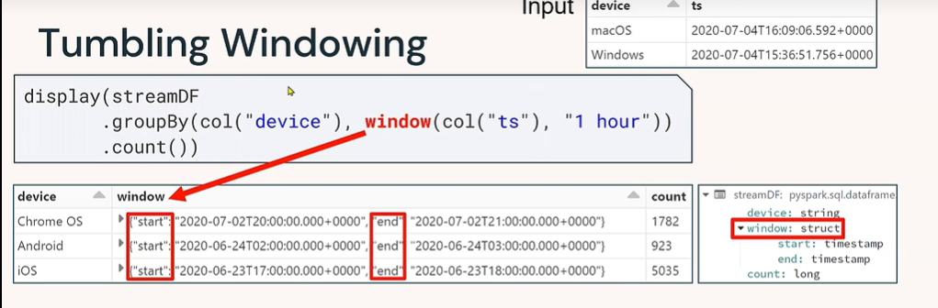

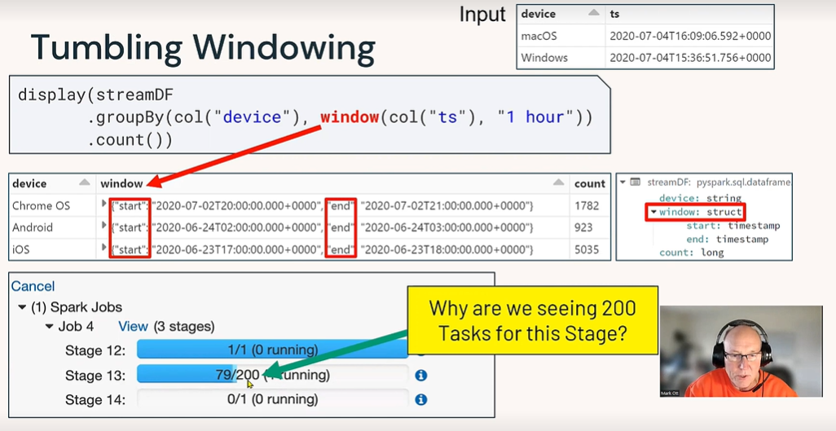

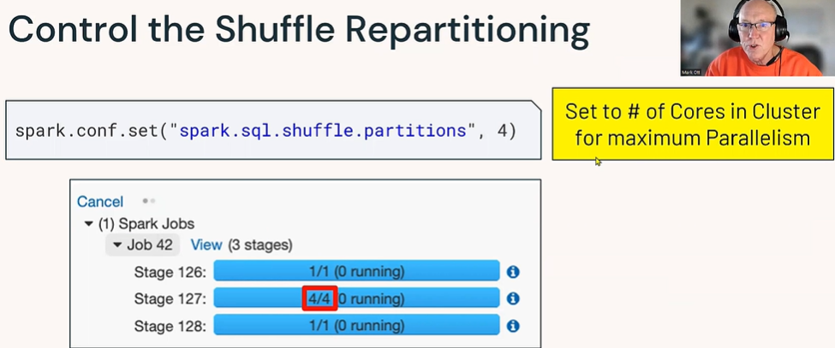

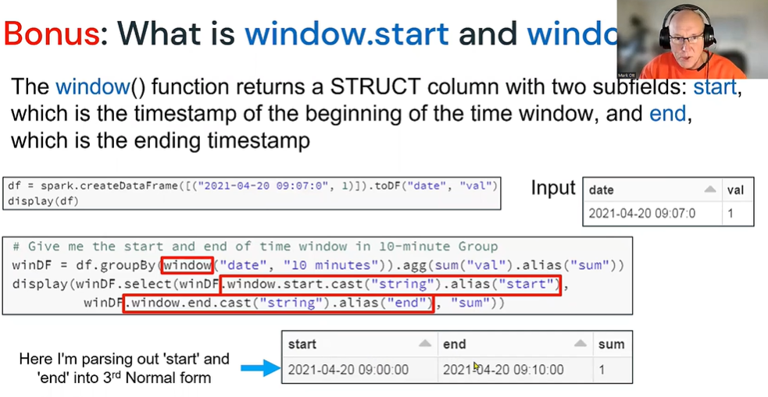

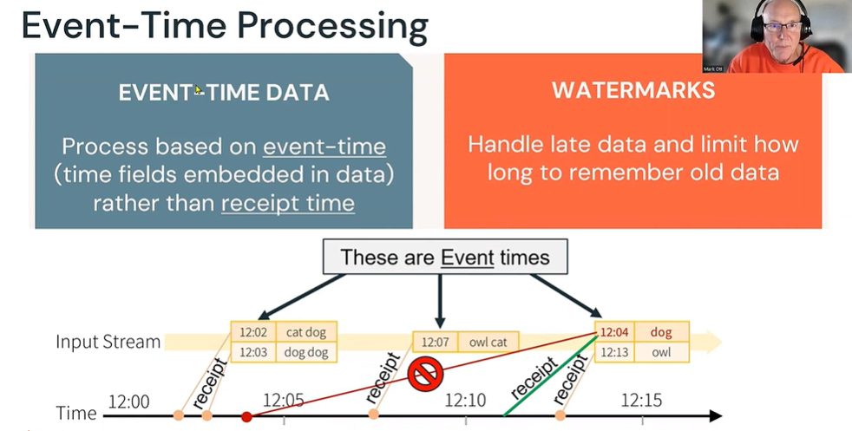

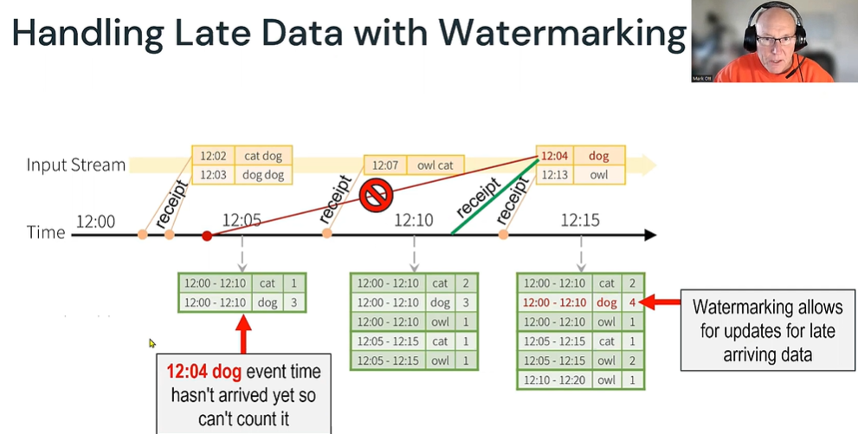

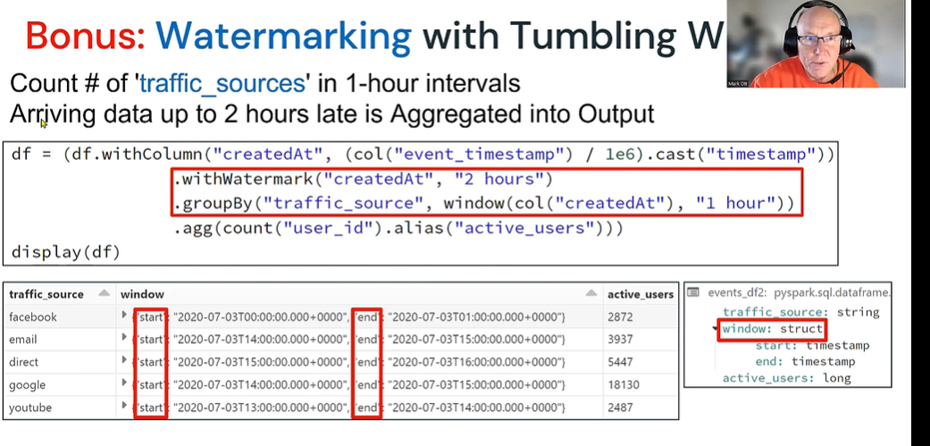

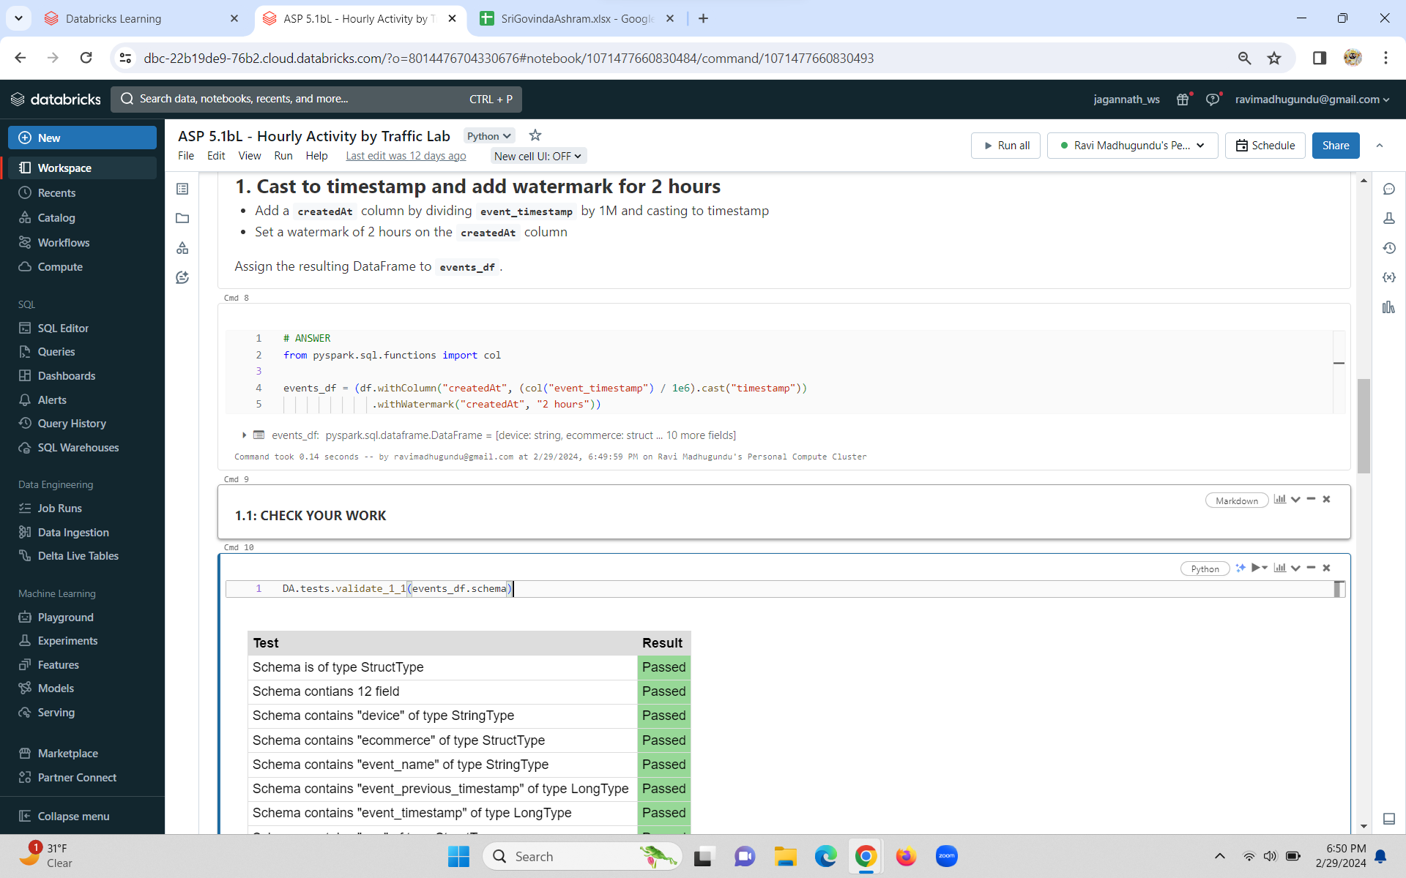

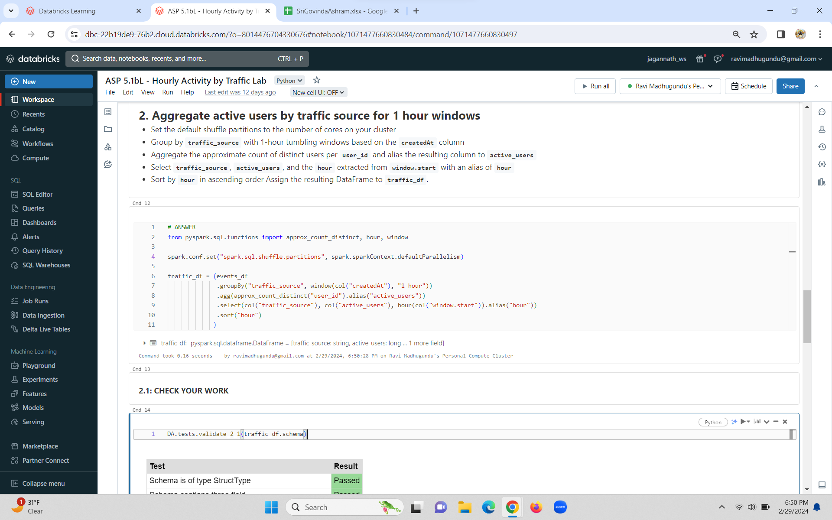

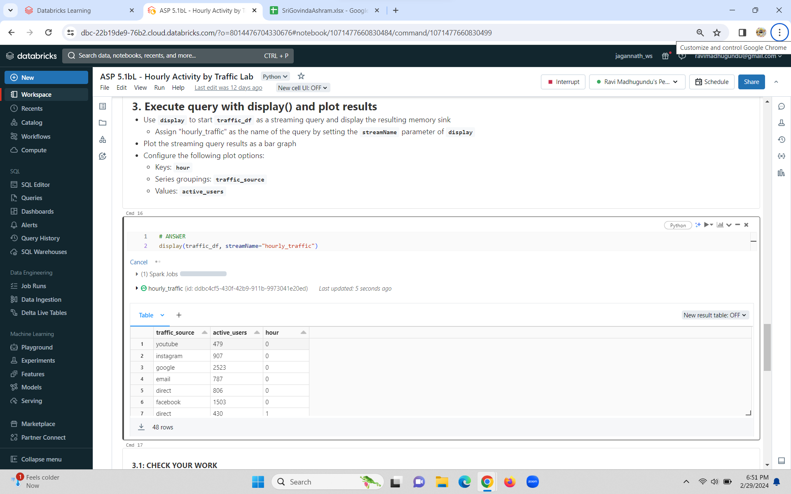

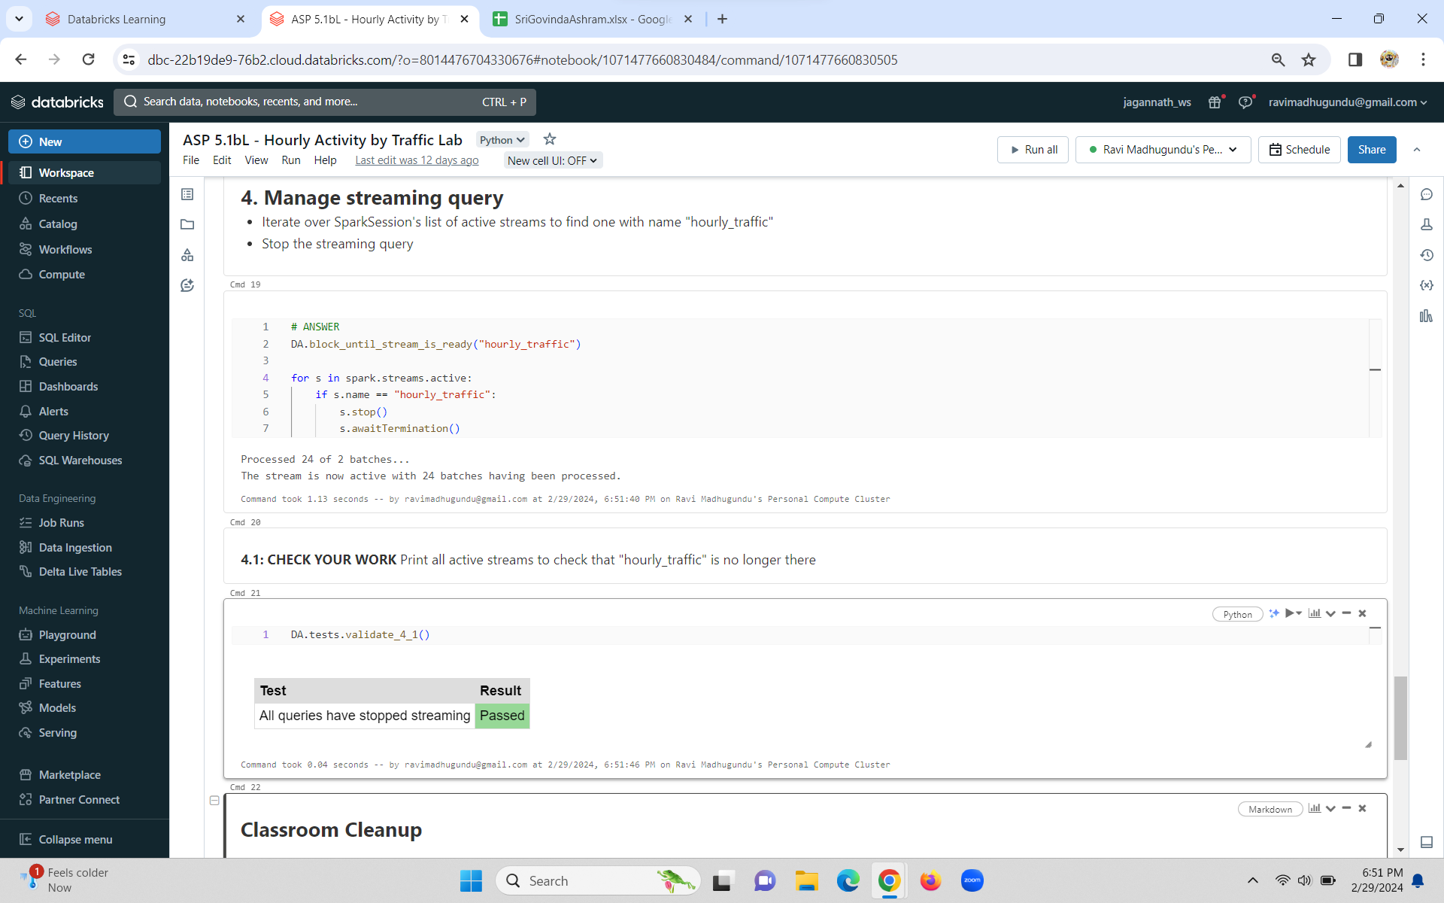

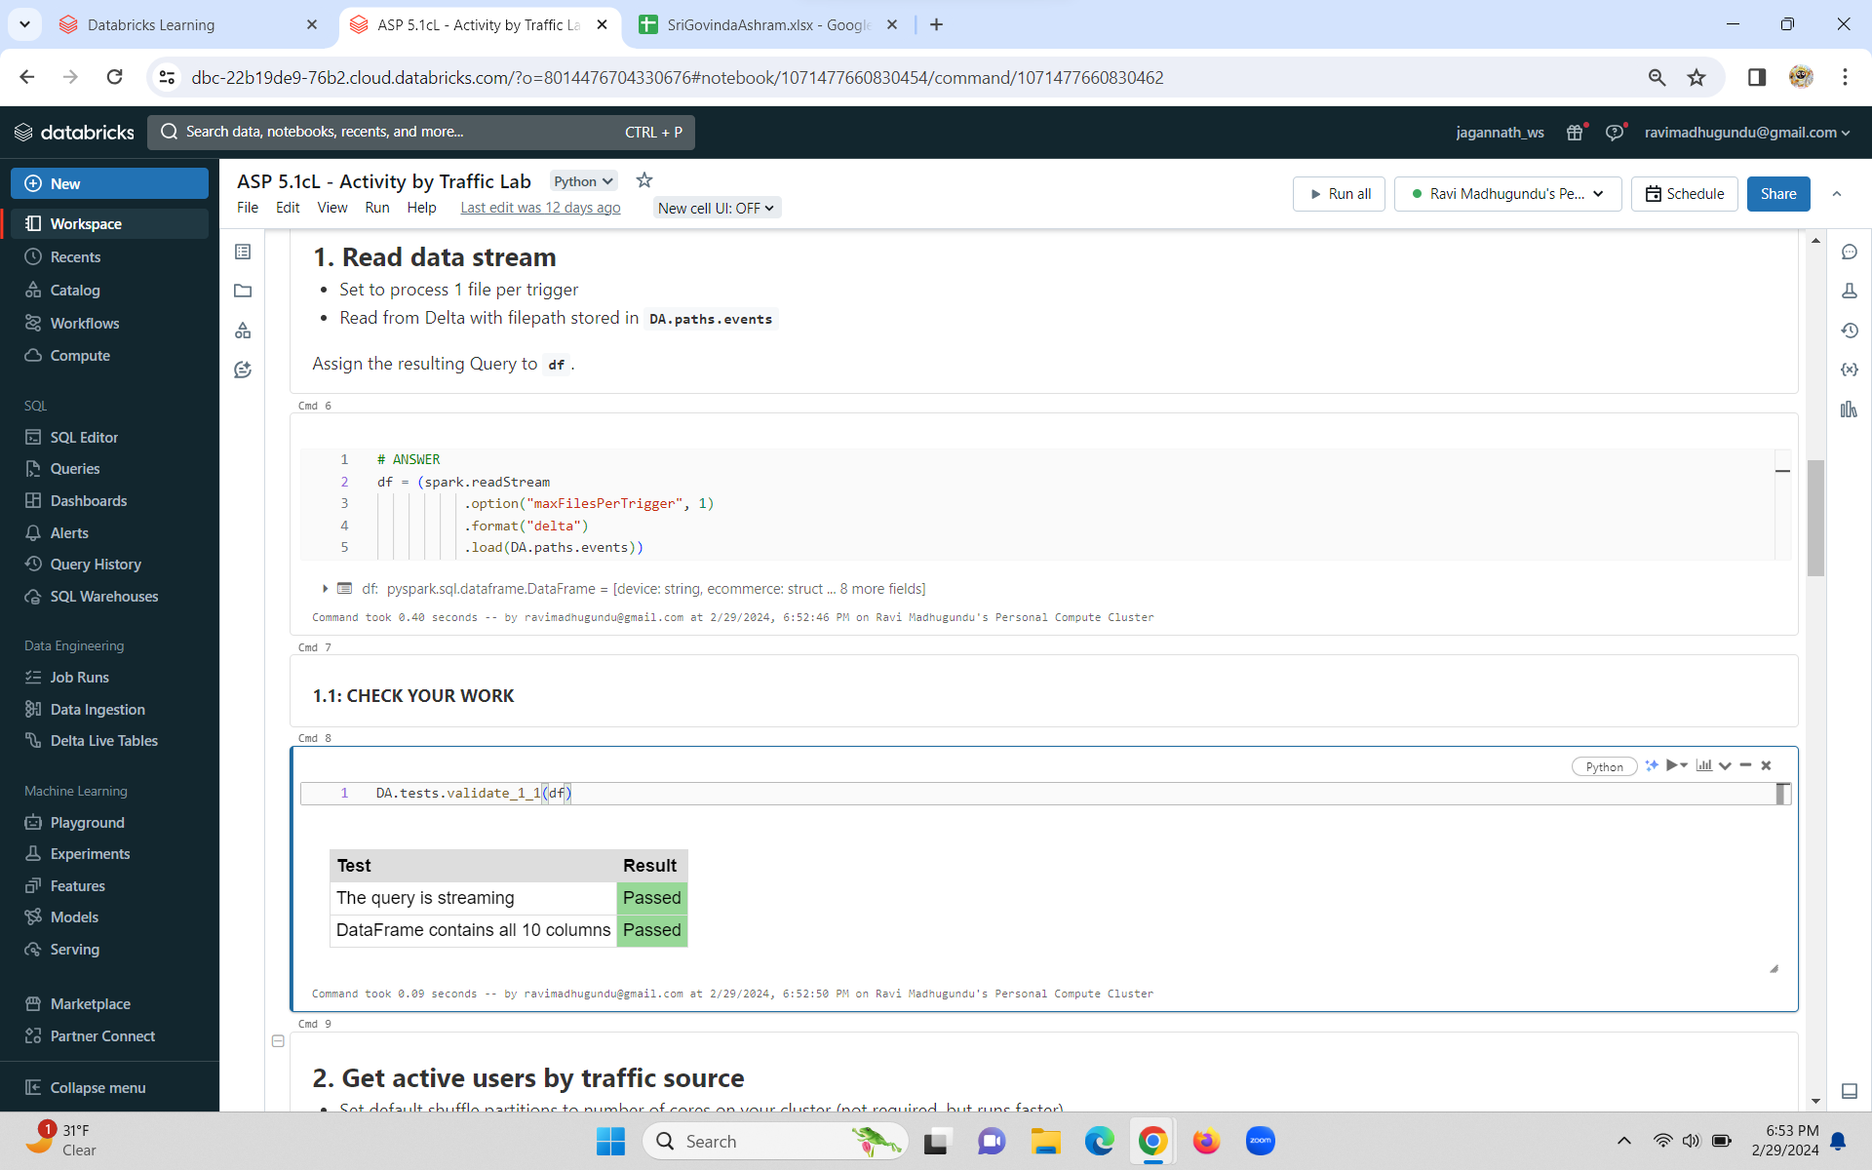

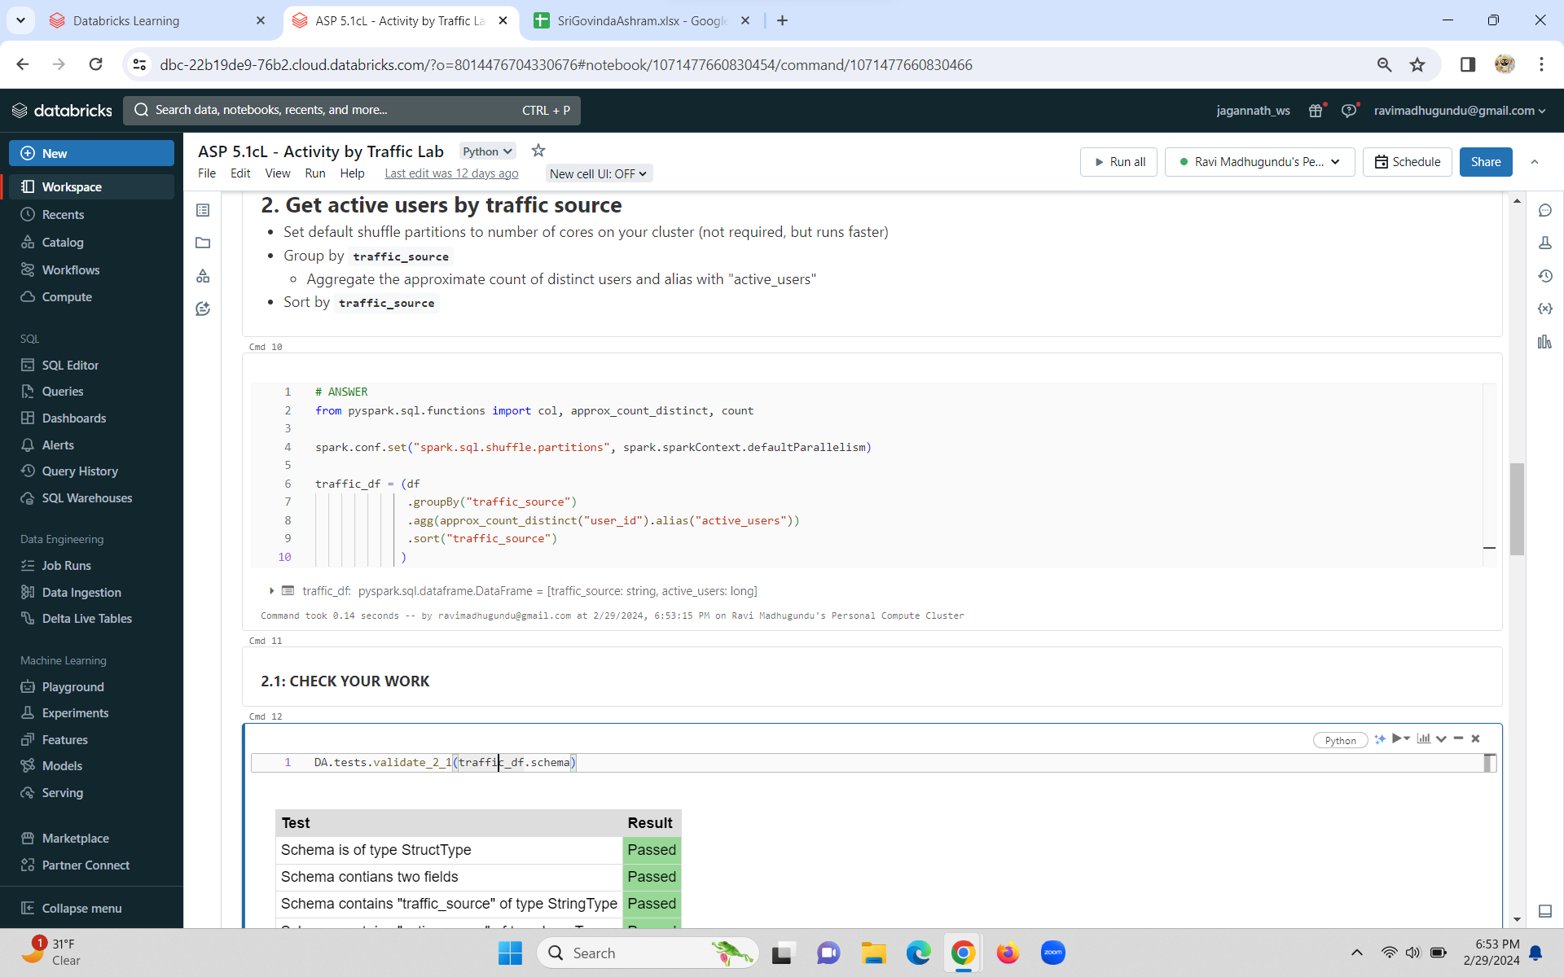

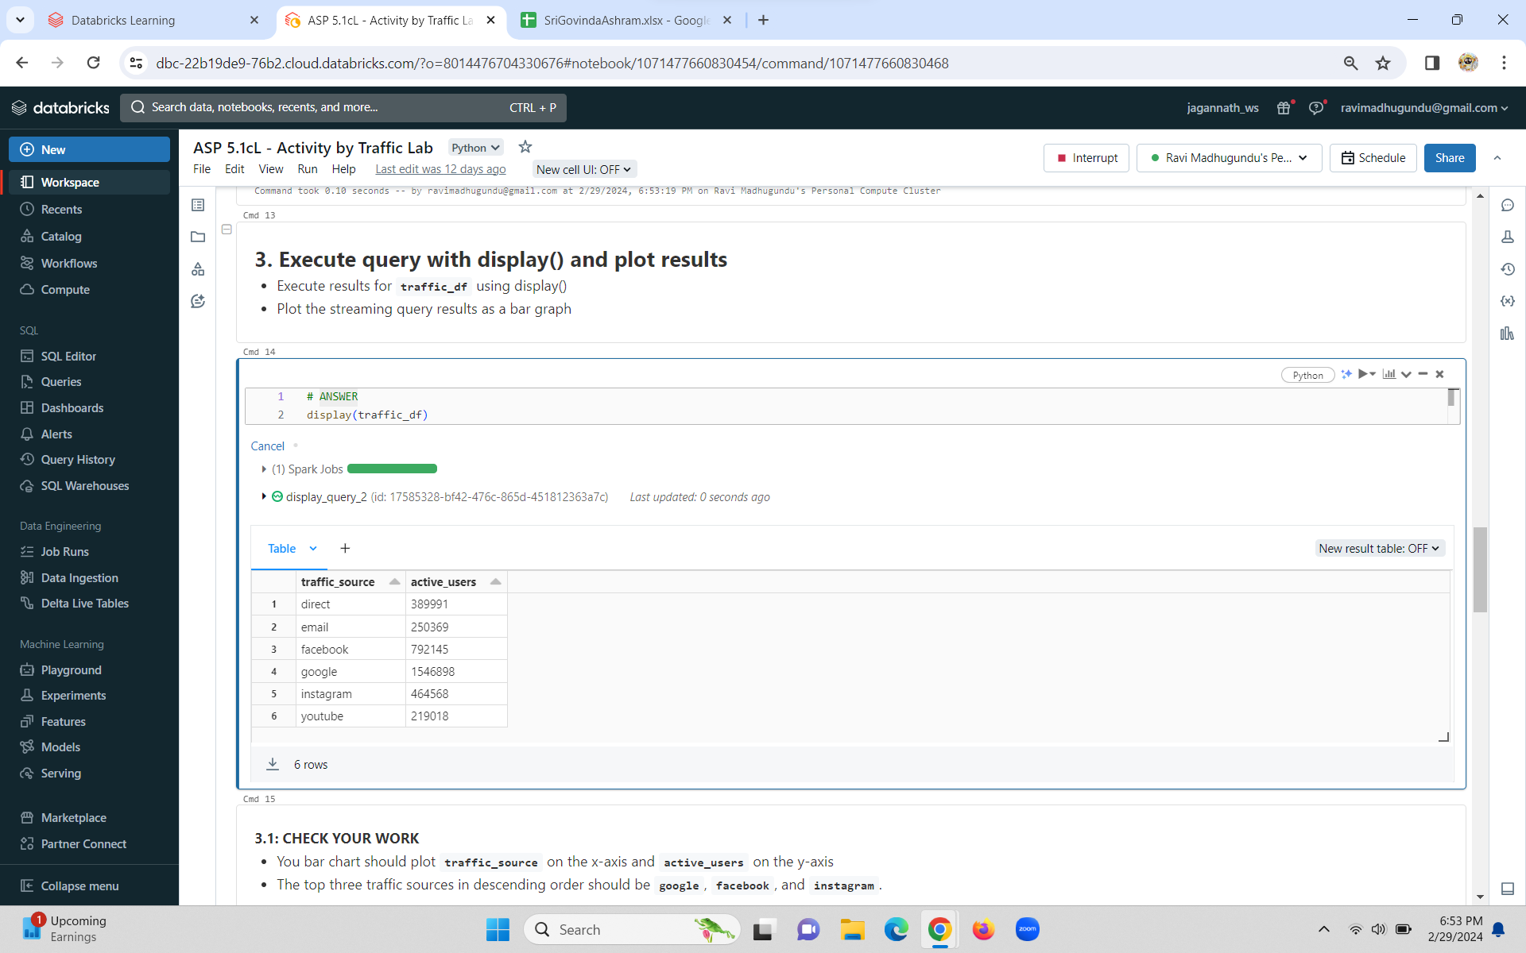

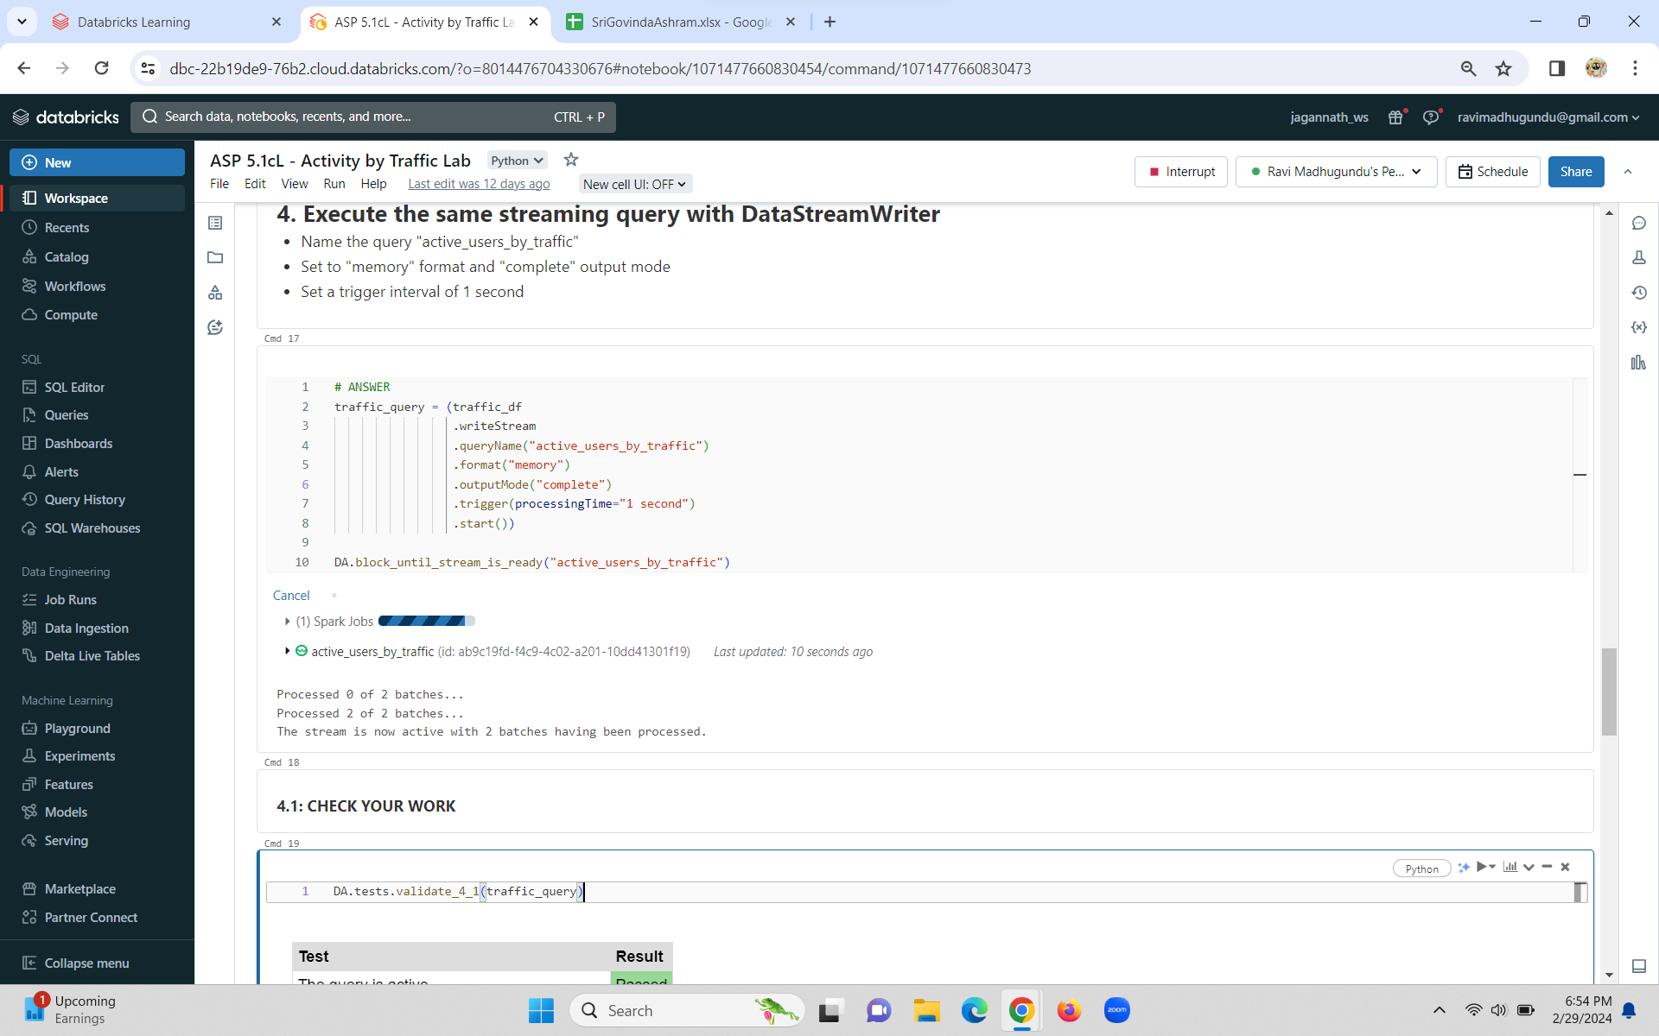

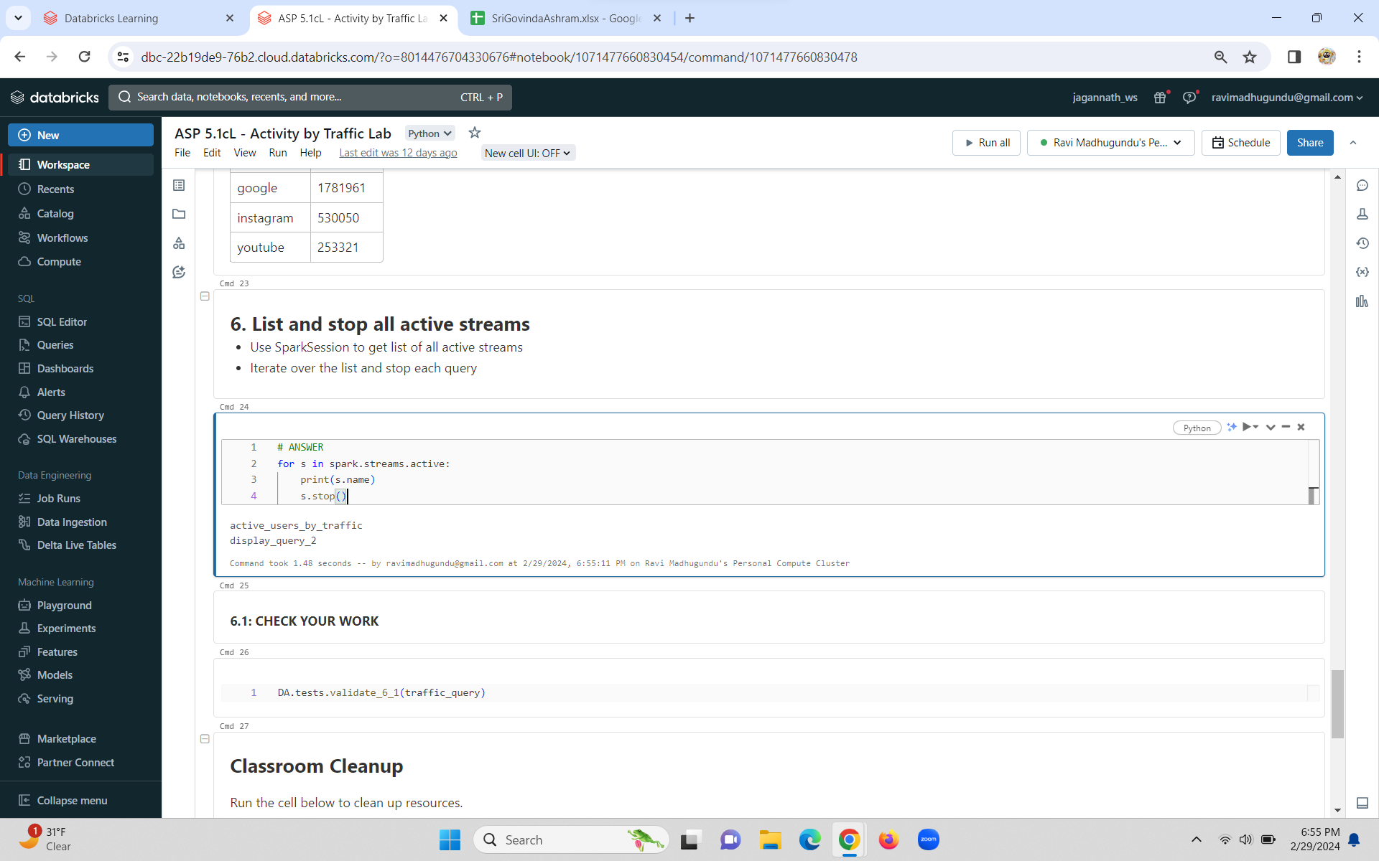

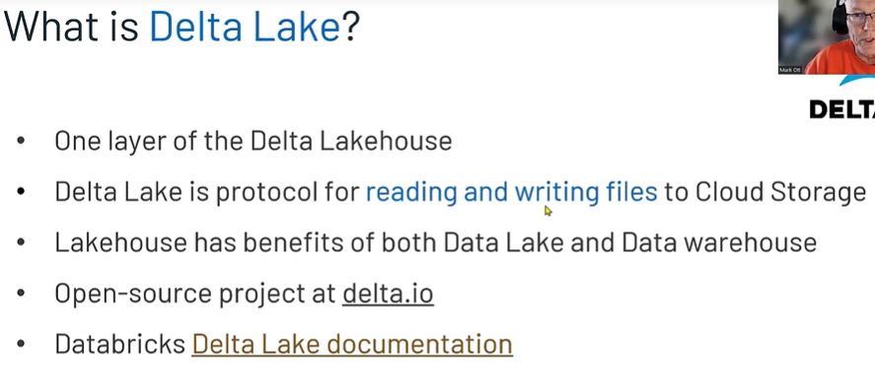

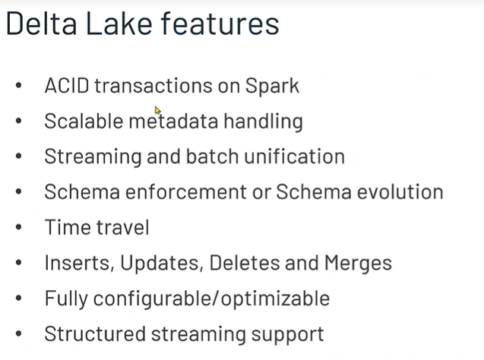

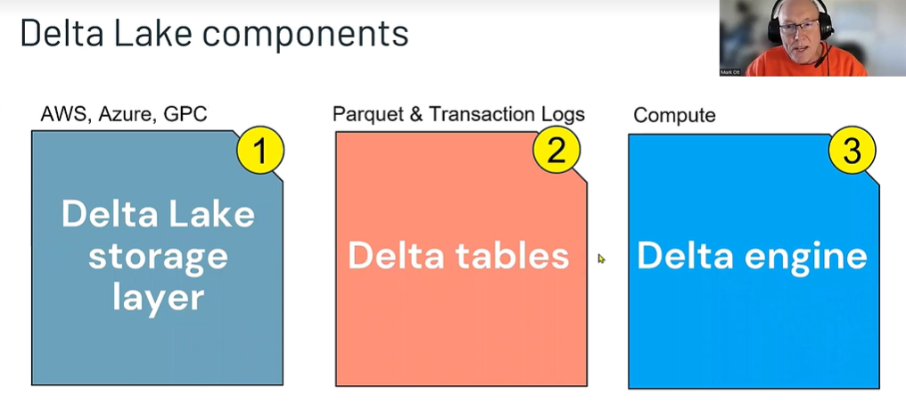

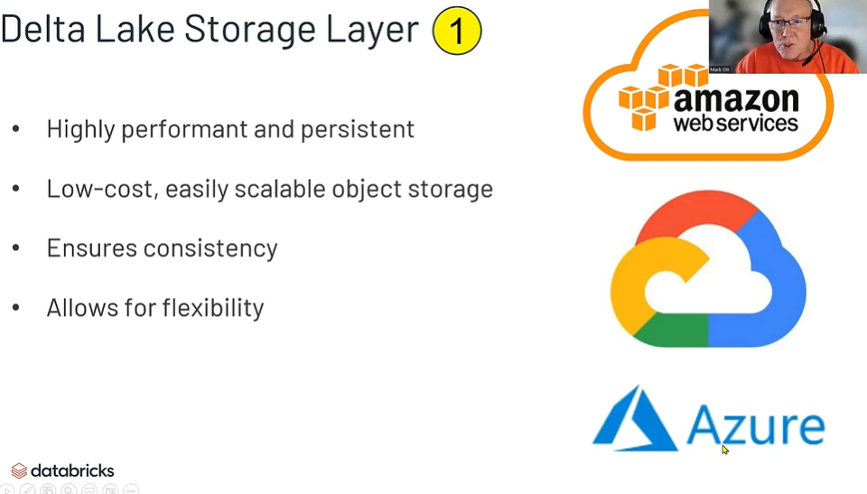

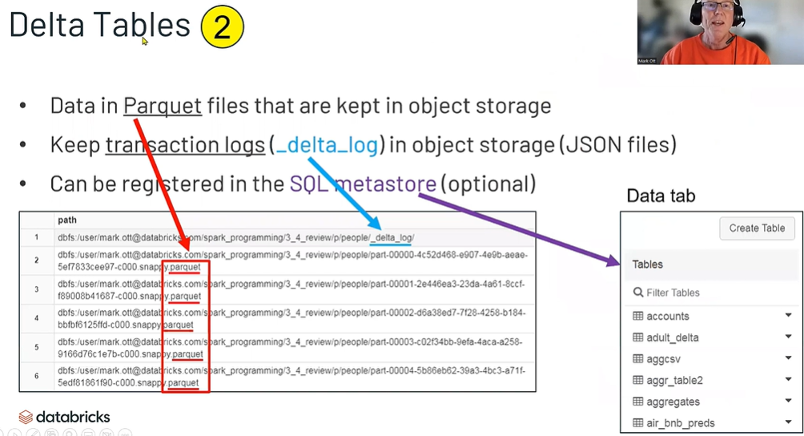

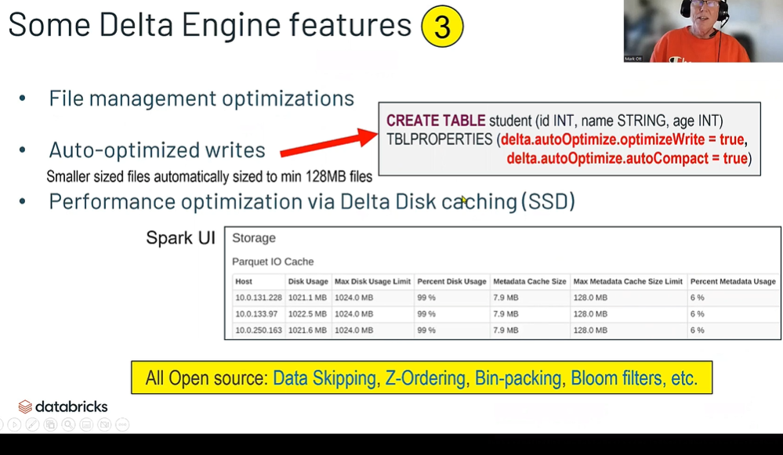

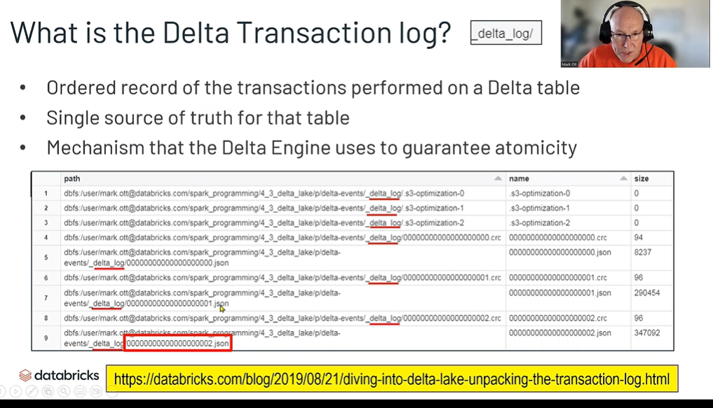

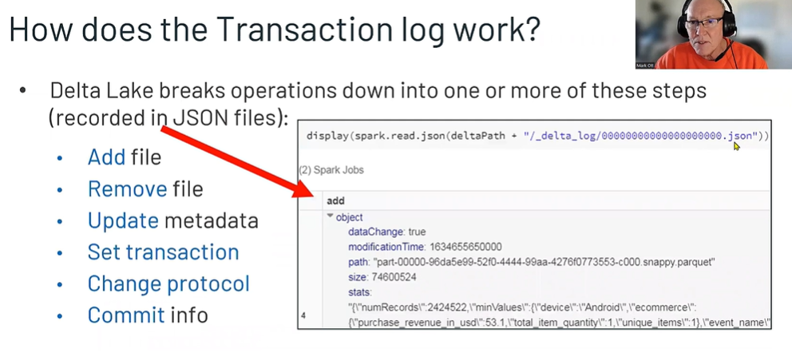

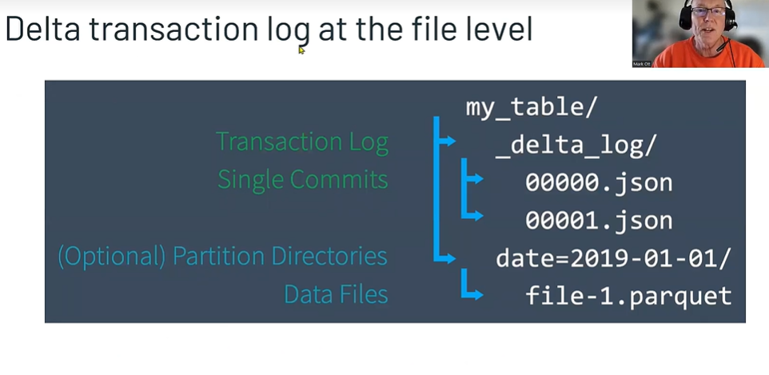

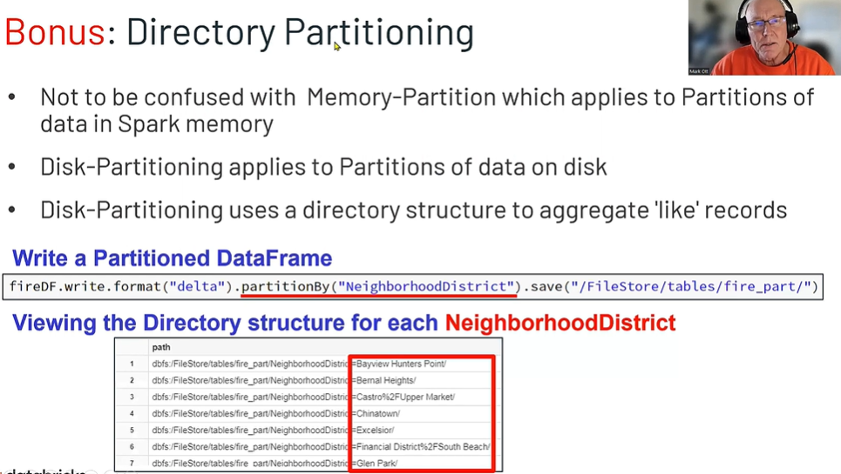

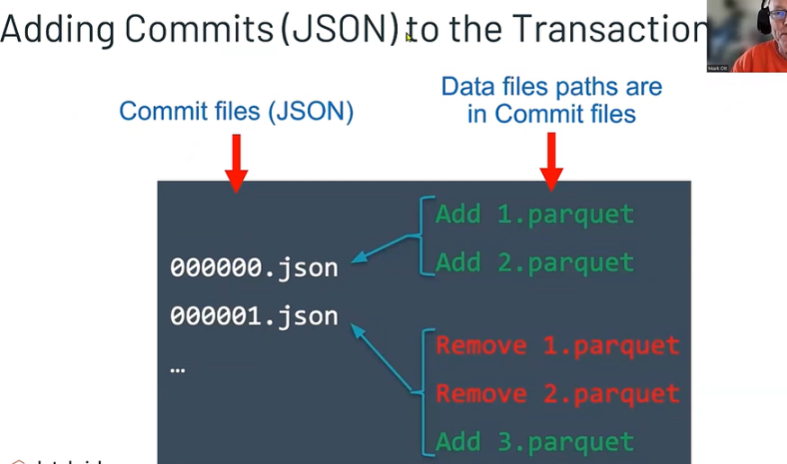

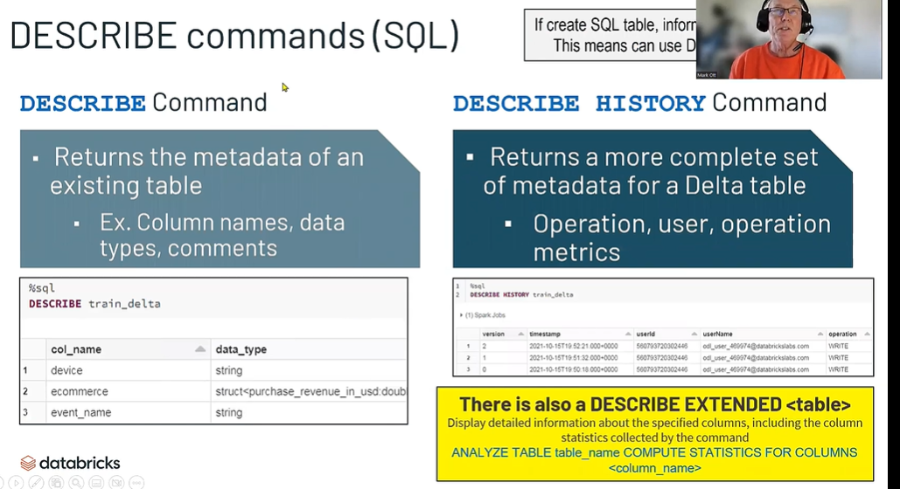

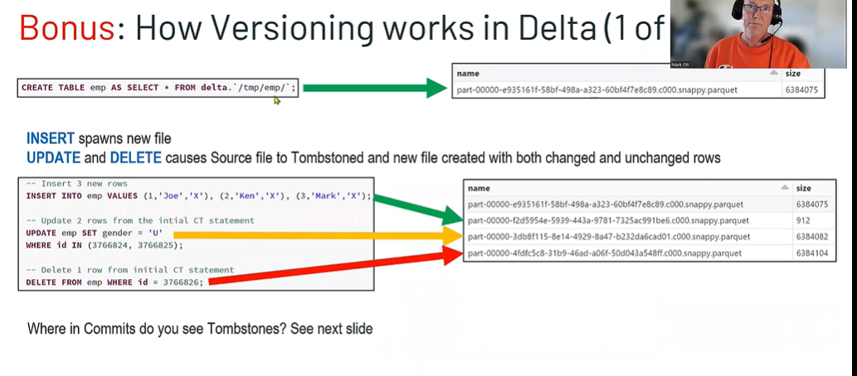

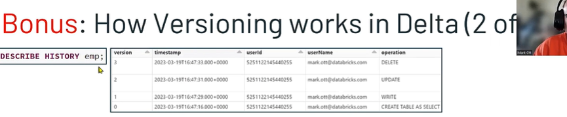

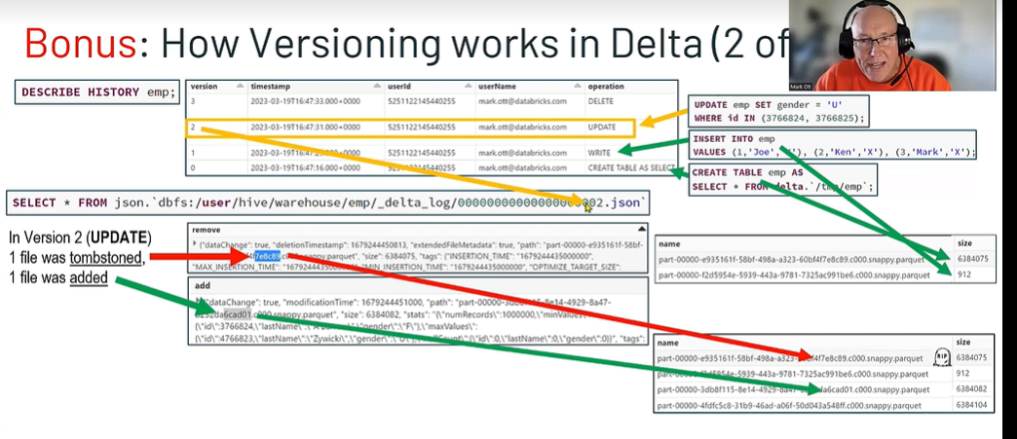

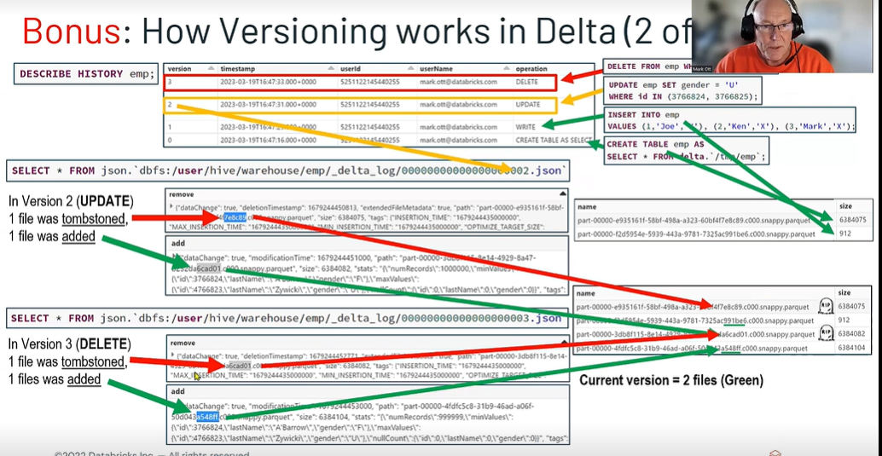

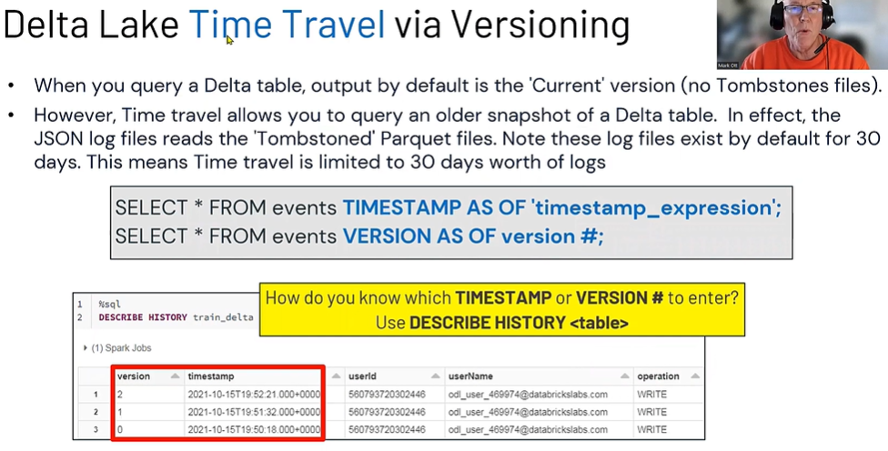

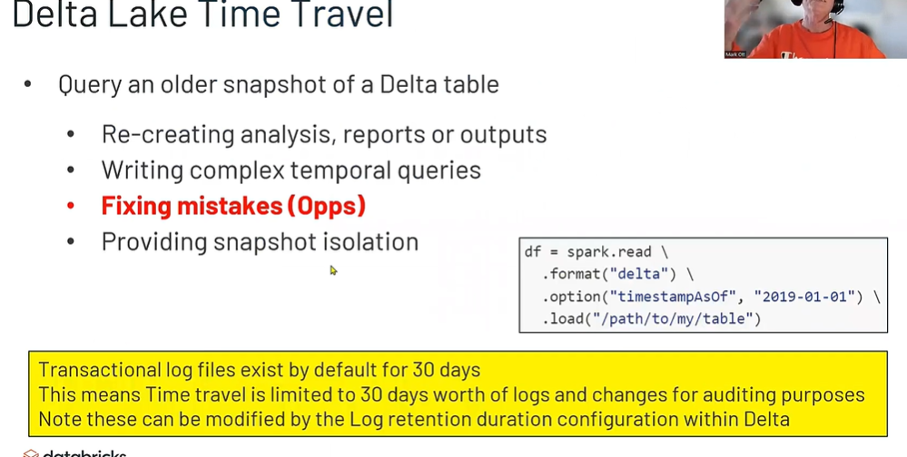

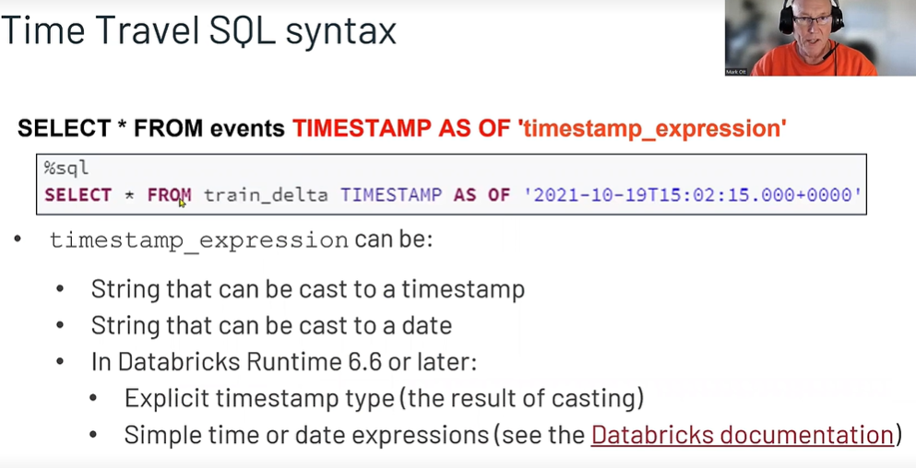

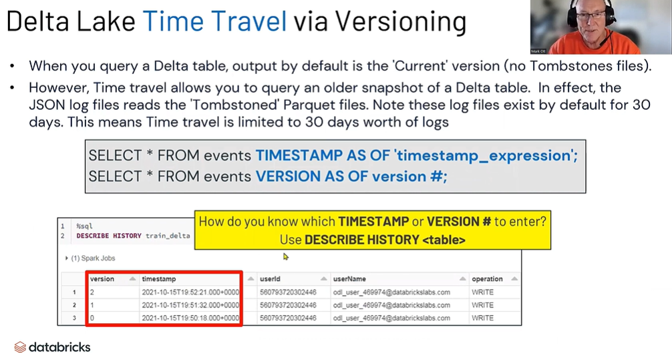

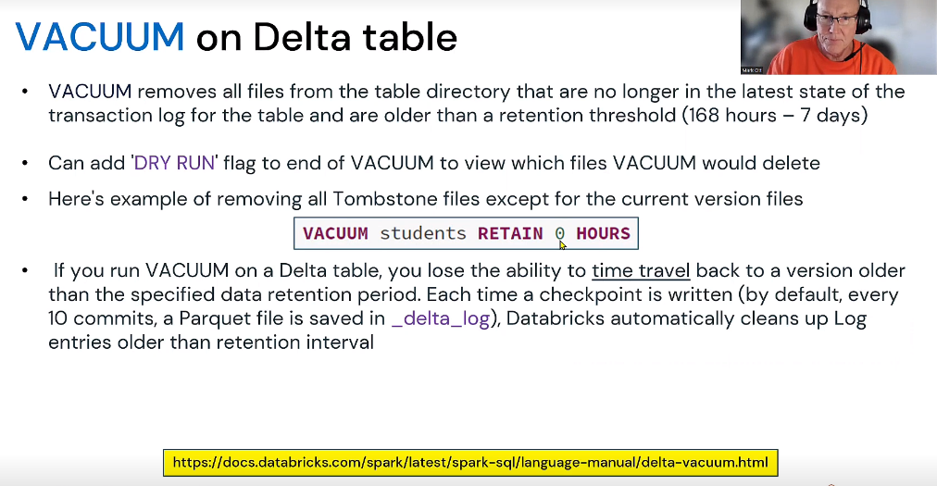

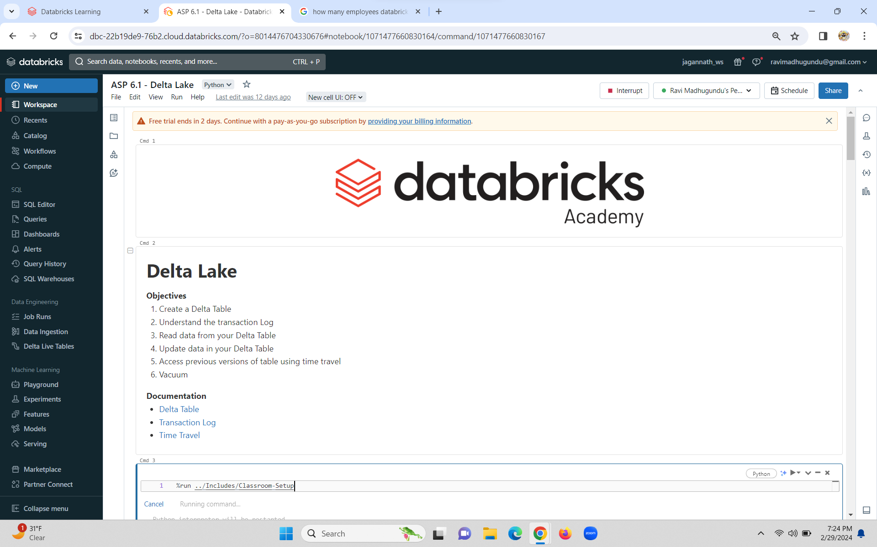

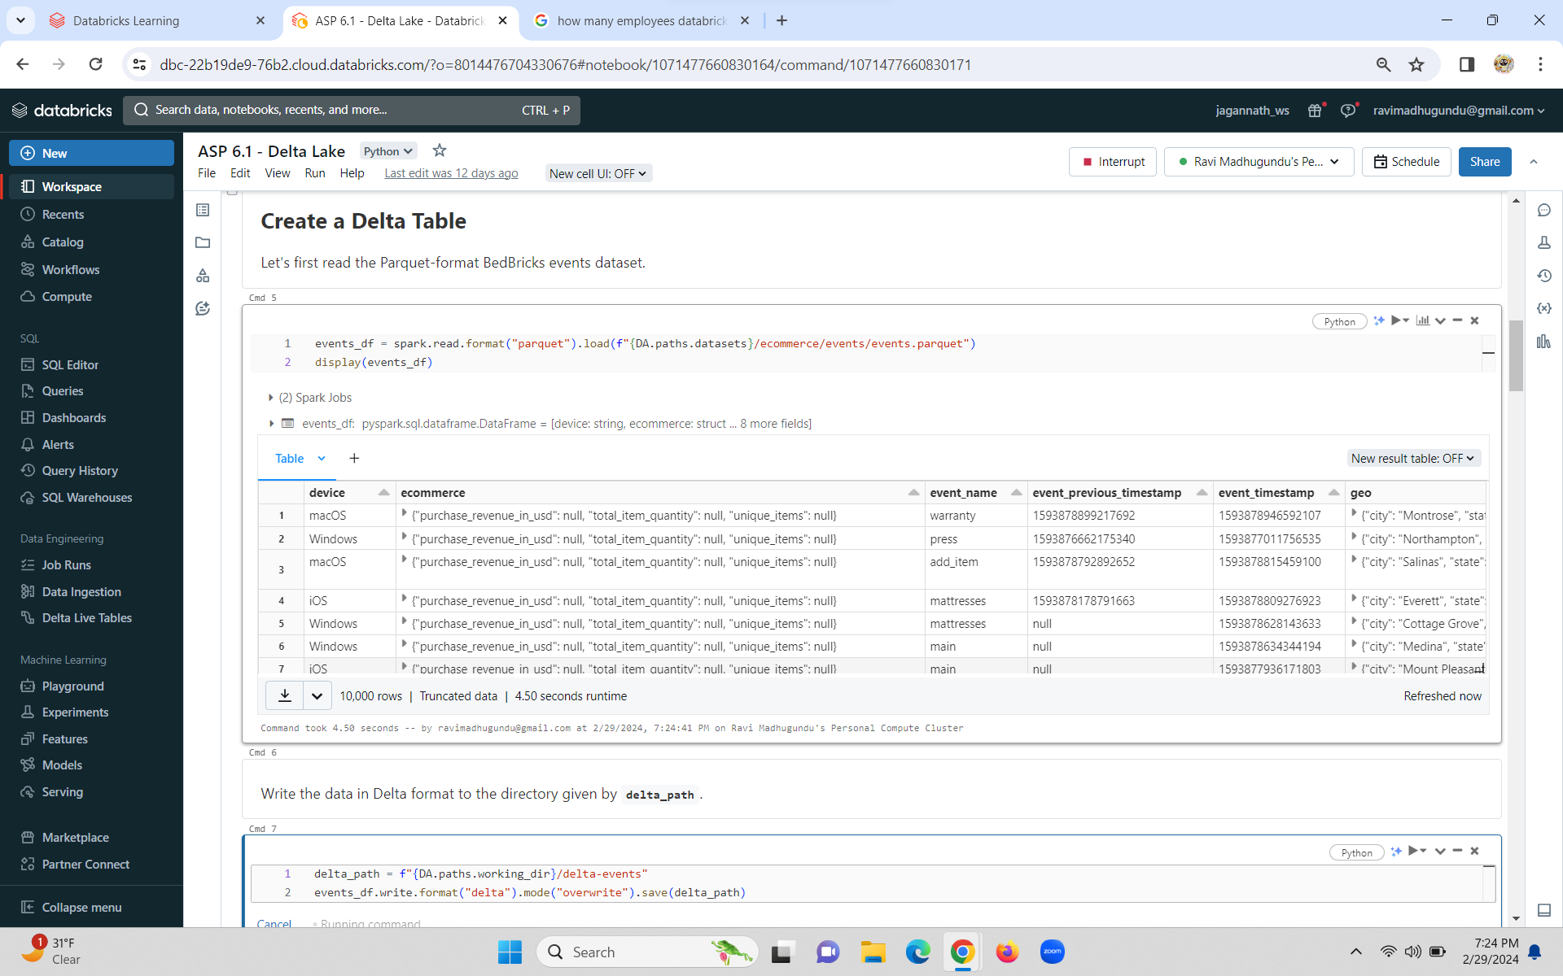

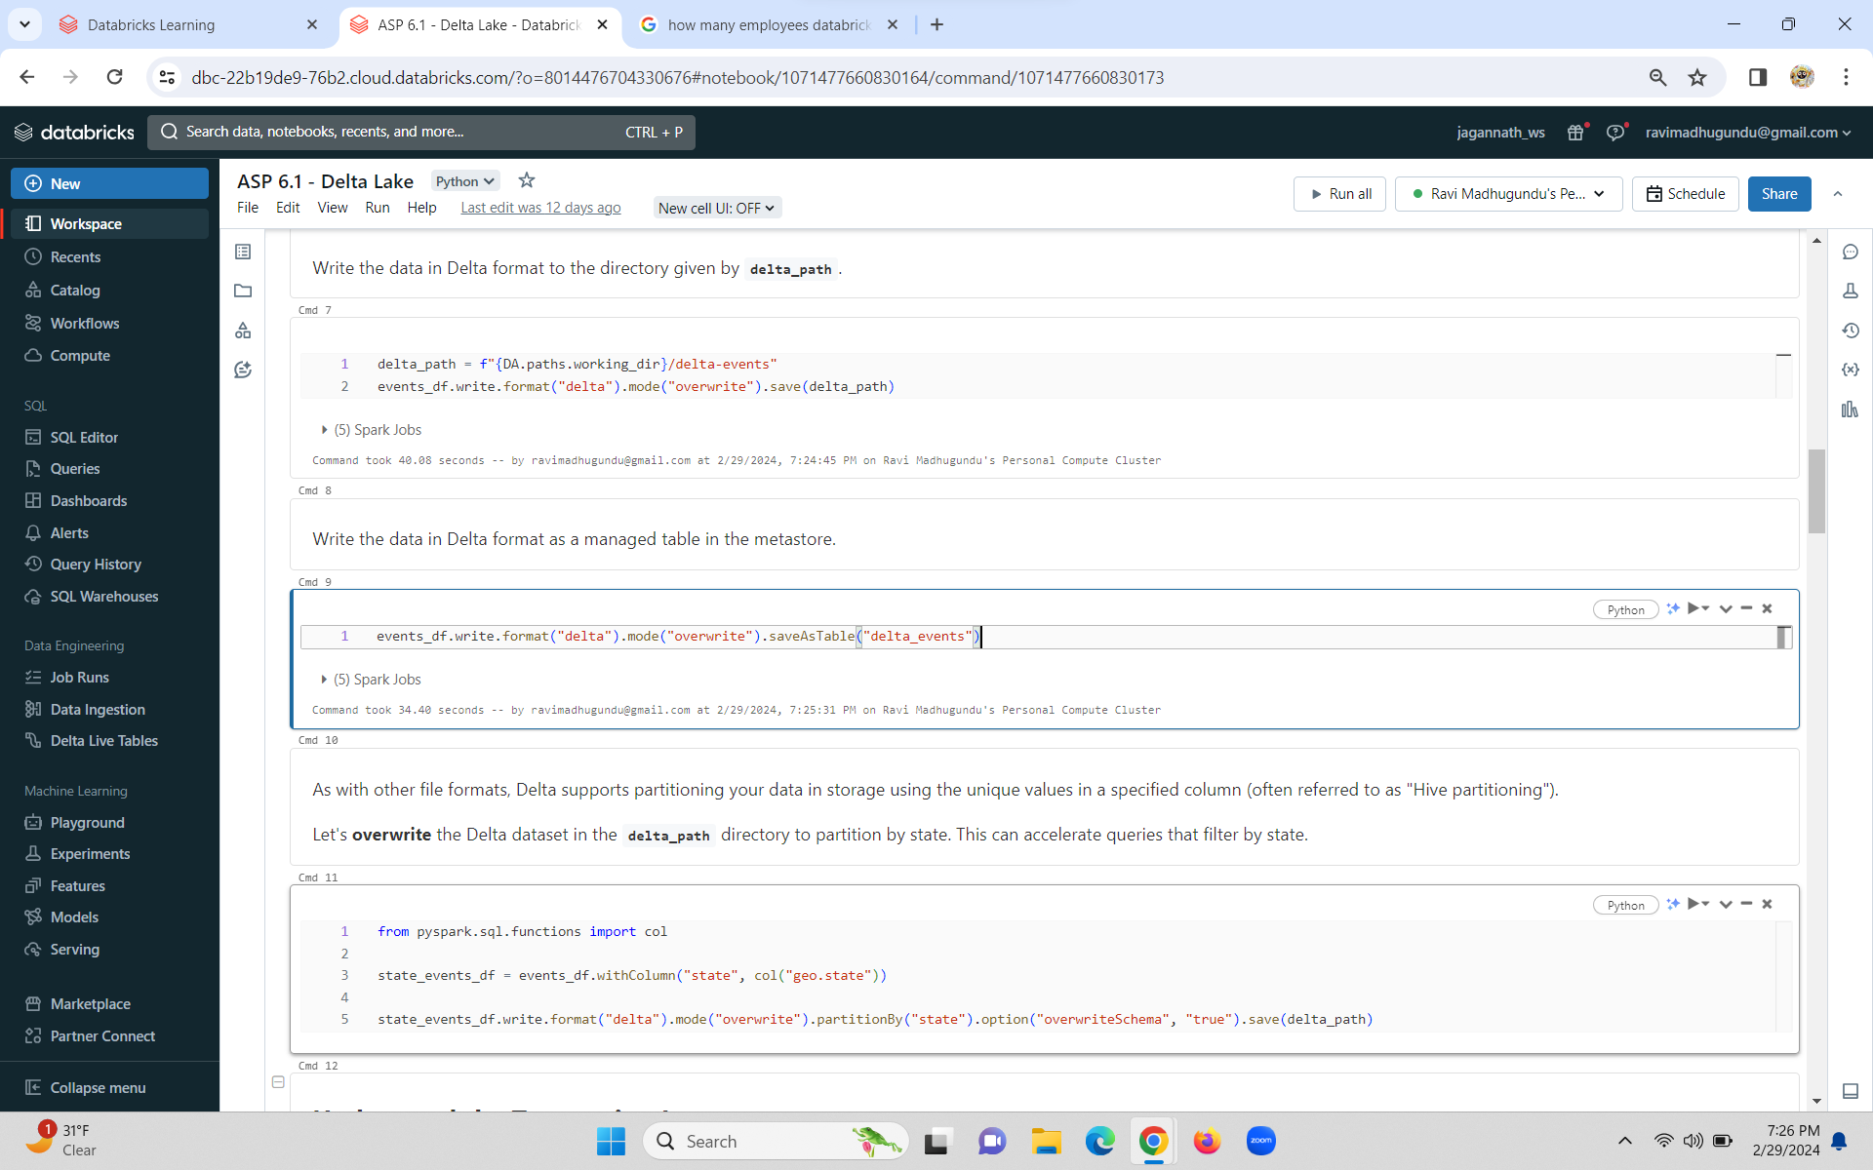

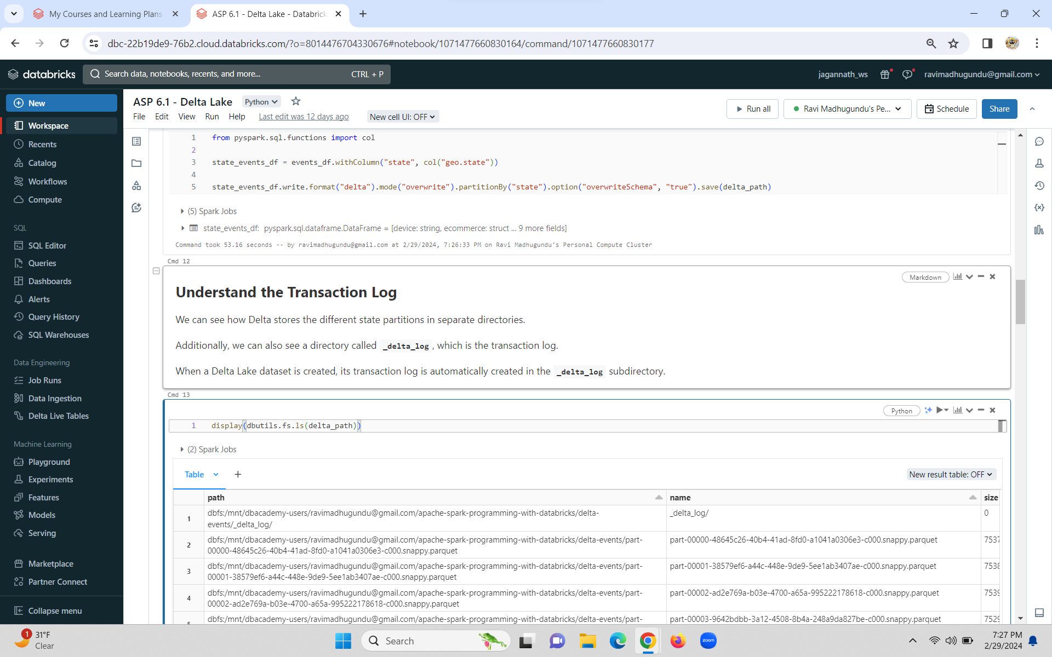

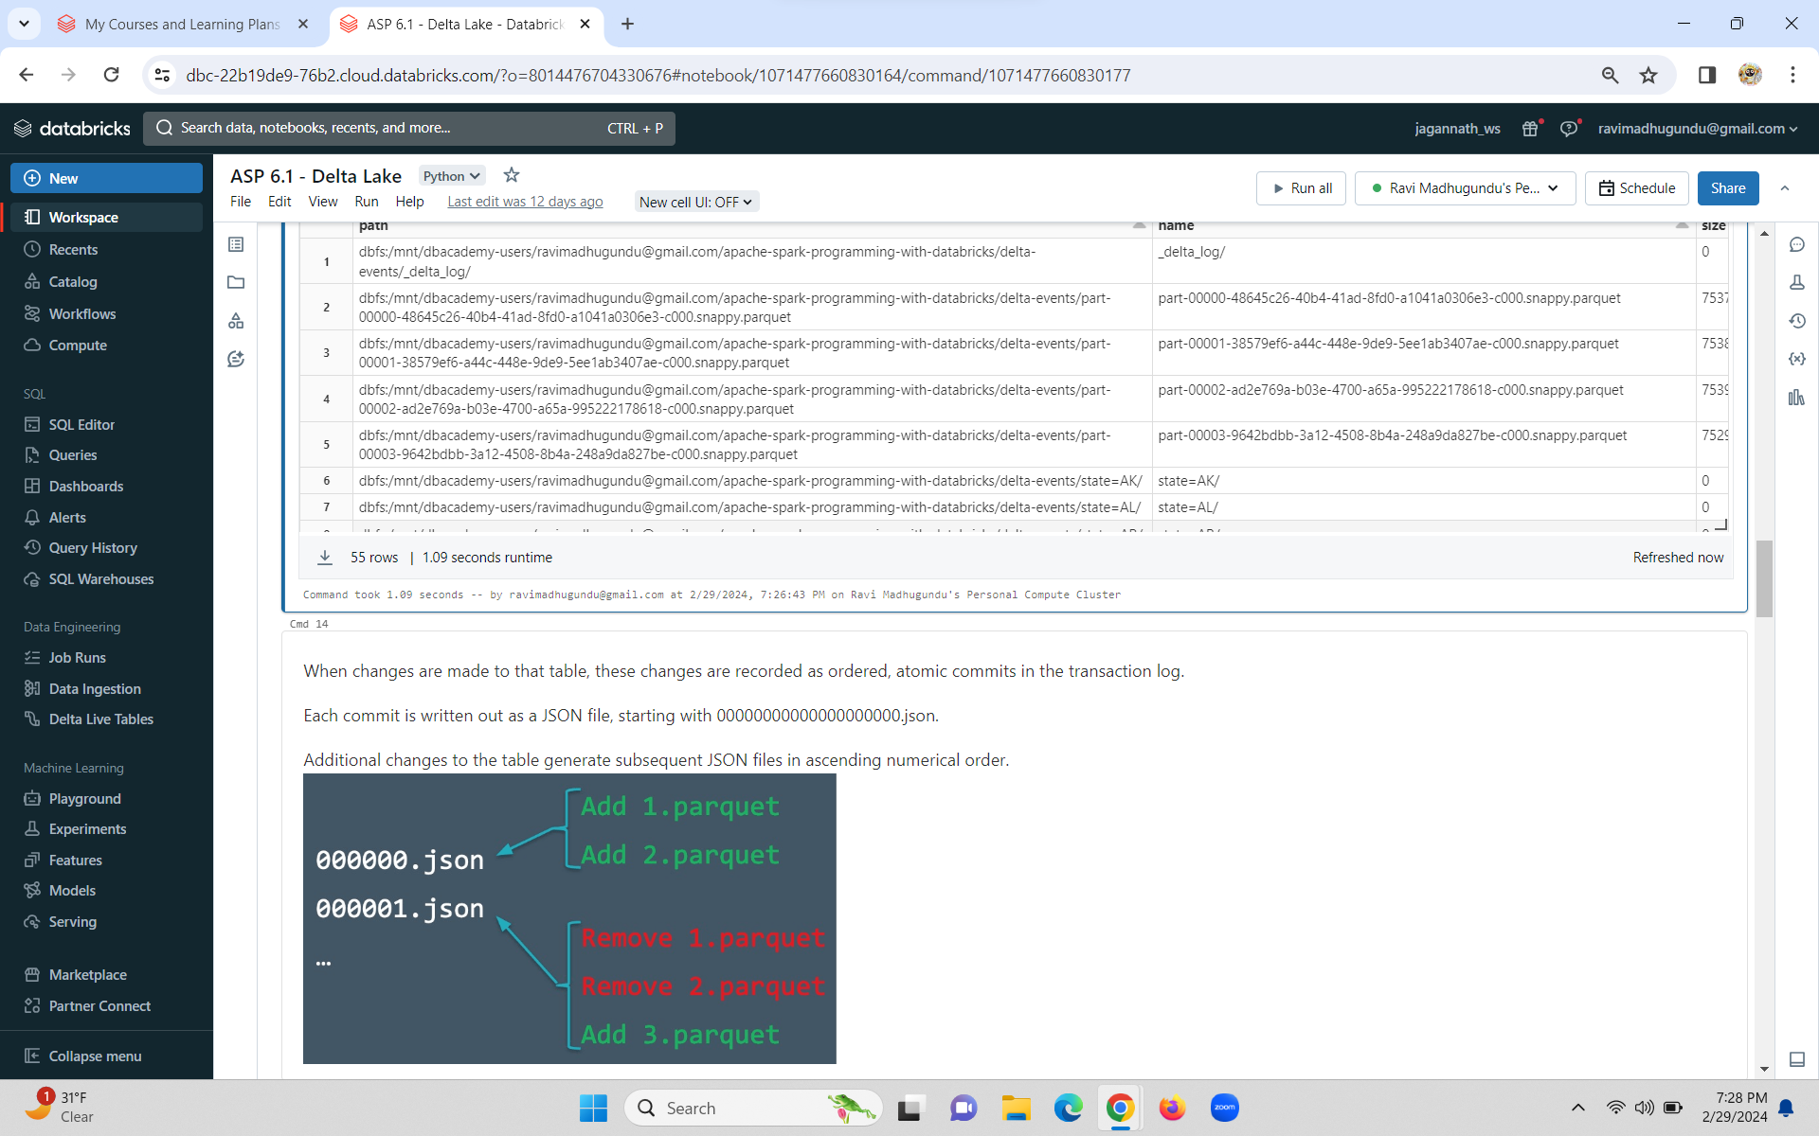

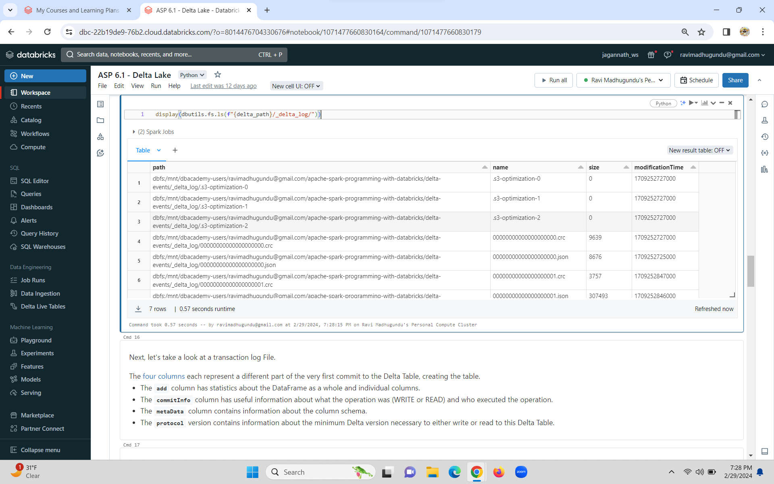

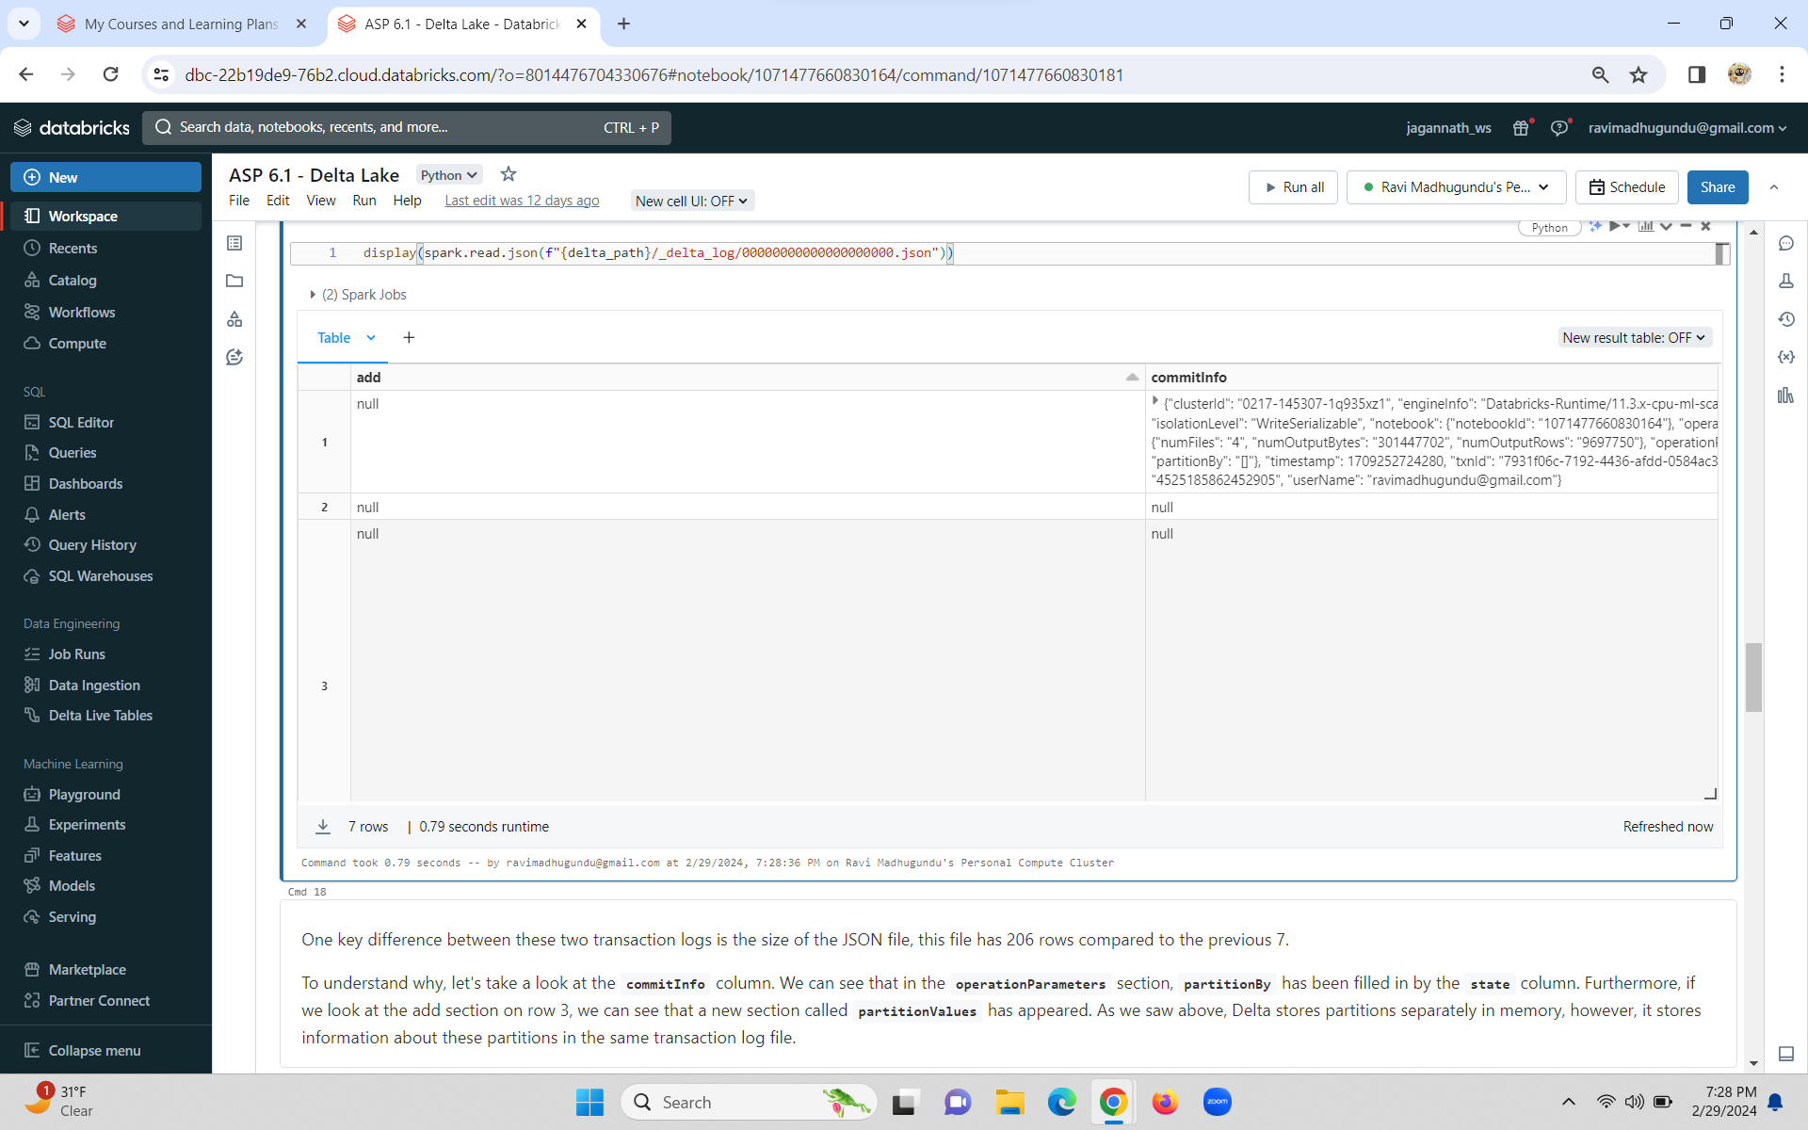

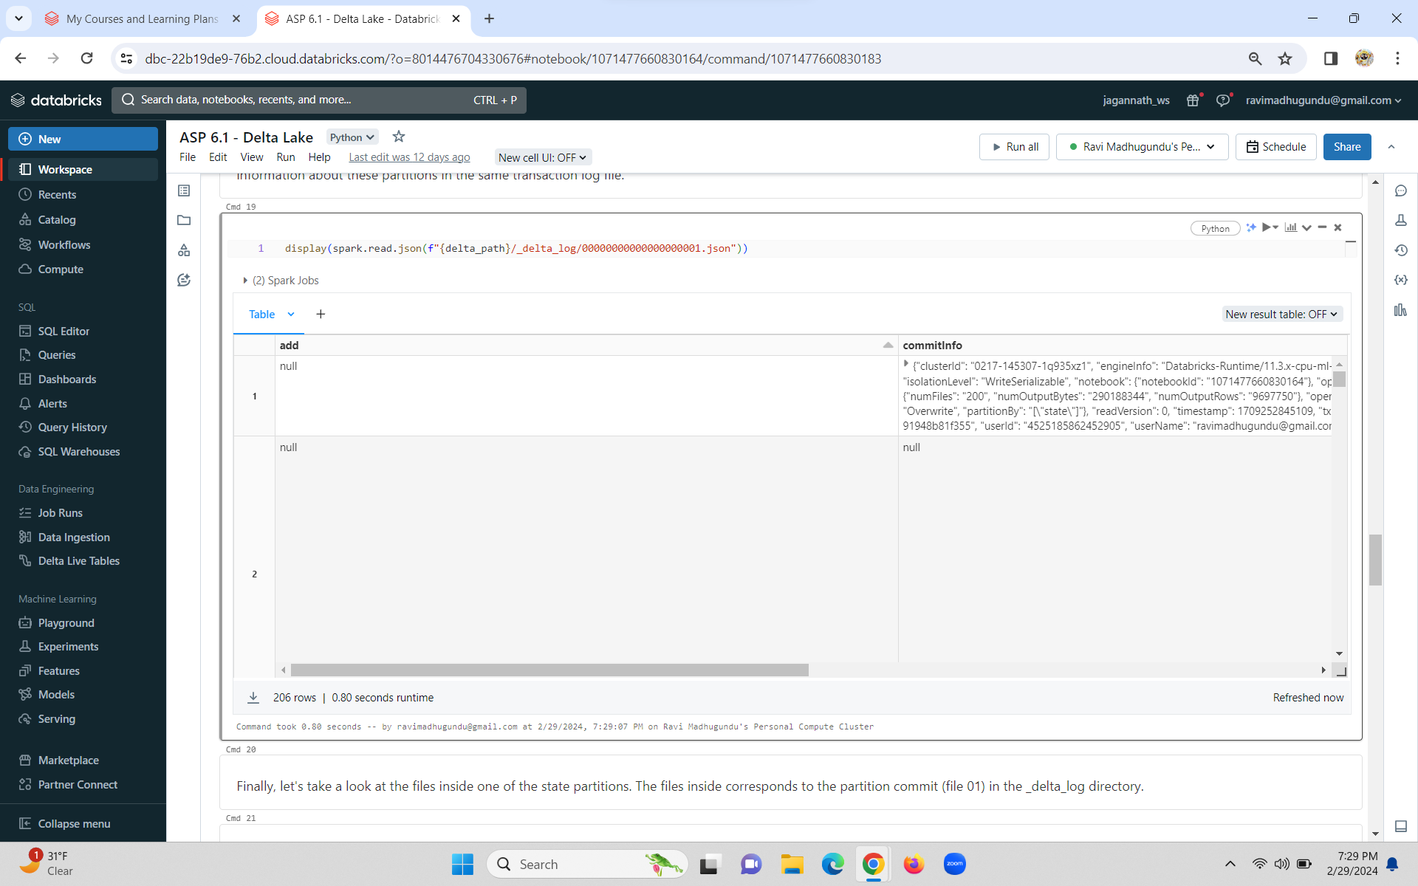

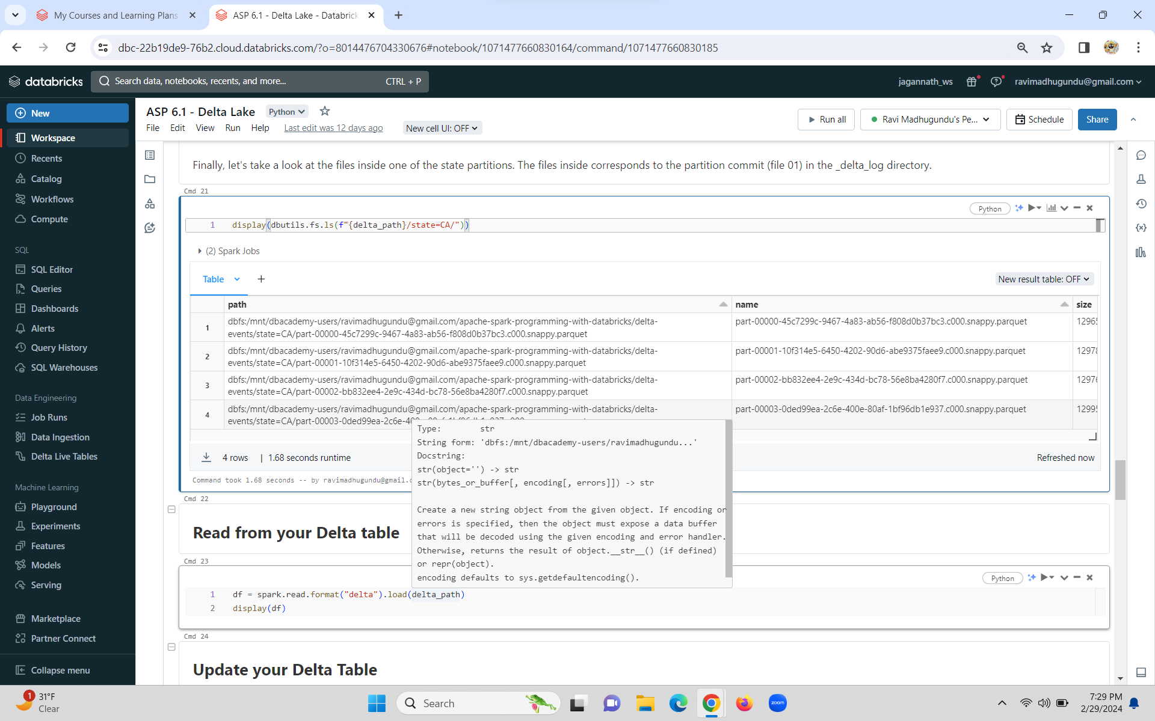

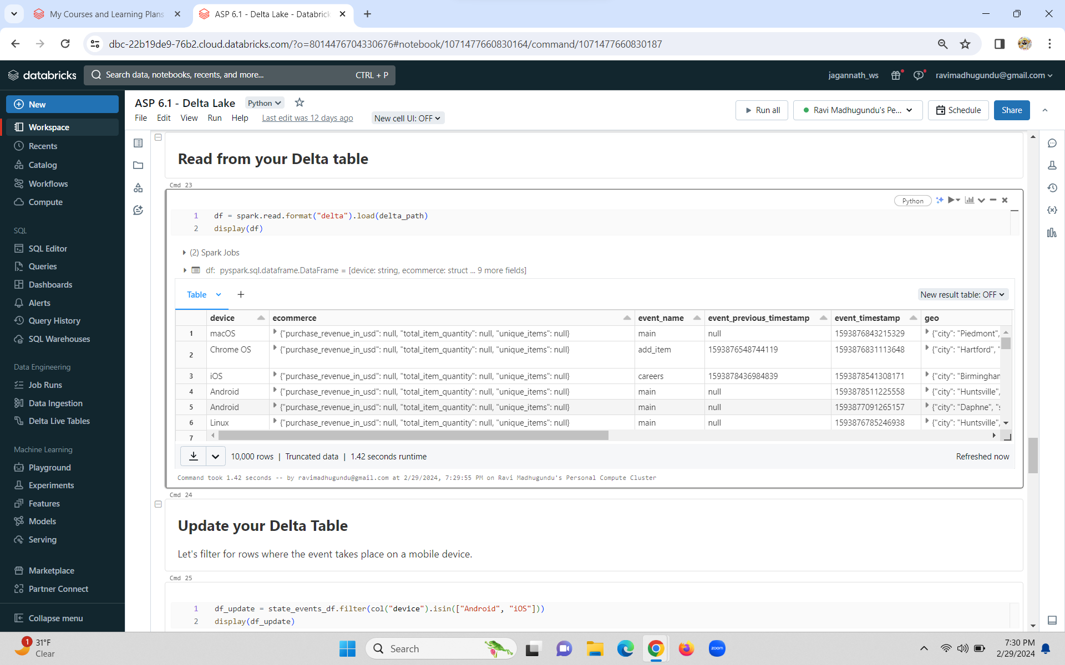

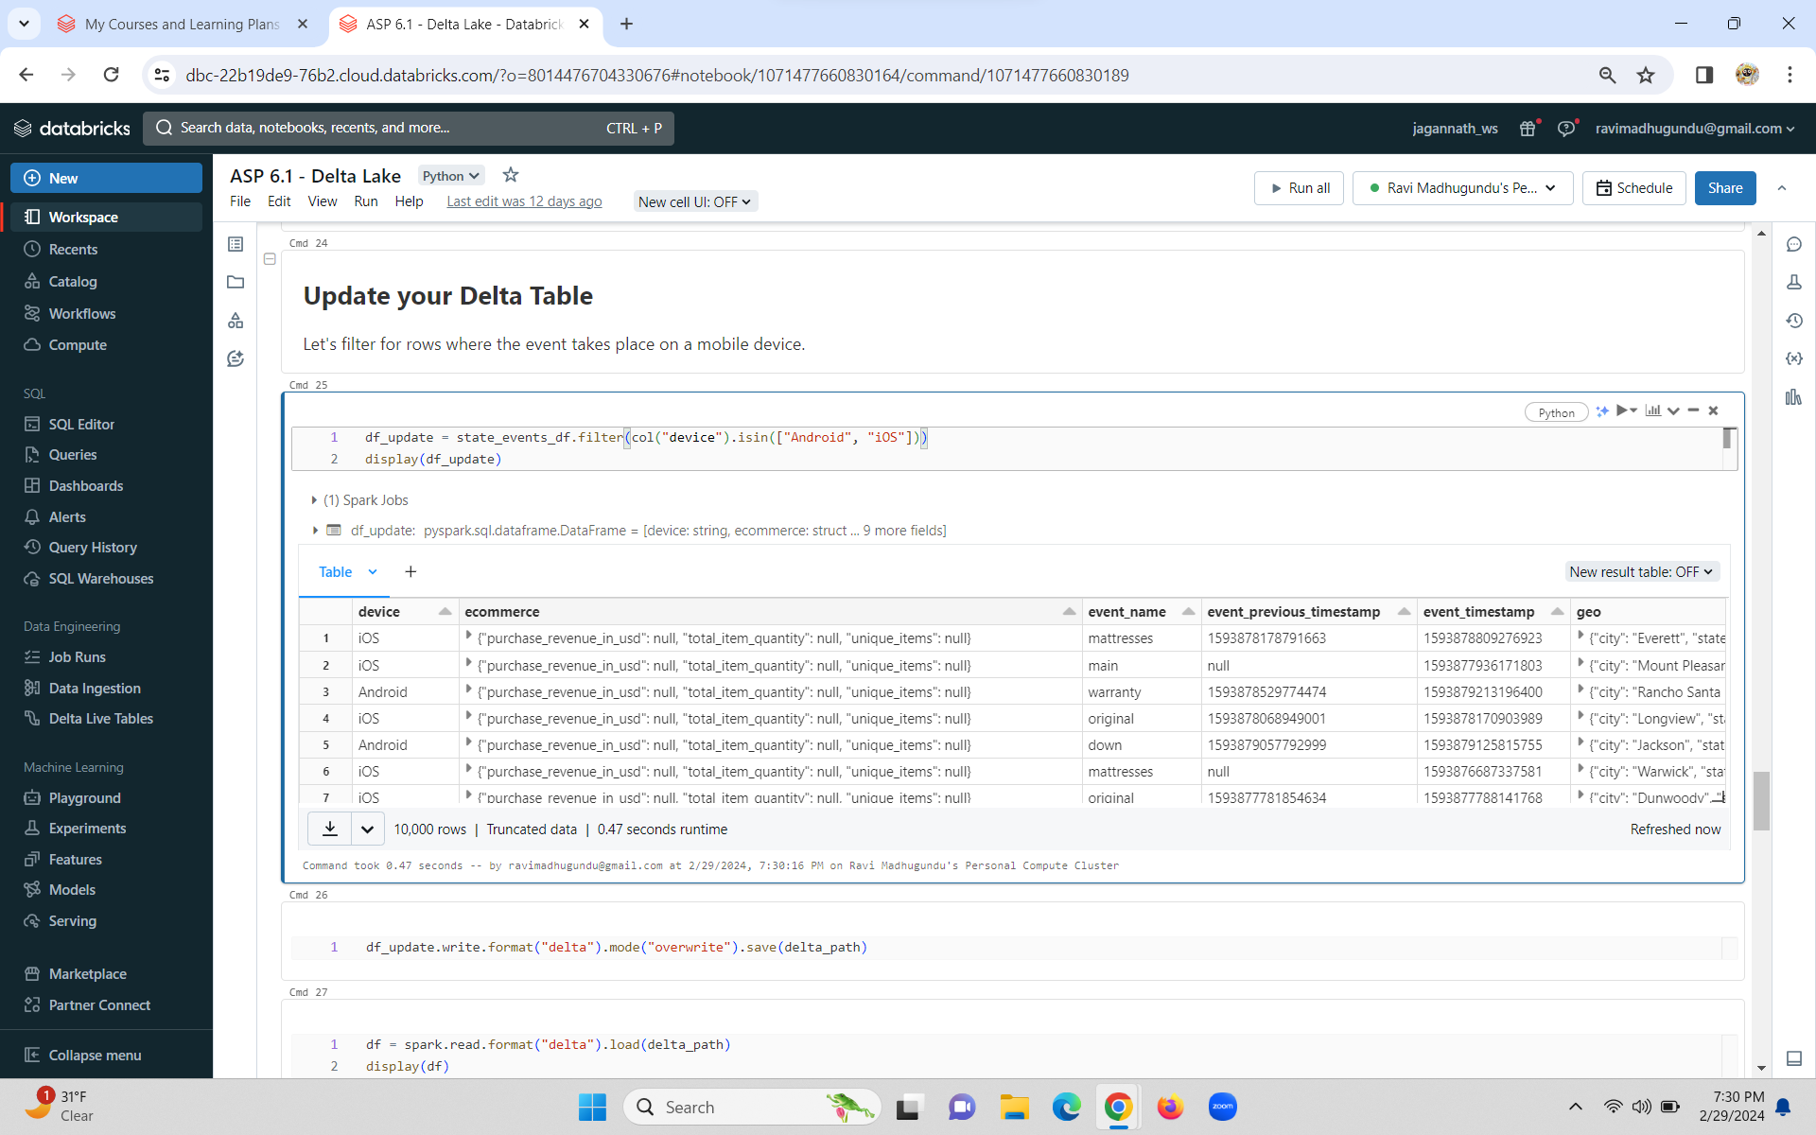

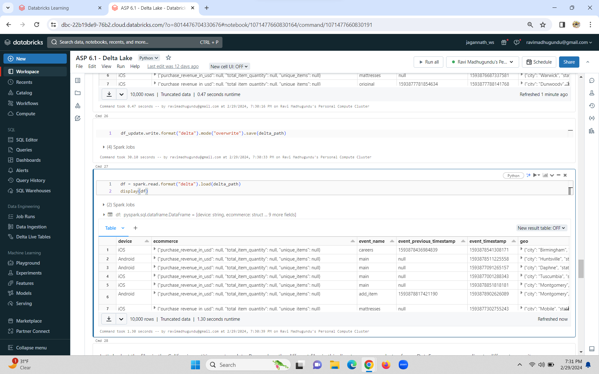

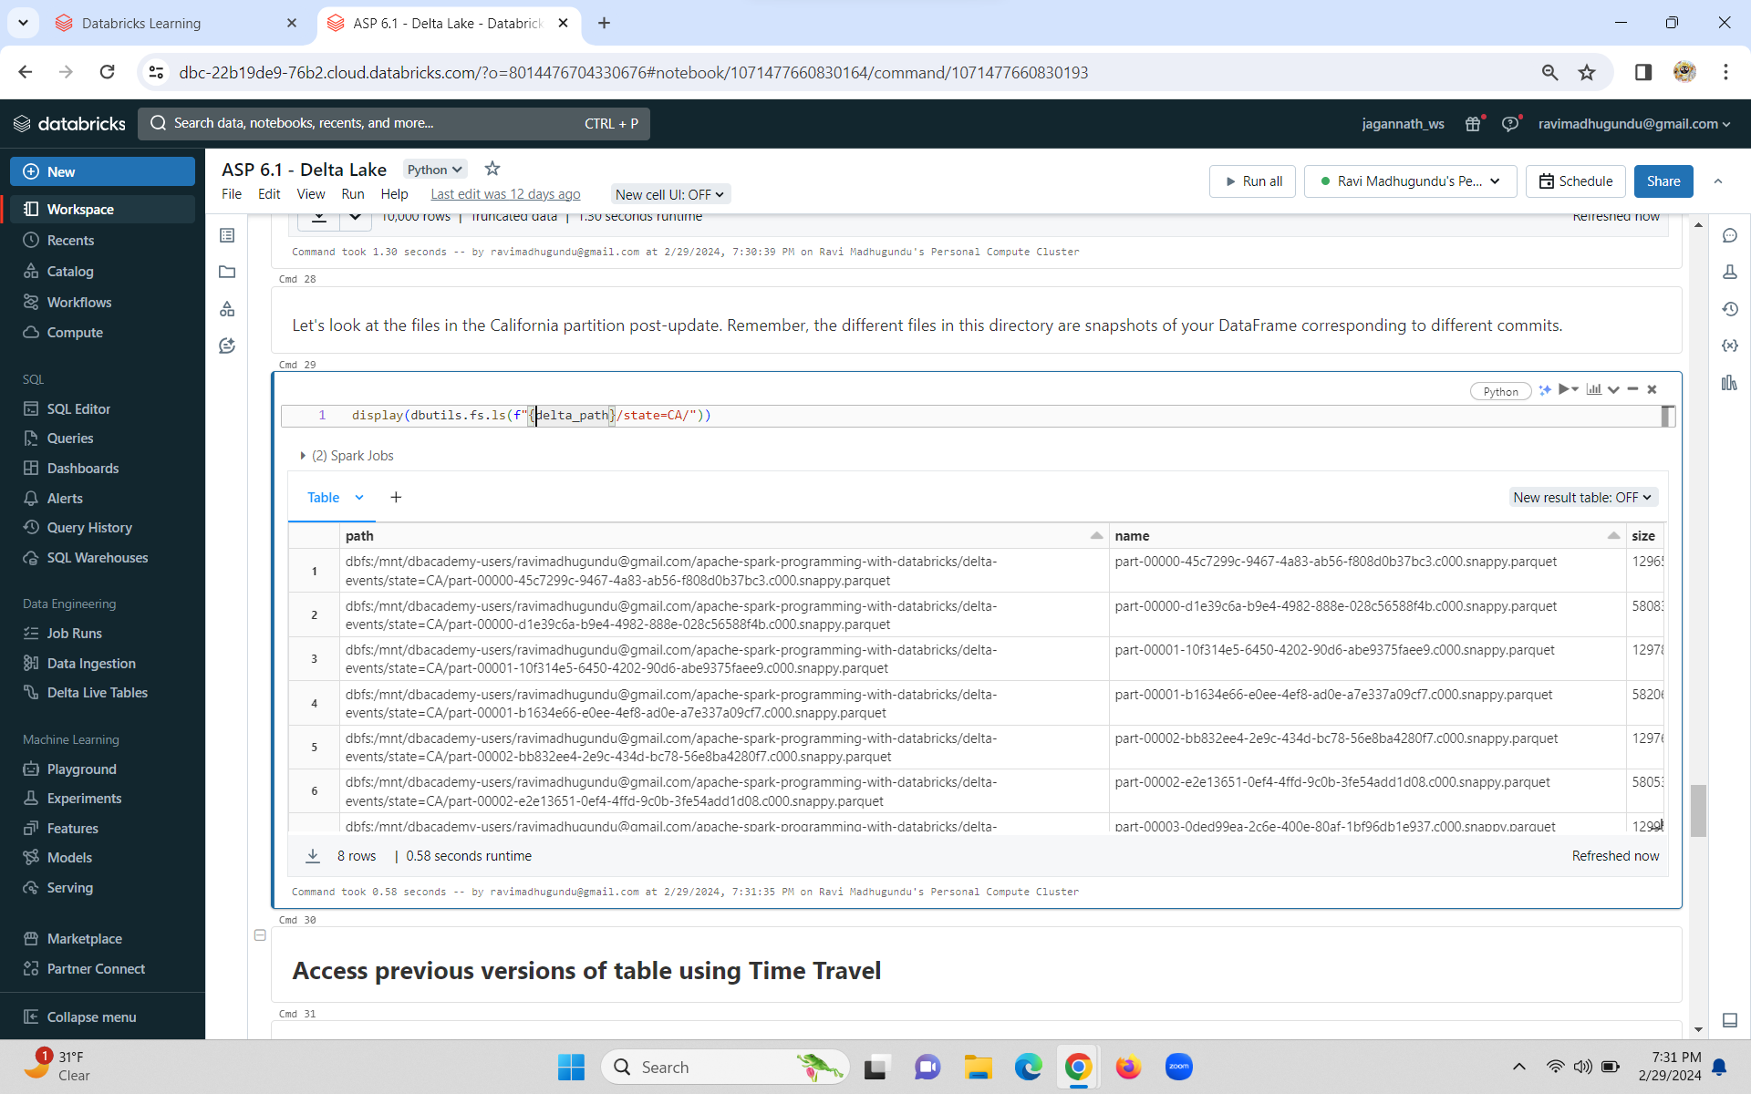

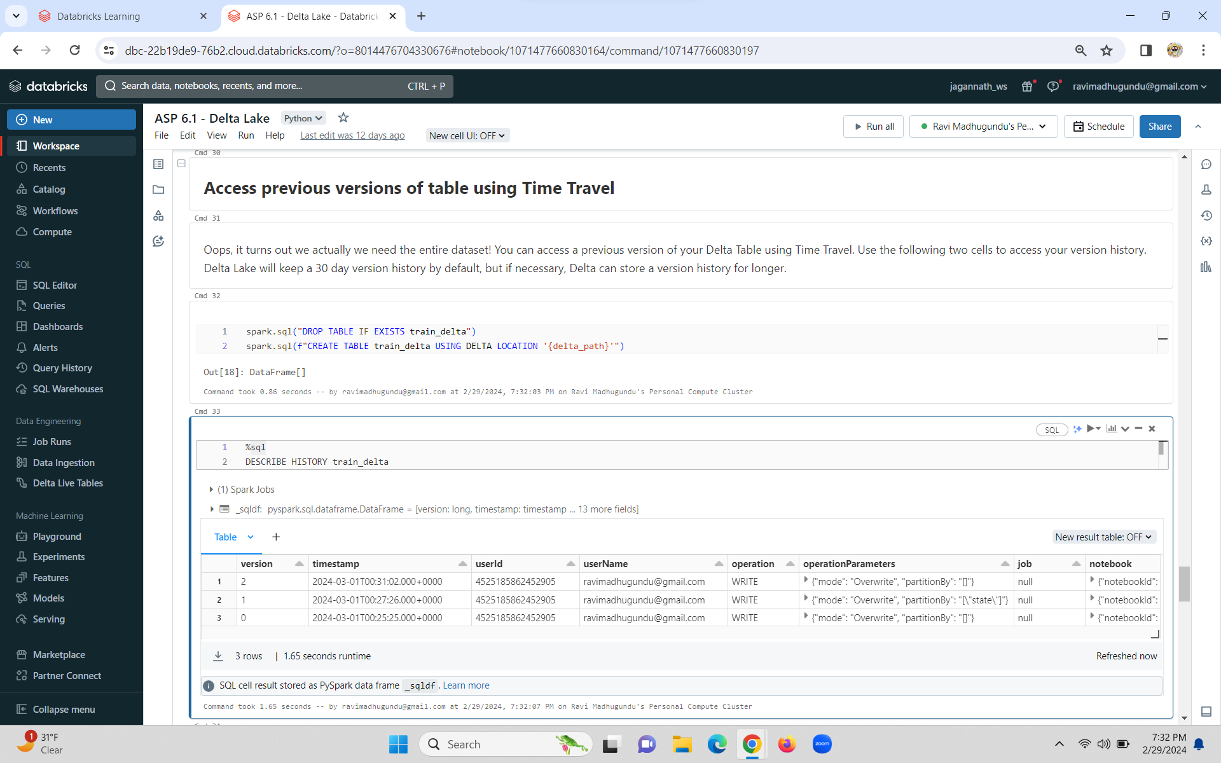

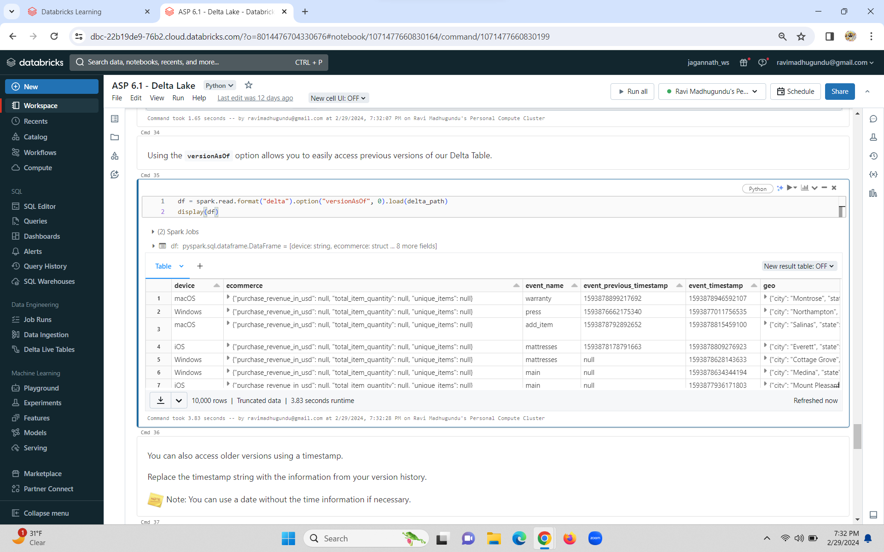

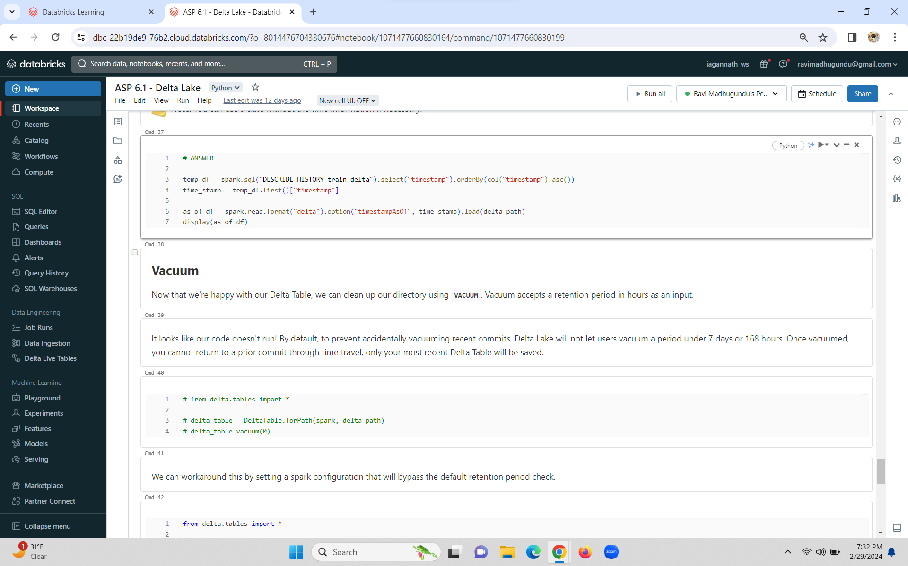



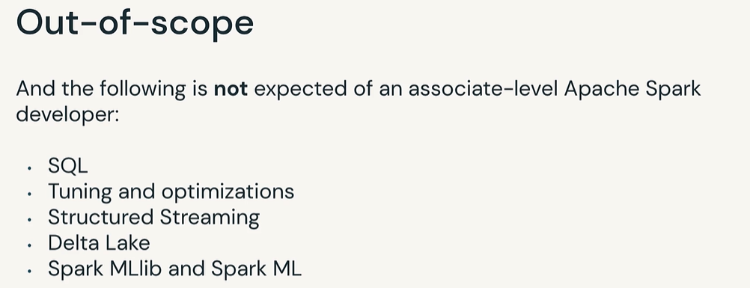



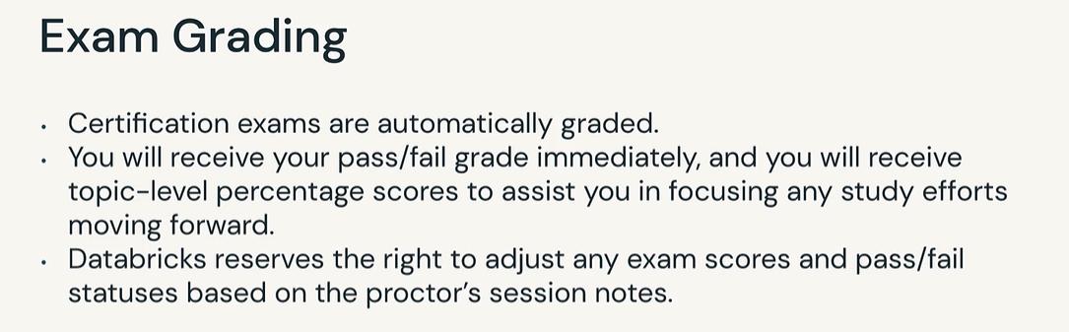

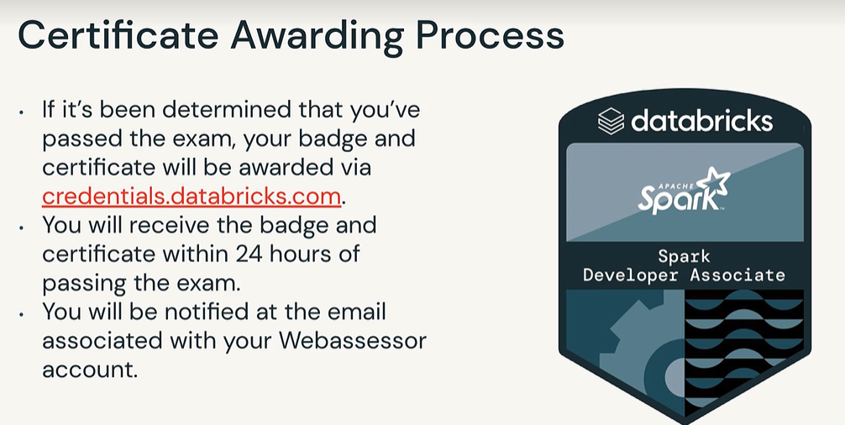

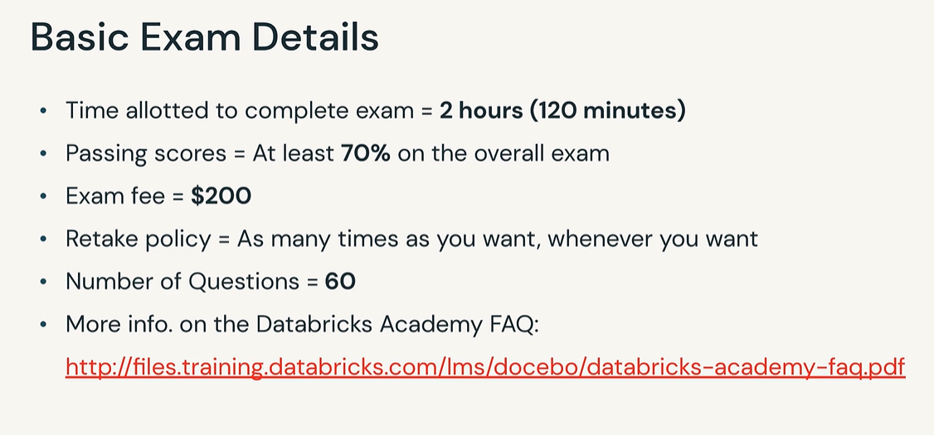

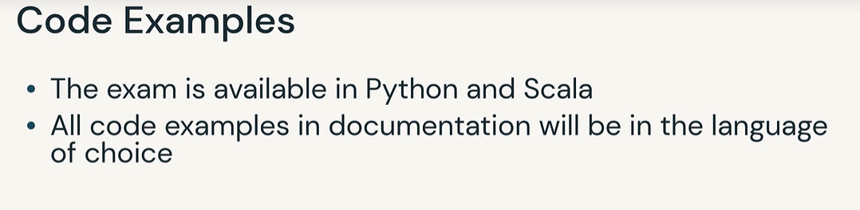



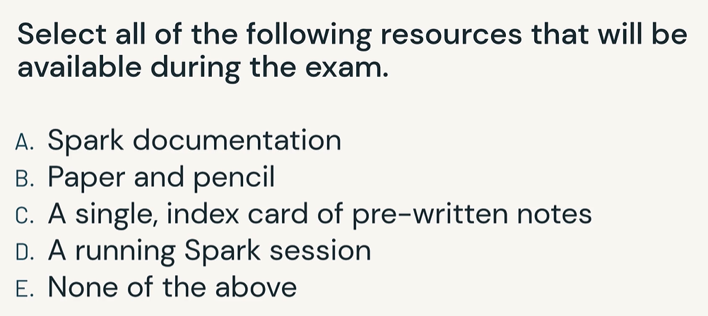

A

The main advantage of dataframe api is that you can use dataframe optimize fonction, for example : cache() , in general you will have more control of the execution plan.

I feel like it easier to test your code also, people tend to write 1 huge query ...

<https://medium.com/@think-data/pyspark-dataframe-api-vs-spark-sql-choosing-your-data-transformation-arsenal-51ee76cf9855>